Current
Current is a measure of the flow of electric charge through a material. A material that can carry a flow of charge is called a conductor. Current is defined as the amount of charge that flows through a conductor in a certain amount of time. The unit of current is the Ampere (A), which is equal to one Coulomb per second (Coulomb is the unit of charge)

Electricity is defined as the rate of flow of charges in a conductor.

VOLTAGE
- Voltage is the difference in charge between two points.

Resistance is a material's tendency to resist the flow of charge (current).
some conductors carry charge more easily than others. The resistivity of a material describes how easily charge can flow. Good conductors have a small resistivity, and good insulators have a large resistivity.

ELECRONICS COMPONETS USED IN COMPUTER

Identify Electronics components and name them
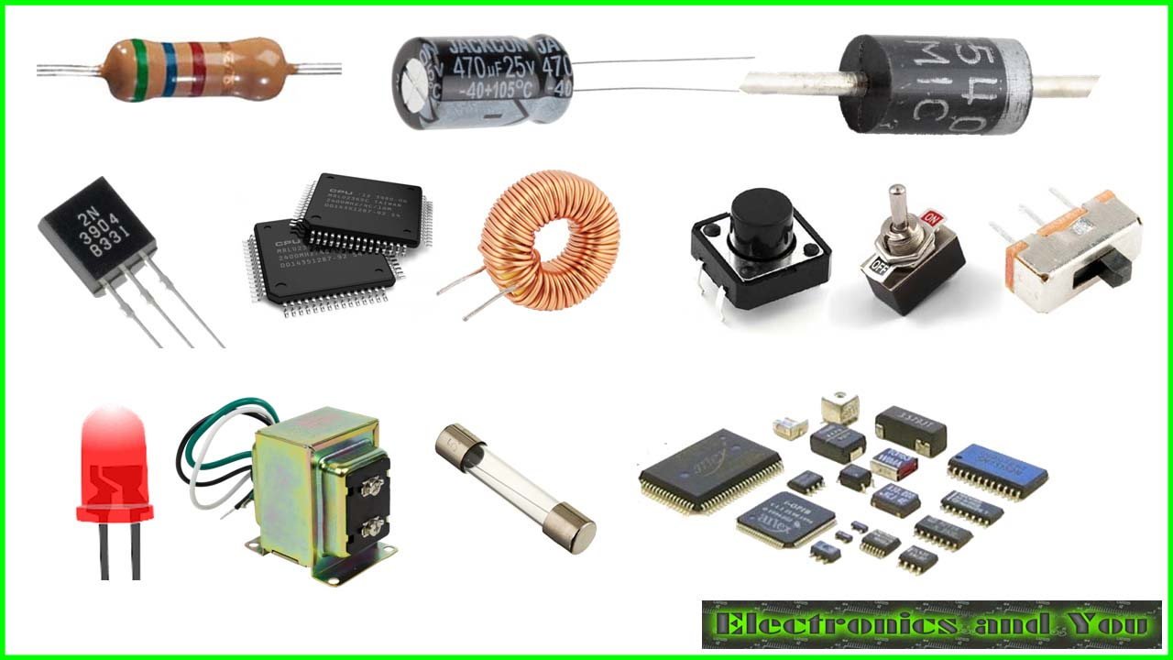
Electronic Components are of 2 types: Active and Passive Electronic Components.
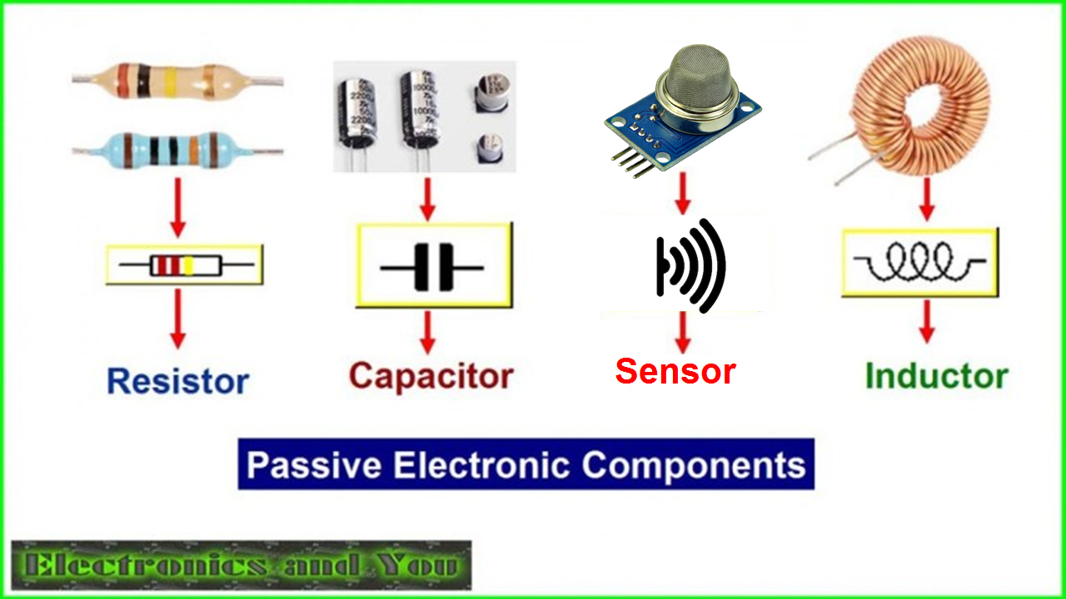

https://youtu.be/3xnsf3zBqSI

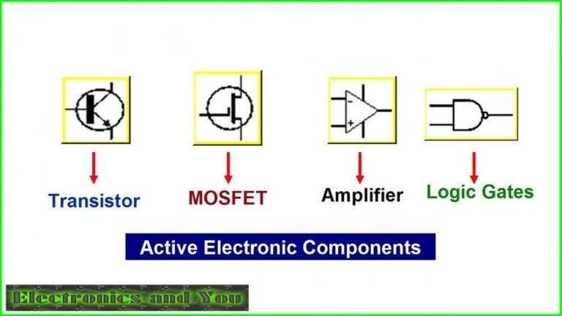

Active components are those components that require energy to work and are able to control the electricity running through them. Passive components are components that don't need any electricity to work.
- Active components are parts of a circuit that rely on an external power source to control or modify electrical signals. Active components such as transistors and silicon-controlled rectifiers (SCRs) use electricity to control electricity.
- Passive components like resistors, transformers, and diodes don’t need an external power source to function. These components use some other property to control the electrical signal. As a result, they only require the current traveling through the connected circuit. Resistors impede the flow of electrons without introducing more electricity into the syst

COMPONENTS | OUTPUT VALUES MEASURED/ STATUS OF THE DEVICE OBSERVED | COMPONENTS | OUTPUT VALUES MEASURED/STATUS OF THE DEVICE OBSERVED

Circuit Symbols of Electronic Components
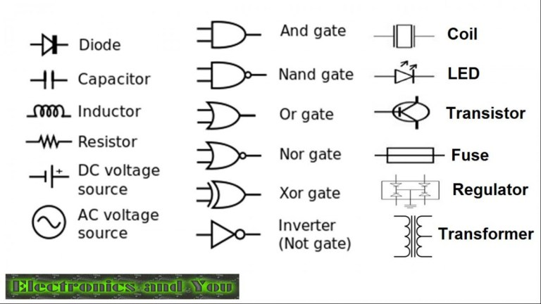

PAGE 19 AND 20
OF MANUAL

