What are the safety precautions to be taken before removing a mother board the removal of the motherboard from a computer?
When handling a bare motherboard, it is important to remember that the slightest impact may damage one of the tiny components on the motherboard.
Wear an anti-static wrist strap make sure it is disconnected from power
- The first step involves powering down the CPU, monitor any other external device connected to the computer.
- All the expansion cards / daughterboard's are removed.
- The keyboard is disconnected from the cpu cabinet
- Now the SMPS`s power connector which is connected to the motherboard is disconnected.
- The cable connecting the front panel buttons / lights is removed.
- Remove any connectors for the floppy, Hard drives, USB ports, serial and parallel ports, this removes all the external devices from the motherboard.
- Remove the graphics accelerator card if available.
- Remove the hard drives and floppy drives to create room for the removal of the motherboard.
- Remove all the screws that are on the motherboard attaching it to the cabinet
- Once all the above steps are done gently remove the motherboard out of the cabinet.

1.Using cupid cpu z tool find the different features of CPU
CPU-Z is a freeware that gathers information on some of the main devices of your system :
- Processor name and number, codename, process, package, cache levels.
- Mainboard and chipset.
- Memory type, size, timings, and module specifications (SPD).
- Real time measurement of each core's internal frequency, memory frequency.
. The following image shows CPU details in the CPU-Z program.
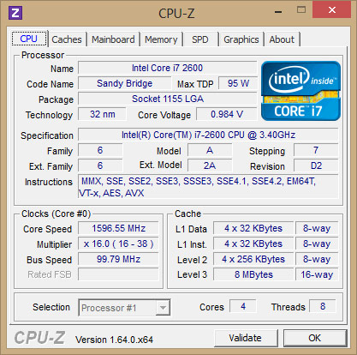

The CPU tab will tell you information about your computer's CPU\
Name: CPU name, in the screenshot of your computer is Intel Core i7 2600.

Code Name: Code name of the CPU architecture.

Max TDP: Maximum CPU power consumption.

Package: The socket type of the CPU, for each different socket type, will have a different number of pins. This parameter is very important when you want to upgrade the CPU, you cannot bring 1 CPU socket 478 chip attached to socket 1155 and vice versa.

Technology: Technology of transistors. As in my example, 32nm, this number is as small as possible, because it helps the chip to contain more transistors, running faster and more efficiently. This technology is increasingly improving, at the latest CPUs it has been able to reach 14nm (Intel's Coffee Lake series). On the phone Apple has started producing 7nm A12 processors for its devices.

Core Voltage: Voltage for the core of the chip, this parameter is usually not fixed because modern chips often adjust the consumption voltage to save electricity.

Specification: Full CPU name of the computer.

Family: The main architecture of the chip. For example, on Intel's CPU with Family 6, the P6 generation (Pentium Pro, Pentium II, Pentium III and Pentium M - all have the same execution unit). You can refer to Wikipedia for a list of Intel microprocessor chips.

Model: . This model number is basically a way to identify the CPU core type. You can look up your model in the link of the Family section above for more information about your CPU.

Stepping: This is the number that determines what kind of improvements have been made to the core, and how much new is. It can be understood that like software patches, the larger this number means that it has been fixed many times, improved from previous versions.

Revision: Combination Family, Model and Stepping can tell you the name Revision ,. And with the CPU Revision, CPU-Z, you can easily know the name Revision without looking for the datasheet. In this article example of my Revision is D2.

Instructions: This is the list of scripts that the chip processes.

Core Speed: CPU clock, this parameter with core voltage frequently changes to save power.
Multiplier: The coefficient of impulse (also known as bus ratio) sets the ratio of the internal clock rate to the external pulse provided. For example, this number is x10, then you will see 10 internal cycles for each external clock cycle.
Bus Speed: Bus speed.

Level 3: The cache specification, the higher the better, because the CPU will be less congested when processing. The higher the level, the faster the CPU runs.

Cores and Threads: Number of cores (or cores) and number of CPU threads. This number is usually an even number, as in my photos, there are 2 cores, 4 threads.

2. Using the CPUID CPU-ZTOOL , identify the CPU cache features of your working system

CACHE FEATURES
In the second tab, called Caches, we have information about the processor cache, indicating separately the size and format of the L1, L2, L3 and L4 caches in the case of having it.

system memory (RAM) is too slow to directly work with CP slowing the CPU down. This is where the cache memory comes in. It acts as an intermediate between the two, storing small chunks of repeatedly used data or in some cases, the memory addresses of those files.
Instruction cache
Used to speed up executable instruction fetch
Data cache
Used to speed up data fetch and store; the data cache is usually organized as a hierarchy of more cache levels

In contemporary processors, cache memory is divided into three segments: L1, L2, and L3 cache, in order of increasing size and decreasing speed. L4 Cache is the largest and also the slowest
Cache hile the L1 data cache often acts as an output-cache, the L1 instruction cache behaves like an input-cache. This is helpful when loops are engaged as the required instructions are right next to the fetch unit.
memory is based on the much faster (and expensive) Static RAM while system memory leverages the slower DRAM (Dynamic RAM).
The main difference between the two is that the DRAM is made of CMOS technology and transistors (six for every block) while the CACHE uses capacitors and transistors

L1 cache is further divided into two sections: L1 Data Cache and L1 Instruction Cache. The L1 INST contains the instructions that will be consumed by the CPU core while the L1 DATA is used to hold data that will be written back to the main memory.
L1 cache not only works as the instruction cache, but it also holds pre-decode data and branching information.
While the L1 data cache often acts as an output-cache, the L1 instruction cache behaves like an input-cache. This is helpful when loops are engaged as the required instructions are right next to the fetch unit.

The L3 cache feeds information to the L2 cache, which then forwards information to the L1 cache. Typically, its memory performance is slower compared to L2 cache, but is still faster than the main memory (RAM).
The level 4 cache (L4 cache) is a way to link the Level 3 cache which can be accessed by the CPU and the L4 cache which can be access by both the CPU and GPU. Level 4 on-package cache was introduced by Intel starting with their Haswell microarchitecture

WINDOWS RESOURCE MONITOR
To get started with Resource Monitor, press Windows +R, type Resmon.exe in the Open text box, and press Enter.
Resource Monitor or Resmon lets you easily monitor your CPU usage, memory usage, Disk Activity, Network Activity and more. Like the Reliability Monitor or the Performance Monitor, the Resource Monitor too is a useful built-in tool in Windows.

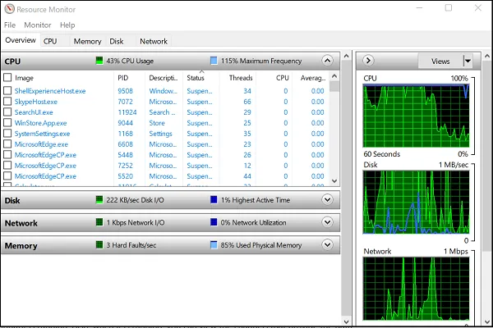
To launch Resource Monitor, type resmon in Start Search and hit Enter. When you first launch the application, an ‘Overview’ tab gets displayed.

1] Overview tab

As the name suggests, the Overview tab displays basic system resource usage information of other four main tabs:
- CPU
- Memory
- Disk
- Network
You can take a look at the base graphs for each of the four categories. It offers at-a-glance, basic overview of your system’s current status.
As you can see, the CPU graph displays the total percentage of CPU capacity currently in use (green curves along the graph)with blue color indicating the maximum CPU Frequency. Alongside it, there’s a Disk graph displaying the total current I/O in green and the highest active time percentage in blue. Similar findings related to the Network graph and Memory graph are also displayed

2] CPU
Under the CPU tab, it is possible to filter each view of the given tabs by the process. Simply check the box for that process, and the bottom window will only show the activity for that process. With no processes selected, the bottom windows will transform into an activity page for all active processes.

3] Memory tab
The memory tab shows the memory being consumed by each of the running processes, along with graphs on the right side. This gives us a quick view of what physical memory is being used for.

4] Disk tab
Under the ‘Disk’ tab you will find those processes that are engaged in some Disk activity. At the time you may find some process engaged in a lot of Read-Write activity. Right-clicking on any process will give you the option to End the process, End the complete process tree, etc.

5] Network tab

Under the Network tab, you can find which programs are accessing the network and which IP address it is connected to. This helps in narrowing down the problem if you find unusually high network activity

https://www.thewindowsclub.com/use-resource-monitor-windows-10

