In computing, a POST card is a plug-in diagnostic interface card that displays progress and error codes generated during power-on self-test (POST) of a computer. It is used to troubleshoot computers that do not start up.
A POST test card displays error codes generated during the Power On Self Test. It's used to identify problems that can be detected as the computer is starting up.
POST test cards plug directly into expansion slots in the motherboard while a few others connect externally through a parallel or serial port. An internal POST test card, of course, requires you to open your computer to use it.

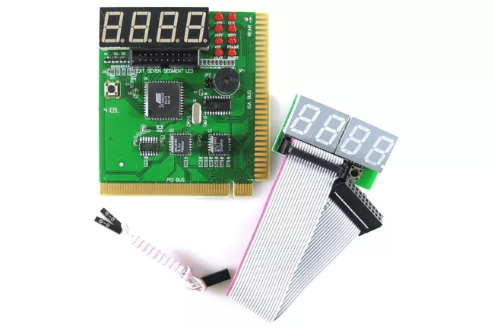
During the Power On Self Test, a two-digit code transmits on port 0x80.
This code is created during each diagnostic step during bootup. After each piece of hardware is identified as working, the next component is checked. If an error is detected, the boot up process usually halts, and the POST test card shows the error code.

How to access UEFI (BIOS) using Settings
- Open Settings.
- Click on Update & Security.
- Click on Recovery.
- Under the "Advanced startup" section, click the Restart now button. Source: Windows Central.
- Click on Troubleshoot. ...
- Click on Advanced options. ...
- Click the UEFI Firmware settings option. ...
- Click the Restart button.

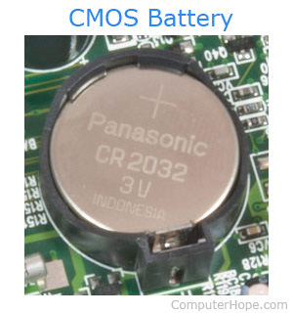
I . Replace the CMOS battery in a computer following procedures

- Open the computer case and find the battery on the motherboard

- Verify it is accessible and can be removed. Today, most computers use a coin cell CMOS battery, like the CR2032 battery shown in the picture.
- f your computer uses a coin cell battery, removing the battery is relatively simple. Use your fingers to grab the edge of the battery and pull it up and out of the socket holding it in place.
- Some motherboards have a clip holding the battery down. If your computer's motherboard has this clip, you may need to use one hand to move the clip up and the other hand to pull the battery out.

II. Insert the new battery

After purchasing a new battery, remove the old battery and replace it with the new battery. Some computers may not have a removable battery, for these computers insert the new battery into the secondary battery socket on the motherboard.

III. Enter CMOS values
Once the battery has been replaced, turn on the computer and reset the CMOS values to the defaults. After the values have all been entered, make sure to save the settings before exiting. Many CMOS setups allow you to press a key, such as F10, to save values and exit with one action

Understanding BIOS (basic input/output system)

BIOS (basic input/output system) is the program a computer's microprocessor uses to start the computer system after it is powered on. It also manages data flow between the computer's operating system (OS) and attached devices, such as the hard disk, video adapter, keyboard, mouse and printer.
BIOS comes included with computers, as firmware on a chip on the motherboard. BIOS is a program that is made accessible to the microprocessor on an erasable programmable read-only memory (EPROM) chip. When users turn on their computer, the microprocessor passes control to the BIOS program, which is always located at the same place on EPROM.

The 4 functions of BIOS
BIOS identifies, configures, tests and connects computer hardware to the OS immediately after a computer is turned on. The combination of these steps is called the boot process.
These tasks are each carried out by BIOS' four main functions:
- Power-on self-test (POST). This tests the hardware of the computer before loading the OS.
- Bootstrap loader. This locates the OS.
- Software/drivers. This locates the software and drivers that interface with the OS once running.
- Complementary metal-oxide semiconductor (CMOS) setup. This is a configuration program that enable users to alter hardware and system settings. CMOS is the name of BIOS' non-volatile memory.

Accessing the BIOS

To access the BIOS, first restart your computer. Press the appropriate key at the start of the boot-up process to access the BIOS setup screen.
Working with settings
Modify the BIOS settings and Observe the changes
. Change the Boot Order
. Create your BIOS password
. Change your Date and Time

. Load Setup Defaults
Change Keyboard and typing speed.
. Adjusting available video memory
https://www.makeuseof.com/tag/the-bios-explained-boot-order-video-memory-saving-resets-and-optimum-defaults-si/

Modified Settings in the BIOS
1.Change the Boot Order
For example, let's say you have Windows installed on your computer and a Linux live CD in your disc drive. (Alternatively, a USB drive plugged into your computer.) When you boot your computer, which operating system starts? The answer is determined by your boot order.
It's referred to as such because it controls the order in which boot devices are checked for an OS. For example, a typical computer might have the DVD drive higher in the boot order list than the HDD. This means that the computer will attempt to boot any inserted operating system installation discs or live CDs first.
If there are no bootable discs in the DVD drive, the computer would try the next option in the list. This would likely be its hard drive. You can boot your PC from:
- Optical drive (CD, DVD, Blu-ray, etc)
- USB drive (hard disk, thumb drive, or even a USB optical drive)
- Network drive

2. BIOS Password
While your operating system should have a login password you can further secure your computer with a BIOS password.
This can be set to control access to the BIOS; however, you can also set a boot password. With this enabled, no one can access the operating system or any attached media.

3. Load Setup Defaults
Your BIOS also contains a Load Setup Defaults or Load Optimized Defaults option. This option resets your BIOS to its factory-default settings, loading default settings optimized for your hardware.
This performs a complete BIOS reset, wiping any BIOS passwords in addition to resetting hardware settings and your boot order.

