Memory
Memory is basically a device that has the capacity to store information. A memory unit is the mount of data that the memory can hold. Besides, we measure this storage capacity in terms of bytes. Moreover, there are different units of memory as per the requirement. Before studying the units of memory let us know about the memory.
Memory is the most essential element of a computing system because without it computer can’t perform simple tasks. Computer memory is of two basic types – Primary memory(RAM and ROM) and Secondary memory (hard drive, CD, etc). Random Access Memory (RAM) is primary-volatile memory and Read-Only Memory (ROM) is primary-non-volatile memory.

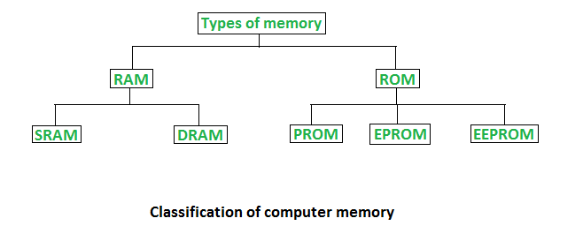

Random Access Memory (RAM) –
- It is also called read-write memory or the main memory or the primary memory.
- The programs and data that the CPU requires during the execution of a program are stored in this memory.

- It is a volatile memory as the data is lost when the power is turned off.

- RAM is further classified into two types- SRAM (Static Random Access Memory) and DRAM (Dynamic Random Access Memory).
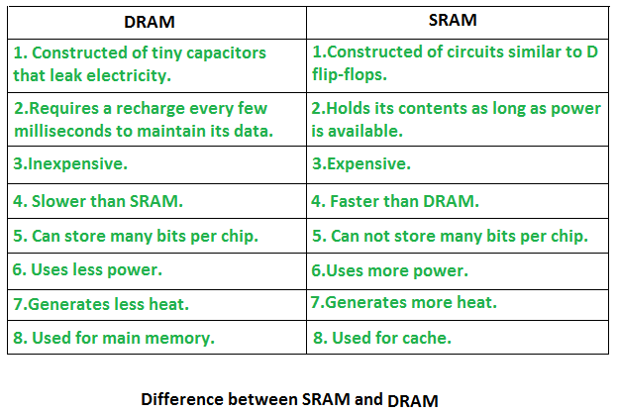
cache memory, also called cache, supplementary memory system that temporarily stores frequently used instructions and data for quicker processing by the central processing unit (CPU) of a computer. ... Cache holds a copy of only the most frequently used information or program codes stored in the main memory.
The smaller capacity of the cache reduces the time required to locate data within it and provide it to the CPU for processing.

Read-Only Memory (ROM)
- Stores crucial information essential to operate the system, like the program essential to boot the computer.
- It is not volatile.
- Always retains its data.
- Used in embedded systems or where the programming needs no change.
- Used in calculators and peripheral devices.
- ROM is further classified into four types- MROM, PROM, EPROM, and EEPROM.

Types of Read-Only Memory (ROM)
- PROM (Programmable read-only memory) – It can be programmed by the user. Once programmed, the data and instructions in it cannot be changed.
- EPROM (Erasable Programmable read-only memory) – It can be reprogrammed. To erase data from it, expose it to ultraviolet light. To reprogram it, erase all the previous data.
- EEPROM (Electrically erasable programmable read-only memory) – The data can be erased by applying an electric field, with no need for ultraviolet light. We can erase only portions of the chip.

- MROM(Mask ROM) – Mask ROM is a kind of read-only memory, that is masked off at the time of production. Like other types of ROM, mask ROM cannot enable the user to change the data stored in it. If it can, the process would be difficult or slow.
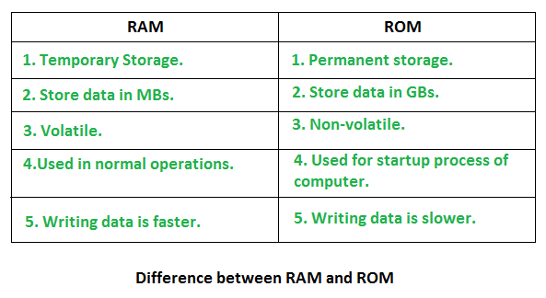
In secondary memory, programs and data are stored. It is also called auxiliary memory. It is different from primary memory as it is not directly accessible through the CPU and is non-volatile. Secondary or external storage devices have a much larger storage capacity and the cost of secondary memory is less as compared to primary memory.

Use of Secondary memory
Secondary memory is used for different purposes but the main purposes of using secondary memory are:
- Permanent storage: As we know that primary memory stores data only when the power supply is on, it loses data when the power is off. So we need a secondary memory to stores data permanently even if the power supply is off.
- Large Storage: Secondary memory provides large storage space so that we can store large data like videos, images, audios, files, etc permanently.
- Portable: Some secondary devices are removable. So, we can easily store or transfer data from one computer or device to another.

Types of Secondary memory
Secondary memory is of two types:
- Fixed storage
- Removable storage

Types of fixed storage:
Following are the types of fixed storage:
- Internal flash memory (rare)
- SSD (solid-state disk)
- Hard disk drives (HDD)

Types of Removable Storage:
- Optical discs (like CDs, DVDs, Blu-ray discs, etc.)
- Memory cards
- Floppy disks
- Magnetic tapes
- Disk packs
- Paper storage (like punched tapes, punched cards, etc.)

Secondary memory devices
Following are the commonly used secondary memory devices are:
- Floppy Disk: A floppy disk consists of a magnetic disc in a square plastic case. It is used to store data and to transfer data from one device to another device. Floppy disks are available in two sizes (a) Size: 3.5 inches, the Storage capacity of 1.44 MB (b) Size: 5.25 inches, the Storage capacity of 1.2 MB. To use a floppy disk, our computer needs to have a floppy disk drive. This storage device becomes obsolete now and has been replaced by CDs, DVDs, and flash drives.

- Compact Disc: A Compact Disc (CD) is a commonly used secondary storage device. It contains tracks and sectors on its surface. Its shape is circular and is made up of polycarbonate plastic. The storage capacity of CD is up to 700 MB of data. A CD may also be called a CD-ROM (Compact Disc Read-Only Memory), in this computers can read the data present in a CD-ROM, but cannot write new data onto it. For a CD-ROM, we require a CD-ROM. CD is of two types:

- CD-R (compact disc recordable): Once the data has been written onto it cannot be erased, it can only be read.
- CD-RW (compact disc rewritable): It is a special type of CD in which data can be erased and rewritten as many times as we want. It is also called an erasable CD.

3. Digital Versatile Disc: A Digital Versatile Disc also known as DVD it is looks just like a CD, but the storage capacity is greater compared to CD, it stores up to 4.7 GB of data. DVD-ROM drive is needed to use DVD on a computer. The video files, like movies or video recordings, etc., are generally stored on DVD and you can run DVD using the DVD player. DVD is of three types:
- DVD-ROM(Digital Versatile Disc Readonly): In DVD-ROM the manufacturer writes the data in it and the user can only read that data, cannot write new data in it. For example movie DVD, movie DVD is already written by the manufacturer we can only watch the movie but we cannot write new data into it.
- DVD-R(Digital Versatile Disc Recordable): In DVD-R you can write the data but only one time. Once the data has been written onto it cannot be erased, it can only be read.
- DVD-RW(Digital Versatile Disc Rewritable and Erasable): It is a special type of DVD in which data can be erased and rewritten as many times as we want. It is also called an erasable DVD.

4. Blu-ray Disc: A Blu-ray disc looks just like a CD or a DVD but it can store data or information up to 25 GB data. If you want to use a Blu-ray disc, you need a Blu-ray reader. The name Blu-ray is derived from the technology that is used to read the disc ‘Blu’ from the blue-violet laser and ‘ray’ from an optical ray.

5. Hard Disk: A hard disk is a part of a unit called a hard disk drive. It is used to storing a large amount of data. Hard disks or hard disk drives come in different storage capacities.(like 256 GB, 500 GB, 1 TB, and 2 TB, etc.). It is created using the collection of discs known as platters. The platters are placed one below the other. They are coated with magnetic material. Each platter consists of a number of invisible circles and each circle having the same centre called tracks. Hard disk is of two types (i) Internal hard disk (ii) External hard disk.

6. Flash Drive: A flash drive or pen drive comes in various storage capacities, such as 1 GB, 2 GB, 4 GB, 8 GB, 16 GB, 32 GB, 64 GB, up to 1 TB. A flash drive is used to transfer and store data. To use a flash drive, we need to plug it into a USB port on a computer. As a flash drive is easy to use and compact in size, Nowadays it is very popular.

7. Solid-state disk: It is also known as SDD. It is a non-volatile storage device that is used to store and access data. It is faster, does noiseless operations(because it does not contain any moving parts like the hard disk), consumes less power, etc. It is a great replacement for standard hard drives in computers and laptops if the price is low and it is also suitable for tablets, notebooks, etc because they do not require large storage.
A solid-state drive (SSD) is a solid-state storage device that uses integrated circuit assemblies to store data persistently, typically using flash memory, and functioning as secondary storage in the hierarchy of computer storage. It is also sometimes called a semiconductor storage device, a solid-state device or a solid-state disk,^{[1]} even though SSDs lack the physical spinning disks and movable read–write heads used in hard disk drives (HDDs) and floppy disks.^{[2]}
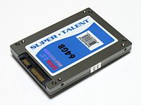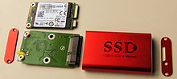
Solid state devices include USB pen drives, SD cards, micro SD cards, newer types of hard drive, the SIM card that goes in your mobile phone and smart cards such as chip and pin credit and debit cards. Solid state devices store data in binary patterns using billions of tiny low-voltage switches called transistors.

8. SD Card: It is known as a Secure Digital Card. It is generally used in portable devices like mobile phones, cameras, etc., to store data. It is available in different sizes like 1 GB, 2 GB, 4 GB, 8 GB, 16 GB, 32 GB, 64 GB, etc. To view the data stored in the SD card you can remove them from the device and insert them into a computer with help of a card reader. The data stores in the SD card is stored in memory chips(present in the SD Card) and it does not contain any moving parts like the hard disk

Units of Memory
The storage capacity of the memory is expressed in various units of memory. These are as follows:

Bit
A microprocessor uses binary digits 0 and 1 to decide the OFF and ON state respectively, of various circuits. Furthermore, a bit is the smallest unit of representation in the binary language.

Nibble
A nibble is a collection of 4 bits.

Byte
A byte is the representation of a group of 8 bits. Moreover, a byte is a unit that expresses any word, symbol, or character in the computer language. Besides, computer memory is always in terms of multiples of bytes.

Word
A computer word is similar to a byte, as it is also a group of bits. Moreover, a computer word is fixed for each computer. At the same time it varies from computer to computer. Besides, the length of a computer word is the word-size or word length. Therefore, a computer stores information in the form of computer word.

Kilobyte
- It is the most common unit of memory which is the smallest of all. But, it is greater than the byte.
- The abbreviation for kilobytes is ‘KB’.
- It contains 1000 bytes. Besides, it is synonyms to kibibytes which contain 1024 (2^10) bytes.
- Megabytes usually measures the size of text documents, graphics of websites, individual files, etc.

Megabyte
- The abbreviation for megabyte is ‘MB’.
- It contains 1000,000 bytes. Besides, it is synonyms to mebibytes which contains 1048576 (2^20) bytes.
- Kilobytes usually measure the size of large files. For example high-resolution images, songs, storage of compact disks, etc.

Gigabyte
- The abbreviation for the gigabyte is ‘GB’ or ‘gigs’.
- It contains 1000,000,000 bytes. Besides, it is synonyms to gibibytes which contain 1073741824 (2^30) bytes.
- Kilobytes usually measure the capacity of storage devices.

Terabyte
- The abbreviation for terabytes is ‘TB’.
- It contains onetrillion bytes. Besides, it is synonyms to tebibytes which contains 2^40 bytes.
- Kilobytes usually measure the capacity of large storage devices, for example, HDDs (Hard Disk Drives).

Petabyte
- The abbreviation for petabyte is ‘PB’.
- It contains 10^15 bytes. Besides, it is synonyms to pebibytes which contains 2^50 bytes.
- Petabytes usually measure the total data storage in large networks or server farms. For example, the data in Google or Facebook data servers is around more than 10 PBs.

Exabyte
- The abbreviation for exabyte is ‘EB’.
- It contains 10^18 bytes. Besides, it is synonyms to exbibytes which contains 2^60 bytes.
- The exabyte unit is so large that it does not even measure the storage of large cloud servers. Rather, it can be used to measure the amount of data transfer over the internet for a certain time limit.

Zettabyte
- The abbreviation for zettabyte is ‘ZB’.
- It contains 10^21 bytes. Besides, it is synonyms to zebibytes which contains 2^70 bytes.
- It can measure a huge amount of data. In fact, the whole data in the world is just a few zettabytes.

Yottabyte
- The abbreviation for yottabyte is ‘YB’.
- It contains 10^24 zettabytes. Besides, it is synonyms to yobibytes which contains 2^80 bytes.
- It is a tremendously huge unit of measurement. Therefore, it has no practical use.

Processor or Virtual Storage
· 1 Bit = Binary Digit
· 8 Bits = 1 Byte
· 1024 Bytes = 1 Kilobyte
· 1024 Kilobytes = 1 Megabyte
· 1024 Megabytes = 1 Gigabyte
· 1024 Gigabytes = 1 Terabyte
· 1024 Terabytes = 1 Petabyte
· 1024 Petabytes = 1 Exabyte
· 1024 Exabytes = 1 Zettabyte
· 1024 Zettabytes = 1 Yottabyte
· 1024 Yottabytes = 1 Brontobyte
· 1024 Brontobytes = 1 Geopbyte

Disk Storage
· 1 Bit = Binary Digit
· 8 Bits = 1 Byte
· 1000 Bytes = 1 Kilobyte
· 1000 Kilobytes = 1 Megabyte
· 1000 Megabytes = 1 Gigabyte
· 1000 Gigabytes = 1 Terabyte
· 1000 Terabytes = 1 Petabyte
· 1000 Petabytes = 1 Exabyte
· 1000 Exabytes = 1 Zettabyte
· 1000 Zettabytes = 1 Yottabyte
· 1000 Yottabytes = 1 Brontobyte
· 1000 Brontobytes = 1 Geopbyte

Memory Locations and Addresses
Memory locations and addresses determine how the computer’s memory is organized so that the user can efficiently store or retrieve information from the computer. The computer’s memory is made of a silicon chip which has millions of storage cell, where each storage cell is capable to store a bit of information which value is either 0 or 1.
But the fact is, computer memory holds instructions and data. And a single bit is very small to hold this information so bits are rarely used individually. As a solution to this, the bits are grouped in fixed sizes of n bits. The memory of the computer is organized in such a way that the group of these n bits can be stored and retrieved easily by the computer in a single operation.
The group of n bit is termed as word where n is termed as the word length. The word length of the computer has evolved from 8, 16, 24, 32 to 64 bits. General-purpose computers nowadays have 32 to 64 bits. The group of 8 bit is called a byte.
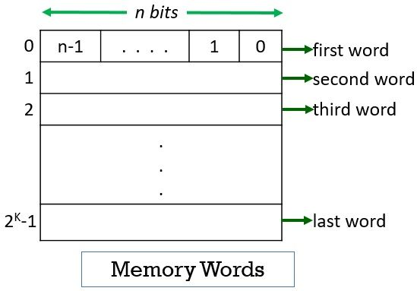
Now, whenever you want to store any instruction or data may it be of a byte or a word you have to access a memory location. To access the memory location either you must know the memory location by its unique name or it is required to provide a unique address to each memory location.
The memory locations are addressed from 0 to 2^{K}-1 i.e. a memory has 2^{K} addressable locations. And thus the address space of the computer has 2^{K} addresses. Let us try some suitable values for K.
2¹⁰ = 1024 = 1K (Kilobyte)
2²⁰ = 1,048,576 = 1M (Megabyte)
2³⁰ = 1073741824 = 1G (Gigabyte)
2⁴⁰ = 1.0995116e+12 = 1T (Terabyte)

Byte Addressability
Till now we have gone through three information storing quantities bit, byte and word. We have seen above that 8 bits together form a byte and this is the fix for every memory. But the word length varies from memory to memory and it ranges from 16 to 64 bit.
Well, it is impossible to allot a unique address to each bit in memory. As a solution, most modern computers assign successive addresses to successive byte locations in memory. This assignment of addresses to individual byte locations is termed byte addressability and memory is referred to as byte-addressable memory.
If we assign an address to individual byte locations in the memory like 0, 1, 2, 3…. .Now if the word length of the machine is 16 bit then the successive words are located at addresses 0, 2, 4, 6… where each word would have 2 bytes of information. Similarly, if we have a machine with a word length of 32 bit then the successive words are located at the addresses 0, 4, 8, 12… where each word would have 4 bytes of information and it could store or retrieve 4 bytes of instruction or data in a single and basic operation.

Memory Access Methods
These are 4 types of memory access methods:
1. Sequential Access:-
2. Random Access
3. Direct Access
4. Associate Access:-

Single In-Line Memory Modules (SIMM) is that the little circuit boards having notches wherever the RAM chips are fixed. SIMM connectors and therefore the slot situated on the motherboard are created of metal(gold or tin). In SIMM, Pins present in either facet are connected. There are two type of SIMM presents, one with 30 pins and another one is with 72 pins.

Dual In-Line Memory Module (DIMM), additionally has metal connectors almost like SIMM, however either of the perimeters of the connective doesn’t admit the opposite. DIMM supports 64 bit channel for data transferring while SIMM supports only maximum of 32 bit channel. There are three type of DIMM presents which are used by modern motherboard, one with 168 pins and second one is with 184 pins and third one is 240 pins.

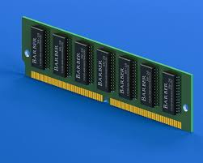
72 pins simm

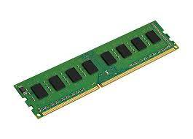
DIMM 240 pin

BASIS FOR COMPARISON | SIMM | DIMM
Basic | Pins present in either side are connected. | DIMM pins are independent.
Channel | 32 bit | 64 bit
Power consumption | 5 volts | 3.3 volts
Storage provided | 4MB to 64 MB | 32MB to 1 GB

SRAM (static RAM) is a type of random access memory (RAM) that retains data bits in its memory as long as power is being supplied. Unlike dynamic RAM (DRAM), which must be continuously refreshed, SRAM does not have this requirement, resulting in better performance and lower power usage. However, SRAM is also more expensive than DRAM, and it requires a lot more space.
SRAM is commonly used for a computer's cache memory, such as a processor's L2 or L3 cache. It is not used for a computer's main memory because of its cost and size. Most computers use DRAM instead because it supports greater densities at a lower cost per megabyte (MB). However, SRAM is often used for other purposes. For example, it might be part of a RAM digital-to-analog converter (RAMDAC) on a computer's video or graphic card. It might also be used in a disk drive as buffer cache, in a peripheral such as a printer or LCD display, or in a network device such as router or switch.
SRAM can be found in other devices ways as well. For example, SRAM chips are often used in cell phones, wearables and other consumer electronics. They might also be embedded in medical products, which can include anything from hearing aids to body area networks that include multiple devices embedded in the body. In addition, SRAM is used in toys, appliances, automobiles, industrial equipment and a wide range of IoT devices.

Types of SIMM
There are two variants of the SIMM, one with 30 pins and other with 72 pins.
- 30 pins SIMM contain an address width of 8 bits and 1MB or 4 MB of RAM. Therefore, the data it can transfer from the memory bus at a time is 8 bits. Later hardware of 30 pins SIMM contains parity bit for the error detection which makes the address width of 9 bits. To ensure the proper installation of the SIMM, it has a notch on the bottom left.

- 72 pins SIMM can have an address width of 32 bits or 36 bits including parity bits. Each byte is allotted a parity bits (for 32 data bits 4 bits are for parity). The amount of RAM memory it has can be 4, 8, 16, 32, or 64 MB. It is notched at the side and centre of the module.

Types of DIMM
- 168 pin DIMM structure is different from the SIMM because it has tiny notches along the rows of the pins at the bottom of the module.

- 184 and 240 pin DIMMs is provided with only one notch at the different position to prevent the improper placement of the DIMM in the socket.

Key Differences Between SIMM and DIMM
- A DIMM is double sided SIMM, as SIMM can be installed in in-line pairs while DIMM is independent of the side.
- SIMM can have a maximum 32-bit channel for data transfer. In contrast, DIMM support 64-bit channel.
- The amount of power consumed by SIMM is 5 volts. As against, it is 3.3 volts for DIMM.
- SIMM modules can store at maximum 64 bits. On the contrary, DIMM offer up to 1 GB.
- SIMM is outdated technology, in recent time DIMM is used mainly because its performance is better than SIMM.

168-pin DIMM
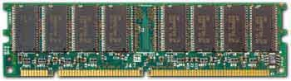

184-pin DIMM DDR
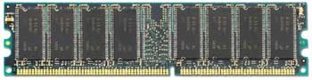

240-pin DIMM
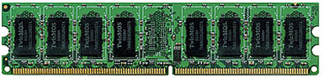

RAM TECHNOLOGY

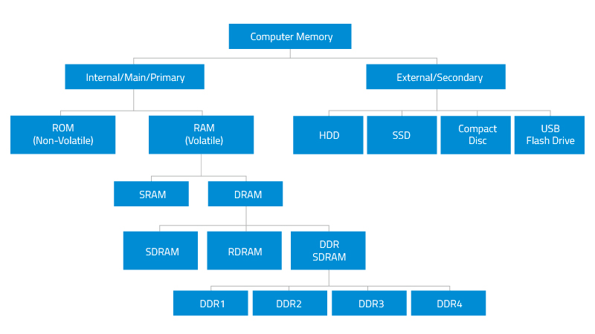
SRAM (static RAM) is a type of random access memory (RAM) that retains data bits in its memory as long as power is being supplied. Unlike dynamic RAM (DRAM), which must be continuously refreshed, SRAM does not have this requirement, resulting in better performance and lower power usage. However, SRAM is also more expensive than DRAM, and it requires a lot more space.
SRAM is commonly used for a computer's cache memory, such as a processor's L2 or L3 cache. It is not used for a computer's main memory because of its cost and size. Most computers use DRAM instead because it supports greater densities at a lower cost per megabyte (MB). However, SRAM is often used for other purposes. For example, it might be part of a RAM digital-to-analog converter (RAMDAC) on a computer's video or graphic card. It might also be used in a disk drive as buffer cache, in a peripheral such as a printer or LCD display, or in a network device such as router or switch.
SRAM can be found in other devices ways as well. For example, SRAM chips are often used in cell phones, wearables and other consumer electronics. They might also be embedded in medical products, which can include anything from hearing aids to body area networks that include multiple devices embedded in the body. In addition, SRAM is used in toys, appliances, automobiles, industrial equipment and a wide range of IoT devices.
Double Data Rate Synchronous Dynamic Random-Access Memory (DDR SDRAM) is a double data rate (DDR) synchronous dynamic random-access memory (SDRAM) class of memory integrated circuits used in computers. DDR SDRAM, also retroactively called DDR1 SDRAM, has been superseded by DDR2 SDRAM, DDR3 SDRAM, DDR4 SDRAM and DDR5 SDRAM. None of its successors are forward or backward compatible with DDR1 SDRAM, meaning DDR2, DDR3, DDR4 and DDR5 memory modules will not work in DDR1-equipped motherboards, and vice versa.

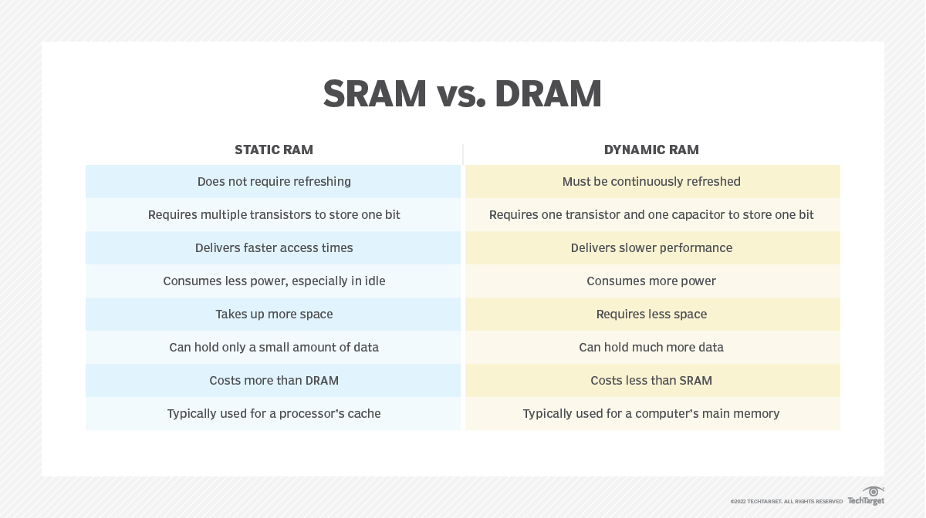
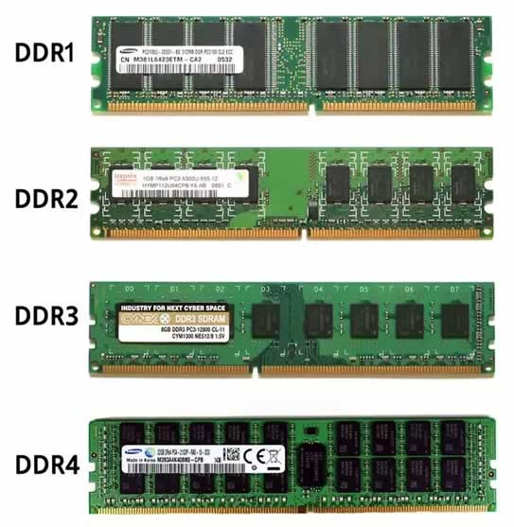

- DDR1: 184-pin (DIMM), 200-pin (SO-DIMM), and 172-pin (micro DIMM).
- DDR2: 240-pin (DIMM), 200-pin (SO-DIMM), and 214-pin (micro DIMM).
- DDR3: 240 pins (DIMM), 204 pins (SO-DIMM), and 214 pins (micro DIMM).
- DDR4: 288-pin (DIMM), 256-pin (SO-DIMM). DDR4 micro DIMMs no longer exist.

Difference between SDR SDRAM and DDR SDRAM
SDR SDRAM:
It is the short form of Single Data Rate SDRAM. In this SDRAM type, same frequency is used for Input/Output operations, bus clock and internal clock. As mentioned above PC133 uses 133 MHz for all these purpose. SDR SDRAM can either read or write one at a time in single clock cycle.
DDR SDRAM:
It is the short form of Double Data Rate SDRAM. It can transfer data on both the rising edge of the clock as well as falling edge of the clock i.e. doubles the transfer rate without even increasing the clock signal frequency. DDR SDRAM has 2 bit prefetch buffer size which is double of SDR SDRAM. There are various versions of DDR SDRAM viz. DDR1 (or simply DDR), DDR2, DDR3 and DDR4 based on various features as explained below.

DDR1 SDRAM or DDR SDRAM
Following are the features of DDR1 SDRAM type:
• It transfers data on rising and falling edge of clock. Hence it has data transfer rate double compare to SDR SDRAM type.
• Clock speed: 133 to 200 MHz
• Prefetch buffer size: 2 bits
• Operating voltage: 2.5V
• Data transfer rate: 266 to 400 MT/s (MegaTransfers per SECond)
• Examples: DDR266, DDR400

DDR2 SDRAM
Following are the features of DDR2 SDRAM type:
• It operates external data bus two times faster compare to DDR1 SDRAM type or DDR SDRAM.
• Clock speed: 133 to 200 MHz
• Operating voltage: 1.8 V
• Prefetch buffer size: 4 bits
• Data transfer rate: 533 to 800 MT/s (MegaTransfers per SECond)
• Examples: DDR2 533, DDR2 800

DDR3 SDRAM
Following are the features of DDR3 SDRAM type:
• Its power consumption is less compare to previous version i.e. DDR2 which is about 40% less. This is due to use of lower operating voltage of 1.5V compare to DDR and DDR2 SDRAM types.
• Operating voltage: 1.8 V
• Prefetch buffer size: 8 bits
• Data transfer rate: 800 to 1600 MT/s (MegaTransfers per SECond)
• DDR3L-800 , DDR3L-1066 , DDR3L-1333 and DDR3L-1600
• Special functions used: ASR (i.e. Automatic Self Refresh) , SRT (Self Refresh Temperature).

DDR4 SDRAM
Following are the features of DDR4 SDRAM type:
• It provides further lower operating voltage and faster transfer rate compare to other DDR types.
• Operating voltage: 1.2V
• Data transfer rate: 2133 to 3200 MT/s
• Example: DDR4-2400, Micro Technology Inc.
• It processes four data in a single clock cycle.
• Efficiency: better than DDR3.
• Special functions: DBI (i.e. Data Bus inversion), CRC, CA parity

ECC RAM
SPD RAM CHIP
In computing, serial presence detect (SPD) is a standardized way to automatically access information about a memory module. ... SPD is a memory hardware feature that makes it possible for the computer to know what memory is present, and what memory timings to use to access the memory.
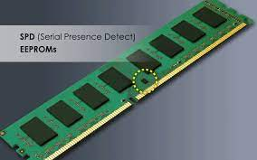
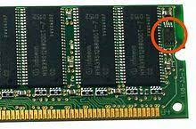
What does the SPD chip do?
The SPD (Serial Presence Detect) chip on a memory module is an additional chip holding 128Hex bytes of information about the module. This identifies the module to the BIOS during POST so the Motherboard knows its characteristics and timings that can be used. This was introduced at the same time as SDRAM.

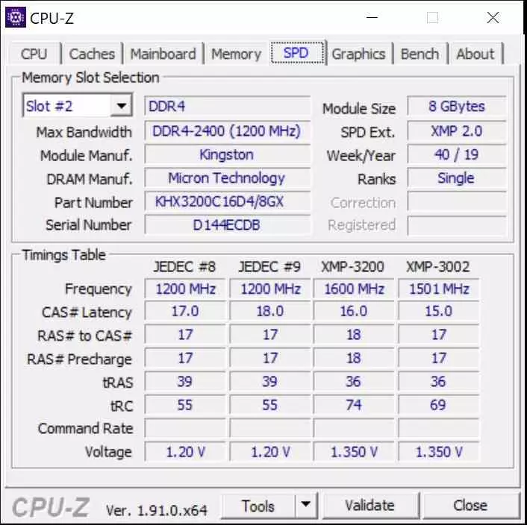

The direct and simple answer is one that requires the CPU to function, we cannot forget that it is a ROM memory of a very small size and therefore it must have its data arranged in the most compact way possible.
That is why the way in which such information is stored within the EEPROM of the SPD is always the same, which helps to save space and facilitates not only communication with the CPU, but also with the motherboard chipset. And what is the order and who dictates it? Well, the committee that is the JEDEC does it, which is the one that sets the memory standards for both NAND Flash and RAM that we use in our computing devices.
In each JEDEC standard the content of the SPD varies, but the data it contains is not only about speed, but also information like now:
- The type of RAM it is: DDR, LPDDR, etc.
- How many chips are there and the storage capacity of each one.
- Serial number and manufacturer.
- Voltages supported by the DIMM for overclocking.
- And so on.

Working principle of hardisk
The first hard drive was developed by IBM's Reynold B. Johnson and announced on September 4, 1956 as the IBM 350 Disk Storage Unit.
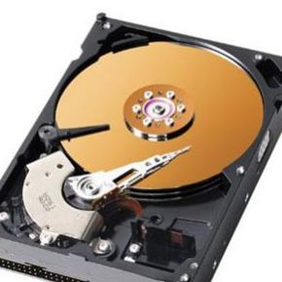
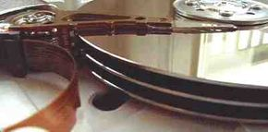
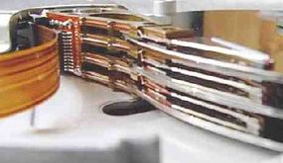
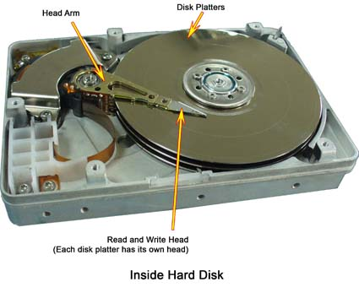

https://cs.stanford.edu/people/nick/how-hard-drive-works/

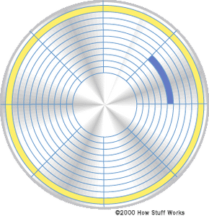

When your computer stores data on its hard drive, it doesn't just throw magnetized nails into a box, all jumbled up together. The data is stored in a very orderly pattern on each platter. Bits of data are arranged in concentric, circular paths called tracks. Each track is broken up into smaller areas called sectors. Part of the hard drive stores a map of sectors that have already been used up and others that are still free. (In Windows, this map is called the File Allocation Table or FAT.) When the computer wants to store new information, it takes a look at the map to find some free sectors. Then it instructs the read-write head to move across the platter to exactly the right location and store the data there. To read information, the same process runs in reverse.
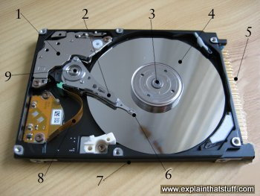
- Actuator that moves the read-write arm. In older hard drives, the actuators were stepper motors. In most modern hard drives, voice coils are used instead. As their name suggests, these are simple electromagnets, working rather like the moving coils that make sounds in loudspeakers. They position the read-write arm more quickly, precisely, and reliably than stepper motors and are less sensitive to problems such as temperature variations.
- Read-write arm swings read-write head back and forth across platter.
- Central spindle allows platter to rotate at high speed.
- Magnetic platter stores information in binary form.
- Plug connections link hard drive to circuit board in personal computer.
- Read-write head is a tiny magnet on the end of the read-write arm.
- Circuit board on underside controls the flow of data to and from the platter.
- Flexible connector carries data from circuit board to read-write head and platter.
- Small spindle allows read-write arm to swing across platter.

How a hard drive works:
- When you save a document, it gets written somewhere "non-volatile" that keeps its state even when the power is off. How does that work for a hard drive?
- The hard drive contains a spinning platter with a thin magnetic coating
- A "head" moves over the platter, writing 0's and 1's as tiny areas of magnetic North or South on the platter
- To read the data back, the head goes to the same spot, notices the North and South spots flying by, and so deduces the stored 0's and 1's
- A Modern hard drive can store well over a trillion 0/1 bits per platter, so the individual North/South spots are quite small
- "Flash" storage is made with chips (no moving parts) and is gradually replacing spinning hard drives like this. Flash chips are what's inside camera SDHC memory cards and USB storage keys.

Data is stored on a hard drive in binary code, using 1s and 0s. The information is spread out on the magnetic layer of the disk(s) and are read or written by the read heads that 'float' above the surface thanks to the layer of air produced by the ultra fast rotation of the disk.
In writing mode, an electrical current travels via the heads and modifies the surface of the electric field by inscribing a 0 or a 1. In read mode, the process is reversed: the magnetic field transmits an electrical current to the read head, and this signal is then translated into a digital signal readable by the computer.


HDD or SSD?
A traditional hard disk drive (HDD), sometimes referred to by its abbreviated names hard disk or hard drive, is a form of magnetic mass storage used primarily in computers, but also in some portable music players, video cameras, DVD players, and video game consoles etc.
Solid state drive (SSD) technology can also be used as hard drives, where data is stored on an array of chips attached directly to the circuit board. These are also found in music players, but also in mobile phones, tablets, and many modern smart devices.

