PowerShell?
Windows PowerShell is an object-oriented automation engine and scripting language. It is designed mainly for IT professionals and system administrators to control & automate the administration of Windows OS and other applications. It provides compelling new concepts to extend the knowledge you have gained and scripts you have created within the Windows Command Prompt and Windows Script Host environments.

How to launch PowerShell
PowerShell is pre-installed in all latest versions of Windows. We need to launch PowerShell for that we need to follow the given steps:
Step 1) Search for PowerShell in Windows. Select and Click

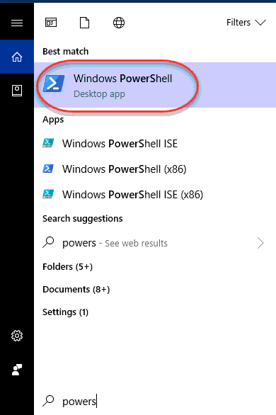

PowerShell Cmdlet
A cmdlet which is also called Command let is a is a lightweight command used in the Window base PowerShell environment. PowerShell invokes these cmdlets in the command prompt. You can create and invoke cmdlets command using PowerShell APIS.
mdlet vs. Command:
Cmdlets are different from commands in other command-shell environments in the following manners ?
- Cmdlets are .NET Framework class objects It can’t be executed separately
- Cmdlets can construct from as few as a dozen lines of code
- Parsing, output formatting, and error presentation are not handled by cmdlets
- Cmdlets process works on objects. So text stream and objects can’t be passed as output for pipelining
- Cmdlets are record-based as so it processes a single object at a time
Most of the PowerShell functionality comes from Cmdlet’s which is always in verb-noun format and not plural. Moreover, Cmdlet’s return objects not text. A cmdlet is a series of commands, which is more than one line, stored in a text file with a .ps1 extension.
A cmdlet always consists of a verb and a noun, separated with a hyphen. Some of the verbs use for you to learn PowerShell is:
- Get — To get something
- Start — To run something
- Out — To output something
- Stop — To stop something that is running
- Set — To define something
- New — To create something

PowerShell commands
Following is a list of important PowerShell Commands:
Get-Help: Help about PowerShell commands and topics
Example: Display help information about the command Format-Table
Get-Help Format-Table
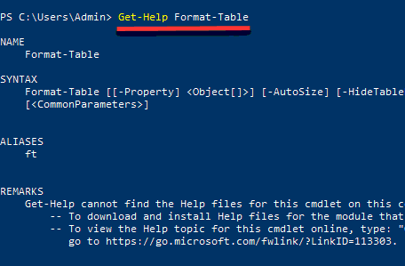
Get-Command: Get information about anything that can be invoked
Powershell Script Example: To generate a list of cmdlets, functions installed in your machine
Get-Command
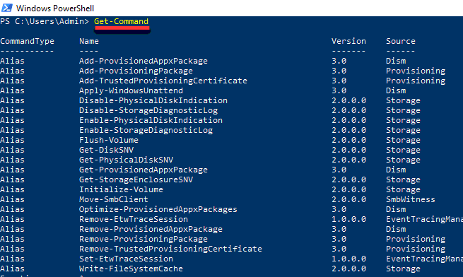
- Get-Process — Shows the processes currently running on your computer:
Get-Service — Shows the list of services with their status
Get-Content — Shows the content of the file you specify (for example, Get-Content C:\Windows\System32\drivers\etc\hosts)

Get drives in the current session
The Get-PSDrive cmdlet gets the drives in the current session. You can get a particular drive or all drives in the session.
PS C:\> Get-PSDrive

Name Used (GB) Free (GB) Provider Root
---- --------- --------- -------- ----
Alias Alias
C 202.06 23718.91 FileSystem C:\
Cert Certificate \
D 1211.06 123642.32 FileSystem D:\
Env Environment
Function Function
HKCU Registry HKEY_CURRENT_USER
HKLM Registry HKEY_LOCAL_MACHINE
Variable Variable

Create a file in the current directory

This command creates a text file that is named "testfile1.txt" in the current directory. The dot ('.') in the value of the Path parameter indicates the current directory. The quoted text that follows the Value parameter is added to the file as content.

PowerShell Example to create file

New-Item -Path . -Name "testfile1.txt" -ItemType "file" -Value "This is a text string.

Create a directory

This command creates a directory named "Logfiles" in the C: drive. The ItemType parameter specifies that the new item is a directory, not a file or other file system object.

PowerShell Example

New-Item -Path "c:\" -Name "logfiles" -ItemType "directory"

Cmdlet
Remove-Item cmdlet is used to delete a file by passing the path of the file to be deleted.
Example 1
In this example, we'll delete a file D:\Temp\Test Folder\Test.txt
Type the following command in PowerShell ISE Console
Remove-Item 'D:\temp\Test Folder\test.txt'
You can see the Test Folder1 in Windows Explorer is deleted now.
Example 2
In this example, we'll remove the folder D:\Temp\Test Folder recursively deleting its all files. In first example, PowerShell confirms if directory is not empty. In this case, it will simply delete the item.
Type the following command in PowerShell ISE Console
Remove-Item 'D:\temp\Test Folder' -Recurse
You can see the content of temp folder in Windows Explorer where its folder is now removed.

How to Encrypt and Decrypt Files or Folders using Command Prompt ?
Encryption
- Encryption is the process of coding an information from a plain text into a cipher text, especially to hide its meaning and is the most common ways that no other person than you can take a look at your data.
- We can use the cipher command to encrypt and decrypt data at the command line.

Steps to Encrypt your file using Command Prompt
- Open ‘cmd‘ from the start menu and change your working directory to the folder where your files are. This can be done by using the “cd”. E.g. C:\>cd Desktop C:\>cd specific
- Type ‘cipher /E’ and press Enter. E.g. C:\specific>cipher /E and automatically the command prompt encrypt the files in the folder.
- Files in that specific folder will get Encrypted with [OK] written in front of the File name.
Decryption
- Decryption is also the process of decoding a cipher text into a plain text.
Steps to Decrypt your file using Command Prompt
- As for decryption, the process of encryption is the same, but the only difference is typing cipher /D and automatically the command prompt decrypted the files in the folder.
- Files in that specific folder will be Decrypted With [OK] written in front of the file name.
Type cipher /u /n and press ↵ Enter . A list of all the encrypted files on your computer and their locations will appear along with their locations on your hard drive
DOS COMMANDS
- Date command
Displays current date and allows you to change the date

Synatx : DATE

- Time command
Displays current Time and allows you to change the Time
Synatx :TIME

- Cls Command
Clears the Screen
Synatx : cls

- For listing the Sub-directories and Files within a directory, we use the DIR command
Syntax : ◦ DIR/ [Directory_name]
DIR/P – Displays the files and directory names in page wise Layout
DIR/w – Displays the files and directory names in widthwise Layout

- Creating Files in MS DOS
For creating the files in DOS, the command COPY CON is used
Syntax: ◦ COPY CON filename
Note: File name should not exceed eight characters excluding three characters for extension ◦ E.g. College1.txt ◦ To save the file press Ctrl+z then Enter.

- Renaming Files
For renaming the files in MS DOS we use the REN Command
Syntax: ◦ REN <oldfilename> <newfilename>
Eg. REN gpt1 gptdte

- Deleting Files in MS DOS

For deleting files in MS DOS we use the DEL command

Syntax : ◦ DEL Filename

- Creating a Directory in MS DOS
For creating the Directory in MS DOS, we use the MD (Make Directory)comman
Syntax: ◦ C:\> MD NCIT

- Changing a Directory in MS DOS
For changing the directory in MS DOS, we use the CD (Change Directory) command
Syntax: ◦ C:\>CD NCIT
Now it appears as: ◦ C:\NCIT>

- Switching between Directories

For switching between the directories we use the CD.. Or CD\ commands

CD.. Command switches from the current directory to the Parent directory

CD\ command switches from the current directory to the Root directory

- Deleting directories in MSDOS
For deleting the directories in MS DOS we use the RD
command

Syntax : ◦ RD Directoryname

Note : For removing the directory first the directory should be empty.

