Data recovery technique is a process of recovering deleted, inaccessible, lost, corrupted, damaged or formatted data from PC, hard drive, secondary storage, removable media, when the data stored in them cannot be accessed in a normal way.

when you delete your data or format a hard drive, your data is not really lost. The file system only deletes the entry of the data. For example, when you delete some files in Windows and empty the recycle bin, the system only removes the pointer of the files and makes the storage space of the deleted files be available. Before new files completely overwrite the storage space of the deleted files, the deleted files can be easily recovered by data recovery techniques.
Data recovery technique is a process of recovering deleted, inaccessible, lost, corrupted, damaged or formatted data from PC, hard drive, secondary storage, removable media, when the data stored in them cannot be accessed in a normal way. There are thousands of data recovery techniques in the internet. Many companies offer data recovery techniques which can recover lost data from hard drive, USB flash drive, memory card, digital camera, etc.

How to recover deleted data from PC” is a quite common user query on the internet. That’s the first thing people look for after data loss. However, when you delete data from your computer, the Operating System (OS) automatically moves the deleted data to the Recycle Bin. And you can always effortlessly recover deleted data from PC’s Recycle Bin—that is, if you hadn’t deleted the data by using ’Ctrl + Shift + Delete’ or emptied the Recycle Bin.
When data is permanently deleted using CTRL+SHIFT+DEL combination, the OS removes only its file address from the Master file Table (MFT)—a database that the OS uses to locate and access files. The actual file or data remains intact, unless overwritten which happens as follows. After file deletion, the space allocated to the deleted file is marked as available and new data can be stored in that location. When this happens, it leads to data overwriting which permanently destroys data from the drive beyond recovery.

Methods to Recover Deleted Data from PC

Check the Recycle Bin
Recycle Bin is the first place where you should look for your deleted data.Go to the Recycle Bin. Search the data and if you find it, right-click on it and choose ‘Restore’. You will find the restored data in the original folder location from where it was deleted.

METHOD #2: Restore Files from Backup
If you have Windows Backup, follow these steps to restore deleted files:
1. Go to Control Panel, select System and Security < File History and select Restore files from backup
2. If the backup is not listed or is stored in a different drive, click ‘Select another backup to restore files from.’

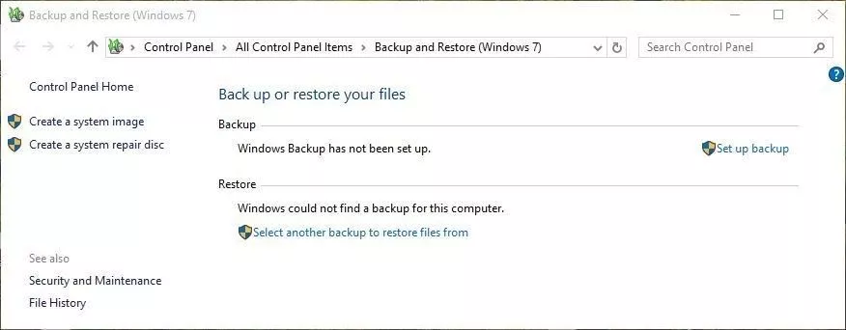
3. Follow the wizard and restore your deleted files from the backup.
Alternatively, you can schedule automatic Windows 10 backup using File History. All you have to do is go to Control Panel, turn on the ‘File History’ option, and then follow the setup wizard.
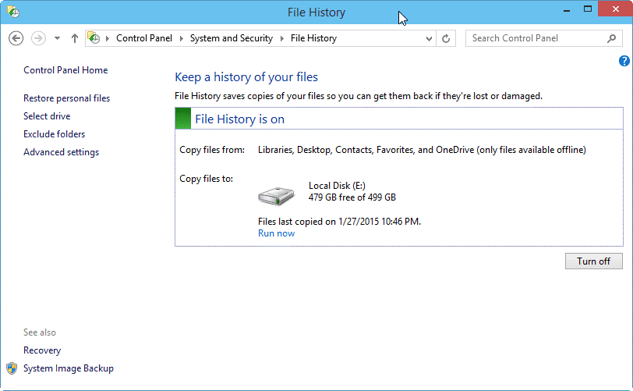

If you have a backup readily available and File History on, you can recover your deleted files anytime using Windows backup and restore utilities.

METHOD #3: Recover Data using Advanced Data Recovery Software
A data recovery software is one of the safest and easiest ways to recover deleted data from PC. Software
Besides, with the software, you can always recover the data from formatted, corrupt, deleted, or lost partitions of internal or external media such as SSD, HDD, Flash drives, SD cards etc.
Working with task manager
The Windows Task Manager is a powerful tool packed with useful information, from your system’s overall resource usage to detailed statistics about each process. This guide explains every feature and technical term in the Task Manager.
How to open windows task manager
Windows offers many ways to launch the Task Manager. Press Ctrl+Shift+Esc to open the Task Manager with a keyboard shortcut or right-click the Windows taskbar and select “Task Manager.”
You can also press Ctrl+Alt+Delete and then click “Task Manager” on the screen that appears or find the Task Manager shortcut in your Start menu.
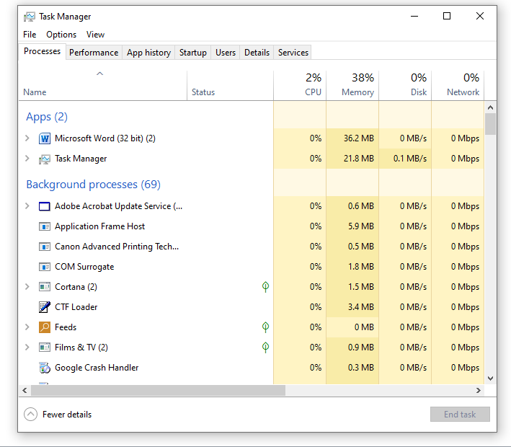

Task Manager includes the following tabs:
- Processes: A list of running applications and background processes on your system along with CPU, memory, disk, network, GPU, and other resource usage information.
- Performance: Real-time graphs showing total CPU, memory, disk, network, and GPU resource usage for your system. You’ll find many other details here, too, from your computer’s IP address to the model names of your computer’s CPU and GPU.
- App History: Information about how much CPU and network resources apps have used for your current user account. This only applies to new Universal Windows Platform (UWP) apps—in other words, Store apps—and not traditional Windows desktop apps (Win32 applications.)
- Startup: A list of your startup programs, which are the applications Windows automatically starts when you sign into your user account. You can disable startup programs from here, although you can also do that from Settings > Apps > Startup.
- Users: The user accounts currently signed into your PC, how much resources they’re using, and what applications they’re running.
- Details: More detailed information about the processes running on your system. This is basically the traditional “Processes” tab from the Task Manager on Windows
- Services: Management of system services. This is the same information you’ll find in services.msc, the Services management console.

Other tabs
- End Task: End the process. This works the same as the “End Task” button.

- https://www.howtogeek.com/405806/windows-task-manager-the-complete-guide/

Working with task scheduler
On Windows 10, Task Scheduler is a tool that allows you to create and run virtually any task automatically.
Task Scheduler works by keeping tabs of the time and events on your computer and executes the task as soon as the condition is met.

How to create a basic task using Task Scheduler
To create a task using basic settings on Windows 10, use these steps:
- Open Start.
- Search for Task Scheduler, and click the top result to open the experience.
- Right-click the "Task Scheduler Library" branch, and select the New Folder option.
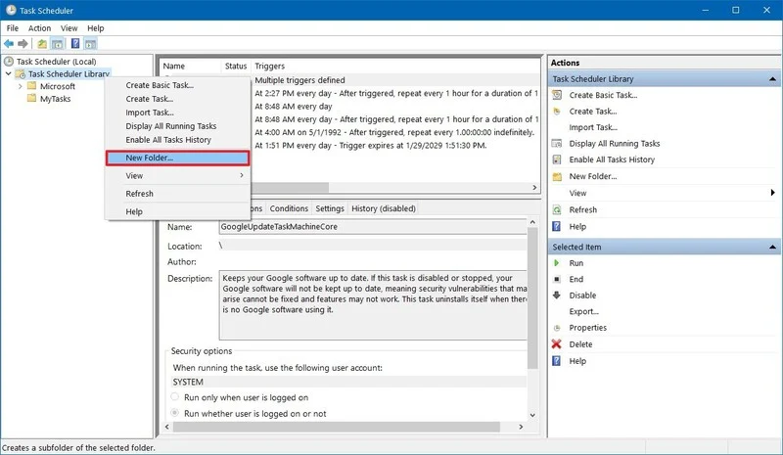
- Type a name for the folder. For example, MyTasks. (This step isn't a requirement, but it's a recommended step to keep your tasks separate from the system and apps tasks.)
- Click the OK button.
- Expand the "Task Scheduler Library" branch, and select the MyTasks folder.
- Click the Action menu.
- Select the Create Basic Task option.

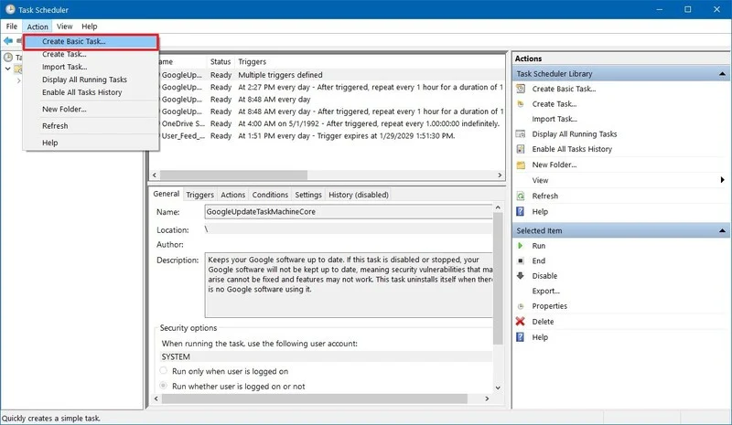
In the "Name" field, type a short descriptive name for the task. For example, Notepad Launcher.
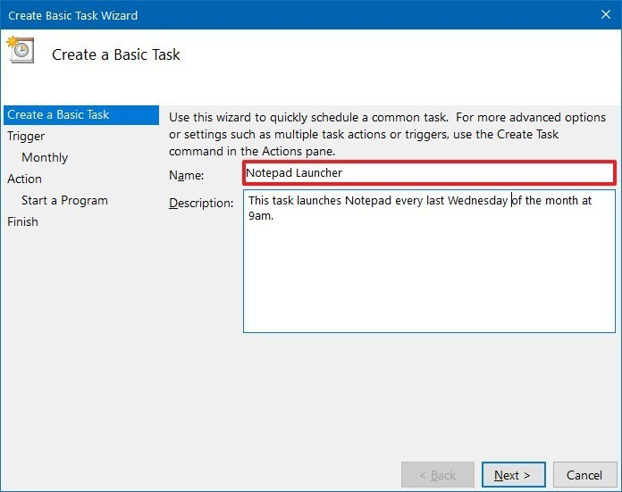
- Optional) In the "Description" field, create a description for the task.
- Click the Next button.
- Select the Monthly option.
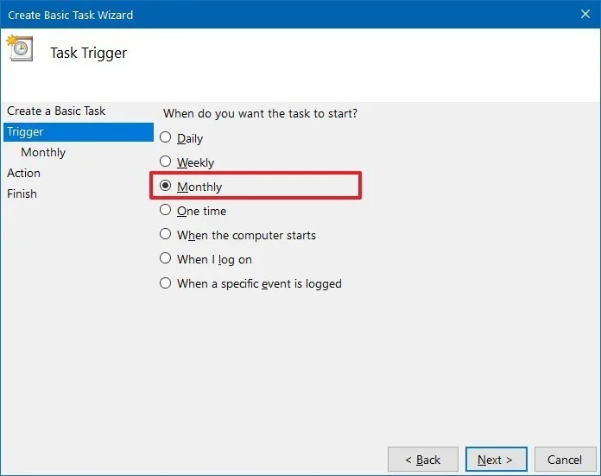
- Task Scheduler allows you to select from a number of triggers, including on a specific date, during startup, or when you or a particular user signs in. Depending on your requirements, you'll need to configure additional parameters. In this case, we'll be selecting the option to run a task every month.
- Click the Next button.
- Using the "Start" settings, specify when the task should start running and the time (very important).
- Use the "Monthly" drop-down menu to the months of the year that you want to run the task.
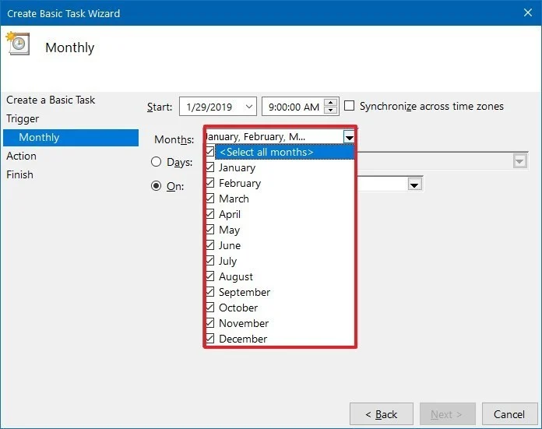
Use the "Days" or "On" drop-down menu to specify the days that the task will run.

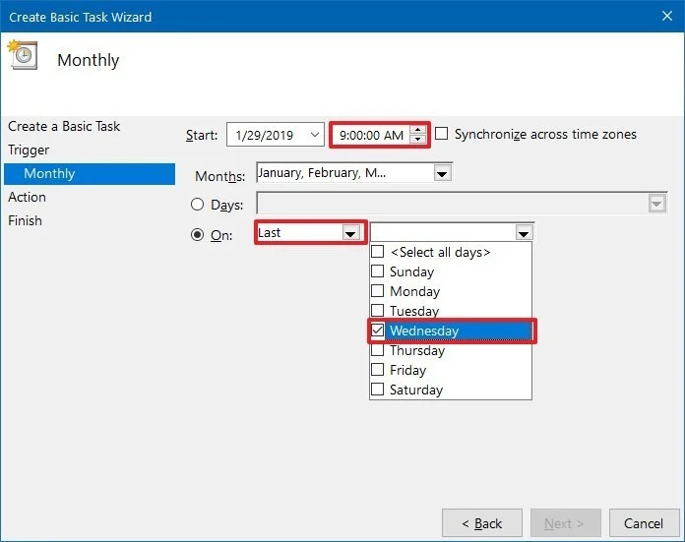
- Quick Tip: Using the "On" setting may be your best option if you're planning to run a task during a specific day of the week.
- Click the Next button.
- Select the Start a program option to launch an app, run a command, or execute a script file.
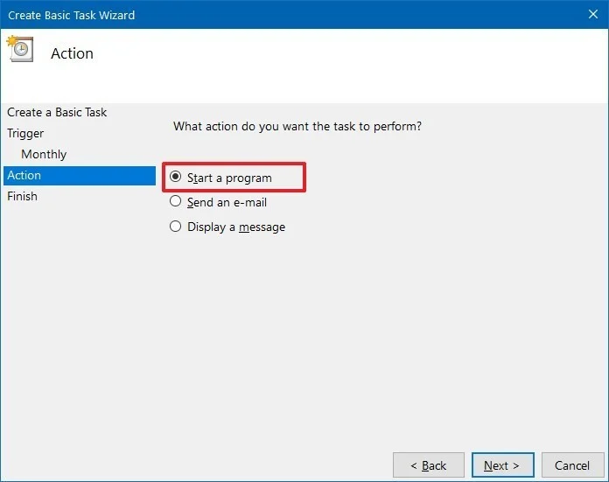
- ou can select the Send an e-mail or Display a message option, but these are deprecated features, which means that they may or may not work because Microsoft is no longer maintaining them.
  - Send an e-mail: Triggers an email notification with a custom message on schedule, but it requires to specify an email server to work.
  - Display a message: Allows to display a text message on the screen on schedule.
- In the "Program/script" field, specify the path for the application.
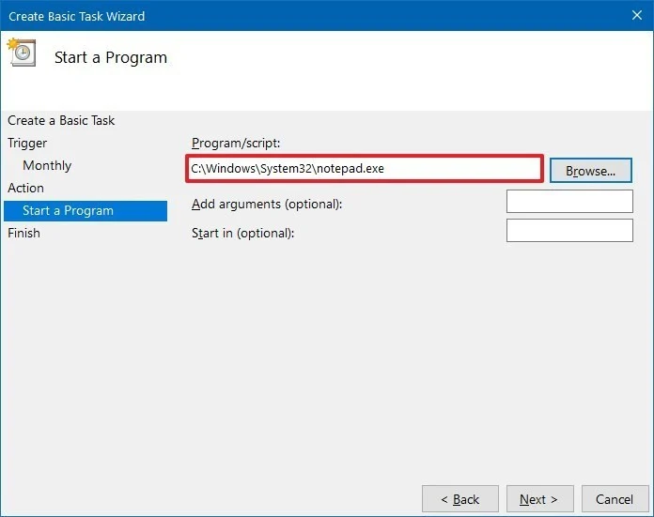

- Quick Tip: If you don't know the path of the app, click the Browse button to find it.
- (Optional) In the "Add arguments" field, you can specify arguments to run the task with special instructions.
- (Optional) In the "Start in" field, specify the folder in which the program will start. (Usually, you can leave this setting empty.)
- Click the Finish button.
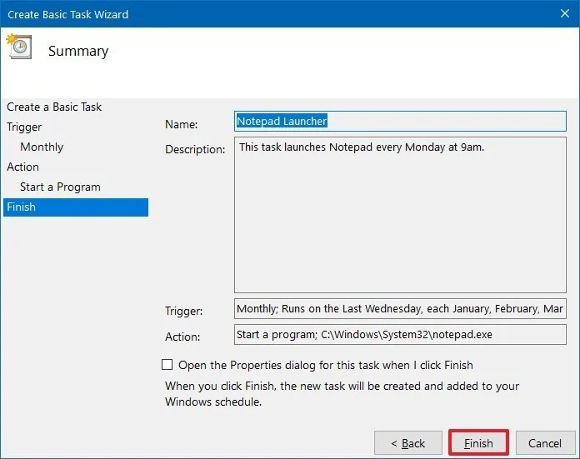
Once you've completed the steps, the task will be saved, and it'll run automatically on the schedule you specified.

CUSTOMIZING A DESKTOP
Windows 10 makes it easy to customize the look and feel of your desktop. To access the Personalization settings, right-click anywhere on the desktop, then select Personalize from the drop-down menu. The Personalization settings will appear.
Click the buttons in the interactive below to learn more about using the Personalization settings.
You can change the background, colours , Themes, fonts, Fonts Size, start bar and task bar options.

