

SOEN6611 Deliverable 1
Instructor: Dr. Pankaj Kamthan

Date: July 15, 2012
Presented by: Team F
Team Member: Lu Ma, Meng Jia, Yuan Tao

Table of Contents
1. Part 1 3
1.1. Use Case Model 3
1.1.1. System Behavior 3
1.1.2. Actors 3
1.1.3. Use Cases 3
1.1.3.1. Quadratic 4
1.1.3.2. Prime 4
1.1.4. Use Case Diagrams 5
1.1.5. Activity Diagrams 6
1.1.6. Actions 7
1.1.7. Control Flows 7
1.1.8. Flow Diagram 7
1.2. Effort of Project based on Use Case Points 9
1.2.1. UAW 10
1.2.2. UUCW 10
1.2.3. TCF 11
1.2.4. ECF 12
1.2.5. PF 14
1.2.6. Estimate 14
2. Part 2 15
2.1. Choice of Algorithms 15
2.1.1. Quadratic 15
2.1.1.1. Babylonian Method of Computing Square Root 15
2.1.1.2. Compute The Roots of Quadratic Equation. 15
2.1.2. Prime 16
2.2. Programming Style & Patterns 16
2.2.1. Programming style 16
2.2.2. Programming patterns 17
2.3. Quality Attributes 18
2.3.1. Maintainability 18
2.3.2. Portability 18
2.3.3. Generality 19
2.3.4. Usability 19
2.3.5. Efficiency 19
2.3.5.1. Quadratic 19
2.3.5.2. Prime 20
2.4. Cyclomatic number 23
3. How to run the program 30
3.1. File List 30
3.2. To run the program 30
Appendix A: Reference 32
Appendix B: Revision History 33

Table of Figures
Figure 1-1 General Use Cases 5
Figure 1-2 Sub Use Cases of Quadratic 6
Figure 1-3 Sub Use Cases of Prime 6
Figure 1-4 Actions 7
Figure 1-5 Control Flows 7
Figure 1-6 Overall Flow Diagrams 8
Figure 1-7 sub flow diagrams for the Quadratic 9
Figure 1-8 sub flow diagrams for the Prime 9
Figure 1-9 Estimate of UAW 10
Figure 1-10 Estimate of UUCW 11
Figure 1-11 Estimate of TCF 12
Figure 1-12 Estimate of ECF 13
Figure 1-13 Effort Estimate 14
Figure 2-1 Class diagram of project 17
Figure 2-2 the flowgraph of the package default 24
Figure 2-3 the flowgraph for the package utils 24
Figure 2-4 the flowgraph for the package ui 25
Figure 2-5 the flowgraph for the package libs 25
Figure 2-6 the Cyclomatic Complexity for Class MySqrt 26
Figure 2-7 Cyclomatic Complexity for Class Quadratic 27
Figure 2-8 Cyclomatic Complexity for Class Prime 28
Figure 2-9 Cyclomatic Complexity for Class UIConsole 29

Part 1

Use Case Model
The functional requirements of a system under development are documented in a use case model that illustrates the system’s intended functionalities (use cases), its surroundings (actors) and relationships between the use cases and actors (use case diagrams). At the same time, it is useful to see the flow of control and the flow of data between the different scenarios represented in a use case. Activity diagrams are used to visually document the different flows in a use case.

System Behavior
MINSK is a calculating system, which has two main functionalities. The first one is the QUADRATIC and the second one is the PRIME. Therefore, the system must have certain behaviors in order to run. Particularly in this system, the MINSK should be able to receive input data, check the validity and do the calculation then output the results. Especially for the validation function, certain criteria and algorithms must be adopted. Details will be stated in the later chapter.

Actors
There will be two kinds of actors in the system, one is” human being”, the other one is” another program”. Based on the “Effort Estimation Based on Use Cases”, we simplify our actor into these two kinds. Since “another program” can represent neither “Simple Actor” or “Average Actor” and “Human Being” will represent the “Complex Actor”, so, basically, these two kinds of actors we have chosen have covered all the possibilities.

Use Cases
As aforementioned, use cases can be identified as system functionalities. Therefore, in this part, we will briefly introduce the function of our system. The main functionalities are the Quadratic and Prime. Thus, the use cases in general are two: one is for Quadratic and the other is for the Prime.

Quadratic
The sub use cases in Quadratic contain mainly 3 categories----input/output, calculation and validation.
- Input/output
As an interacting system, the input/output function provides the interactions between actors and the system. Input module, which is a mandatory, requires actors to parameters in order to do the further calculation. Output module will provide the feedbacks from the system. The feedbacks include not only the results, but also errors or illegal format.
- Validation
This is the one of the most important sub use cases in Quadratic, which will guarantee the usability of the program. There are some constraints for the program, such as the sum of parameters’ absolute values is an odd number; a≠0 and b²>4ac, etc. In order to meet the requirements, validation use cases must be made.
For instance, if an actor entered parameters such as a=2, b=9, c=1, then, based on the criteria, the sum of parameters’ values is an even number which is not satisfied with our system. Therefore, the parameters are not valid.
- Calculation
Based on the quadratic equation, the system would do the calculation after (1) and (2). 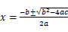 is the regular solution formula the calculation should be based on. However, there are some special circumstances needed to be discussed. In the algorithm part, we will expound those circumstances explicitly. The whole calculation procedure will run on the backstage choosing the proper algorithm depends on different conditions.

Prime
The same as Quadratic, the sub use cases in Prime can also be provided into 3 categories----the input/output use case, the validation use cases and the calculation use cases.
- Input/output Use Case
Same as Quadratic, space must be left for actors to input the number needed to be checked and get the feedback.
- Validation
The validation in Prime consists of 2 sub use cases. The first one is to check whether the input parameter is a natural number greater than 1. The second one is to check if there are any other divisors other than 1 and the parameter itself. If so, then it is not a prime number; if it is not, then it is a prime number.
- Calculation
In order to check whether the input natural number is a prime number or not, we need to find all its divisors. A proper algorithm will be adopted to do the calculation, which will be discussed in the following chapter.

Use Case Diagrams
A USE CASE diagram is used to visualize the relationships between use cases and actors and between use cases and other use cases. In MINSK, there are two major use cases as aforementioned, the Quadratic and the Prime. Based on that, the General Use Case Diagram is showed in Figure 1-1
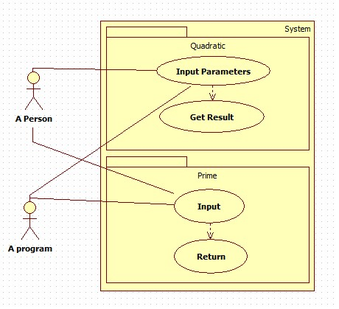
Figure 1-1 General Use Cases

In both Quadratic and Prime, the function mainly supports the actors to input data then get the result. However, the function is a complex one rather than a single one. The main functionality is formed by a few sub functionalities. Therefore, the Figure 1-2 & Figure 1-3 illustrate the sub use cases of Quadratic and Prime separately.
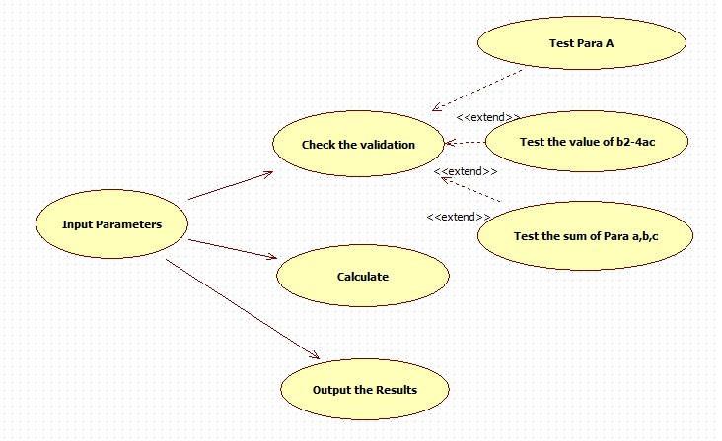
Figure 1-2 Sub Use Cases of Quadratic
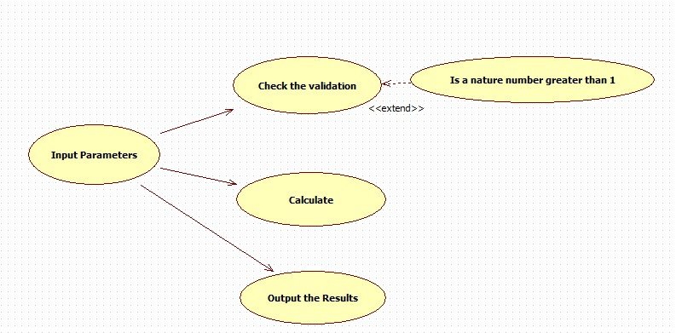
Figure 1-3 Sub Use Cases of Prime

Activity Diagrams
Activity Diagrams may be created at this stage in the life cycle to show the flow of control and data flow within a use case. Activities are containing nodes that include actions and control flow and/or data flow between the actions. The diagrams show action sequence, control flows, and joins and decision points.

Actions
An action represents the performance of some behavior in the workflow. Actions can be determined by examining the use case specification and determining what behaviors are needed to be executed. In MINSK, the action can be generally divided into 4 parts (showed in Figure 1-4): Input, Validation Checking, Calculating and Output. Of course, in Quadratic and Prime, there are different criteria and formulas needed.
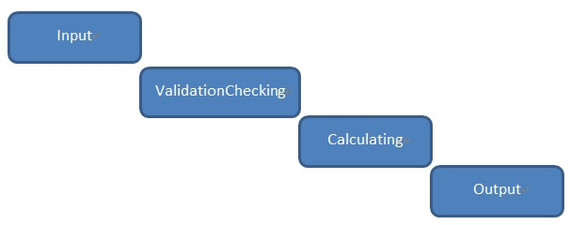
Figure 1-4 Actions

Control Flows
Once an action finishes, control is passed to the next action in the activity diagram. Control flows show the passing of control from one action to the next action in sequence. In UML, a control flow is represented as a directed arrow. Therefore, the graph below is the control flow diagram of the MINSK.
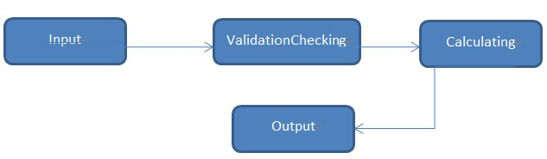
Figure 1-5 Control Flows

Flow Diagram
When modeling the workflow of MINSK, the flow diagram is an abstraction of the whole functionalities. The graphs above will all be involved in the flow diagram, including decision points and joints. The flow diagram of MINSK is shown in Figure 1-6.

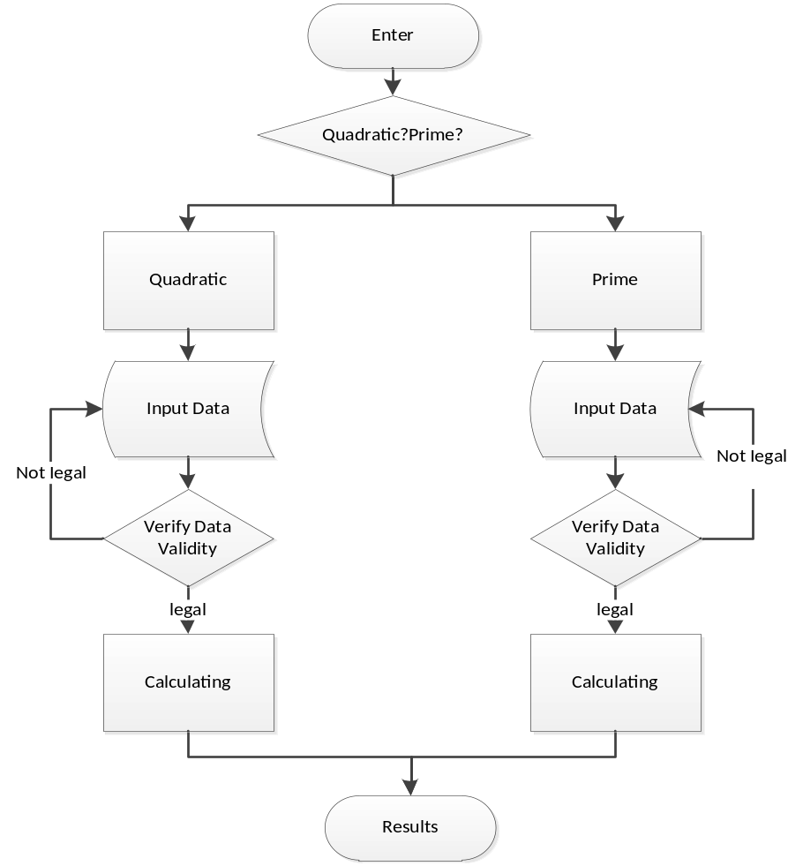
Figure 1-6 Overall Flow Diagrams

The validation action calls for control branches. There are different criteria to verify the data validation. Therefore, the decision should be made after checking the validation. Here in this document, a decision point is equal to a piece of criteria. The control flows from a decision point contain a guard condition, which is used to determine which path from the decision point is taken. In Figure 1-7, it shows clearly that the decision points in the Quadratic program are “Check the validity of a”, ”Check the validity of b₂-4ac”, ”Check the value of a+b+c”. In Figure 1-8, there is the detailed flow diagram for Prime. Just like above, there are 2 decision points in Prime as well, “Is X a nature number”, ”Is it greater than 1”.
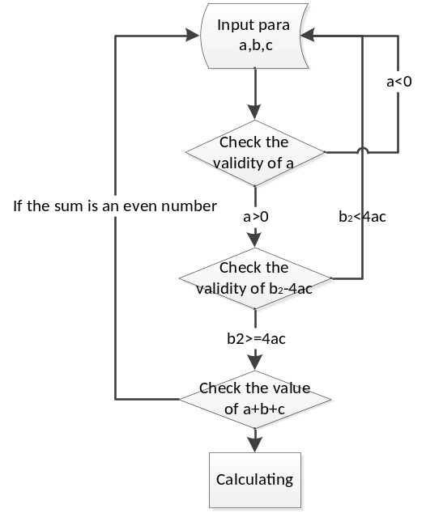
Figure 1-7 sub flow diagrams for the Quadratic

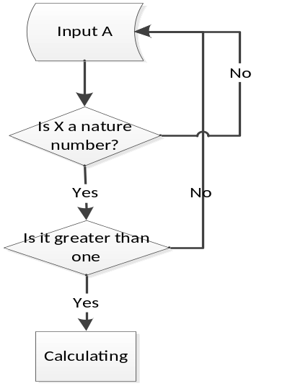
Figure 1-8 sub flow diagrams for the Prime

Effort of Project based on Use Case Points
In MINSK, we use the Use Case points (UCP) approach to estimate the effort. From on the “Estimation of Effort Based on Use Cases”, the reasons why we choose to estimate the effort are the advantages of UCP approach on organizational, social and technical aspects. It is relatively easy to train, learn and apply. It is largely mechanical; it is a relatively ‘lightweight’ approach which does not require infrastructure to produce an estimate; Last but not least, it is ‘competitive ’but cheaper than an expert estimate.
Based on the effort estimation equation: Effort Estimate=UCP*PF. Due to PF is a constant, so we need to calculate the value of UCP. Here in this document we adopted the ‘Free Excel Spreadsheet’ approach to get UCP.
UCP consists of UUCP, TCF, ECF and UUCP consists of UAW and UUCW

UAW
UAW stands for Unadjusted Actor Weight. UAW is based on the actors we chose from Use Case Model, which are a program and a person. A program can stands for neither a simple actor or an average actor, depends on the complexity of the program. And the person stands for the complex actor. Therefore, the estimate of UAW is shown in Figure 1-9.
Actor Summary |  | Multiplier | Number of Actors | Description
1 | Simple | 1 | 1 | Simple actors are other systems that communicate with your software via a pre-defined API. An API could be exposed through a dll, or as a REST, SOAP, or any web-service API or remote procedure call (RPC). The key element is that you are exposing interaction with your software through a specific, well-defined mechanism.
2 | Average | 2 | 1 | Average actors can either be human beings interacting in a well defined protocol, or they could be systems that interact through a more complex or flexible API.
3 | Complex | 3 | 0 | The original definition of complex actors specifies that users who interact with the software through a graphical user interface are complex actors. While that is true, the same classifcation should apply to users who interact with the system in unpredictable ways. An AJAX interface that exposes more of the underlying application (and data stores) than would be available through a rigid protocol might introduce similar complexity.
Calculated AW |  |  | 3
Figure 1-9 Estimate of UAW

UUCW
In MINSK, there are 2 main use cases. Each one of the sub program has 3. The validation use case in the Quadratic has 4 transactions: including Checking the format of input data, the value of a, the relationship between b² and4ac, the sum of a, b, c. Prime has 4 transactions as well: checking the input data is a nature number or not; the relationship between the input number and 2; They all have less than 4 transactions. So the estimate of UUCW is shown in Figure 1-10.

Unadjusted  Use Case Points |  | Multiplier | Number of Use Cases | Description
1 | Simple | 5 | 2 | Simple Use Case - up to 3 transactions.
2 | Average | 10 | 0 | Average Use Case - 4 to 7 transactions.
3 | Complex | 15 | 0 | Complex Use Case - more than 7 transactions.
Calculated UUCP |  |  | 10
Figure 1-10 Estimate of UUCW

TCF
The technical complexity factors for UCP approach are listed below. Based on the marking standard, 0 stands for ‘no influence’ and 5 stands for ‘strong influence’, the relative magnitude we discussed is shown in Figure 1-11
Technical Factor |  | Multiplier | Relative Magnitude  (Enter 0-5) | Description
1 | Distributed System Required | 2 | 0 | The architecture of the solution may be centralized or single-tenant , or it may be distributed (like an n-tier solution) or multi-tenant. Higher numbers represent a more complex architecture.
2 | Response Time Is Important | 1 | 2 | The quickness of response for users is an important (and non-trivial) factor. For example, if the server load is expected to be very low, this may be a trivial factor. Higher numbers represent increasing importance of response time (a search engine would have a high number, a daily news aggregator would have a low number).
3 | End User Efficiency | 1 | 3 | Is the application being developed to optimize on user efficiency, or just capability? Higher numbers represent projects that rely more heavily on the application to improve user efficiency.
4 | Complex Internal Processing Required | 1 | 2 | Is there a lot of difficult algorithmic work to do and test? Complex algorithms (resource leveling, time-domain systems analysis, OLAP cubes) have higher numbers. Simple database queries would have low numbers.
5 | Reusable Code Must Be A Focus | 1 | 1 | Is heavy code reuse an objective or goal? Code reuse reduces the amount of effort required to deploy a project. It also reduces the amount of time required to debug a project. A shared library function can be re-used multiple times, and fixing the code in one place can resolve multiple bugs. The higher the level of re-use, the lower the number.
6 | Installation Ease | 0.5 | 2 | Is ease of installation for end users a key factor? The higher the level of competence of the users, the lower the number.
7 | Usability | 0.5 | 3 | Is ease of use a primary criteria for acceptance? The greater the importance of usability, the higher the number.
8 | Cross-Platform Support | 2 | 4 | Is multi-platform support required? The more platforms that have to be supported (this could be browser versions, mobile devices, etc. or Windows/OSX/Unix), the higher the value.
9 | Easy To Change | 1 | 3 | Does the customer require the ability to change or customize the application in the future? The more change / customization that is required in the future, the higher the value.
10 | Highly Concurrent | 1 | 0 | Will you have to address database locking and other concurrency issues? The more attention you have to spend to resolving conflicts in the data or application, the higher the value.
11 | Custom Security | 1 | 0 | Can existing security solutions be leveraged, or must custom code be developed? The more custom security work you have to do (field level, page level, or role based security, for example), the higher the value.
12 | Dependence On Third-Party Code | 1 | 0 | Will the application require the use of third party controls or libraries? Like re-usable code, third party code can reduce the effort required to deploy a solution. The more third party code (and the more reliable the third party code), the lower the number.
13 | User Training | 1 | 0 | How much user training is required? Is the application complex, or supporting complex activities? The longer it takes users to cross the suck threshold (achieve a level of mastery of the product), the higher the value.
Calculated TCF |  |  | 0.815
Figure 1-11 Estimate of TCF

ECF
The Environment Complexity Factor is more relied on the experiences of the team members. Therefore, after discussion, we marked the different factor with the values showed in Figure 1-12.
Environmental Factor |  | Multiplier | Relative Magnitude  (Enter 0-5) | Description
1 | Familiarity With The Project | 1.5 | 4 | How much experience does your team have working in this domain? The domain of the project will be a reflection of what the software is intended to accomplish, not the implementation language. In other words, for an insurance compensation system written in java, you care about the team’s experience in the insurance compensation space - not how much java they’ve written. Higher levels of experience get a higher number.
2 | Application Experience | 0.5 | 5 | How much experience does your team have with the application. This will only be relevant when making changes to an existing application. Higher numbers represent more experience. For a new application, everyone’s experience will be 0.
3 | OO Programming Experience | 1 | 5 | How much experience does your team have at OO? It can be easy to forget that many people have no object oriented programming experience if you are used to having it. A user-centric or use-case-driven project will have an inherently OO structure in the implementation. Higher numbers represent more OO experience.
4 | Lead Analyst Capability | 0.5 | 5 | How knowledgeable and capable is the person responsible for the requirements? Bad requirements are the number one killer of projects - the Standish Group reports that 40% to 60% of defects come from bad requirements. Higher numbers represent increased skill and knowledge.
5 | Motivation | 1 | 5 | How motivated is your team? Higher numbers represent more motivation.
6 | Stable Requirements | 2 | 5 | Changes in requirements can cause increases in work. The way to avoid this is by planning for change and instituting a timing system for managing those changes. Most people don’t do this, and some rework will be unavoidable. Higher numbers represent more change (or a less effective system for managing change).
7 | Part Time Staff | -1 | 0 | Note, the multiplier for this number is negative. Higher numbers reflect team members that are part time, outside consultants, and developers who are splitting their time across projects. Context switching and other intangible factors make these team members less efficient.
8 | Difficult Programming Language | -1 | 0 | This multiplier is also negative. Harder languages represent higher numbers. We believe that difficulty is in the eye of the be-coder (groan). Java might be difficult for a fortran programmer. Think of it in terms of difficulty for your team, not abstract difficulty.
Calculated EF |  |  | 0.47
Figure 1-12 Estimate of ECF

PF
Usually the range of productivity factor is from 15 to 30 person-hours per use case point. However, in MINSK, we adopted 10 as the constant value for the PF because the UC is not as complicated as it is in the big commercial software development. After all it is a course project, so in order to be more reasonable, after discussion, we think 10 person-hours would be a better choice for the PF in MINSK when we estimate the effort.

Estimate
Based on the equation and aforementioned variables, constant, the Free Excel Spreadsheet deduce the estimate effort showed in Figure 1-13.
Calculations From Other Tabs
TCF | Technical Complexity Factor | 0.815
EF | Environmental Factor | 0.47
UUCP | Unadjusted Use Case Points | 10
AW | Actor Weighting | 3
Calculation of Use Case Points
UCP | Use Case Points | 5.1
Calculation of Estimated Effort
Ratio | Hours of Effort per Use Case Point | 10
Hours of Effort |  | 51
Figure 1-13 Effort Estimate

Part 2

Choice of Algorithms

Quadratic

Babylonian Method of Computing Square Root
To compute the square root of a non-negative real number based on Babylonian Method, the process is:
- Begin with an arbitrary positive starting value X₀ (the closer to the actual square root of S, the better).
- Let X_{n}+1 be the average of X_{n} and S / X_{n} (using the arithmetic mean to approximate the geometric mean).
- Repeat step 2 until the desired accuracy is achieved.

For more information about the algorithm, please click the link:
http://en.wikipedia.org/wiki/Methods_of_computing_square_roots.

For this program, we have following definitions:
- X₀ = S / 2
- Accuracy Tolerance = 0.0000000001

Compute The Roots of Quadratic Equation.
For a quadratic equation forma as: ax² + bx + c=0.
1. We have to calculate how many roots the equation going to have. Use the result of b² – 4ac
(1) if b² – 4ac<0, that means there is no real roots for this equation. The roots can be any imaginary numbers.
(2) if b² – 4ac=0, there is one real roots
(3) if b² – 4ac>0, there is two real roots.

2. Use formula to calculate the roots.
(1) Quadratic equation formula:
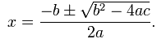
The equation is not stable when b² is a way larger than 4ac, this equation will cause problem. The loss of significance will produced by this equation. This is due to the subtraction of two numbers of about the same size. Therefore, we come up with alternative quadratic formula.
(2) Alternative quadratic formula.
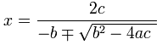
This formula requires c to be nonzero. This equation will still have problem when doing cancelation. So we come up with a mixed approach.
(3) Mixed approach.
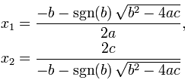
Use the alternative formula to calculate the smaller root and use the formula to calculate the other one. It avoids the limitation of c being zero and only same sign are added.

Prime
We choose the Primality Algorithm 3 introduced in the PDF, because this algorithm is the most efficient one. And we limit the input to be less than 33767 which is the upper bound of int type.
The process of the algorithm is as follows:
1. Check number 1,2,3.
2. Check if 2 and 3 is the factor
3. Check if the integers are the factor of n. The integers is in form 6k ± 1 util√n

Programming Style & Patterns

Programming style
Please refer to http://geosoft.no/development/javastyle.html.
For this project, we are mainly focusing on the following aspects:
- Comments
- Naming
- Layout & while space

Programming patterns
Here is the Class Diagram of the project:
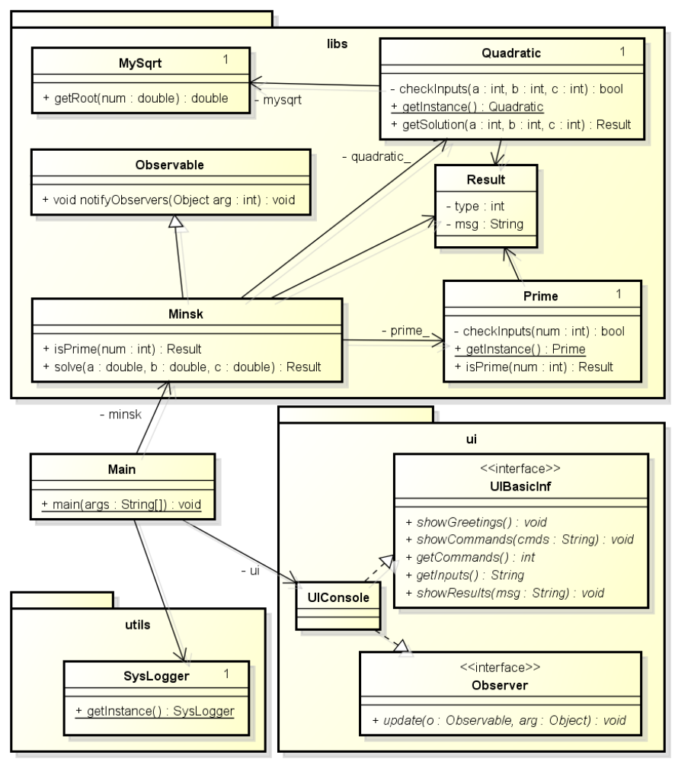
Figure 2-14 Class diagram of project

From the figure, we can see that the project has applied following design patterns:
- Singleton Pattern
See class Quadratic, class Prime, class MySqrt and class SysLogger.
- Observer Pattern
When it gets a result from Quadratic or Prime classes, the program needs to show the results on UI. In this case, the UI is an observer which is monitoring the event of getting the results.
- GRASP Controller
For information about GRASP Controller, please see:
http://en.wikipedia.org/wiki/GRASP_(object-oriented_design).
In the project, the main class is a controller, which gets the command/input from UI and transfers this information to classes in libs package. When it gets results from libs, it will notify UI to show messages.

Quality Attributes

Maintainability
- Document
This document describes some design of the project, like class diagram, which will help future improvement of the project.
- Design patterns
With the design patterns we used, the program has low coupling and high cohesion. These features will be greatly helpful for later development. For example, we do not need to change much the libs package of the program when replacing the Console UI with Graphic UI in the future if necessary.
- Log
We design a SysLogger module for the project in order to easily debug and trace.
- Unit Test
We created some unit test cases for classes MySqrt, Prime, Quadratic.

Portability
- Java Programming Language
We decide to develop with Java programming language, as the Java program can be run on many kinds of operating system.
- Console UI
We decide to use console UI as it does not require much Java libraries, such as JFC, Swing. So the program is compatible with different version of Java JRE, and could run on different guest operating system.

Generality
- Possible input.
1. The input for quadratic equation is set to be float type, which includes larger range of numbers. And the value of a can’t be 0. The mixed approach used for the quadratic equation can solve the problem of loss significance.
2. The input for Prime is set to be int type. The number can’t be larger than 33767. This assumption is made based on assuring the efficiency of algorithm.
- Error tolerance
We set the error tolerance to be 0.0000000001 for quadratic equation. That it can handle the various differences between b² and 4ac.

Usability
- Input Instruction
The instruction for user to make valid input is clearly shown. For example, for quadratic equation the a can’t be 0. We will show it for user that the a can’t be 0.
- Specific output
MINSK will not only show the output result but also the error type if no result is calculated. For example, if no root is calculated out, MINSK will show the result type if it is no real root or the input is not valid.

Efficiency
The efficiency here we mainly refer to the efficiency of the algorithms we adopted in MINSK.

Quadratic
Wikipedia discusses a number of algorithms for calculating square roots. In the MINSK, what we need is a reasonably fast algorithm that would give accurate results. Wikipedia and various other places produced two possibilities, both iterative methods: The Babylonian or Heron method, which is known to converge rapidly and a binary search method that should be logarithmic in the size of the input. Other algorithms such as Chebyshev polynomials methods were left as subjects for future investigations.
A commonly used algorithm for approximating √x is known as the "Babylonian method" and is based on Newton's method. It proceeds as follows:
- start with an arbitrary positive start value r (the closer to the root the better)
- replace r by the average of r and x/r
- go to 2
This is a quadratically convergent algorithm, which means that the number of correct digits of r roughly doubles with each step.
This algorithm works equally well in the p-adic numbers, but cannot be used to identify real square roots with p-adic square roots; it is easy, for example, to construct a sequence of rational numbers by this method which converges to +3 in the reals, but to -3 in the 2-adics.
Despite any weaknesses in the method of measurement, it is clear that BigDecimal calculations have an enormous overhead, orders of magnitude, compared with the limited precision of the square root calculation of the Java Math package.
It is also apparent that for high precision calculations the “Babylonian” method converges much faster, for the same precision, than the iterative methods though this advantage is reduced as the precision decreases. The same effect is seen for the fixed precision calculations of the Java Math package.
BigDecimal and Big Integer calculations should only be used when unavoidable or when speed is not critical but precision is critical. It is possible other algorithms would be faster with BigDecimals but the overhead involved makes it unlikely they will ever compete in terms of speed.
The original goal of deciding whether the “Babylonian” or “iterative” algorithm is faster was achieved. The “Babylonian” algorithm won decisively at high precision. Therefore, in the MINSK, we adopted “Babylonian” algorithm as the solution for the Quadratic.

Prime
A primality test is an algorithm for determining whether an input number is prime or not. Unlike integer factorization, primality tests do not generally give prime factors, only stating whether the input number is prime or not. Factorization is thought to be a computationally difficult problem, whereas primality testing is comparatively easy (its running time is polynomial in the size of the input). Here we rationalize the reason why we adopted the algorithm we selected by making comparison to other possible algorithms.
1). Trivial Case
It is common knowledge that numbers are prime if the only divisors they have are 1 and itself. Trivially, we can check every integer from 1 to itself (exclusive) and test whether it divides evenly.
For example, one might be tempted to run this algorithm:
//checks whether an int is prime or not.
boolean isPrime(int n) {
for(int i=2;i<n;i++) {
if(n%i==0)
return false;
}
return true;
}
2). N/2 Case
So, the algorithm above can definitely provide the right answer. However, it is not effective. In order to make it run faster, much faster, we can change the algorithm a bit. Consider that if 2 divides some integer n, then (n/2) divides n as well. This tells us we don’t have to try out all integers from 2 to n. Now we can modify our algorithm:
//checks whether an int is prime or not.
boolean isPrime(int n) {
for(int i=2;2*i<n;i++) {
if(n%i==0)
return false;
}
return true;
}
3). Square Root Case
A better than N/2 algorithm is that we only go up to the square root of n, because if you list out all of the factors of a number, the square root will always be in the middle.
As for 2, the “oddest” even prime number, we need to discuss it separately and then traverse odd numbers up to the square root of n. The source code should be like this:
//checks whether an int is prime or not.
boolean isPrime(int n) {
//check if n is a multiple of 2
if (n%2==0) return false;
//if not, then just check the odds
for(int i=3;i*i<=n;i+=2) {
if(n%i==0)
return false;
}
return true;
}
4). Final Algorithm
Above all, we have discussed 3 different algorithms for determining a prime number. Based on efficiency, apparently the third one is most effective. However, the requirement for the Prime is to find out whether an input number has any other factors rather than 1 and itself. The algorithm above all discussed about how to traverse from 2 to the minimum number we can find. Therefore, there is still space for us to improve, such as we don’t need to traverse all the potential numbers.

First, we can test if the number can be represented by the form 6k+1 or 6k-1 and then if it is a multiple of 2 or 3,.If it can be represented in either of the forms(6k+1 or 6k-1), then it proceeds to the checking loop. If the condition fails, the program exits after “return false”. Then, sqrt stores the square root of the number the user inputs. The loop counter i starts from 5 (2 and 3 have been already checked. Every multiple of 4 is divisible by 2 which have already been checked too).
Then, the counter is checked if it is even or if it is a multiple of 3. If it is either, then the program proceeds to the next iteration.

Then, the program checks if input data is a multiple of the current number (counter).

If it is, then the program prints "Not Prime".

If no number divides the input number, finally, the program prints that the number is prime and exits.
Here is the final source code of the Prime Algorithm we adopted in MINSK.
public boolean isPrime(int num)
{
if(num==1)
return false;
if(num==2||num==3)
return true;
if(num%2==0||num%3==0)
return false;
for(int i=1;(6*i-1)*(6*i-1)<=num;i++)//check for integer in form 6i+-1 till sqr(n)
{
if(num%(6*i+1)==0||num%(6*i-1)==0)//if integer 6i+-1 is the facter of n
return false;
}
return true;
}

Cyclomatic number
Cyclomatic complexity (or conditional complexity) is a piece of software metric (measurement).
It is computed using the control flow graph of the program: the nodes of the graph correspond to indivisible groups of commands of a program, and a directed edge connects two nodes if the second command might be executed immediately after the first command. Cyclomatic complexity may also be applied to individual functions, modules, methods or classes within a program.
There are a few tools for creating flow graphs and calculating the cyclomatic numbers. As introduced in the Note “CONTROL FLOW STRUCTURE OF SOURCE CODE”, we used the CyVis tool to calculate the cyclomatic numbers for the MINSK.
Cyclomatic number of MINSK can be considered as equal to the sum of all the individual graphs’ cyclomatic numbers.
There are 4 different packages in the MINSK: package default, utils, ui, libs.
Here is the flowgraphs of those 4 packages generated by CyVis:
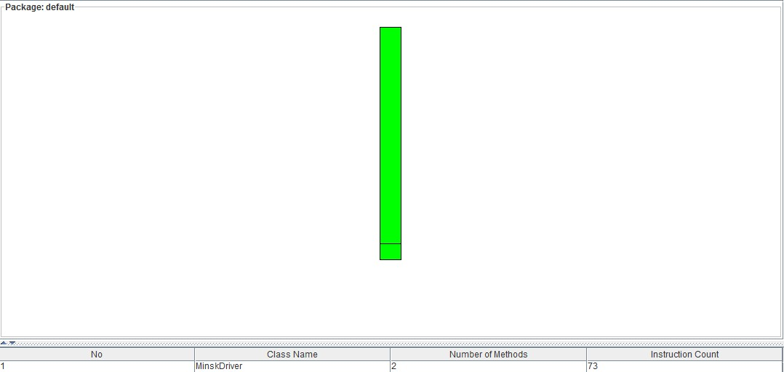
Figure 2-15 the flowgraph of the package default

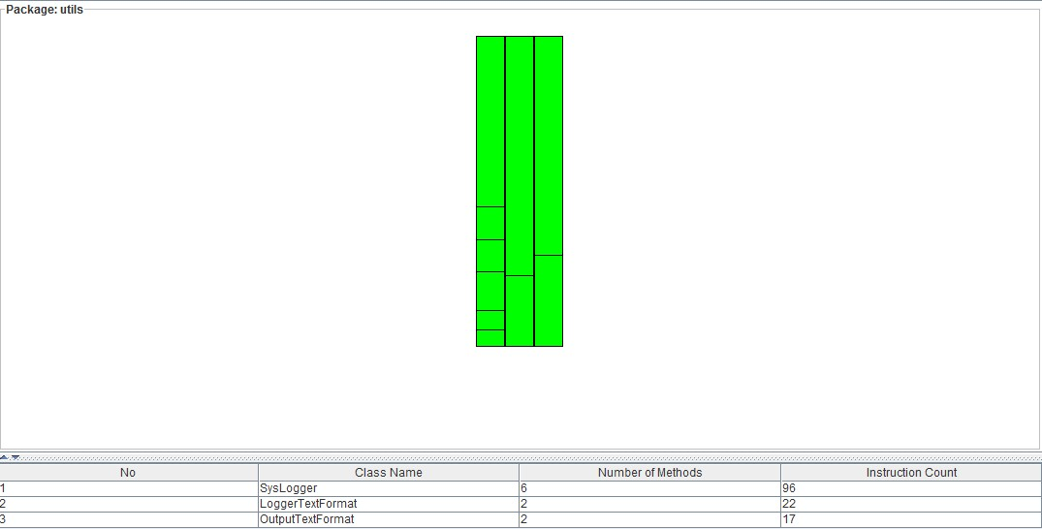
Figure 2-16 the flowgraph for the package utils
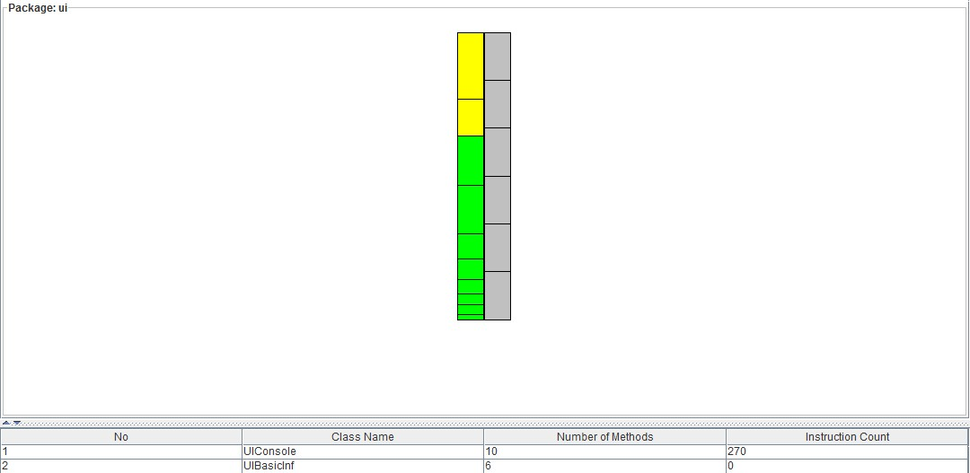
Figure 2-17 the flowgraph for the package ui

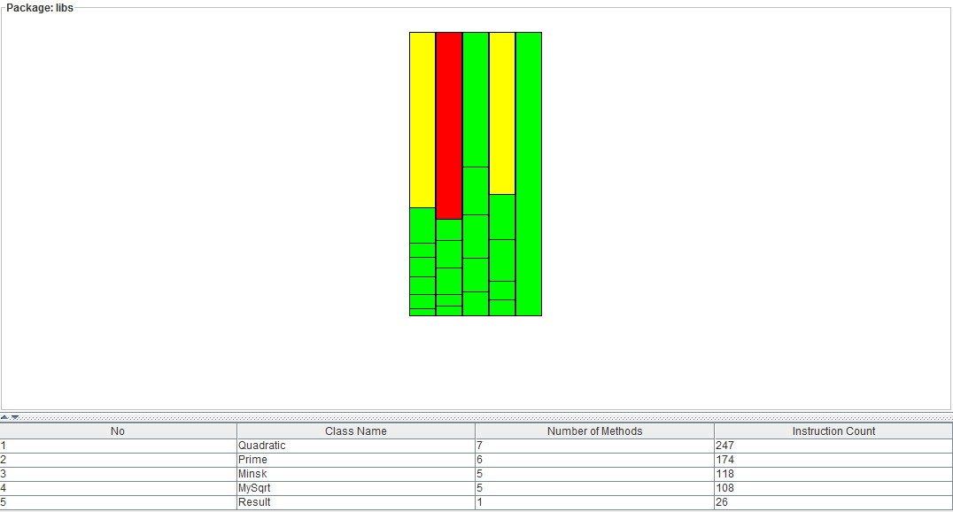
Figure 2-18 the flowgraph for the package libs

Since the cyclomatic number is calculated by each method individual, therefore the graphs below show the cyclomatic numbers in different classes.
From those graphs above, it shows clearly that except 4 classes, the others’ cyclomatic complexity are all has “simple” control flow with the range lower than 10, which have low risk assessment. Therefore, next, in this document we are going to discuss about the 4 classes may cause for concern and rationalize the reasons.

- The Cyclomatic Complexity for the Class MySqrt equals to the sum of the cyclomatic numbers for each method which is 10(6+1+1+1+1)
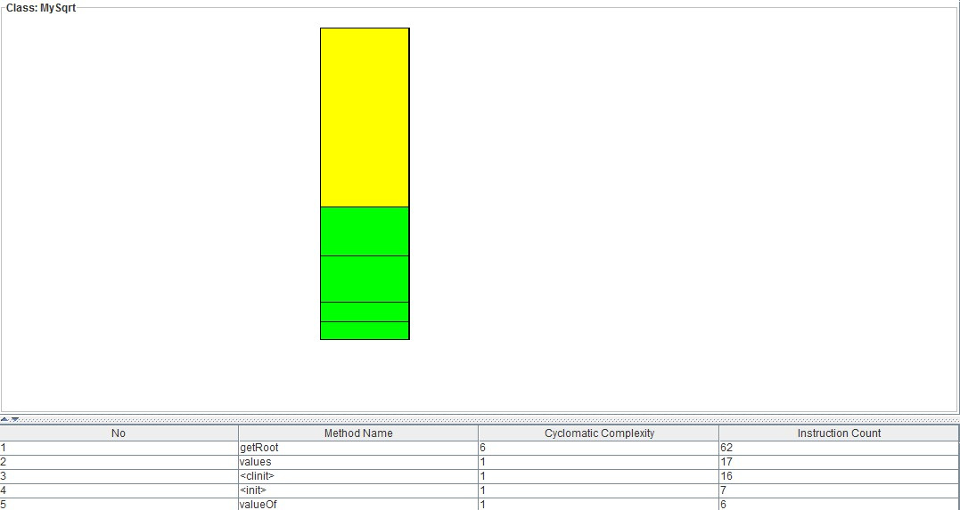
Figure 2-19 the Cyclomatic Complexity for Class MySqrt

In MySqrt, we define the solution for how to find a given number’s the square root. In this class, there is a method named getRoot, which happen to have the highest complexity. In this method, there are only two loops. Without any of them, we cannot get the right result. So based on the algorithm we used for the square roots, the cyclomatic numbers for the Class MySqrt is the minimum already. Besides each individual method’s cyclomatic complexity doesn’t exceed 10 which is the limited of “Simple” control flow.

- The Cyclomatic Complexity for the Class Quadratic (shown in Figure 2-7)is 15
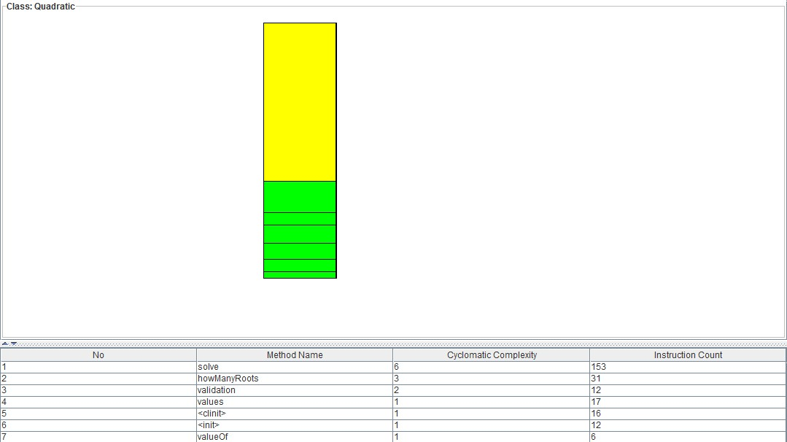
Figure 2-20 Cyclomatic Complexity for Class Quadratic

The cyclomatic complexity in the Class Quadratic has strongly connection with the algorithm we adopted. Both in the Validation and howManyRoots classes, there are essential loops to verify the validation of the input data. Therefore, the cyclomatic numbers are 2 and 3. As for the solve calsses, it is a class where the result will be deliver to the actors. Hence, the verification condition is also be used as a solution condition in this method to deduce the proper result. Therefore, the cyclomatic number is 6. Just like above mentioned, although the overall complexity is more than 10, each individual is still simple. No method’s complexity exceeds the limitation of 10.

- The Cyclomatic number for the Class Prime (shown Figure 2-8)is 17
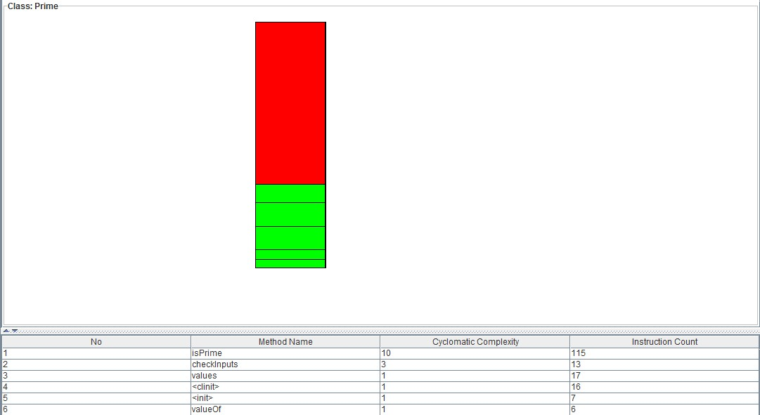
Figure 2-21 Cyclomatic Complexity for Class Prime

In the Prime class, the main cyclomatic complexity exists in the method called isPrime. The algorithm for determining a prime number is implemented in this method. Just like aforementioned in the “Comparison of Algorithms”, the algorithm we adopted needs to meet the criteria of judging input data and the efficiency. On the contrary, the more detailed we state in the efficiency and requirement, the higher the cyclomatic number will be. Therefore, in order to find the balance of the two sides. We used Babylonian method to calculate the quadratic. With the cyclomatic number 10, the efficiency also reaches the best we can achieve.

- Figure 2-9 shows the cyclomatic numbers for the class UIConsole.
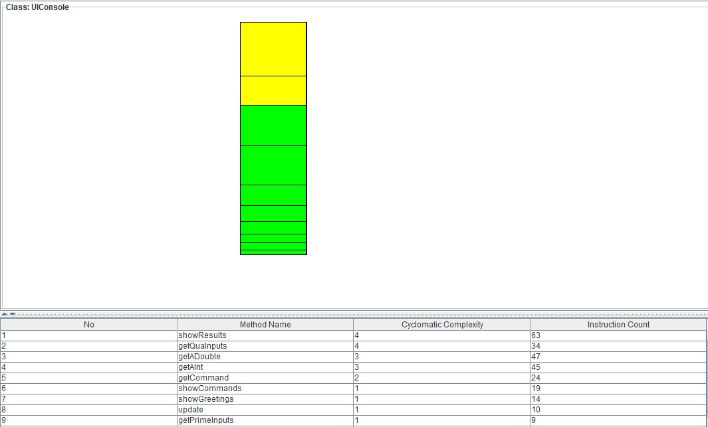
Figure 2-22 Cyclomatic Complexity for Class UIConsole

In this class, it is mainly about usability. When an actor interacts with MINSK, the options he/she could select and the results one can get from MINSK. In order to implementing the usability, it is mandatory for the source code to have certain complexity. The methods whose cyclomatic complexity is more than 1 are all related to the usability for users. Of course, there is some not essential usability we didn’t adopt in MINSK and the complexity is in the acceptance range: no more than 10 in a single method. Therefore, it is the balance of usability and cyclomatic complexity.

How to run the program

File List
- SOEN6611ProjectD1.zip
  - ProjectSourceCode
    - logs // empty directory
    - src
      - libs
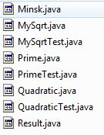
      - ui
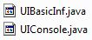
      - utils
      - MinskDriver.java
    - .classpath
    - .project
  - SOEN6611ProjectD1.jar // executable file
  - SOEN6611ProjectD1.pdf // this file

All the latest source code and documents can be found from here:
http://all-projects-concordia.googlecode.com/svn/soen6611/

To run the program
- Install JRE (v5.0 or higher)
- Extract SOEN6611ProjectD1.zip to $DIR
- cd $DIR\ SOEN6611ProjectD1
- $ java -jar SOEN6611ProjectD1.jar

Appendix A: Reference
- http://users.encs.concordia.ca/~kamthan/courses/soen-6611/effort_estimation_use_cases.pdf
- http://www.teach-ict.com/as_as_computing/ocr/H447/F453/3_3_6/uml/miniweb/pg11.htm
- http://www.accelerateddeliveryplatform.com/Default.aspx?Page=SmartUseCaseIdentifySubFunction&NS=&AspxAutoDetectCookieSupport=1
- http://www.scribd.com/doc/58088849/Quatrani-ch03
- http://users.encs.concordia.ca/~kamthan/courses/soen-6611/effort_estimation_use_cases.pdf
- http://tynerblain.com/blog/2007/02/20/software-cost-estimation-ucp-7/
- Estimating Object-Oriented Software Projects with Use Cases. By K.Ribu. M.Sc. Thesis. University of Oslo. Oslo,Norway.2001
- http://scienceray.com/mathematics/computing-square-roots-of-large-numbers-with-java-bigdecimals/
- http://neohumanism.org/s/sq/square_root.html
- http://www.codeproject.com/Tips/86995/Quicker-Prime-Number-Test
- http://users.encs.concordia.ca/~kamthan/courses/soen-6611/primality.pdf
- http://en.wikipedia.org/wiki/Cyclomatic_complexity
- Metrics and Models in Software Quality Engineering. By S.H.Kan. Second Edition. Addison-Wesley.2003.
- http://en.wikipedia.org/wiki/Methods_of_computing_square_roots
- http://geosoft.no/development/javastyle.html
- http://en.wikipedia.org/wiki/GRASP_(object-oriented_design)

Appendix B: Revision History
Version | Date | Author | Remark
V0.1 | July 15, 2012 | Team F

http://users.encs.concordia.ca/~kamthan/courses/soen-6611/effort_estimation_use_cases.pdf
http://www.teach-ict.com/as_as_computing/ocr/H447/F453/3_3_6/uml/miniweb/pg11.htm
http://www.accelerateddeliveryplatform.com/Default.aspx?Page=SmartUseCaseIdentifySubFunction&NS=&AspxAutoDetectCookieSupport=1
http://www.scribd.com/doc/58088849/Quatrani-ch03
http://users.encs.concordia.ca/~kamthan/courses/soen-6611/effort_estimation_use_cases.pdf
http://tynerblain.com/blog/2007/02/20/software-cost-estimation-ucp-7/
Estimating Object-Oriented Software Projects with Use Cases. By K.Ribu. M.Sc. Thesis. University of Oslo. Oslo,Norway.2001
http://scienceray.com/mathematics/computing-square-roots-of-large-numbers-with-java-bigdecimals/
http://neohumanism.org/s/sq/square_root.html
http://www.codeproject.com/Tips/86995/Quicker-Prime-Number-Test
http://users.encs.concordia.ca/~kamthan/courses/soen-6611/primality.pdf
http://en.wikipedia.org/wiki/Cyclomatic_complexity
Metrics and Models in Software Quality Engineering. By S.H.Kan. Second Edition. Addison-Wesley.2003.

