COMP6791 Project 3

Current Version: 0.1
Date: Dec. 05, 2012

Author:
Wei Han
Lin Cheng
Yuan Tao

Instructor: Dr. Sabine Bergler
TA: Marc-André

Concordia University

Table of Contents
1. Answers to the questions 2
1.1. What was the hardest step? 2
1.2. How big is the index? 2
1.3. Does the automatic clustering bear any resemblance to the organization of the ENCS web Space? Elaborate your findings. 2
1.4. What did you learn from your experience? 2
2. Crawler 4
2.1. Crawling tools 4
2.1.1. WebSPINX 4
2.1.2. NYUcrawl 4
2.1.3. JSpider 4
3. Inverted index 6
3.1. Documents preprocessing 6
3.1.1. Traverse files downloaded by the crawler 6
3.1.2. HTML parser 6
3.1.3. Additional files to store the URLs 9
3.2. Bugs found 9
3.3. Space to improve 9
4. Searching 10
4.1. Cluster Retrieval Mode 10
4.2. Probabilistic Retrieval Mode 10
4.3. Duplicate Removal 10
5. References 12

Answers to the questions

What was the hardest step?
- Select the usable and effective web crawler.
The former two web crawlers, NYUcrawl and WebSPHINX are hard to understand and use. At last, we choose JSpider and it can work very well.
- Select the threshold value for duplicate removal.
It needs testing from large number of samples and select two identical webpages.
- Group collaboration.
I need to understand other’s codes and use them correctly and it’s not quite easy.

How big is the index?
- Collection Size: 12,053 files, 72 sub domain names, xxG?
- The number of valid documents: 7297
- The number of terms: j
- The size of inverted index files:

Does the automatic clustering bear any resemblance to the organization of the ENCS web Space? Elaborate your findings.

What did you learn from your experience?
- Public repository for group development
Thought it is not a quite big project, it is still better to create a public repository (like GitHub or Google Code) for managing the source code of the system. Sometimes we were too confident about our source code that we thought we would not have many changes during the integration test.

- Detail information of module interfaces
Only a simple description of the interfaces which will be used by others is not enough, it is better to provide a detail example of how to use the interfaces. On the other hand, the examples might help the interface designer to design better interfaces.

Overall, this is the most comprehensive and challenging final project. It’s not only time-consuming, but also time-pressing. We need to understand and exploit almost all knowledge learned from the course, from tokenization, inverted index construction, vector space model, similarity comparison, probabilistic retrieval, to clustering. It’s very rewarding to run the final product and see it work, and work well, in real-life situation.

Crawler

Crawling tools

WebSPINX
I tried the WebSPHINX in my machine with 4GB memory in Windows 8. As [1] said, by default, WebSPHINX retains all the pages and links that it has crawled until you clear the crawler. This can use up memory quickly to 1.04GB, and stop with error:
java.lang.OutOfMemoryError: GC overhead limit exceeded
For Concordia website, the WebSPHINX only get about 1700 files.

NYUcrawl
NYUcrawl has only one java file. I don’t understand how it saves web resources to local storage, so I didn’t try it.

JSpider
- General information
The JSpider application is a web robot that fetches web resources, parse the result content, search for new links, and fetch those also. JSpider is much more robust and efficient and it’s in 100% pure Java. JSpider is distributed under the LGPL license.
This whole process is highly configurable, and only resources that apply to certain rules are spidered and parsed.
JSpider can easily limit the spidering process to:
- a certain web site
- a certain group of websites
- a certain part of a web site
- resources with a certain content type
- resources that are referenced from a certain other site
- How to use
The command is very simple:
JSpider http://www.concordia.ca download
I kept it running for several days to start spidering from http://www.concordia.ca. In the domain of Concordia.ca, I collected 12,053 files with 72 subdomain names. And 7297 documents are indexed.
- URL & file structures
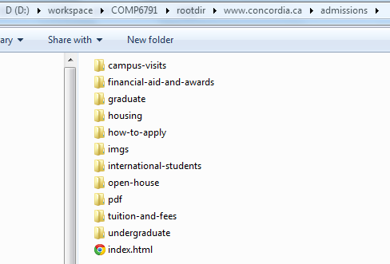

As you can see that there is an index.html file under directory www.concordia.ca/admissions/. The directory/file structure is the same as the structure of the URL.
NOTE: index.html is the file created by JSpider. It might not exist on the HTTP server. It only means that it has the same content of the default web page of the URL www.concordia.ca/admissions/. In fact, all of the default pages for www.concordia.ca website are index.php.

Inverted index

Documents preprocessing
For projects 1 and 2, the documents are from reuters21578, and of .sgm type. However, this project requires the system to parse the real html/php web pages on the internet.

Traverse files downloaded by the crawler
These files are located in different directories, and they may be not html type files. The types of these files might be:
- html
- shtml
- php
- css
- image files like jpg, png, gif, ico
- document files like pdf
- js

As a result, when building the inverted index, only the html, shtml and php files are processed.

HTML parser
- JSoup
We use JSoup to assist the system parse the HTML files. It provides very efficient and convenient APIs to extract the contents of HTML format files. You can get more information about it from:
http://jsoup.org/

- What contents of HTML files do we index?
  - Contents of the meta data for keywords and description
<meta name="keywords" content="xxx">
<meta name="description" content="xxx">
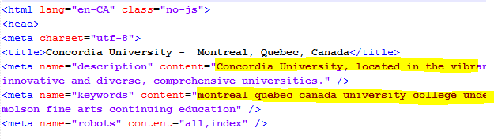

  - All the plain text of the HTML file, except the following:
- Text within the tag of <a> and </a> only if this pair of tags outside of <p> and </p>.
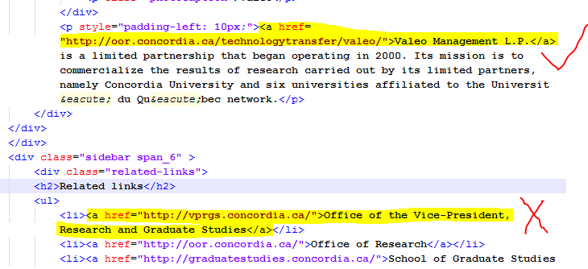

- When the parser detects one of the following tags, the text followed will NOT be processed:
<div id=”footer…”> (… means any characters, in order words, id starts with “footer”)
<div class=”footer…”>
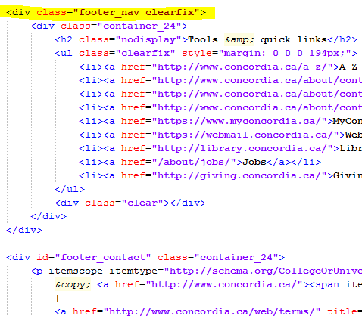

NOTE: Usually, these tags indicate the footer or bottom of the HTML page. And such contents do not need to be indexed.

- About the title of HTML page
Because we need the title of HTML file to assign labels for clusters, the system stores the title of each analyzing some web pages, we find that it is better to do like this:
- If the web page has <h1>, the text of the first <h1> tag will be stored on the disk.
- Otherwise, the text of <title> tag will be used.
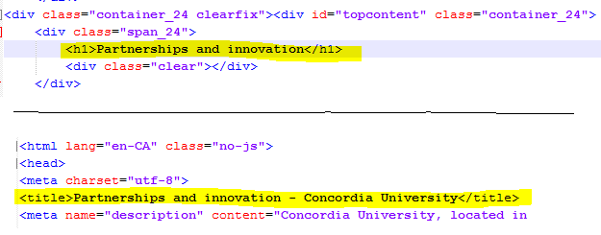

Additional files to store the URLs
It is another difference compared to the previous projects. What the system retrieves and sends to the users is the URL and summary of the content of this URL (if possible), the system needs to store the relationship between document ID and URL. We decide to store the information on disk.

The format of these files is:
URL1
URL2
…

Note that the line number equals to the document ID for the first file.

The name of these files is defined as:
url-<the first doc ID>.txt

For the first file, the name is “url-1.txt”.
If the first file has 1234 URLs in it, then if the system creates the second file, its name is:
“url-1235.txt”.

Bugs found
- When the system encounters a binary HTML file, it will skip parsing all the files afterwards.
Usually the HTML files are text files, but there is at least one file at Concordia.ca which is a binary file:
http://ehs.concordia.ca/securimage/securimage_show.php

Space to improve
- Compressing, especially for postings list and the files storing the URLs.
- Storing the relationship between the text of a link and the link, as the text might be quite relevant to the document to which the link is linked. So the information can be used later when ranking the documents.

Searching

Cluster Retrieval Mode
Cluster hypothesis: Documents in the same cluster behave similarity with respect to relevance to information needs.
So we can use clustering to exploit the cluster hypothesis directly for improving search results, based on a clustering of the entire collection. We use a standard inverted index to identify an initial set of documents that match the query, but we then add other documents from the same clusters even if they have low similarity to the query. This can increase recall since a group of documents with high mutual similarity is often relevant as a whole.
Clustering also helps speed up search. The cluster hypothesis offers an alternative: Find the clusters that are closest to the query and only consider documents from these clusters. Within this much smaller set, we can compute similarities exhaustively and rank documents in the usual way. Since there are many fewer clusters than documents, finding the closest cluster is fast; and since the documents matching a query are all similar to each other, they tend to be in the same clusters.

Probabilistic Retrieval Mode
For comparison with cluster retrieval mode, we also tried probabilistic retrieval mode. In this mode we retrieve documents that have at least one of the terms from query. Postingslists of each query’s term is pulled from the inverted index and all of them are spliced together using union operation removing all duplicate entries. The result postingslist is passed to BM-25 ranking algorithm.

Duplicate Removal
Duplicates were identified by representing each document as vector and then, for each pair of vector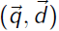, computing the similarity with the formula:
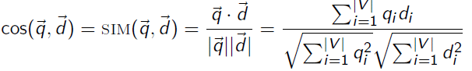 q_{i ,} d_{i} is the tf-idf weight of term i in the document.
When the value exceeds a certain threshold, the documents are recorded. The threshold value is selected manually. I tested the most identical webpages for comparison. Then I selected the following identical webpages and got the value 0.8944 and set it as the threshold.
This is the first webpage for comparison:
http://athletics.concordia.ca/intercollegiate/recruiting/recruiting_whockey.shtml
And the main content of it:
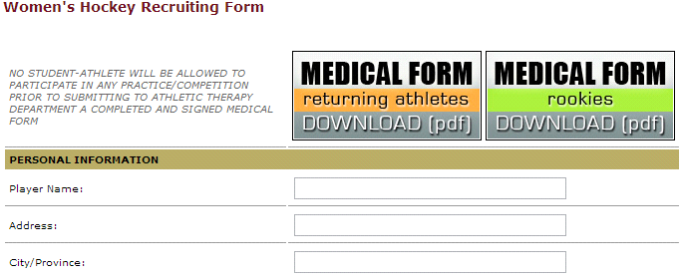
This is the second webpage for comparison:
http://athletics.concordia.ca/intercollegiate/recruiting/recruiting_wbasketball.shtml
And the main content of it:


References
- Christopher D. Manning, Prabhakar Raghavan and Hinrich Schütze, Introduction to Information Retrieval, Cambridge University Press. 2008.
- [WebSPHINX] http://www.cs.cmu.edu/~rcm/websphinx/
- [JSpider] http://j-spider.sourceforge.net/
- [NYUcrawl] http://cs.nyu.edu/courses/fall02/G22.3033-008/WebCrawler.java
- [JSoup] http://jsoup.org/

