

SOEN6611 Deliverable 2
Instructor: Dr. Pankaj Kamthan

Date: Aug. 05, 2012
Presented by: Team F
Team Member: Lu Ma, Meng Jia, Yuan Tao

Table of Contents
1. Part 1 3
1.1. WMC (Weighted Method Per Class) 3
1.1.1. Prime 3
1.1.2. Quadratic 4
1.1.3. Summary 5
1.2. CF (Coupling Factor) 5
1.2.1. Default package. 6
1.2.2. libs 6
1.2.3. ui 6
1.2.4. utils 7
1.2.5. Summery 7
1.3. LCOM*(LACK OF COHESION IN METHODS) 7
1.3.1. Prime 8
1.3.2. Quadratic 8
1.3.3. Summery 8
2. Part2 (Logical SLOC) 9
2.1. USC CodeCount: 9
2.1.1. MySqrt 9
2.1.2. Quardatic 10
2.1.3. Prime 10
2.2. LocMetrics 10
3. Part3 (Spearman’s Rank Correlation Coefficient) 12
3.1. Correlation between Quadratic and Prime classes 12
3.2. Correlation between three classes 12
3.2.1. WMC of MySqrt 13
3.3. Conclusion 14
Appendix A: Reference 15
Appendix B: Revision History 16

Table of Tables
Table 1-1 Attributes of Prime 8
Table 1-2 Attributes of Quadratic 8
Table 2-1 Overall metrics of MINSK 11
Table 2-2 LOC of classes 11
Table 3-1 Statistic between Quadratic and Prime 12
Table 3-2 Statistic between three classes 14

Table of Figures
Figure 1-1 WMC of Prime 4
Figure 1-2 WMC of Quadratic 5
Figure 1-3 UML diagram of libs package 6
Figure 1-4 UML diagram of ui package 7
Figure 3-1 WMC of MySqrt 13

Part 1

WMC (Weighted Method Per Class)
The equation to calculate WMC is:
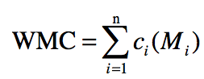
We have to assume that the weight is not normalized. Therefore, the cyclomatic number of the methods suggests the value that can be used for Ci.
From last deliverable, we calculated the cyclomatic number for all the methods in ‘Prime’ and ‘Quadratic’ class. Here, we are going to make use of those calculated data.

Prime
There are totally two functions in the ‘Prime’ class.
1. checkInputs()
Cyclomatic number is 3. The weight for the checkInputs is set to be 3.
2. isPrime()
Cyclomatic number is 10. The weight for the isPrime is set to be 10.
WMC=10+3=13.
The result from CodePro:
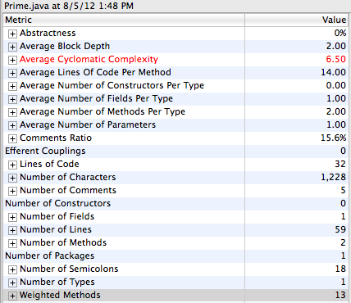
Figure 1-1 WMC of Prime

Quadratic
There are totally three functions in the ‘Quadratic’ class.
1. validation()
Cyclomatic number is 2. The weight for validation is set to be 2.
2. howManyRoots()
Cyclomatic number is 3. The weight for howManyRoots is set to be 3.
3. solve()
Cyclomatic number is 6. The weight for solve is set to be 6.
WMC=2+3+6=11.
Result from CodePro:
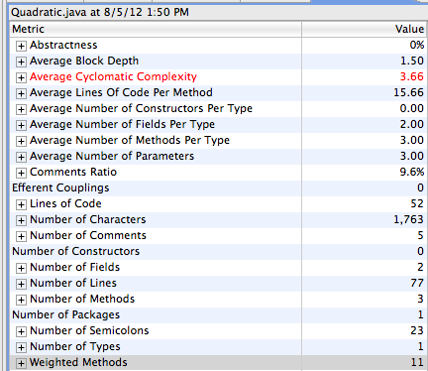
Figure 1-2 WMC of Quadratic

Summary
We want WMC to be low as it measures the size and the complexity of the class. The low value of WMC indicates the class is easy to maintain and reuse. In our project, the WMC for ‘Prime’ and ‘Quadratic’ is not very small, because those two classes involve a lot of logical determination and algorithm. We want to balance the algorithm efficiency and the program complexity.

CF (Coupling Factor)
The equation to calculate CF is:
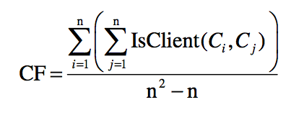
CF is one coefficient that associated with packages. We have four packages in our MINSK. Below is the CF calculation for each package.

Default package.
We have only one class in this package, which is MinskDriver. Therefore, there is no IsClient relationship inside this package. CF=0.

libs
This package contains our main logic of the MINSK project. We have five classes in this package. N=5.

CF = [3+2+1+0+0] / (5*5 – 5)
CF = 6 / 20
CF = 0.3
Here is the UML diagram of the package:
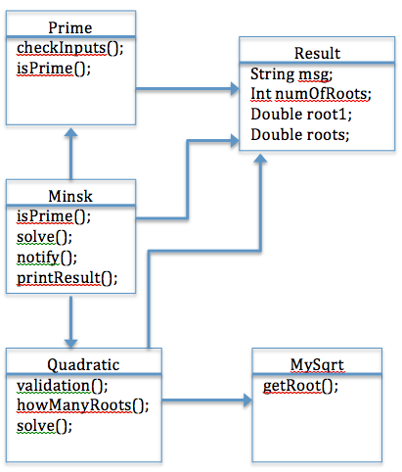
Figure 1-3 UML diagram of libs package

ui
This package contains two classes, that is n=2. UIBasicInf is a interface that UIconsole implements it. This relationship is not inheritance.
CF = [0+1] / (2*2 – 2)
CF = 1 / 2
CF = 0.5
Right is the UML diagram of the package:
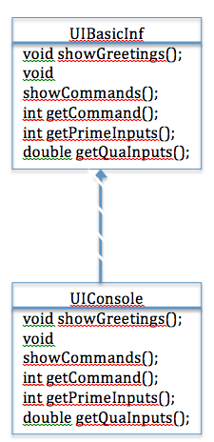
Figure 1-4 UML diagram of ui package

utils
We have only one class in this package, which is SysLogger. Therefore, there is no IsClient relationship inside this package. CF=0.

Summery
For each of our package, we have our coupling factor less than or equal to 0.5, which is not a large value. And our goal is to achieve a small number of CF. The CF value shows our project is easy to maintain.

LCOM*(LACK OF COHESION IN METHODS)
The equation to calculate CF is:
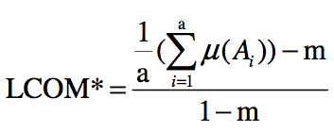

Prime
This class contains 2 methods. That m=2.
Below table is the summery of attributes:
Attribute Name: | Accessed by:
ret | isPrime
retTrue | isPrime
retFalse | isPrime
Table 1-1 Attributes of Prime

From above table, we can see that a=3, and each attribute is only accessed by one method. This situation is when LCOM* is the maximum.
LCOM*=1.

Quadratic
This class contains 3 methods. That is m=3.
Below table is the summery of attributes:
Attribute Name: | Accessed by:
mySqrt | solve
myRes | solve
delta | howManyRoots
Table 1-2 Attributes of Quadratic

From above table, we can see that a=3, and each attribute is only accessed by one method. This situation is when LCOM* is the maximum.
LCOM*=1.

Summery
Ideally, we want LCOM* to be low, but in our project, we have a very high value. Because that class ‘Prime’ and ‘Quadratic’ both don’t have a lot of methods. And each method does independent functions, which will increase the LCOM*.

Part2 (Logical SLOC)
In MINSK, there are three main classes which contain the functional algorithms.
There are three classes including:
- MySqrt
- Quadratic
- Prime
As required, we have used USC CodeCount to calculate logical SLOC of each class. Besides, we also use LocMetrics as another tool to testify the results of the UCC.

USC CodeCount:
For calculating logical SLOC for each class and the results are the following ones:

MySqrt
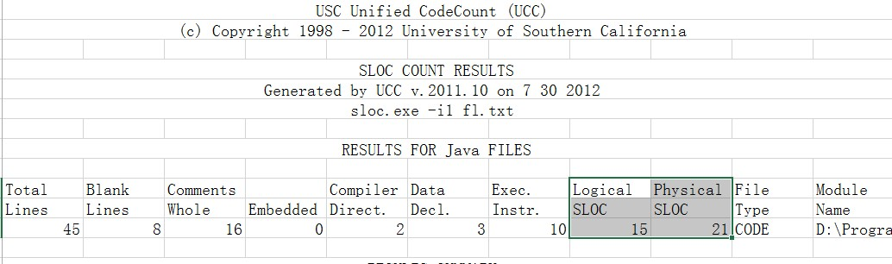

Quardatic
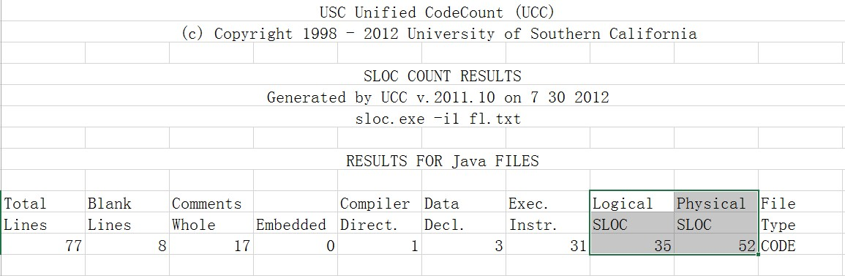

Prime
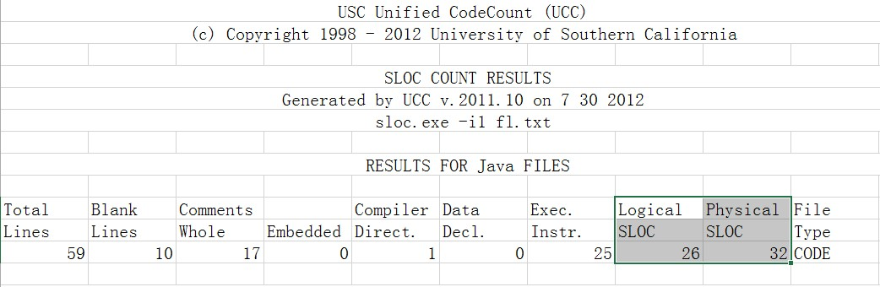

LocMetrics
LocMetrics counts total lines of code (LOC), blank lines of code (BLOC), comment lines of code (CLOC), lines with both code and comments (C&SLOC), logical source lines of code (SLOC-L), McCabe VG complexity (MVG), and number of comment words (CWORDS). Physical executable source lines of code (SLOC-P) is calculated as the total lines of source code minus blank lines and comment lines. Counts are calculated on a per file basis and accumulated for the entire project. LocMetrics also generates a comment word histogram.

In LocMetrics, it generated all metrics information of the whole project. The Table below is the overall metrics information of the MINSK.

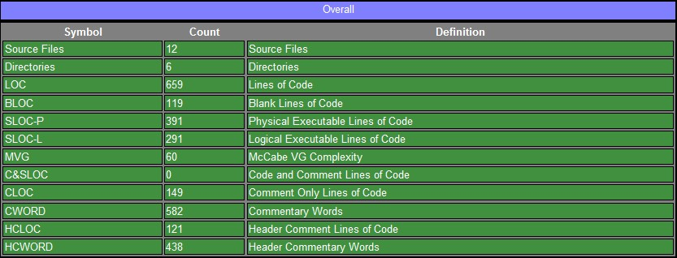
Table 2-3 Overall metrics of MINSK

The Table below is the detailed LOC information of each class. Take a look at the three classes we calculated with UCC, MySqrt, Quadratic and Prime. In LocMetrics, the logical SLOC results of the classes match the ones in UCC.

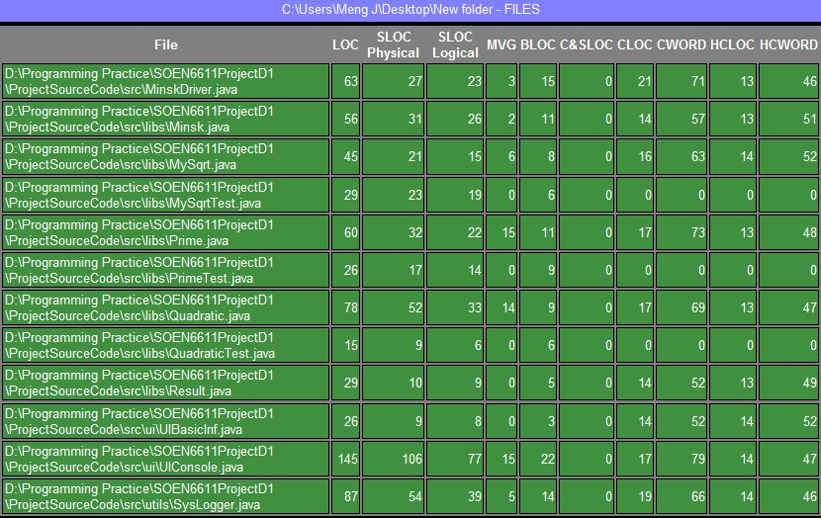
Table 2-4 LOC of classes

Part3 (Spearman’s Rank Correlation Coefficient)

Correlation between Quadratic and Prime classes
Let Xi be the rank of Logic SLOC for each class.
Let Yi be the rank of WMC for each class.
Let Di be the result of Xi – Yi.

According to the data we obtained from previous chapter, we can get the statistics:

 | Logic SLOC(x_{i}) | Rank(x_{i}) | WMC(y_{i}) | Rank(y_{i}) | d_{i} = x_{i} - y_{i} | (d_{i})²
Quadratic | 35 | 2 | 11 | 1 | 1 | 1
Prime | 26 | 1 | 13 | 2 | -1 | 1
Table 3-5 Statistic between Quadratic and Prime

Now ∑_{i=1,2}(d_{i})² = 1 + 1 = 2 and n = 2. Thus r_{s} = 1 – (6*2 / (2³ – 2)) = -1.

“The value r_{s} varies from -1 to 1. The values near 1 indicate a strong positive correlation, the values near -1 indicate a strong negative correlation, and the values near 0 indicate very weak or no correlation.”

As a result, the correlation between Logic SLOC and WMC for classes Quadratic and Prime has a strong negative correlation.

Correlation between three classes
Since there are only two classes, the correlation is either strong negative correlation or strong positive correlation. We decide to add MySqrt class for analysis.

WMC of MySqrt
From CodePro, we get the following data of MySqrt Class:
- Average Cyclomatic Complexity: 7.00
- Weighted Methods: 7

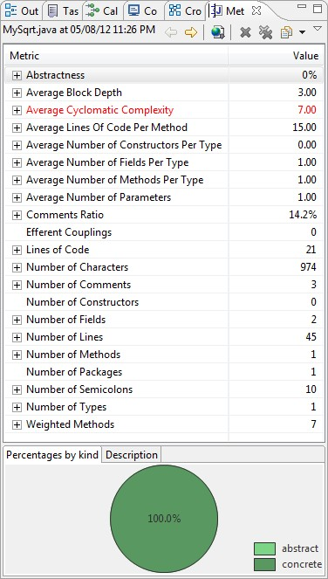
Figure 3-5 WMC of MySqrt

Here is the statistic of three classes:
 | Logic SLOC(x_{i}) | Rank(x_{i}) | WMC(y_{i}) | Rank(y_{i}) | d_{i} = x_{i} - y_{i} | (d_{i})²
Quadratic | 35 | 3 | 11 | 2 | 1 | 1
Prime | 26 | 2 | 13 | 3 | -1 | 1
MySqrt | 15 | 1 | 7 | 1 | 0 | 0
Table 3-6 Statistic between three classes

Now ∑_{i=1,2}(d_{i})² = 1 + 1 + 0 = 2 and n = 3. Thus r_{s} = 1 – (6*2 / (3³ – 3)) = 0.5.

The result shows that between Quadratic, Prime and MySqrt classes, there is a positive correlation, which is opposite to the previous result.

Conclusion
The correlation of Logic SLOC and WMC is quite different between two classes and three classes. In order to get more meaningful results, we need to do the analysis with more number of classes.

Appendix A: Reference
- https://developers.google.com/java-dev-tools/download-codepro
- http://sunset.usc.edu/research/CODECOUNT/
- http://www.locmetrics.com/
- software_measurement_data_analysis.pdf, Dr. Pankaj Kamthan, 2012

Appendix B: Revision History
Version | Date | Author | Remark
V0.1 | Aug. 05, 2012 | Team F

https://developers.google.com/java-dev-tools/download-codepro
http://sunset.usc.edu/research/CODECOUNT/
http://www.locmetrics.com/
software_measurement_data_analysis.pdf, Dr. Pankaj Kamthan, 2012

