首先关于Jia的那部分给点我个人的看法：
PPT中图最直观。如果要用文字，一定是最重要的部分。Jia文档中的内容可以当成底稿，到时候照着念或者说。我建议Jia最好再改一改，明确说明哪些是需要放到PPT上的，哪些是底稿，我担心Ma和我都不一定能完全理解你的思路。另外底稿也要控制一下字数。

下面是我的部分：
PPT
Algorithm of computing square root: Babylonian Method
底稿
我只想PPT中表现出这个函数是我们自己实现的。可以一句话带过，不需要讲算法。这部分合并到下面的project design中也行。

注意：底稿的文字可以直接copy到ppt下面的备注中，这样讲解时可以直接看着屏幕。你愿意打印出来，或者拿个ipad照着读也行。

PPT
Programming Style
- Comments
- Naming
- Layout
底稿
For this project, we are mainly focusing on the following aspects:
- Comments (e.g. For each file, we have comments showing the meaning of the file, who creates the file, and who modifies the file etc. We also have comments explaining the importance statements of source code.)
- Naming (Our team has same naming conventions for the name of packages, classes, variables, constants, methods, etc.)
- Layout & while space (The layout of our project is automatically done by Eclipse.)
此部分PPT可要可不要，视情况而定。

PPT
Project design
然后贴上下面的图，可能有些大，不过没关系，没几个人会仔细看。
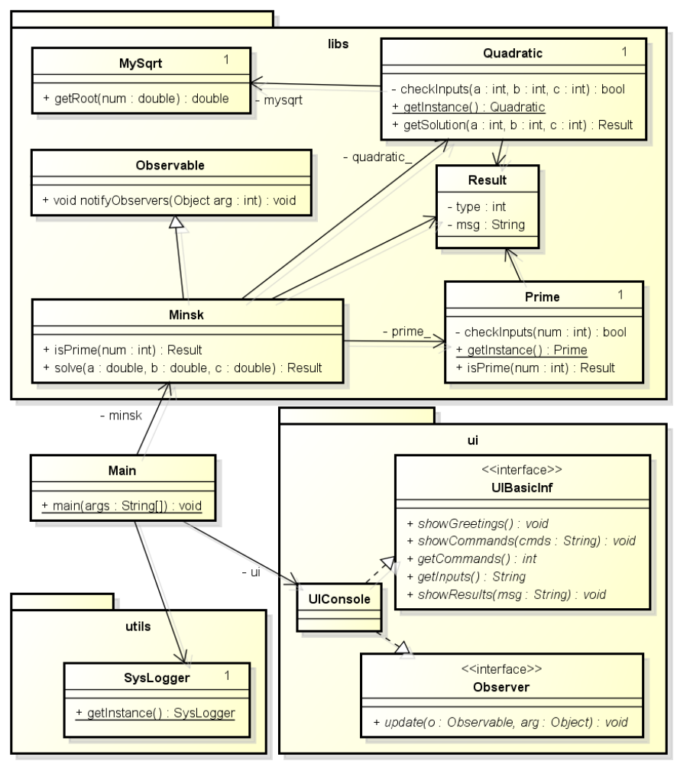

底稿：
The picture that we are seeing is the final version. At beginning of the design, we did not have the ui package. We did not apply observer pattern either. After group discussing, we changed the design again and again in order to get low coupling and high cohesion for the project. From the picture, we can see that within libs package, there are classes like Prime, Quadratic, and MySqrt. We create a SysLogger class in the uitls package. We have applied some design patterns for the project:
- Singleton Pattern
See class Quadratic, class Prime, class MySqrt and class SysLogger, which have a number 1 at the right-top corner of the class in the picture.
- Observer Pattern
When it gets a result from Quadratic or Prime classes, the program needs to show the results on UI. In this case, the UI is an observer which is monitoring the event of getting the results.
- GRASP (General Responsibility Assignment Software Patterns) Controller
In the project, the main class is a GRASP controller, which gets the command/input from UI and transfers this information to classes in libs package. When it gets results from libs, it will notify UI to show messages.

PPT
Quality Attributes
- Maintenance
  - Document
  - Design patterns
  - Log
  - Unit Test

底稿
- Document
The document we have delivered describes some design of the project, like class diagram, which will help future improvement of the project.
- Design patterns
With the design patterns we used, the program has low coupling and high cohesion. These features will be greatly helpful for later development. For example, we do not need to change much the libs package of the program when replacing the Console UI with Graphic UI in the future if necessary.
- Log
We design a SysLogger module for the project in order to easily debug and trace.
- Unit Test
We create some unit test cases for classes MySqrt, Prime, Quadratic.

PPT
File list of our project
- SOEN6611ProjectD1.zip
  - ProjectSourceCode
    - logs // empty directory which for generating log when executing
    - src
      - libs
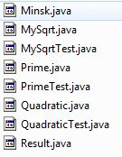
      - ui
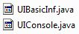
      - utils
      - MinskDriver.java
    - .classpath
    - .project
  - SOEN6611ProjectD1.jar // executable file
  - SOEN6611ProjectD1.pdf // the document

一页PPT显示不完就两页显示

底稿：
一句话带过即可。需要说明的部分就是//注释的部分。照着list读文件名也成。
此部分PPT可要可不要，视情况而定。

PPT
Lessons Learnt
Correlation between less than three classes.
r_{s}=1 – 6*e/… (把Spearman’s Rank Correlation Coefficient公式贴在这里)
然后贴上下面的两张图，贴不下就放到第二页
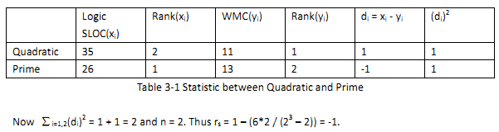
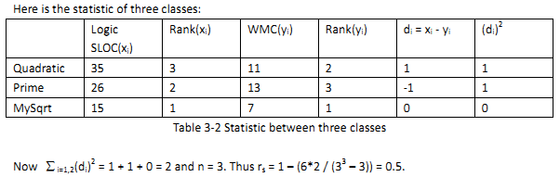
这两张图片从D2的文档中截取的，如果需要调整大小或者重新截取，建议从D2的DOC文档中操作。

底稿：
When we are computing the correlation for the data of metrics between classes with Spearman’s Rank Correlation Coefficient, we find that if the number of classes is two, the result if r_{s} is either -1 or 1. But if we add a class for the analysis, the result might be changed greatly. The table 3-1 shows the result between classes Quadratic and Prime, which is -1, showing that there is strong negative correlation between these two classes. But the table 3-2 shows that the result is 0.5 if we add class MySqrt. That means the correlation has changed from strong negative to positive.
So if we want the result more sensitive, we need data from more classes when we use Spearman’s Rank …

对于我总结的这一点，你们也看看，如果有道理那可以考虑放到PPT中，如果没什么意义，那删了吧。

老师可能提出的问题：
- 我们学到了什么
一些用于软件测量的Metrics；如何使用一些工具来计算这些metrics。
- 我们遇到了哪些问题
程序设计中为了low coupling、high cohesion，以及可移植性、便于后期维护等，反复修改程序，并且使用一些design pattern。

