Curriculum Vitae

Aviran Ben-Hamo

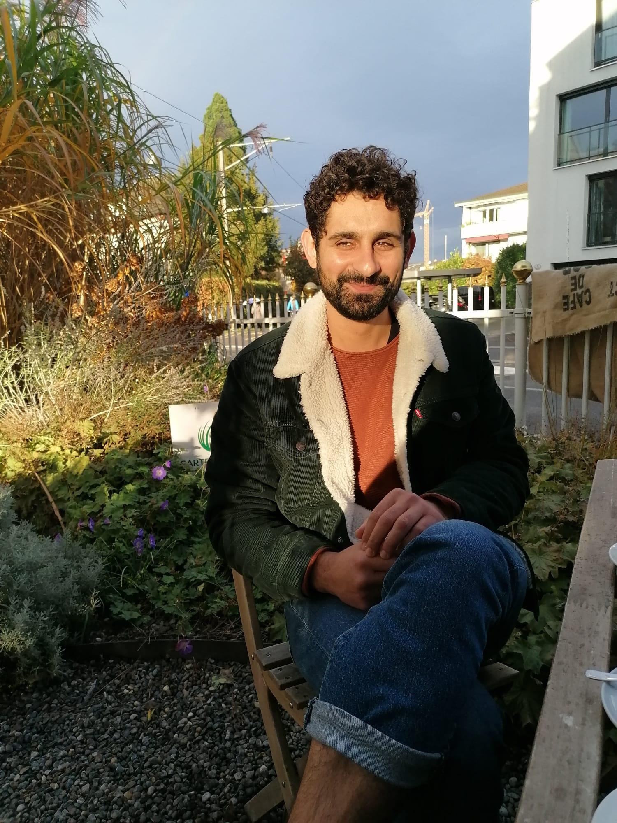

**Personal information**

Address Murifeldweg 5

3006 Bern

Mail aviranbenhamo@gmail.com

Phone 077 430 55 31

Date of birth 27.07.1987

Place of birth Haifa, Israel

Citizenship Israeli, Swiss residence permit C

Marital status married

**Professional experience**

**10/2019 – today Cook**

Restaurant Löscher, Bern Switzerland

**07/2015 – 09/2019 Cook and kitchen chef**

Restaurant Punto Buchowski, Bern Switzerland

**02/2013 – 03/2017 Cook**

Restaurant Sous Le Pont, Bern, Switzerland

**05/2011 – 03/2012 Cook**

Restaurant Uri Buri, Akko, Israel

**08/2009 – 04/2011 IT supporter**

Shoshi’s film editing studios western Galilee, Israel

**01/2010 – 08/2010 Manager**

Jungly Restaurant, Karkor, Israel

**05/2009 – 12/2009 Computer mechanic and salesman**

Bug Company, Nahariya, Israel

**09/2001 – 06/2006 IT supporter**

Shoshi’s film editing studios western Galilee, Israel

**11/2003 – 05/2006 IT supporter**

Library Kibbutz Lohamei HaGeta’ot, Israel

**Army**

**03/2006 – 03/2009**

**Education**

**1999 – 2005**  **High school, focus subject: Chemistry and physics**

Sulam Tzor High school, Israel

**1995 – 1999**  **Primary school**

Hofei Ha Galil, Israel

**1993 – 1995**  **Primary school**

Janusz Korczak school, Israel

**Skills**

**Languages** Hebrew: native

English: fluent

German: basic knowledge, learning ☺

**Experience**  Computer and network technician

IT support basic

Windows, Mac OS, office

Basic HTML and CSS

Different martial arts

Fitness and condition teaching

**Interests & hobbies**

**Interests** Computer and technology

Natural sciences

Philosophy

Nature

Music

**Hobbies** Hiking

Cycling

Swimming

Cooking

Reading