-- core data download from Portal webpage http://portal.core.edu.au/conf-ranks/?search=&by=all&source=CORE2014&sort=atitle&page=1

- all files in this folder are matched by Match by **upper** name (==)

- all data are the same, just in different formats

- available formats: html, csv, xls

- file CORE-csv-csv.openrefine.tar is export of a openRefine project after this iteration

- after this iteration there are 172 matching cases

- columns description:

SPRINGER_PROPERTY_ORG - value of springer property from conferences.ttl

SPRINGER_ID_ORG - value of id from conferences.ttl

SPRINGER_NAME_ORG -value of confSeries name from conferences.ttl

SPRINGER_NAME - value of upper caeses confSeries name from conferences.ttl

NAME_UPPER_ALL - working facet column

No - this column appears when you export table from CORE portal

History fields:

when you click on some confSerie on portal it take you to its page, where is the history.

Conference can have one, two, tree or all four.

CORE2014,

CORE2013,

ERA2010,

CORE2008

They have 3 fields : Source, Rank , Field of Science

In History_1,History_2,History_3,History_4 contains all these 3 fields separated by ||

H4_Field

H4_Rank

H4_Source

Hisory_4

H3_Field

H3_Rank

H3_Source

History_3

H2_Field

H2_Rank

H2_Source

History_2

H1_Field

H1_Rank

H1_Source

History_1

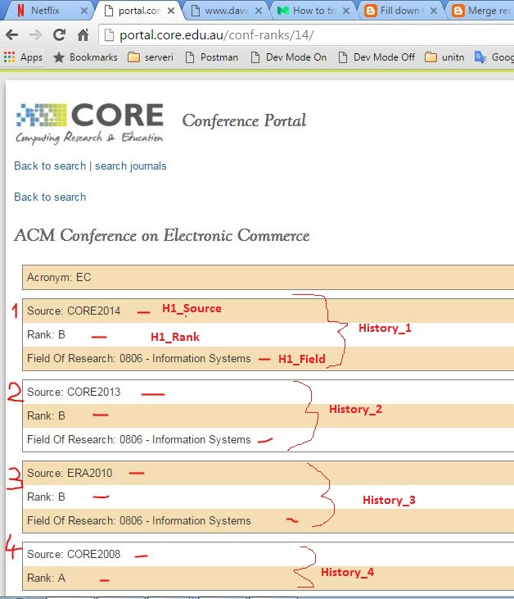

Title_CORE_ORIG ALL

ALL_UPER - all upper names , control column made by me

Acro - values the same as they are on portal in Acro column

Source - values the same as they are on portal in Source column

Rank_CORE_ORIG - values the same as they are on portal in Rank column

Changed? -values the same as they are on portal in Changed? column

For -values the same as they are on portal in For column

MATCH -Match by name (==) - string name in upper cases in columns "Title_CORE_ORIG" and "SPRINGER_NAME" are the equal

COMMENT

