Volume Ducking addon for Blender VSE
Addon for the Blender VSE to easily perform volume ducking in a strip with respect to a channel.

Get the add-on here
Github: Download

How to use ?

Install the addon
Goto to edit > preferences > add-ons and load the ‘main.py’ file
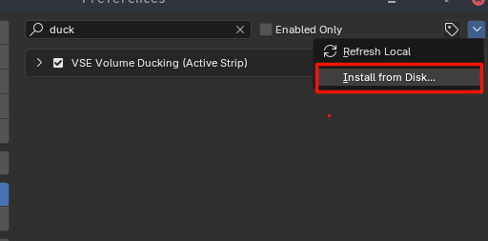

Go to the Video Sequence editor
Load all of your strips in such a way that your target audio strip and your masking/narration strips align on different channels.

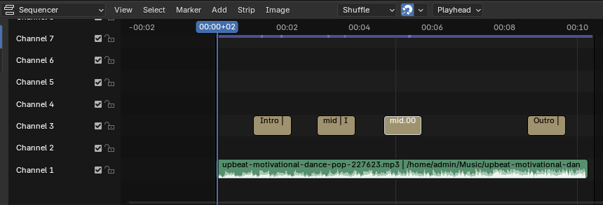
Note down the source channel number – in this example, ‘3’.

Select your target strip
Here, the background music to which ducking is to be applied – keep it selected.

Navigate to the side panel
Drag the right panel open or press ‘n’ to toggle it open. Open up the ‘Channel Volume’ tab
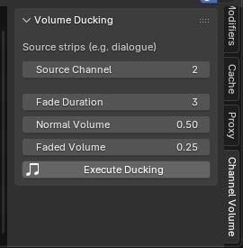

Duck 🦆️
Set values as follows
Field
Source Channel | value to the channel noted down before (e.g., 3)
Fade Duration | to the frame count you want the transition to take (3 frames to fade in/out)
Faded Volume | to the volume the strip should be at when not ducked
Normal Volume | to the volume the strip should be at when ducked

Hit ‘Execute Ducking’ and you’re set !!

