Creating realtime dashboards in libreoffice calc
The libreoffice suite is capable of great many things. The libreoffice SDK lets programmers extend the features of the suite and do even more with it.
I really haven’t looked up the VBscript documentation for similar functionality. But I’m pretty sure almost all of the information covered here is transferable to MS Excel.

Mouse tracking application
In this article we’ll see how to setup a simple flask web application to serve data, which in this case are mouse pointer coordinates from a web page, and configure the spreadsheet to update the graph in real-time (well kinda..)
The libreoffice SDK’s star module should provide all the features you’ll need for this project.

Writing the server
So the flask app will do nothing more record the user’s mouse movements on a canvas and serve it to the spreadsheet. Once you start the server, you can access the app on any device connected to the same network.
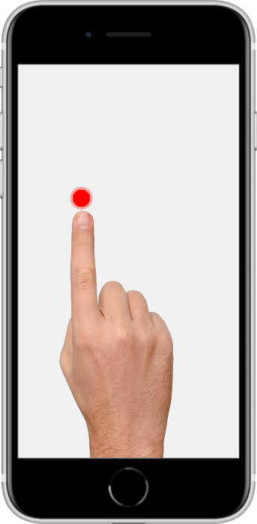

Webpage

index.html
/media/admin/New Volume/prog_stuff_calc/mouse-tracker/index.html

Flask server program

server.py
/media/admin/New Volume/prog_stuff_calc/mouse-tracker/server.py

Building the dashboard
Our setup is a basic spreadsheet to display a real-time line graph. And if possible, add a few fancy buttons to start and stop the listening process.
You may download the .ods file here📥.

The Graph
As you can see, the graph takes data from cells C4:C14. This will be the most important component of the program. The idea is that since the graph updates itself with whatever values are given in the corresponding cells, any code/formula to modify these cells should automatically be reflected in the graph.
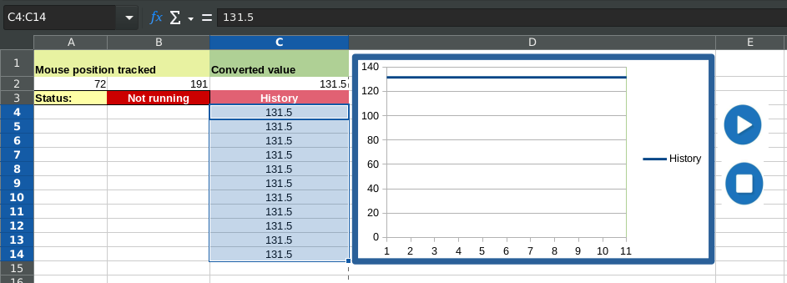

The Code
There are 3 major code snippets / macros we’ll be using to control the program:
- fetchMousePos - Fetch data from the server program and populate the cells
- updateHistory – Cleanup any entries more than 10 (C4:C14)
- triggerMacro – Start / Stop the listening process
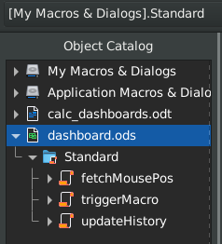

fetchMousePos
First we need to fetch the data from the server, which can be achieved with this function.
Next, we populate the data fetched in the step above into the “Mouse Position Tracked” cells.
/media/admin/New Volume/prog_stuff_calc/mouse-tracker/snippets_for_joeleldo_com/getMousePos.vbscript
Upon the code updating those fields, it should automatically update the “Converted value” cell as well, which is nothing but the average of the x and y coordinates; which in turn pushes the value to the history queue, ultimately updating the graph.
/media/admin/New Volume/prog_stuff_calc/mouse-tracker/snippets_for_joeleldo_com/parseAndInsert.vbscript

updateHistory
Here’s the fun part. This is where we push the existing data to the cells below such that any incoming data always remains at the top of list. We’ll also need to take care of any entries exceeding the limit of the preset number of cells.
Essentially, we implement a queue push.
/media/admin/New Volume/prog_stuff_calc/mouse-tracker/snippets_for_joeleldo_com/updateHistory.vbscript

Start/Stop listening

triggerMacro
This is more like an add-on feature we can implement to make the dashboard – well, feel like a dashboard.
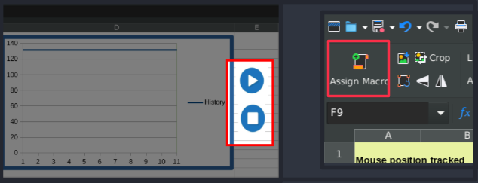
These “buttons” are actually just images to which macros are attached – turning them into trigger points without any having to deal with any fancy event listeners or such.

The triggerMacro macro is implemented as follows
/media/admin/New Volume/prog_stuff_calc/mouse-tracker/snippets_for_joeleldo_com/trigger.vbscript

Bringing everything together..
Yes !! Time to start your python server, launch your app in the browser and hit the play button on your dashboard.
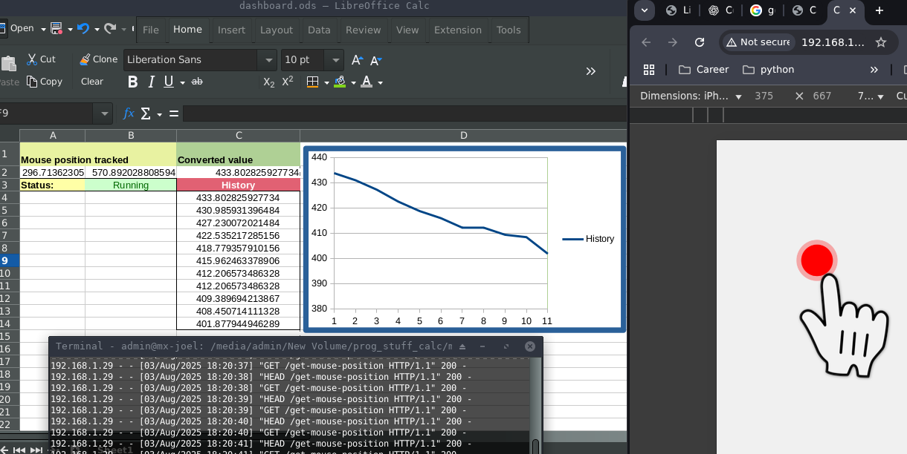
Click around on the webpage to see how the graph behaves.
Note: In case you get the following error, its probably because flask is serving on a different address
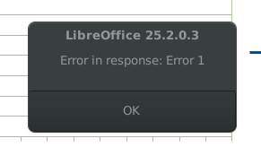
Correct the address in ‘fetchMousePos’ function with the address displayed in the flask app terminal and you should be good to go.

