Making code highlighters for vim
Friday, 18/07/2025
Vim makes it absolutely easy to build code highlighters for your domain specific languages. Regular expressions are at the core of vim syntax configuration files.

Target grammar
Let’s consider a toy scripting language (called smsh script) I wrote a while back, that resembles yaml.

utils.smsh (library)
code-snippets/utils.smsh.python

example.smsh (Main code)
code-snippets/example.smsh.python
As you can see the constructs of this language are pretty simple, and so will be the syntax configuration.

Tokenizing the text
A tool like regex101 is quite handy for testing out regular expressions
Below are the regular expressions that single out the language constructs for this example:
Element Type | Regex Pattern
String on its own line ending with colon | /:$/
Indented strings | /^\s\s*.*$/
Non-indented strings without colon | /^\S.*[^:]$/
import keyword | /^import\s/
using keyword | /^using\s/
Decorator | /^@[^" "\t]*/
Comment | /^\s*#[^if].*$/
#if Statement | /^\s*#if.*$/

Picking out the colors
Execute ‘:highlight’ in the vim console
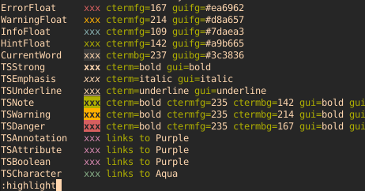
This shows you a list of various styles as rendered by the active color theme. Keeping this as a reference, we can specify in our language file how each token is rendered.
Note: these colors vary depending on the active color theme.

The syntax file
This is what the final syntax file looks like:
smsh.vim 📥
code-snippets/smsh.vim
As shown, putting this file in ~/.vim/syntax/ directory will register your language syntax in vim every time vim loads.
Thats it !!
From here, it is straight forward. You could either:
- Open a .smsh script file in vim or
- use the command [:set filetype=smsh] to activate syntax highlighting in an already opened file.

Refer
superuser QA

