Let’s visualize a bar graph in blender
Data visualization is an integral part of anything to do with IT. Be it when dealing Database monitoring, Observability metrics or Revenue streams or anything else.

Let’s begin
In this article we’ll explore how we can automate the visualization of a large air quality index dataset using open source tools.
(Note that we are not building any dashboards here, just an animated bar graph that you can show off in presentations or your website.)

What we need
- Any blender version upwards of 2.8. In this project I am using 4.5.5.
- Python 3.9
- Libreoffice calc / MS excel
- Freely available dataset from Kaggle

Downloading the dataset
For this project, we will be using this dataset from Kaggle. The idea is to visualize the level of O3 in the environment in different cities over time.
You could also go a step further and calculate the AQI for each city.

Prepping the data
Open up the csv in any spreadsheet software of your choice (Calc for me).
First we sort the data in increasing order of time.
Then we can optionally fill in missing values in the columns we want; or we can handle this in the visualization part by ignoring those entries altogether or averaging the values.
To make things easier, I have also created a separate file with the names of all the cities separated by commas.

Scripting the graph
The purpose of our python scripts is to automate this graph creation and animation process in blender.

Creating the graph
The initial scene will contain a sample bar and sample text along with the axes. We will tell blender to read from our “cities list file” and create the bars and text for all cities.

Initial scene
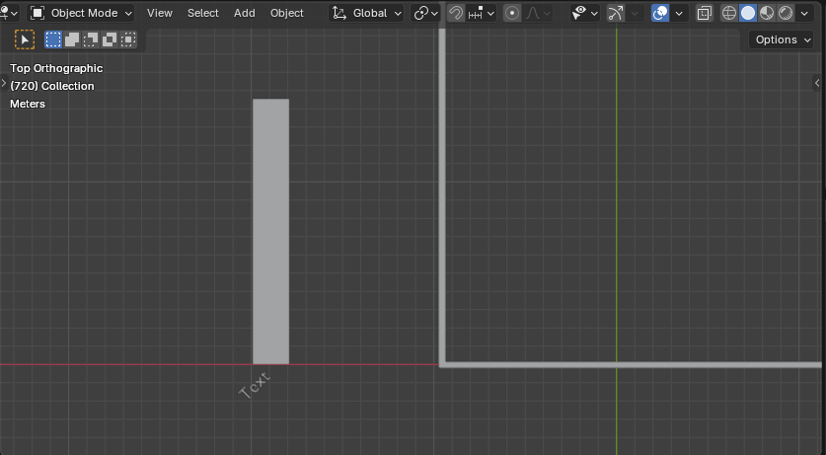
Below is the code for generating the bars in the graph:-

create-graph.py
code-snippets/create-graph.py

Bars generated
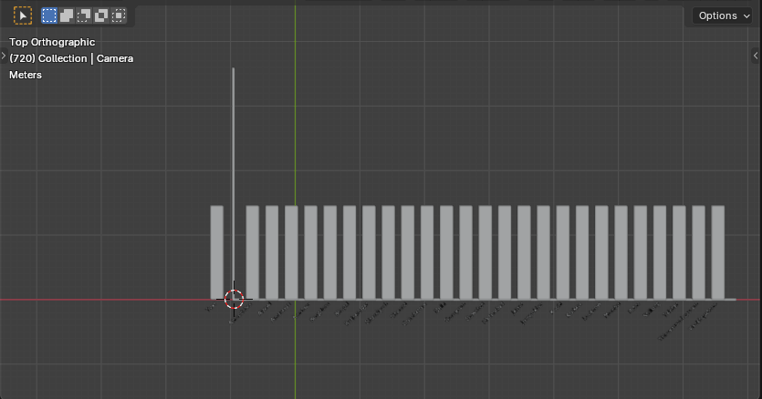

Animating the graph
Once the scene is created, we can now tell blender to animate the graph based on the values in the cleaned up csv file:-

animate-graph.py
code-snippets/anim_graph.py
Once the keyframes have been set, you can preview the animation in the 3d view.

Graph with keyframes generated
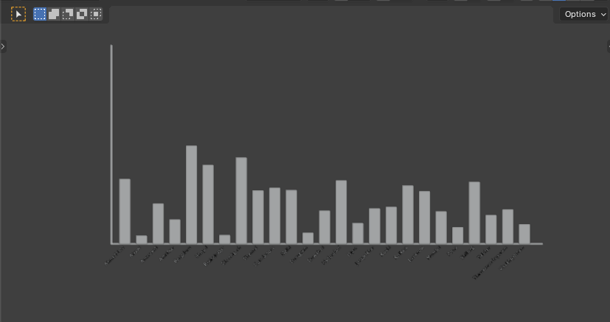
As a bonus, using the timeline, you can also clean up the keyframes or even better,
add / duplicate a set of keyframes to fill in the gaps to simulate data cleanup.

Rendering the graph
Its time to add colours to the bars and render the video. Use emission shaders (pure light, no shadows) with clever driver magic to animate the color of the bars. That, and a complementary background color for the sky adds to the perfection.

Your graph should look something like this
