Description of the scripts

*‘threeApproachComparison_v4.py’* and *‘threeApproachVisualization_v0.py’*

Code flow diagram for *‘threeApproachComparison_v4.py’:*

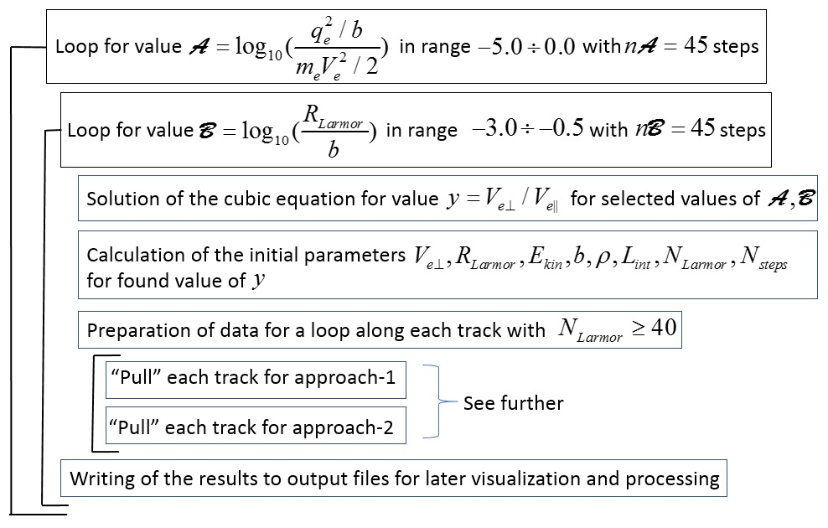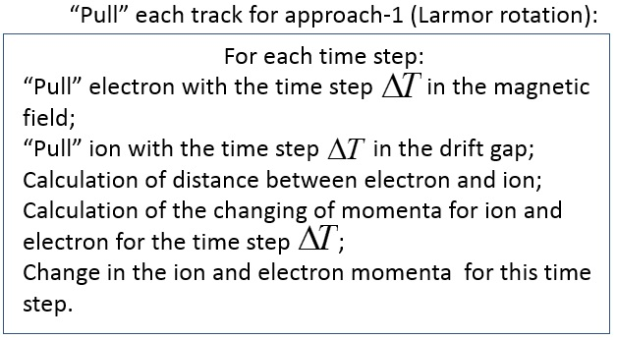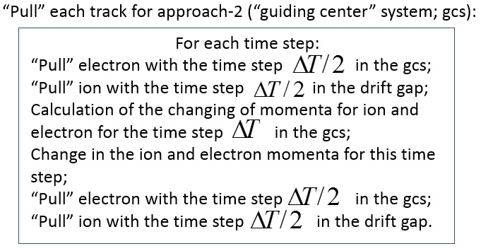

The comparison of the first track for each approach are shown in the next figures.

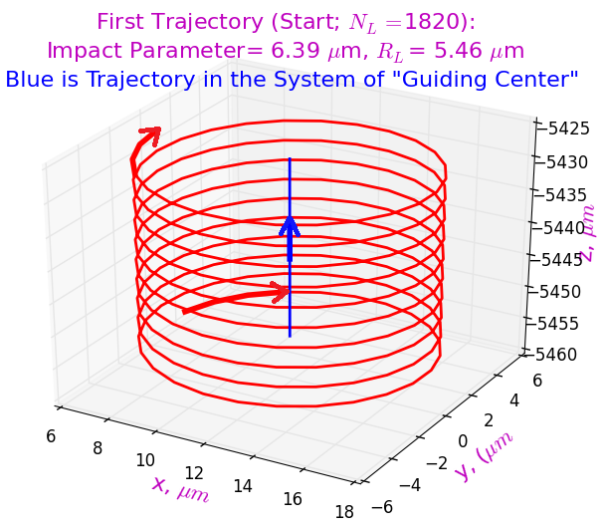 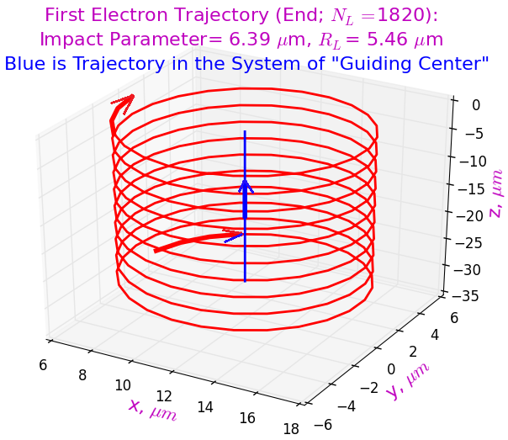

Beginning and end of electron’s trajectory for both approaches.

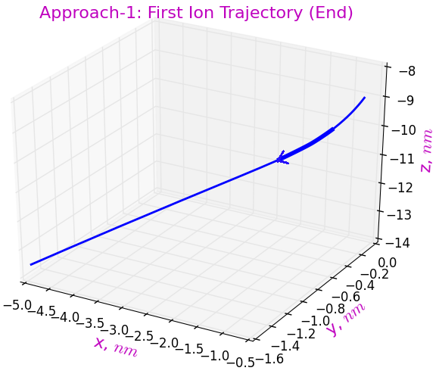 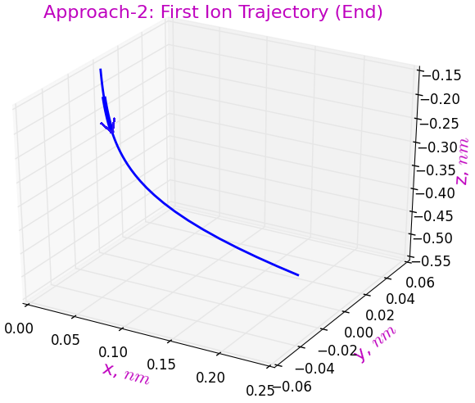

End of ion’s trajectory for both approaches.

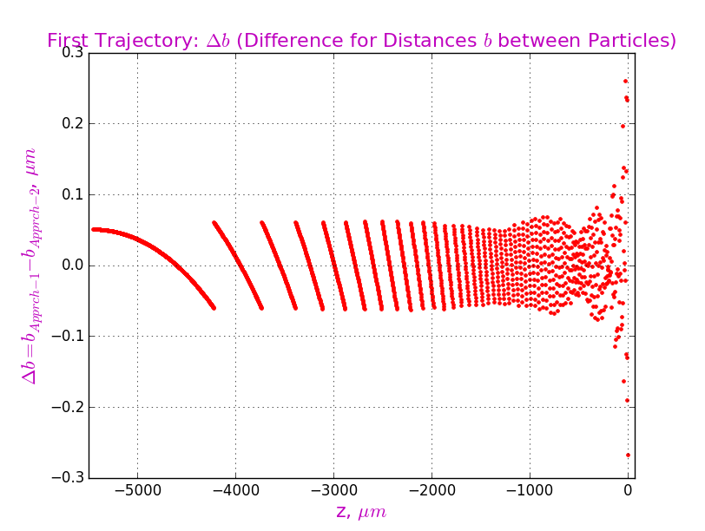

Last figure shows a very small (less then part of micron) difference in the approaches in determining the distance between the electron and the ion during their mutual movement past each other. So, the comparison of transferred momenta for both approaches is entirely acceptable.

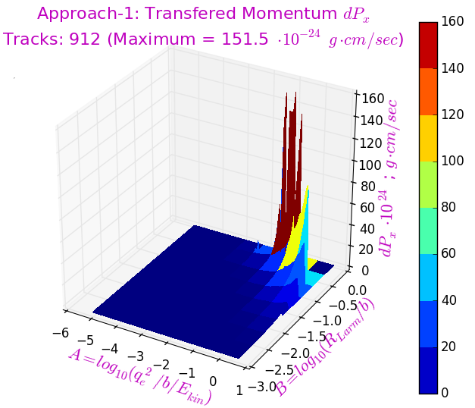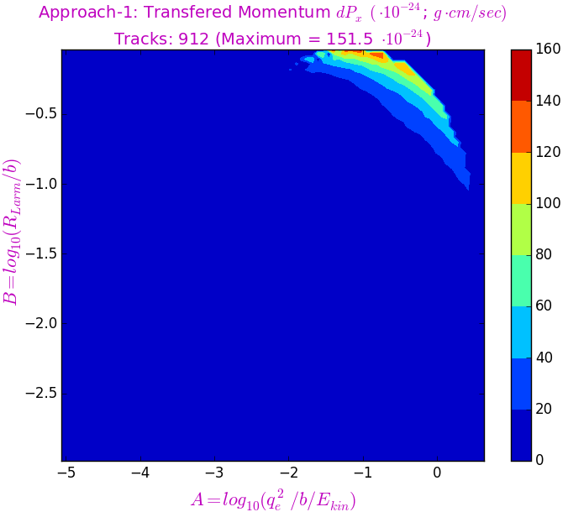

Transferred Momentum : Approach-1.

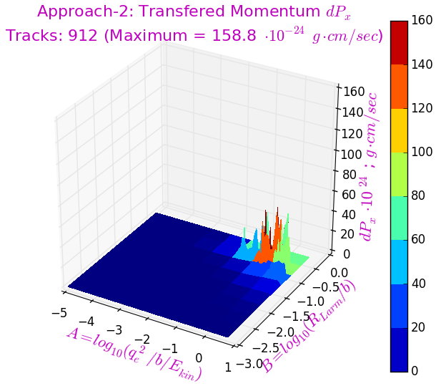 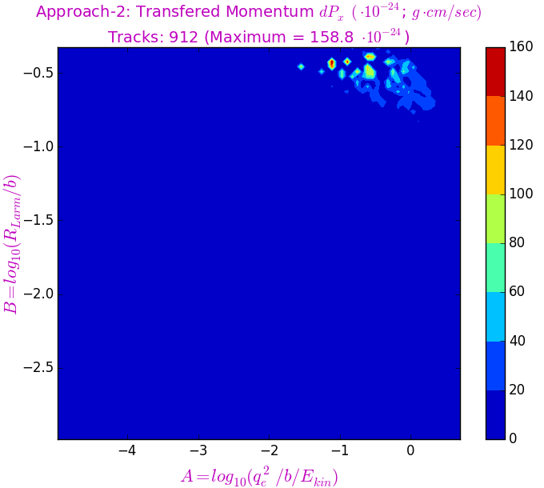

Transferred Momentum : Approach-2.

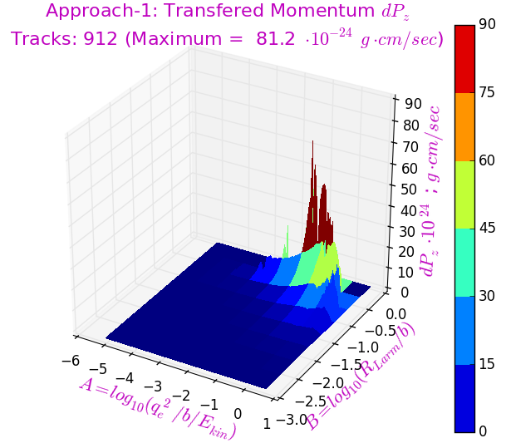 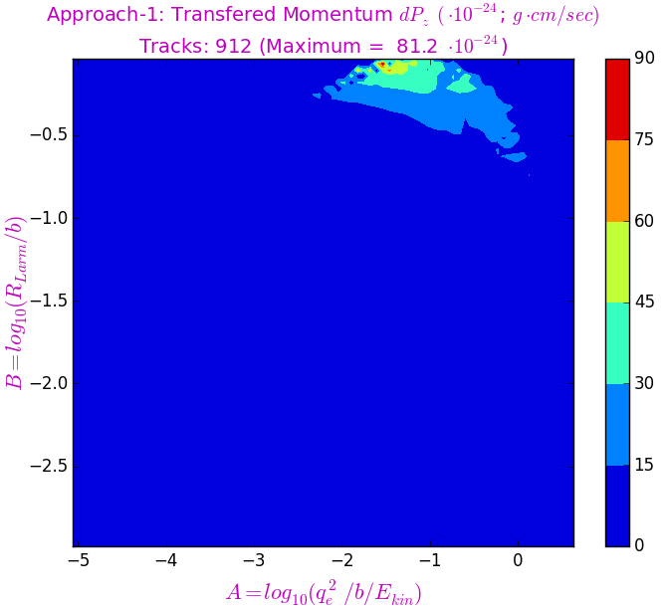

Transferred Momentum : Approach-1.

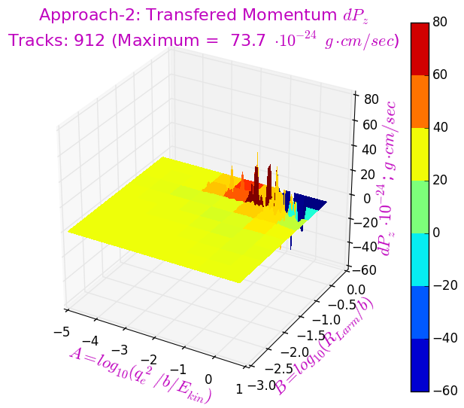 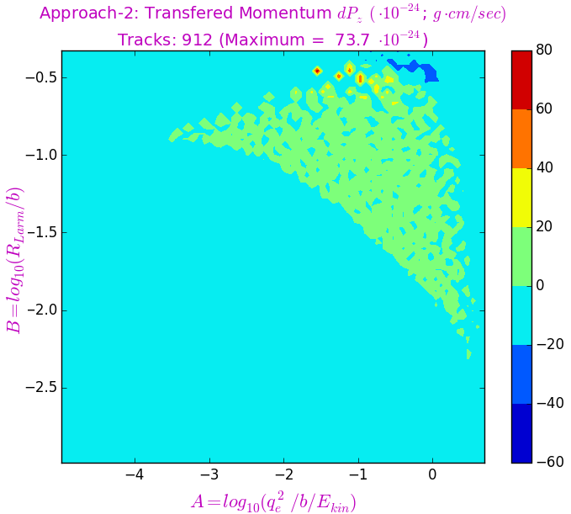

Transferred Momentum : Approach-2.

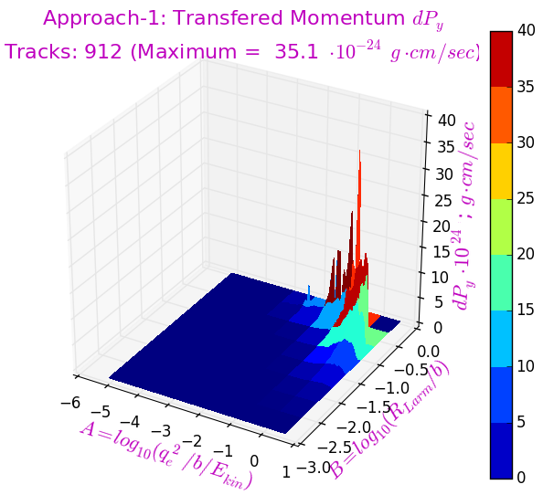 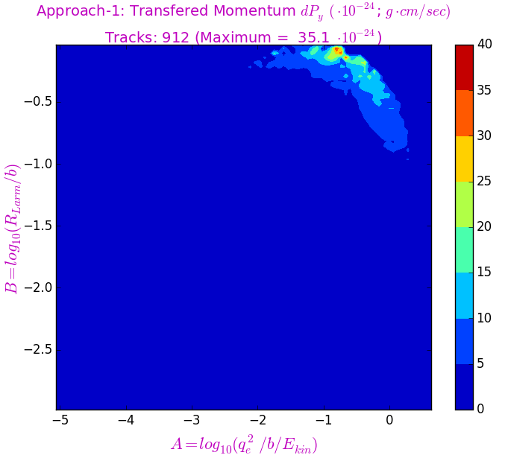

Transferred Momentum : Approach-1.