When writing the program, the following technical problems should be solved: the choice of the minimum  and maximum  values of the impact parameter , the choice of the length  of the interaction region of the particles, and the choice of the range of possible transverse electron velocities  that determine the Larmor radius .

These problems are solved as follows.

1. For  the value of the critical distance  is taken, for which in the equation of transverse motion of the electron



the first term on the right-hand side is much larger than the second (that is, the acceleration of the electron due to the Lorentz force is significantly larger than the acceleration due to the Coulomb interaction with the ion). This condition leads to the following value :



For a magnetic field of order  we have .

1. Maximal impact parameter  is determined by the relation of several quantities: a radius  of neutralization, Debye screening radius  and a "flight radius"  (characterized by the time of flight through the region of the interaction of an electron with an ion beam):



It has been shown that for reasonable parameters of the beams and the cooling system, the maximum possible value of  can be chosen as .

c) Initially, the choice of  was based on the relationship between the selected value of the impact parameter  and the angle characterizing the interaction region of the particles:



In this case, both relatively small (of the order of tens) and very significant (of the order of several thousand) values can be obtained for the number  of Larmor revolutions of the electron during the time of its interaction with the ion (the longitudinal velocity  of the electron determines the time  of interaction between the particles) :



In fact, it is more correct to choose  as a quantity , because in this case the distance between the particles  is such that the ion field is screened and there is no interaction between the particles already.

1. The choice of the range of possible values of  is determined by the fact that the magnetized electron during its Larmor rotation, when passing by beside the ion, should not approach to it on a distance less than , i.e.



1. Based on the above considerations, the following algorithm in the script threeApproachesComparison_v2.py was used: the impact parameter  changed uniformly in  steps from the minimum value  to the maximum value ; For each of these values , the value of the maximum transverse velocity  of the electron is determined by the fact that the electron remains magnetized, i.e. it did not come near to the ion a distance less than :



Further, for each value , the current value of the transverse velocity of the electron varied uniformly in  steps:



and thus, the current value  of the Larmor radius was determined. The initial point of the electron trajectory has the following coordinates:



Such a choice of parameters of the beam particles determines their trajectory and, therefore, a possible range of values of the parameters  and  for which the momentum's transfer of the particle can be found:



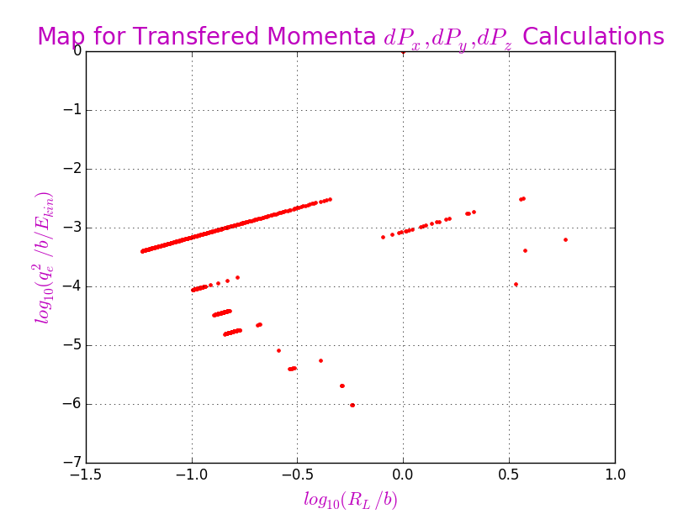Fig. on the left shows that with such a choice of the initial point of the trajectory it is possible to analyze the momentum transfer only for very limited ranges of parameters  and  ("pieces" of straight lines describing individual particle trajectories).

1. For a more "dense" filling of the parameter plane  and  one can use the following method. The choice of any point on this plane uniquely determines the value of the transverse velocity :



Thus, passing to the dimensionless transverse velocity , we obtain for it the following reduced cubic equation:



With such coefficients () of the equation, it has one real positive root, equal to

 where 

which "restores" the current value of the following values (the transverse velocity , the Larmor radius , the maximal distance between particles , the impact parameter , the length of the interaction , and the number  of Larmor turns during the interaction):



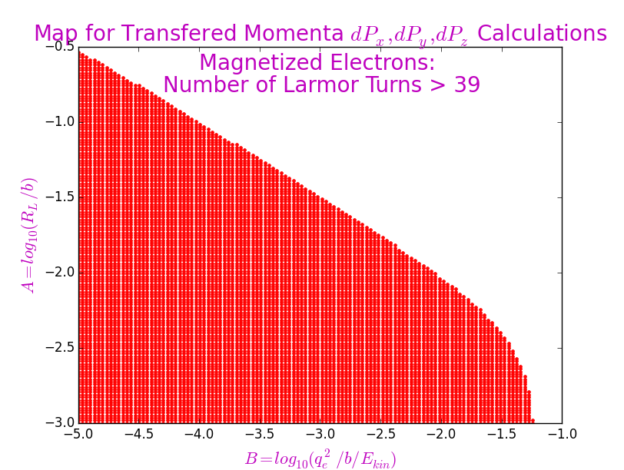Fig. on the left shows the range of parameters  and  in which the electrons are magnetized and has enough number of Larmor revolutions  so that in subsequent calculations it is possible to make the averaging over a certain selected number of the turns.

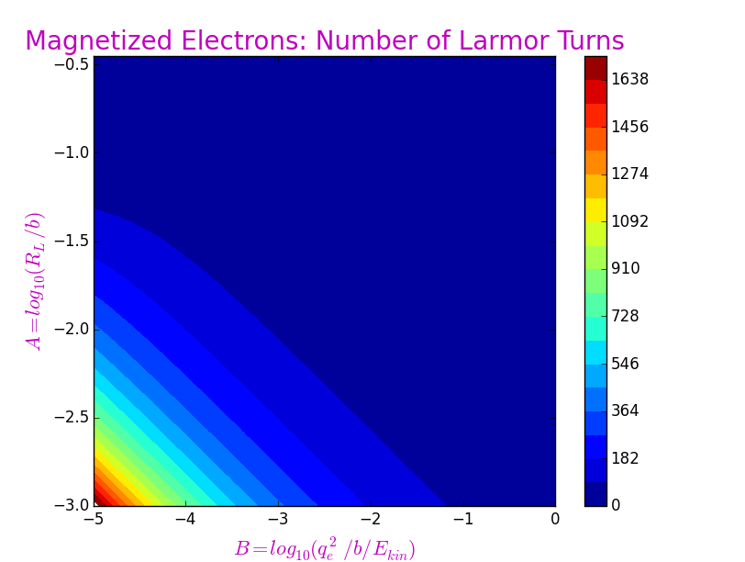Next Fig. shows a "map" the distribution of the number of the Larmor turns in the plane of parameters  and . The map shows that a very large number of turns  fall only on a small area (the lower left corner of the figure) of the parameters.

Based on the above considerations, this new approach was used in the script threeApproachesComparison_v3.py.