Repository:

My Documents/GitHub/radiasoft/rsfriction/examples/MCOOL/all_docs/my_docs

This doc: Description_threeApproachesComparison_v6.docx

Description of the scripts *‘threeApproachComparison_v6.py’*

Let us recall some problems which were solved before writing this code to compare different approaches to calculating the momentum transfer in the collision of electrons with ions (there are *notesToChoiceCodeParameters.docx*, *mapOfMaximalImpactParameter.docx* and *kinematicOfMagnetizedElectron.do*cx in github repository).

The first of these is how to form a set of the tracks of the electrons so that you have enough data to construct a 3D surface of the investigated parameters in a coordinate system of :



As shown in *notesToChoiceCodeParameters.docx*, a simple "scan" over the range of possible values of the impact parameter  and electron velocities  gave a set of separate tracks on the plane with large "voids" between them. In the same document, another approach is proposed. The "scanning" of the "coordinates"  in the required intervals with a sufficiently small step determines the initial value of the relative transverse velocity  of the electron, as the solution of the corresponding cubic equation:

 where 

Further, for the longitudinal electron velocity everywhere a following constant value is used:  (it corresponds to the temperature .

The found value of the relative transverse velocity  is used for sequential calculation of the initial parameters  of the track:



Requirement of the “magnetization” of the electron’s motion is to satisfy the following condition:  or . This condition works in used interval for : .

A close up of a logo

Description generated with very high confidenceNext step consists in selection of the length  of the longitudinal part of the electron's track at which its interaction with the ion is essential for calculating of the transferred momentum. Since the ion field is screened at distances greater than some , the total distance between the particles should not exceed this value, so that

.

As shown in the *mapOfMaximalImpactparameter.docx*, as a reasonable estimate for  is the value . Left Figure (HalfLengthTrack-1_v6-fig20.jpg) shows the “map” of length .

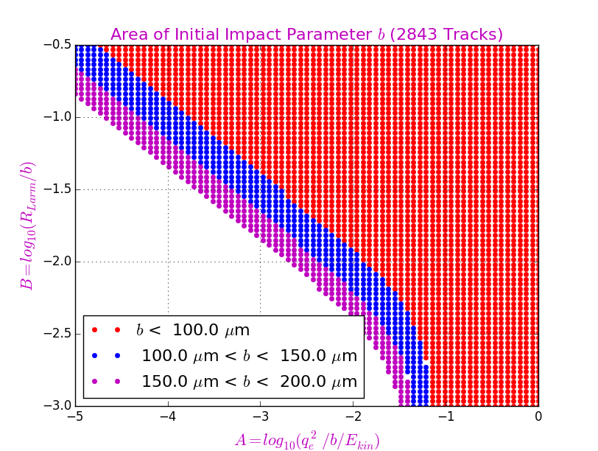The tracks of the electron with the selected initial values of the parameters  leave a "trace" on the plane . If the steps for scanning the quantities  are chosen sufficiently small, then the admissible tracks (with ) fill the plane sufficiently tightly, which is confirmed by the left Figure (in this Figure ). This Figure (areaInitialImpactParameter_v6-fig10.jpg) shows a line separating the regions of "allowable" and impossible A close up of a logo

Description generated with high confidencetrajectories: with , the permissible tracks are shown in red. This boundary line will be used later in other graphs.

Founded parameters  define the values of the number of Larmor rotations  during the time of flight of an electron by the distance . This number is shown on left Figure (larmorNumbers-1_v6-fig30.jpg).

Code flow diagram for *‘threeApproachComparison_v6.py’* is as follows:

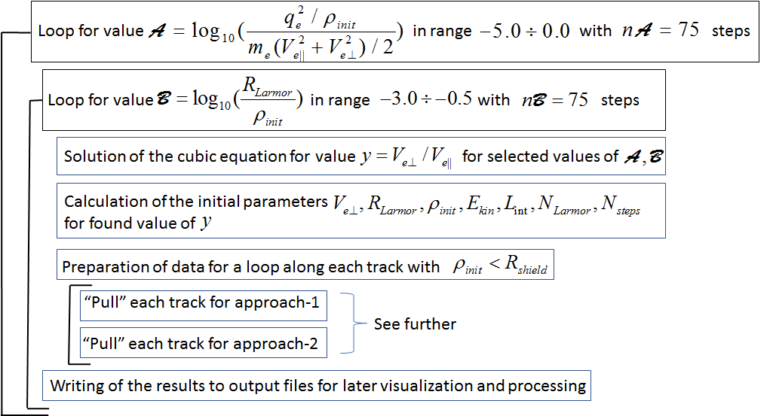

Here:

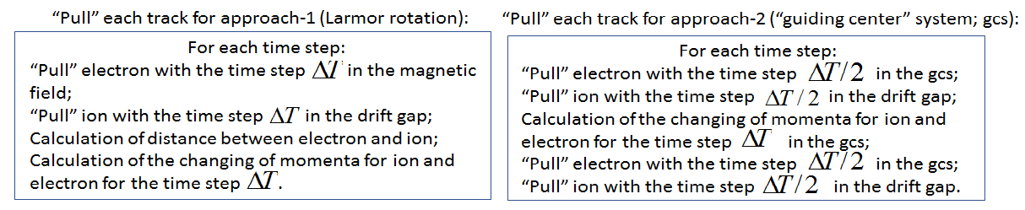

Different results of the code running are presented in the next set of Figures.

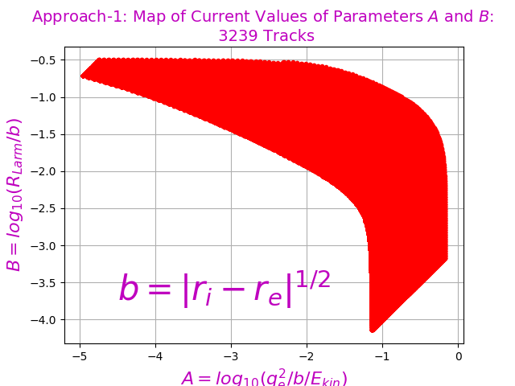 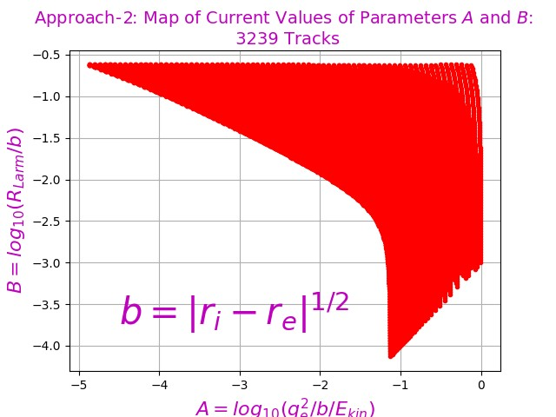

“Filling” of the plane (mapParametersAandB-A1_v6-fig110.jpg and mapParametersAandB-A2_v6-fig115.jpg).

A close up of text on a white background

Description generated with high confidence 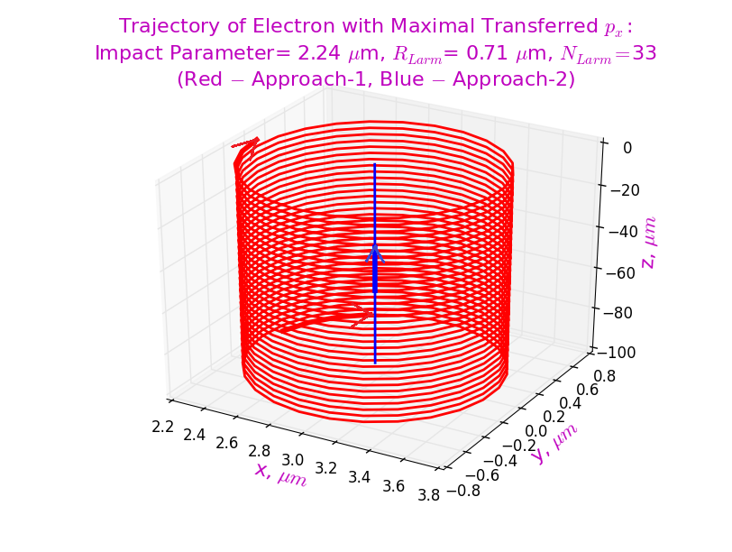

Some electron’s trajectories for both approaches (firstTrack3D-A1andA2_v6-fig440.jpg and trackWithMaxDpx3D-A1andA2_v6-fig445.jpg).

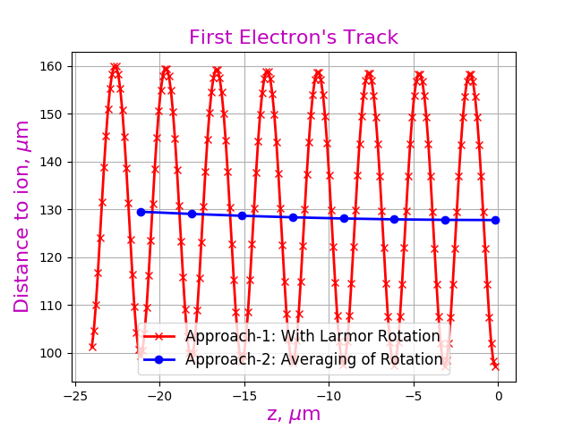A close up of a mans face

Description generated with high confidence

Trajectories of the electron for both approaches (left) and difference for distance between electron and ion for both approach (right) (distanceToIon-A1andA2_v6-fig450.jpg and differenceDistancetoIon-A1andA2_v6-fig325.jpg).

Last Figure show a small difference in the approaches in determining the distance between the electron and the ion during their mutual movement past each other. So, the comparison of transferred momenta for both approaches is entirely acceptable.

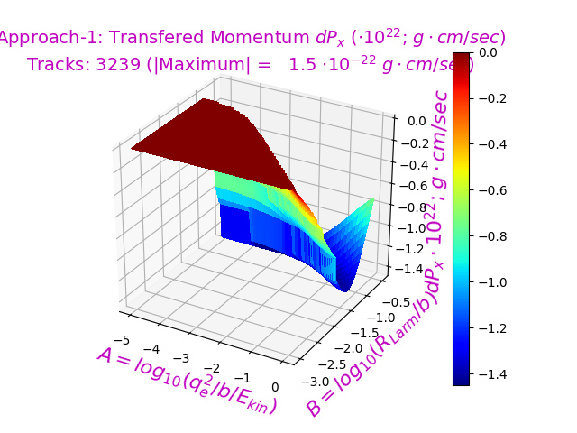 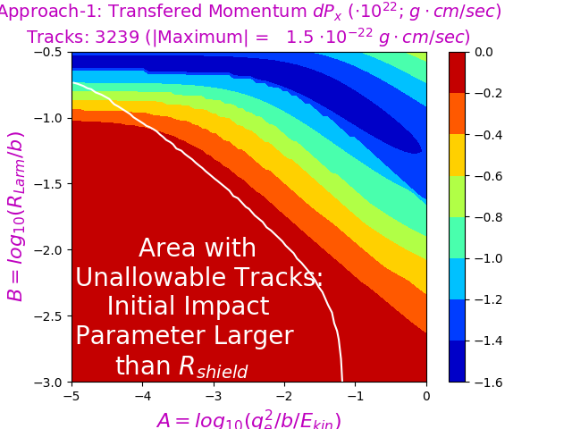

Transferred Momentum : Approach-1 (dpxSurf-A1_v6-fig240.jpg and dpxMap-A1_v6-fig245.jpg).

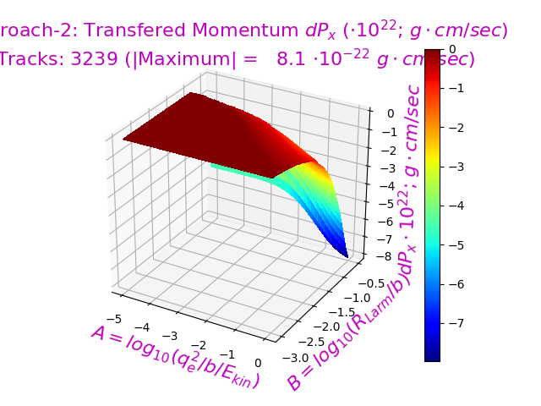 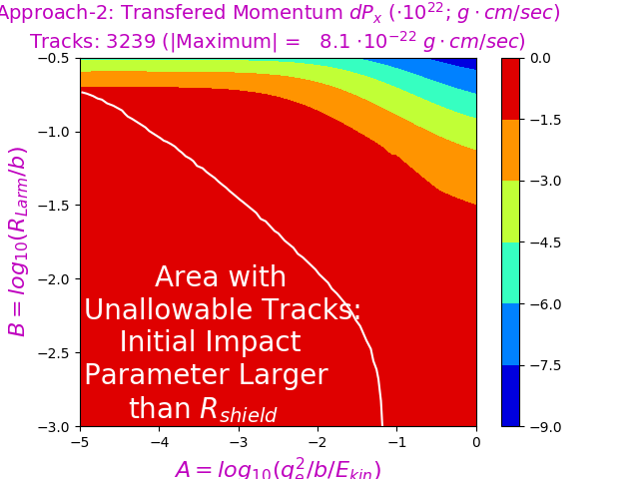

Transferred Momentum : Approach-2 (dpxSurf-A2_v6-fig340.jpg and dpxMap-A2_v6-fig345.jpg).

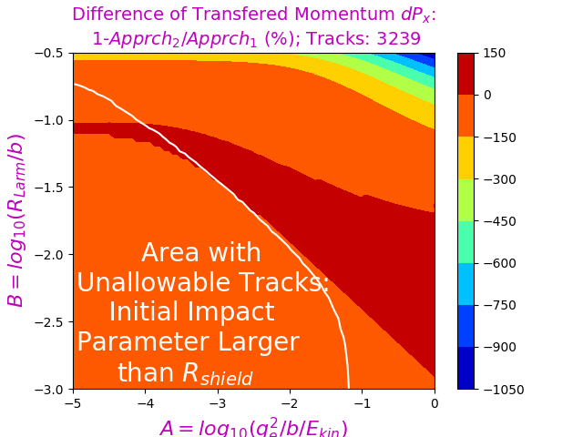 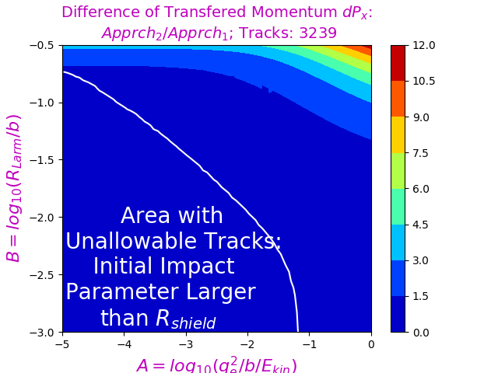

Difference of Transferred Momentum : Approaches 1 (dpxMap-A2minusA1_v6-fig545.jpg) and 2 (dpxMap-A2divideA1_v6-fig546.jpg).

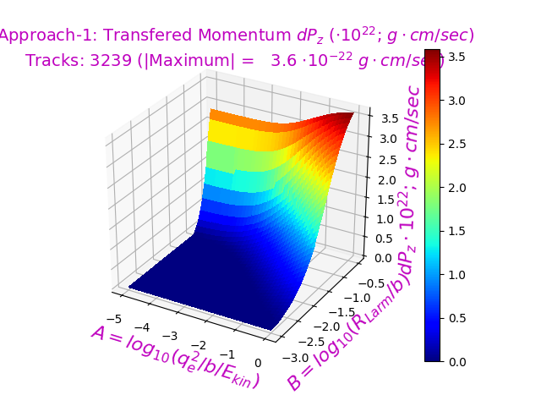 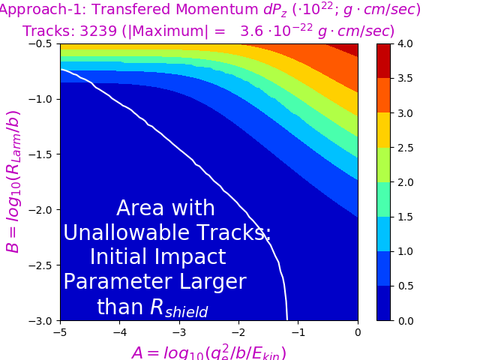

Transferred Momentum : Approach-1 (dpzSurf-A1_v6-fig260.jpg and dpzMap-A1_v6-fig265.jpg).

A close up of text on a white background

Description generated with high confidenceA screenshot of a cell phone

Description generated with high confidence

Transferred Momentum : Approach-2 (dpzSurf-A2_v6-fig360.jpg and dpzMap-A2_v6-fig365.jpg).

A screenshot of a cell phone

Description generated with high confidence A close up of text on a white background

Description generated with high confidence

Difference of Transferred Momentum : Approaches 1 (dpzMap-A2minusA1_v6-fig555.jpg) and 2 (dpzMap-A2divideA1_v6-fig556.jpg).

A close up of a logo

Description generated with high confidence A screenshot of a cell phone

Description generated with high confidence

Transferred Momentum : Approach-3 (dpxSurf-A3_v6-fig540.jpg and dpxMap-A3_v6-fig845.jpg).

A close up of text on a white background

Description generated with high confidence A screenshot of a cell phone

Description generated with high confidence

Difference of Transferred Momentum : Approaches 3 (dpxMap-A3minusA1_v6-fig745.jpg) and 1 (dpxMap-A3divideA1_v6-fig746.jpg).

A screenshot of a cell phone

Description generated with high confidence

Difference of Transferred Momentum : Approaches 3 and 2 (dpxMap-A3minusA2_v6-fig1745.jpg).

A close up of a logo

Description generated with high confidence A screenshot of a cell phone

Description generated with high confidence

Transferred Momentum : Approach-3 (dpzSurf-A3_v6-fig860.jpg and dpzMap-A3_v6-fig865.jpg).

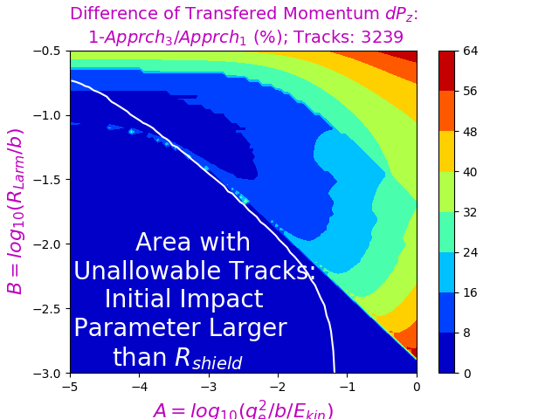 A screenshot of a cell phone

Description generated with high confidence

Difference of Transferred Momentum : Approaches 3 with 1 and 2 (dpzMap-A3minusA1_v6-fig755.jpg and dpzMap-A3minusA2_v6-fig1755.jpg).

A close up of a logo

Description generated with high confidence A screenshot of a cell phone

Description generated with high confidence

Transferred Momentum : Approach-1 (dpySurf-A1_v6-fig250.jpg and dpyMap-A1_v6-fig255.jpg).

Attention! Transferred momentum  for approach-2 equals zero!