Repository:

My Documents/GitHub/radiasoft/rsfriction/examples/MCOOL/all_docs/my_docs

This doc: RS_DynFriction_2019-01-23.docx

Title: “Dynamic friction in magnetized electron coolers for relativistic beams”

Authors: Ilya Pogorelov, David Bruhwiler, Stephen Webb, Yury Eidelman & Dan Abell

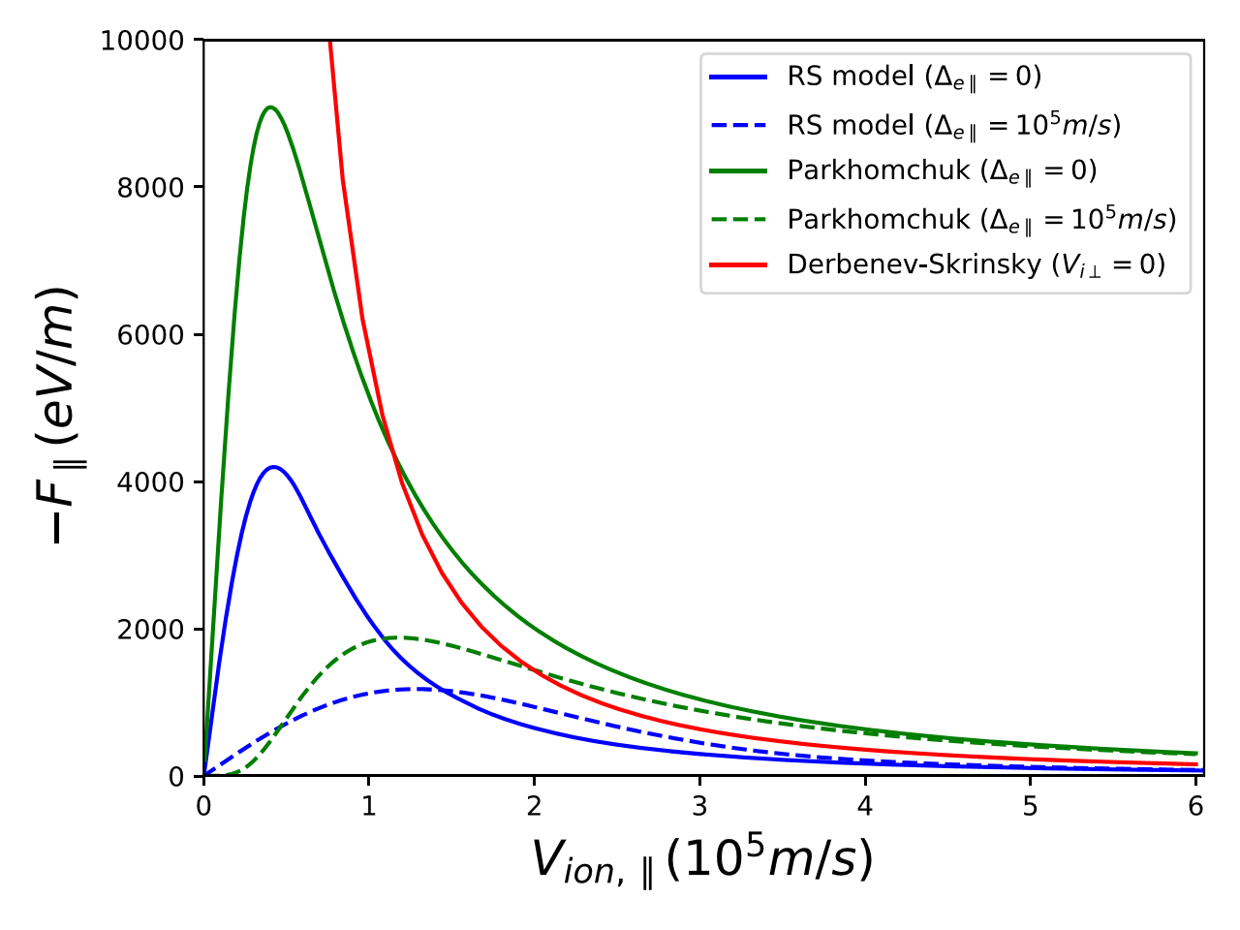Dynamic friction is the key physics underlying electron cooling. Fast, accurate simulations of magnetized dynamic friction are essential for improved understanding and to reduce risk and cost in electron-ion collider (EIC) designs. To date, EIC studies of electron cooling have used parametric [[1]] and approximate analytical [[2],[3]] models for magnetized dynamic friction, which were developed for low-energy cooling systems and do not include the finite time effects that are important at relativistic energies [[4],[5]]. As part of a DOE Office of Science, Office of Nuclear Physics, Phase 2 SBIR project [[6]], we have developed a fundamentally new and improved treatment of longitudinal magnetized dynamic friction.

Figure 1. Comparison of the longitudinal magnetized friction force [eV/m], calculated via various methods, is shown for both cold and warm electrons. “RS model” (blue lines) is the new semi-analytic model developed at RadiaSoft. “Parkhomchuk” (green lines) is from Ref. [1]. “Derbenev-Skrinsky” (red line) is from Refs. [2,3]. The symbol e|| represents the RMS longitudinal electron temperature. The ion is Au+79 with zero transverse velocity and with longitudinal velocity specified by the horizontal axis. The magnetic field is that of an idealized 5 T solenoid (i.e. purely longitudinal). In the lab frame, we have 100 GeV/nucleon ions co-propagating with ~55 MeV electrons. In the beam frame, with nonrelativistic particle motion, the interaction time is 0.4 ns, which corresponds to approximately 640 gyration periods and 0.16 of a plasma period. These parameters are taken from Fedotov *et al*. [7,8].

Figure 1 shows a comparison of the new “RS model” developed at RadiaSoft with previous work. The figure caption summarizes the parameter regime that we are using, which is taken from Fedotov *et al*. [[7],[8]]. These parameters are relevant to EIC designs. In particular, the interaction time (in the beam frame of the two highly relativistic particle bunches) is only 16% of a plasma period. This is in contrast to existing coolers, with nonrelativistic beams, where the interaction time is long compared to a plasma period.

There are 3 important points to take away from Figure 1:

1. All 5 curves scale as the inverse square of Vion,|| for Vion,|| >> e||, as is required by theory. However, it’s notable that the two “RS model” curves agree well with the asymptotic theory of Refs. [2,3], as they should in this regime. In contrast, the parametric Parkhomchuk model is roughly 2x larger in this regime.
2. The “RS model” and Parkhomchuk curves are linear in Vion,|| for Vion,|| << e||, as is required by theory, even for the singular case of e|| = 0 (i.e. cold electrons). In contrast, the asymptotic calculation of Refs. [2,3] is singular as Vion,|| 🡪 0.
3. For finite values of e|| (i.e. warm electrons), the “RS model” (blue dashed curve) shows consistently lower friction force than the Parkhomchuk model (green dashed curve). This is consistent with previous “brute force” simulations using the Vorpal code – see Figure 5 of Ref. [8]. This is important for EIC cooling studies, because it strongly implies that the Parkhomchuk model may be overly optimistic for proposed high-energy cooling systems.

Hence, we have strong indications that the RS model is correct; however, additional testing and benchmarking is required. In the sections below, we describe how the RS model is calculated and list plans for future work.

**Overview of the Technical Approach**

The RS model takes advantage of the Larmor radius being small compared to the distance between the ion and the electrons, and follows the motion of only the guiding center of the electron trajectories. Hamiltonian perturbation theory is used to remove obtain the guiding center equations of motion and average away the fast time scale associated with Larmor oscillations [[9]]. To first order in this perturbation theory, if the ion has zero transverse velocity, the impact parameter D of an electron remains constant. Hence, the longitudinal motion of each electron takes place in an effective 1D potential:

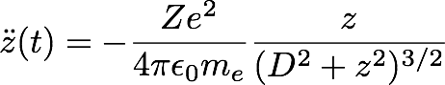 Eq. (1)

where the z axis is aligned with the magnetic field lines, the ion is at the origin of the coordinate system, and the impact parameter D is, of course, different for different electrons.

Although we can write the expressions for the individual trajectories in quadrature or in terms of elliptic functions (and perhaps use some asymptotic approximations of those), a closed-form analytic expression for the force on the ion (correctly averaged over the electron phase space distribution) may not exist. Hence, we pursue a semi-analytic solution, which requires numerical integration of Eq. (1). It is important to note that the strongest contributions to the friction force come from electrons that are “close” to the ion, both in configuration space and in velocity, and that many of these electrons follow oscillatory orbits with varying periods, resulting in a certain amount of phase mixing. Hence, correct averaging over electron phase space requires accurate sampling and numerical integration of Eq. (1) for the correct interaction time.

The initial conditions of the electrons are evolved with a 2nd order symplectic integrator and the force on the ion is computed, electron-by-electron, as a function of time. Before computing the ensemble average of the longitudinal force on the ion, it is important to subtract, particle-by-particle, the longitudinal force on the ion that would come from the same electron moving on the unperturbed trajectory. This negates the purely numerical bulk force on the ion whose origin is in the finite extent of the distribution of macroparticles used in the simulation. The ensemble average then gives the total longitudinal dynamical friction force on the ion as a function of time.

This procedure yields the longitudinal magnetized friction force on the ion as a function of longitudinal ion velocity, assuming zero electron temperature. All that is needed to compute the corresponding force on the ion when the longitudinal electron temperature is non-zero, is to compute the convolution with the electron distribution density in the longitudinal velocity space. The convolution acting essentially as a smoothing filter, the peak friction force produced by a warm electron beam is somewhat smaller than in the cold electron case, and is shifted to the right, with the details depending on the rms electron velocity spread – this is seen in blue curves of Figure 1.

**Future Work**

TBD…

**Acknowledgments**

The authors acknowledge helpful scientific discussions with Alexei Fedotov, Alexey Burov and Valeri Lebedev. This material is based upon work supported by the U.S. Department of Energy, Office of Science, Office of Nuclear Physics SBIR program under Award Number DE-SC0015212.

**Technical References**

1. . V.V. Parkhomchuk, “New insights in the theory of electron cooling,” *Nucl. Instrum. Methods Phys. Res.* **A441**, 9 (2000).
2. . Ya.S. Derbenev and A. Skrinsky, “The effect of an accompanying magnetic field on electron cooling,” *Part. Acc.* **8**, 235 (1978).
3. . Ya.S. Derbenev and A.N. Skrinsky, *Fiz. Plazmy* **4**, 492 (1978) [*Sov. J. Plasma Phys.* **4**, 273 (1978)].
4. . G.I. Bell, D.L. Bruhwiler, A. Fedotov, A. Sobol, R.S. Busby, P. Stoltz, D.T. Abell, P. Messmer, I. Ben-Zvi and V. Litvinenko, “Simulating the dynamical friction force on ions due to a briefly co-propagating electron beam,” *J. Comput. Phys.* **227**, 8714 (2008).
5. . D.L. Bruhwiler, “Simulating single-pass dynamics for relativistic electron cooling,” in *ICFA Beam Dynamics Newsletter* **65**, “Beam Cooling II,” eds. Y. Zhang & W. Chou, Section 2.10, pp. 116-127 (2014); <http://icfa-usa.jlab.org/archive/newsletter/icfa_bd_nl_65.pdf>
6. . Phase II SBIR project, “Dynamic friction in magnetized electron coolers for relativistic beams,” with principal investigator Dr. David Bruhwiler of RadiaSoft LLC, with program manager Dr. Michelle Shinn, with period of performance 2017-04-10 through 2019-04-09, funded under award # DE-SC0015212.
7. . A.V. Fedotov, D.L. Bruhwiler and A.O. Sidorin, Proc. of HB2006, “Analysis of the magnetized friction force,” WEAY04 (2006).
8. . A.V. Fedotov, D.L. Bruhwiler *et al*., “Numerical study of the magnetized friction force,” Phys. Rev. ST Accel. Beams **9**, 074401 (2006).
9. . D.L. Bruhwiler and S.D. Webb, “New algorithm for dynamical friction of ions in a magnetized electron beam,” Proc. Advanced Accel. Concepts Workshop, AIP Conf. Proc. **1812**, 050006 (2017); <https://doi.org/10.1063/1.4975867>