**Magnetized Electron: Kinematic of the Motion**

Equation of motion for electron in the homogeneous magnetic field  and central Coulomb field of the ion:

 (1)

where  is a radius-vector of electron and  is a vector from ion to electron. Let’s divide the velocity of electron into two parts:  is the perpendicular to the direction of magnetic field, i.e.  is the radius-vector from the center of the electron Larmor circle with radius  ( is the electron Larmor frequency) to the electron and along the magnetic field.

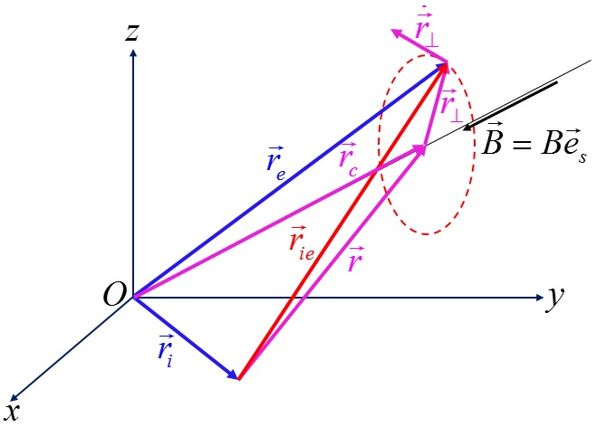Obvious relations between vectors (see Figure on the left) are

 (2)

and allow rewriting equation (1):

 (3)

Equation (3b) allows finding the following condition for magnetization of electron motion: The first term in the right part of the equation must be much more than second one:

 (4)

where it was taken into account that the “reduced mass”  practically equals . Dependence of  on magnetic field is shown in the next Figure.

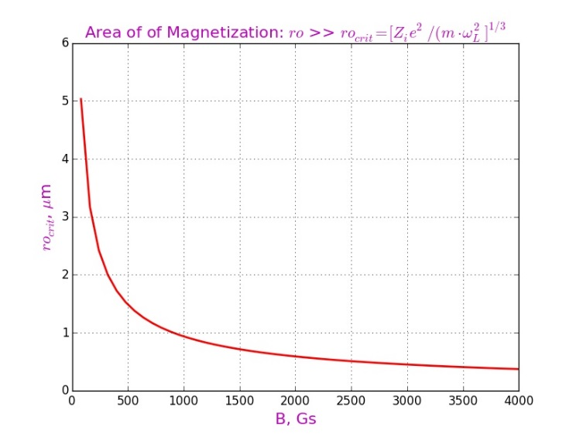The displacement of the magnetized electron across the magnetic field as will be seen from the following is very small. It means that the distance  between ion and electron practically does not change during the collision, i.e. , where  is the impact parameter. Thus, the equation (3b) can be rewritten as follows:

 (5)

On the plane perpendicular to the magnetic field with the origin at the center of the Larmor circle, it is convenient to introduce a local coordinate system , so that  and instead of the equation (5) the following system is in place:

 (6)

where

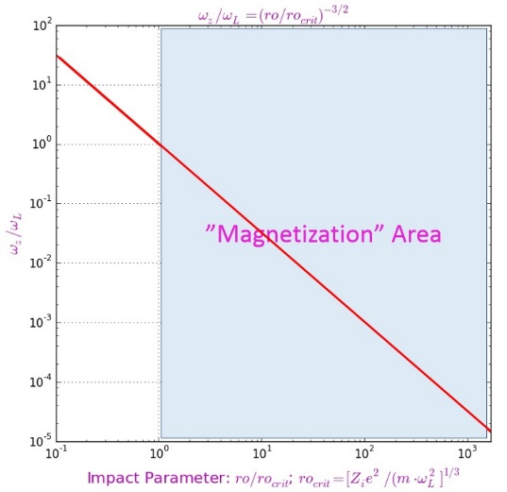 (7)

On the left Figure is shown the dependence of ratio  on the ratio .

System (6) is solved easily, using the substitution . Then the equation for  is as follows:

 (8a)

and has an obvious solution:

 (8b)

with

 (9)

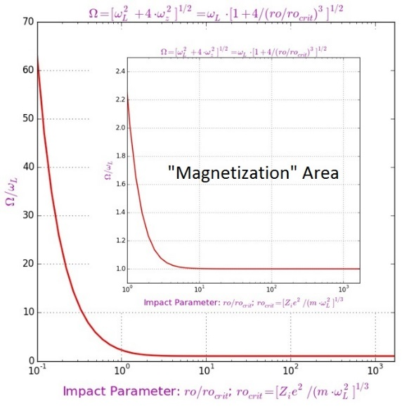Here .

Relative frequencies depend on ratio  only. On the left Figure shows that the frequency  varies insignificantly and is close to the Larmor frequency inside the area of magnetization (). Relations (9) indicate a similar behavior of the frequencies .

Expressions (8) give the following solution of the equations (6):

 (10)

It is convenient to rewrite this solution in the dimensionless variables  and, without violating the generality of the examination, to use the following initial conditions:

. (11)

Then expressions (10) have a very simple form:

 (12)

Relations (12) show very strong dependence of the trajectory of electron on the level of its magnetizing because all frequencies  depend on the value of ratio .

A picture containing text, map

Description generated with very high confidenceIn accordance with the condition (4) the electron is magnetized  while in the opposite case the influence of the ion field will be significant.

The left Figure with first turn for the different value of  confirms that. It shows that the trajectory of a no magnetized electron significantly differs from Larmor circle. Nevertheless, this difference rapidly decreases with an increase in the impact parameter.

The next set of Figures demonstrates the first nine turns for different values of , i.e. out of the “magnetization” area. Each turn is shown in a different color: red, blue, magenta, green and black for turns 1 – 5 correspondingly and the same sequence of colors with sign “X” for turns 6 – 9.

A close up of a map

Description generated with high confidenceA picture containing map, text

Description generated with high confidence

A close up of a logo

Description generated with high confidence A close up of a piece of paper

Description generated with high confidence

It is can be find that the radial of trajectory  oscillates in a time:

. (13)

This behavior is shown in the following Figures for the impact parameter values used in the previous Figures.

A close up of a map

Description generated with very high confidenceA close up of a map

Description generated with very high confidence

it is more convenient to describe these results if recall that the trajectory of an electron looks like a helical line with variable radius, for which from expression (13) follows that  and . So, let define the dimensionless “radial width” of trajectory as , then, with considering the expression (7), one can find that

 (14)

A close up of a map

Description generated with high confidenceDependence of “radial width” on  is shown in the left Figure. It is seen that already for  this “width” becomes less the 10% only.

**Conclusion:**

Links for Figures.

picturesKME/magnetizationArea_vs_Bfield_fig5kme.jpg

picturesKME/omegaZ_vs_impctPrmtr_fig30kme.jpg

picturesKME/torusRadius_vs_impctPrmtr_fig35kme.jp

picturesKME/Omega_vs_impctPrmtr_fig50kme.jpg

picturesKME/Omega_vs_impctPrmtr_zoom_fig55kme.jpg

picturesKME/relativeR_vs_time_fig70kme.jpg

picturesKME/relativeR_vs_time_spec_fig75kme.jpg

picturesKME/nineTurns_relRo_49e-5_fig80kme.jpg

picturesKME/nineTurns_relRo_62e-5_fig90kme.jpg

picturesKME/nineTurns_relRo_103e-5_fig100kme.jpg

picturesKME/nineTurns_relRo_29e-3_fig110kme.jpg

picturesKME/fistTurn_different-relRo_fig120kme.jpg