**Comparison of Two Approaches**

Let us compare two approaches to calculate the transferring of momentum to ion from the magnetized electron during flighting of this electron near the ion.

Approach “Guiding Center” (“GC”)

In this case the motion of the electron is described in guiding center system using set of variables  instead “standard” set . These sets are related to the following expressions :



and vice versa:



In these expressions the Larmor radius  and Larmor frequency  are used.

It can be shown [1] that when an electron flies past an ion, the next pulse is transmitted to the latter:



with



It is convenient to define the value



and then



If initially the fixed ion is at the origin (), then these expressions take the following form:



where



Approach “Magnus Expansion” (“ME”)

Two 6-vectors  and  of the canonic dynamic variables for ion and electron are correspondingly



Lie transformation  is as follows ([1] or formulae (12) from [2]):



with Lie operator  defined by “perturbed” Hamiltonian



Perturbed Hamiltonian  is a function of main parameters characterized the trajectories of the particles (only  for electron and only  for ion correspondingly):



Map  is defined as Lie transformation:



where matrix  is defined by unperturbed Hamiltonian :



This Hamiltonian gives the following equations of the motion:





and not necessary present the changing of the phase , because it does not affect the dynamics of the ion-electron scattering event.

As is known, the Lie transformation of an arbitrary function  of dynamic variables is characterized by the following property of similarity:



So, the Lie transformation  is described by two independent matrices  and  with the following nonzero entries:



It means that



In this expression the velocities  and the coordinate  are used.

Let’s input the following values:





and then (with ) Hamiltonians  and  are equal to



Let’s rearrange the components of the vectors  and , forming two new canonically conjugate vectors  and :

,

where the index  for variables  takes on values . Then



It means that in according with the definition of the Lie operator through the Poison brackets one has



To receive the previous relation two additional 6-vectors were defined: “zero”-vector  and “unit”-vector .

So, for change  and  of 6-vectors  and  are as follows:



Therefore, recalling the expression for the Hamiltonian , we obtain





And, quite similarly, one finds that





Shift of the ion due to interaction with the electron is as follows:



or



where



Quite similarly





and





The changing of the electron parameters due to a collision with the ion can be found as



Further





and at last



In the case of the unmovable ion is at the origin () these expressions take the following form:



where



and



with



*Some numerical evaluations (for “ME” approach)*

Let the unmovable ion be at the origin, i.e. . For the electrons having the same longitudinal velocity , determined by the longitudinal temperature [3,4], one has . For magnetic field  the Larmor frequency equals  so . Numerical simulation for the electrons with transversal temperature  [3,4] gave the following values:



Then it is clear, that the second and third terms under root for the quantity  are much smaller than the first term, so that



Further





and since the first term in the expression for  is much greater than the second, then . It means that



In a completely analogous way we obtain that



and





But  and , then



So, in the approximation under consideration for “ME” approach we have the following result:



i.e. expressions for  are in coincide with corresponding values from approach “GC” (!). It is clearly, that in numerical simulations the calculated values of transferred momenta will differ for both approaches due to real differences between pairs  and ,  and ,  and , and so on.

Comparison of Simulations of Transferred Momenta

To compare the transferred momenta of both approaches the following initial data were used:

* unmovable ion placed at the origin, i.e. ;
* electrons have the same rms longitudinal velocity , determined by the longitudinal temperature [3,4], ;
* magnetic field ;
* electrons have the same rms transversal velocity , determined by the transversal temperature  [3,4] .

Next two pictures show results for transferred momentum in different presentations: in percentages and in logarithmic scale.

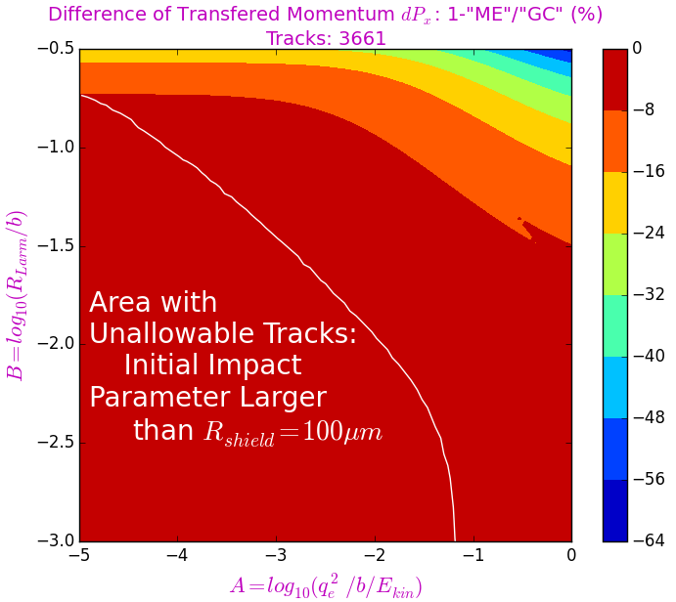 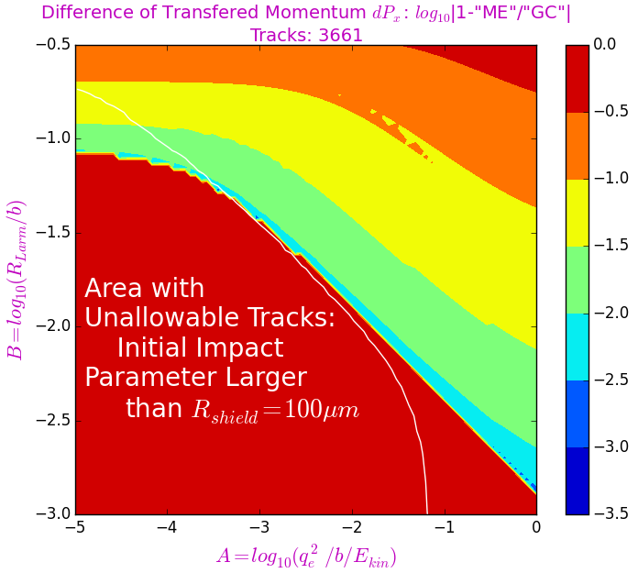

Figure 1.

Next figures show the analogous results for transferred momentum .

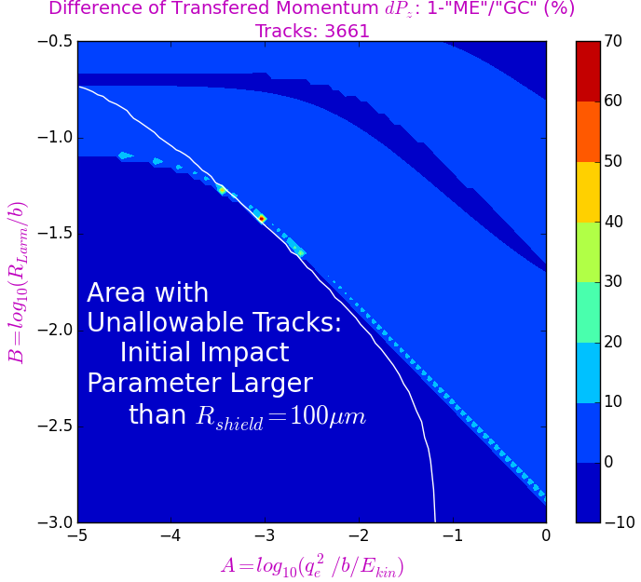 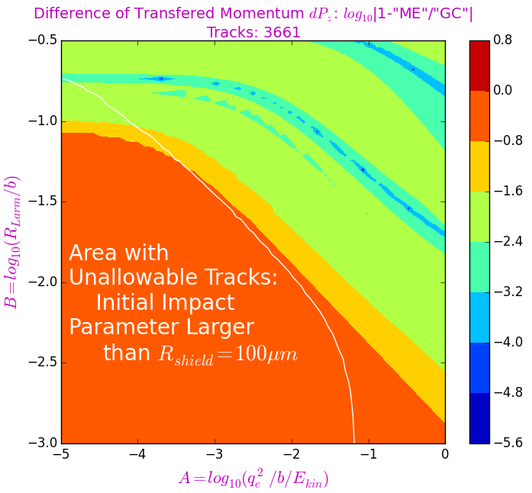

Figure 2.

Friction Forces (“GC” Approach)

The following numerical values were used for main parameters:

* magnetic field  and critical value of the impact parameter, starting from which, the electron can be regarded as magnetized (formula [(4) from [8]) – ;
* Longitudinal temperature of the electrons –  rms longitudinal velocity – ;
* Longitudinal temperature of the electrons – rms transversal velocity – ;
* Density of the electrons in the beam –  electron plasma frequency –  and radius of a sphere containing sufficiently large number of electron () to screen the electric field of the ion (formula (4) from [7]) – 
* Kinetic energy of the electrons –  the stream velocity for electrons and ions – ;
* Length of the cooler – .

The parameters which depend on ion velocity:

* Debye radius (formula (3.12) from [6]) – ;
* One of the possible values of the screening radius of the electric field of the ion (formula (1.33) from [5]) –

;

* Screening radius of the electric field of the ion (formula (1.33) from [5]) – ;
* Radius, starting from which, the electric field of the ion acts on an electron (formula (1.34) from [5]) –

;

* Boundary value of the impact parameter separating the regions of the "fast" and adiabatic interaction between electron and ion (formula (1.34) from [5]) – . In the first case, the Larmor rotation of the electron does not affect its interaction with the ion; in the second case, the electron performs only a few Larmor turns during its interaction with the ion.

A close up of a map

Description generated with very high confidence

Figure 3.

A close up of a map

Description generated with very high confidence

Figure 4.

A close up of a map

Description generated with very high confidence

Figure 5.

A close up of a map

Description generated with high confidence

Figure 6.



A close up of a map

Description generated with high confidence

Figure 7.

A close up of a map

Description generated with high confidence

Figure 8.

Friction Forces:



A close up of a map

Description generated with high confidence

Figure 9.

Link for Figures.

PC Folder: eidelyur/My Documents/GitGub/radiasoft/rsfriction/examples

/MCOOL/threeApproaxhes_v6/pictures/

1. dpxMap-A3toA2_v6fig845.png, dpxMap-A3toA2_v6fig850.png
2. dpzMap-A3toA2_v6fig855.png, dpzMap-A3toA2_v6fig860.png

PC Folder: eidelyur/My Documents/GitGub/radiasoft/rsfriction/examples

/MCOOL/classic_magnus_approaches/picturesCMA/

1. rDebye_rLikeDebye_rPass_fog209cma.jpg
2. rMax_fig215cma.jpg
3. rMin_fig307cma.jpg
4. rFast_rCrit_fig305cma.jpg
5. impctPrmtr_fig3151cma.jpg
6. coulombLgrthm_lin_fig3201.jpg
7. trnsvFF_longFF_fig595.jpg

References.

1. David Bruhwiler, Stephen Webb, Dan T. Abell. *A New Approach to Calculating Dynamical Friction for Magnetized Electron Cooling.* Presented at HSC Section Meeting, CERN (Hadron Synchrotron Collective effects), 24 April 2017, Geneva.
2. D.L. Bruhwiler, S.D. Webb. *New Algorithm for Dynamical Friction of Ions in a Magnetized Electron Beam.* AIP Conf. Proc. **1812**, 050006 (2017). <http://aip.scitation.org/doi/abs/10.1063/1.4975867>.
3. G.I. Budker et al. *Experimental Investigation of the Electron Cooling*. Preprint BINP 76-33, Novosibirsk, 1976 (In Russian);
4. N.S. Dikansky et al. *Influence of the Sign of the Ion Charge on the Friction Force for Electron Cooling*. Preprint BINP 87-102, Novosibirsk, 1987.
5. I.N. Meshkov*. Electron Cooling: Status and Perspectives*. Phys. Part. Nucl. **25 (6)** (1994) 631-661. (In Russian: Fiz. Elem. Chastits and Atom. Yadra **25** (1994) 1487).
6. I. Meshkov, A. Sidorin, A. Smirnov, G. Trubnikov., A. Fedotov. *Physics Guide of BETACOOL Code. Version 1.1.* C-A/AP/#262, November 2006, Brookhaven National Laboratory, Upton.
7. I.N. Meshkov*. Electron Cooling – the First 30 Years and Thereafter*. NIM **A391** (1997) 1-11.
8. Yu.I. Eidelman. *Magnetized Electron: Kinematic of Motion*. 2018, unpublished.