ЗАДАНИЕ 2

|  |
| --- |
|  |
|  |
|  |
|  |
|  |
|  |

ЗАДАНИЕ 3

|  |  |
| --- | --- |
|  | |
|  | |
|  | |
|  | |
|  | |
|  | |
|  |
|  | |
|  | |
|  | |

ЗАДАНИЕ 5

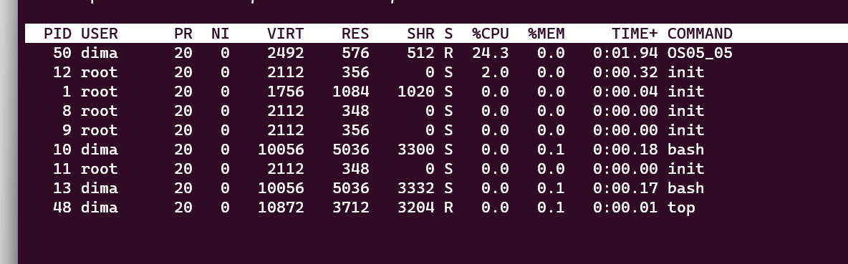

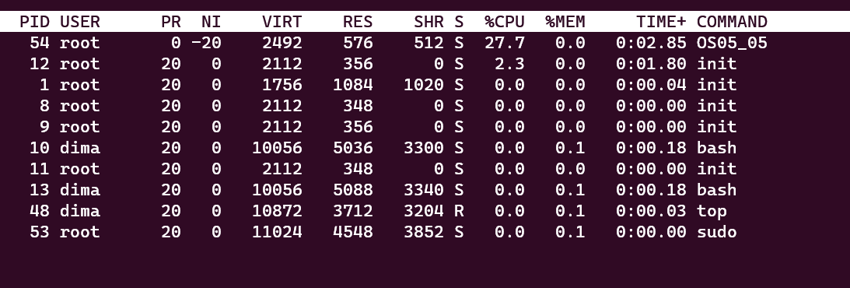

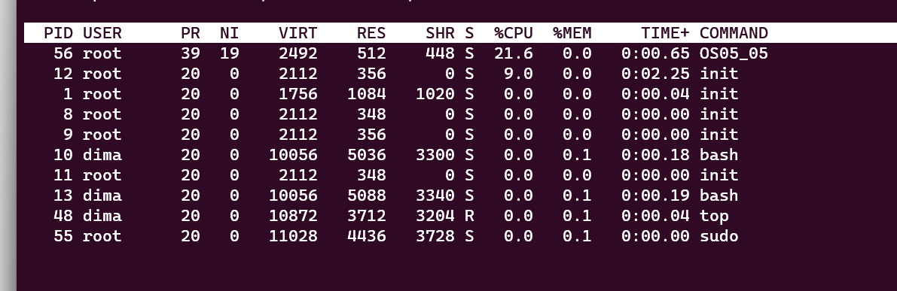

ЗАДАНИЕ 7

