Stock Return Analysis of Coca-Cola:
Implications for EMH
Introduction
This analysis examines the stock price performance of Coca-Cola Company (NYSE: KO), a leading multinational beverage corporation. Coca-Cola's stock price is of significant interest to investors due to its status as an iconic brand and its global market presence. The analysis will be conducted using the Box-Jenkins modelling process. The Efficient Market Hypothesis will also be examined in this case.
Literature Review
A brief literature review was conducted to lay a foundation for the analysis of the stock price. The first paper observed was a study by Burton G. Malkiel, outlining the EMH and its main criticisms. The EMH has 3 possible forms: weak, semi-strong and strong. The weak form says that all past prices and volumes are reflected in the current price, making technical analysis of the stock irrelevant. The semi-strong form suggests that all publicly available information is immediately reflected in the stock price, rendering fundamental analysis ineffective. The strong form asserts that all information even insider is already reflected in the price. Some of the main criticisms highlighted argue that markets aren’t always efficient, because of things such as investor irrationality (also herd mentality), market frictions, information asymmetry and momentum. Moreover, certain market phenomena are hard to explain with EMH, such as bubbles and crashes, which seem to defy the theorem.
The second paper reviewed was a short study by Zhaoyu Zhang on the stock price of several consumer staples companies, such as Coca-Cola. It found that the industry has steady growth even during economic uncertainty, maintaining a steady trend. This is because the growth rates are predictable, and the consumer base is stable. The strength of these stocks is obviously, stability, dividend growth and low volatility, while the weakness is slow growth. These factors are important to this paper, because the reduced volatility makes the stock ideal for ARIMAX modelling, since stationarity can be achieved with more ease compared to more volatile stocks.
Data
The data used was obtained from Yahoo Finance. Several time series were used spanning from 2014 to 2019. First is Coca-Cola itself, the time series of interest, while the others are to be used as external regressors. The second was the S&P500, the benchmark index of the USA, although Coca-Cola has a Beta of 0.57 (current data), indicating only a moderate co-movement with the market, it is still a strong predictor. The third was Pepsi one of Coca-Cola’s main rivals, also a comparable company with a similar market cap and product variety (their goods can also be viewed as substitutes by some), meaning that their movement could be a significant predictor. The fourth and final one was the price of sugar, which is one of the main manufacturing inputs used by the company.
Analysis
You can see from the log returns of the stocks in Figure 1 that Coca-Cola, as mentioned before has a strong co-movement with Pepsi and a moderate one with the S&P500. Based on the trends it has the least co-movement with the price of sugar.
A Johansen test was used on Coca-Cola and Pepsi, for which the null hypothesis that there isn’t a cointegrating vector could not be rejected, telling us that although there seems to be some relation, there is no long-term relationship between the stock prices.
Next to conduct the Box-Jenkins modelling, the data had to be made stationary, this could be achieved using the log difference of the stock prices, this is also the generally approved method of examining stocks. Using the Dickey-Fuller test, it could be concluded that the log of the data is stationary after its first difference.
Moving onto the modelling, the ACF and PACF of the stationary Coca-Cola data was observed (see Figure 2) showing a negative relationship between the current price and return/shocks of the period 2 before, making AR(2), MA(2) models and their combination as possible models. Using information criterion the AR(2) model emerged as the strongest, following this the external regressors were applied. Sugar made almost no improvement on the model, this is probably because the input is still cheap compared to the other costs the company incurs, such as labour. The S&P500 index made some improvements on model performance, for obvious reasons, most stocks will have some form of co-movement with the overall market. The inclusion of Pepsi in the model made the most significant difference, since, as mentioned before, the companies are quite similar and face the market challenges. Using Pepsi and the S&P500 didn’t improve the results compared to the model with only Pepsi, the reason for this is that Pepsi, with a similar beta of 0.52 already captures the overall market trends, making the S&P as a regressor irrelevant.
So the final model of modelling the log returns of Coca-Cola is an ARIMAX(2,1,0) with the log difference of Pepsi as an external regressor. On this robustness checks were made, using the Breusch-Godfrey test, the models’ residuals were found to be white noise. Though using the Shapiro-Wilk test, the residuals of the model did not follow the normal distribution, indicating that the model might not be appropriate for forecasting, but this is common for financial time series data, since they often exhibit fat tails, skewness, and heteroskedasticity, which can all lead to this issue. You can see the model results in Table 1, the first lag has a positive effect, the second has a negative, while the log difference of Pepsi also has a positive effect on the log return of Coca-Cola. The ability of the model was still assessed with forecasting and in-sample fit. The model performance can be seen in Figure 3, with its Forecasting ability seen in Figure 4. From the forecast we can see that the values do not differ that much from the actual values, also somewhat following the trend, indicating that the forecast is adequate.
Implications for EMH
The simple autoregressive model is essentially the testing of the weak form of the EMH. Since past returns should already be incorporated and should not have an effect of future returns. The AR(2) models performance contradicts this assumption, showing that the price 2 periods before does have an effect on the current price. Using external regressors the semi-strong version can be partially tested, with model performance again showing some probable violation of the hypothesis. These indicate that there may be more predictability in the stock price beyond what is already incorporated into it. However, the fact that the residuals of the models do not follow normal distribution puts these findings into question.
Conclusion
In conclusion, the analysis of Coca-Cola Company's stock price performance using Box-Jenkins modelling techniques provides insights into the potential deviations from the Efficient Market Hypothesis (EMH). While the ARIMAX(2,1,0) model with the log difference of Pepsi as an external regressor shows some predictability in stock price movements, the non-normality of the residuals raises questions about the robustness of these findings.
Appendix
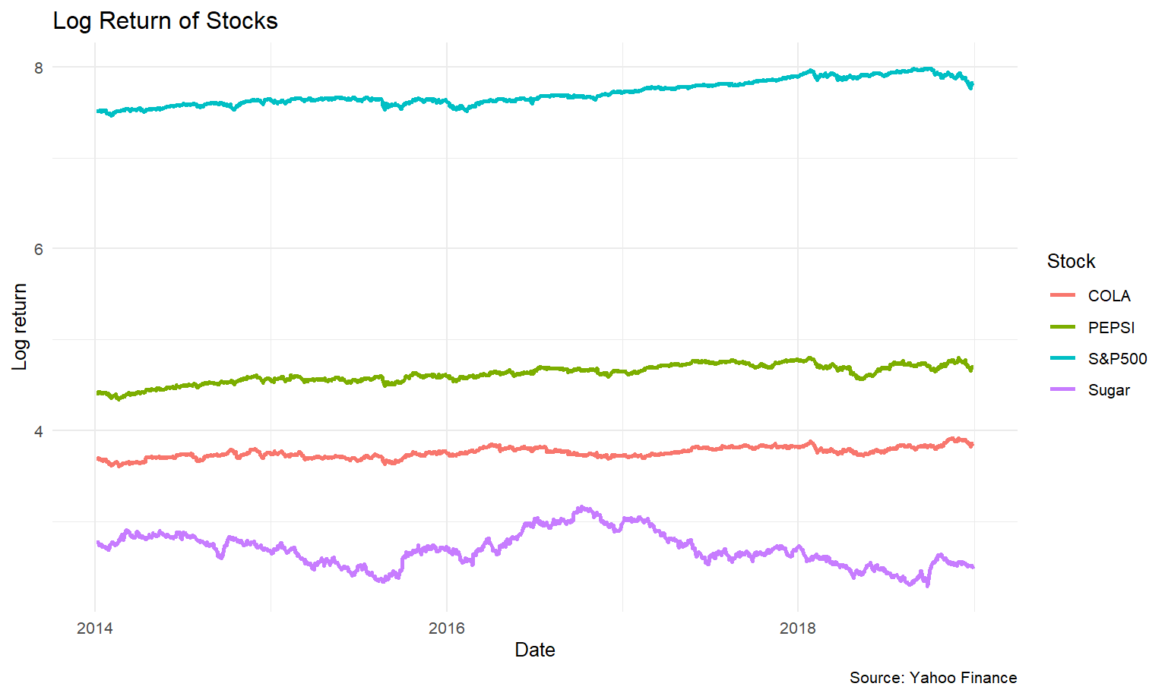
Figure 1
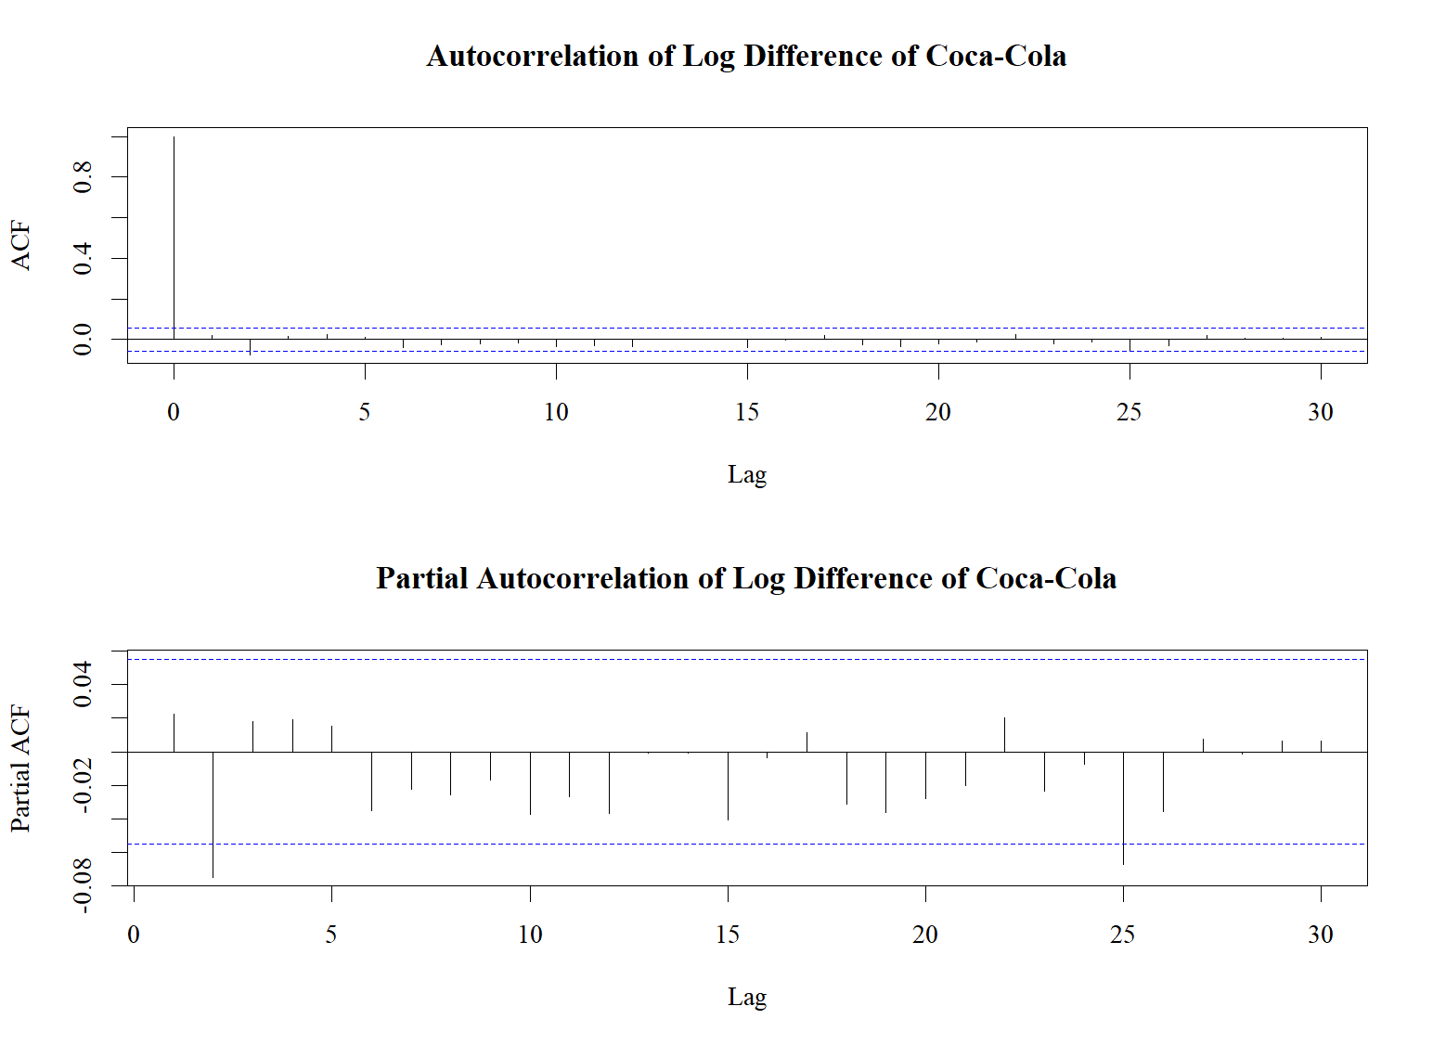
Figure 2
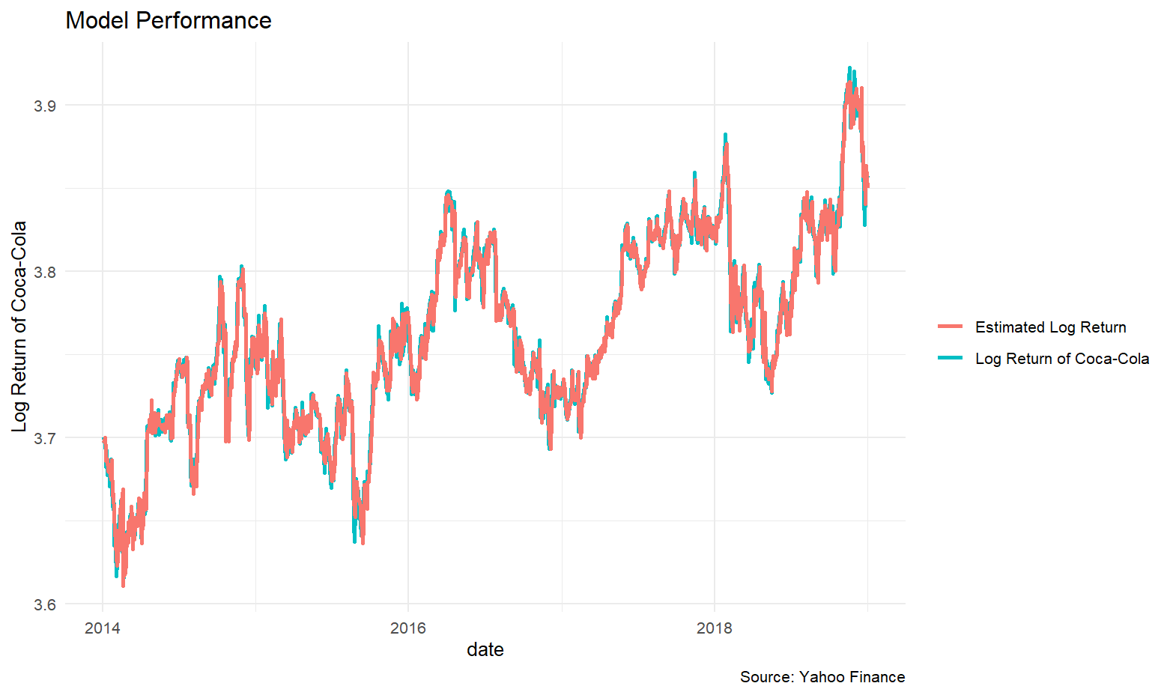
Figure 3

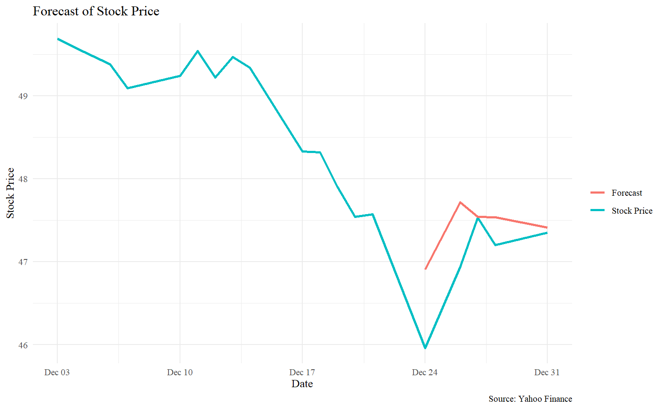
Figure 4
Table 1
Name | Coefficient (S.E.)
Ar1 | 0.171  (0.028)
Ar2 | -0.079  (0.028)
Xreg | 0.325  (0.015)
RMSE | 0.007

Data Source: Yahoo Finance
Bibliography:
Zhang, Z. (2022). Stocks Analysis in Consumer Staples Sector: Case of Johnson & Johnson, Procter & Gamble and Coca-Cola. Highlights in Business, Economics and Management, 4, 205-209.
Malkiel, B. G. (2003). The efficient market hypothesis and its critics. Journal of economic perspectives, 17(1), 59-82.

