Contents

1 Introduction 2

2 Bulk Clearing Process 2

2.1 Select Bulk Process Module 3

2.2 Fill the form 3

2.3 Redirected to Result Page 6

2.4 excel result 7

2.4.1 Result sheet 8

2.4.2 Rejected sheet 10

2.4.3 Settlement Not Done sheet 11

2.4.4 Requests Already Saved sheet 12

3 Log Page 12

3.1 Log Page Capabilities 14

3.1.1 Update 14

3.1.2 Search 14

3.1.3 Paginate 15

3.1.4 Export 15

# Introduction

The YCO (Yegna Clearing Optimizer) web app is designed to help to trace transactions. It accepts an excel file and provide excel file as a result, including all status of the requested transactions.

# Bulk Clearing Process

The bulk clearing module helps the user to process multiple transactions in the excel file.

<http://192.168.15.155:8000/>

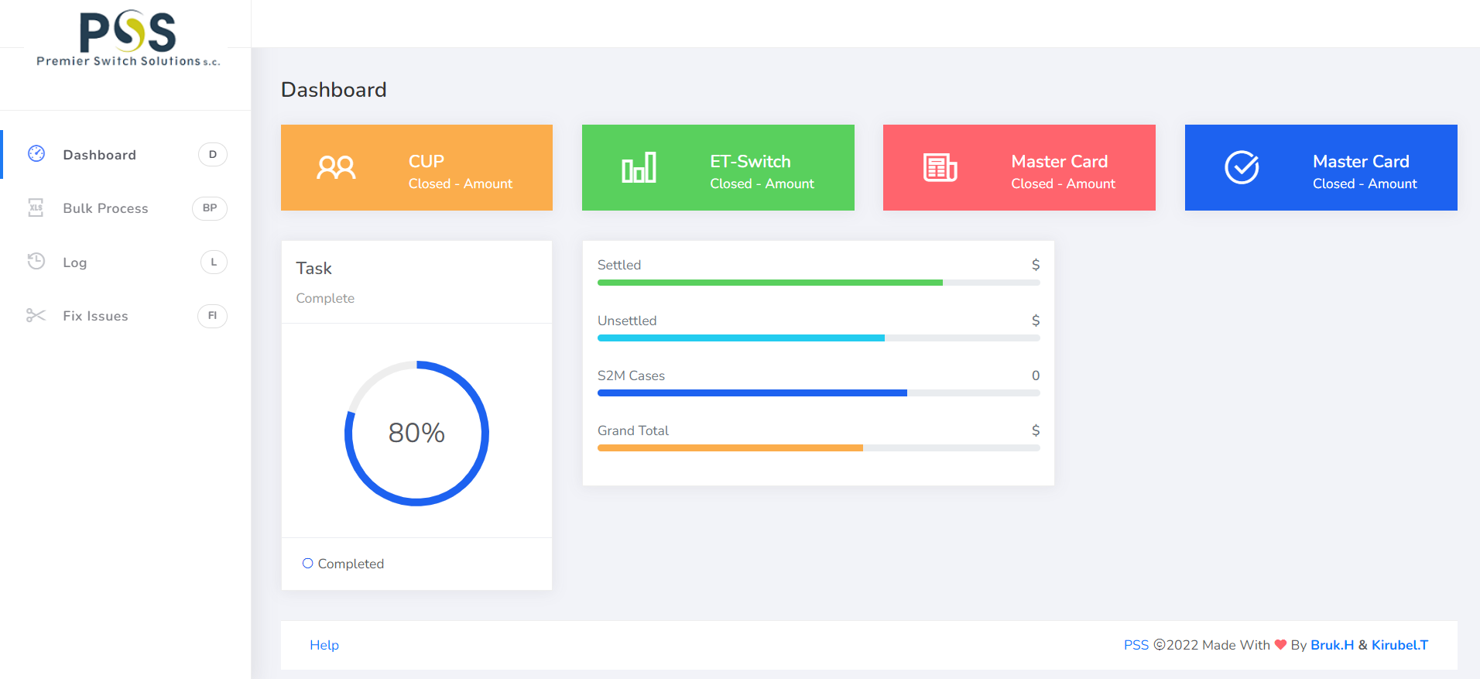

## Select Bulk Process Module

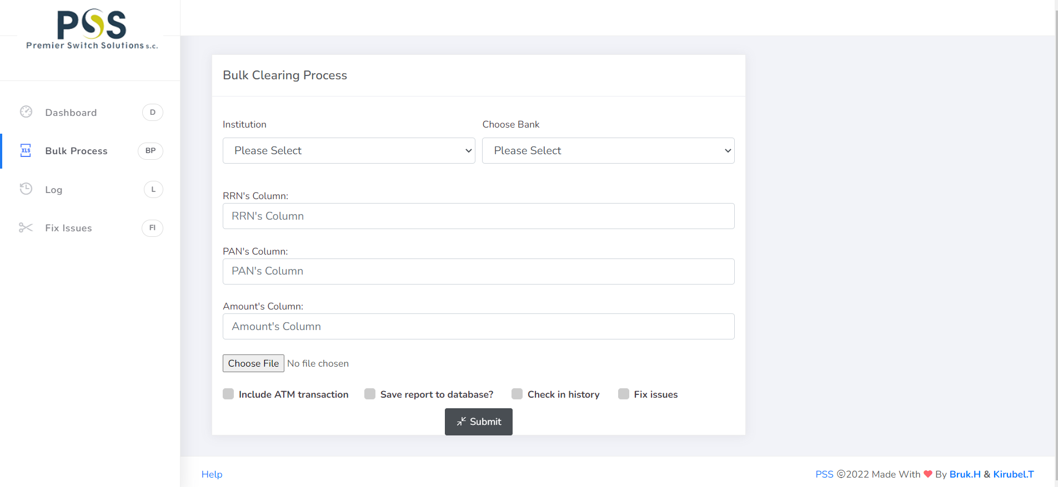

## Fill the form

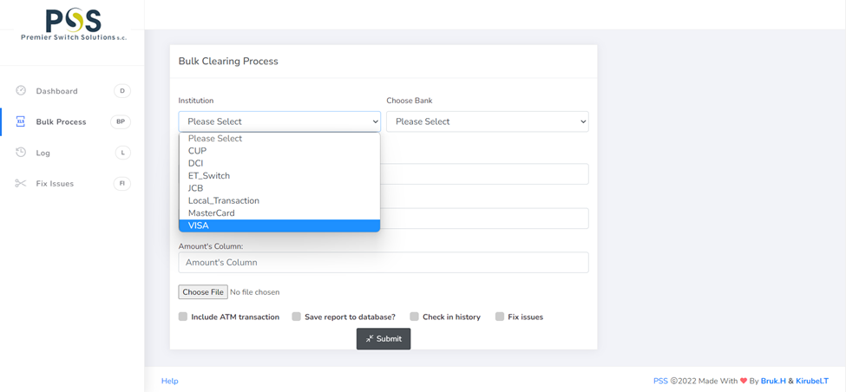 Choose Bank - If the file has a single bank transaction, you can select the option with the specific bank name. But if the file contains multiple Banks’ transactions choose the AUTO_SELECT option.

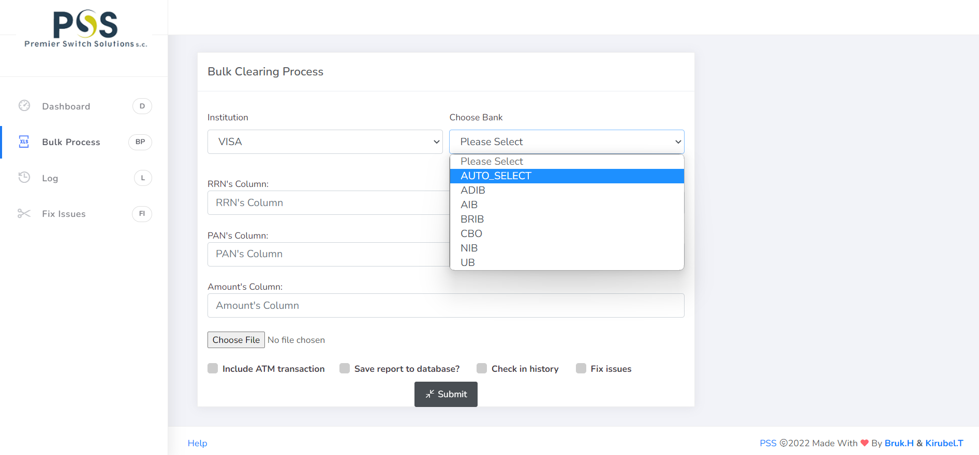

Prepare the excel, get the columns of each necessary field as bellows figure, choose file, check or uncheck the Save report to database option and submit.

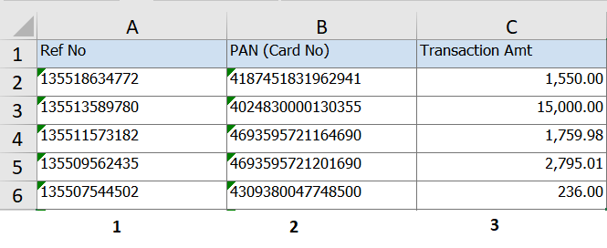

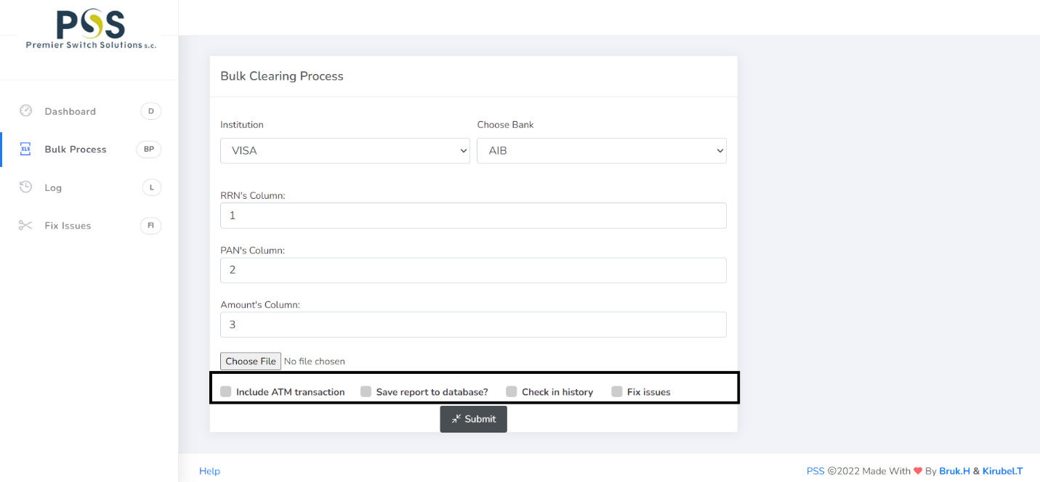

The checkbox options can be checked as if they are necessary.

* **Include ATM transactions** = for ATMs and EthSwitch incoming transactions. The result will not contain the outgoing date, it uses to check clearing.
* **Save report to database** = use for if there are some pending transactions that needs follow-up
* **Check in history** = For a year before transactions
* **Fix Issues** = If there are transactions that their rem_stat needs to be changed to Y.

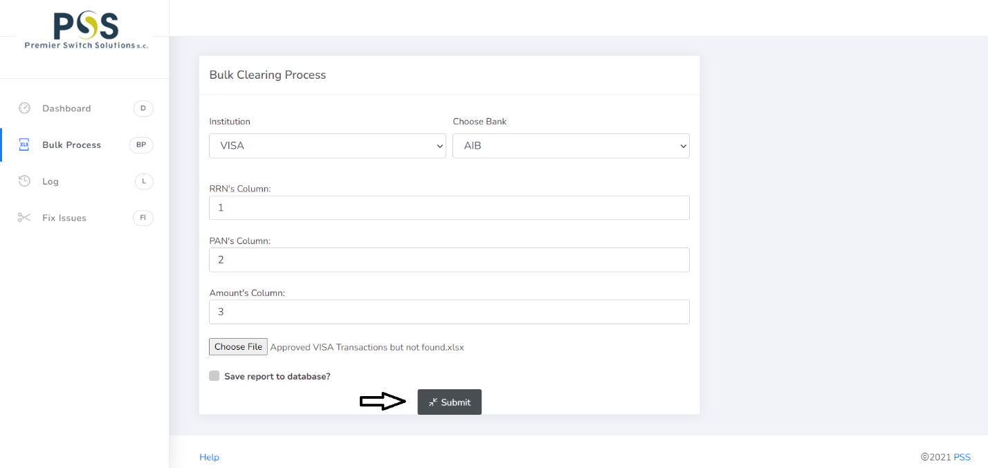

## Redirected to Result Page

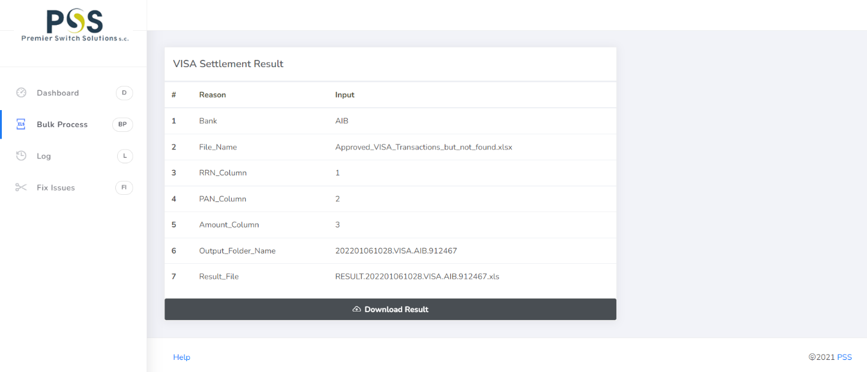

The result page gives compiled information about the process and the result.

The result is an excel file and it’s downloadable.

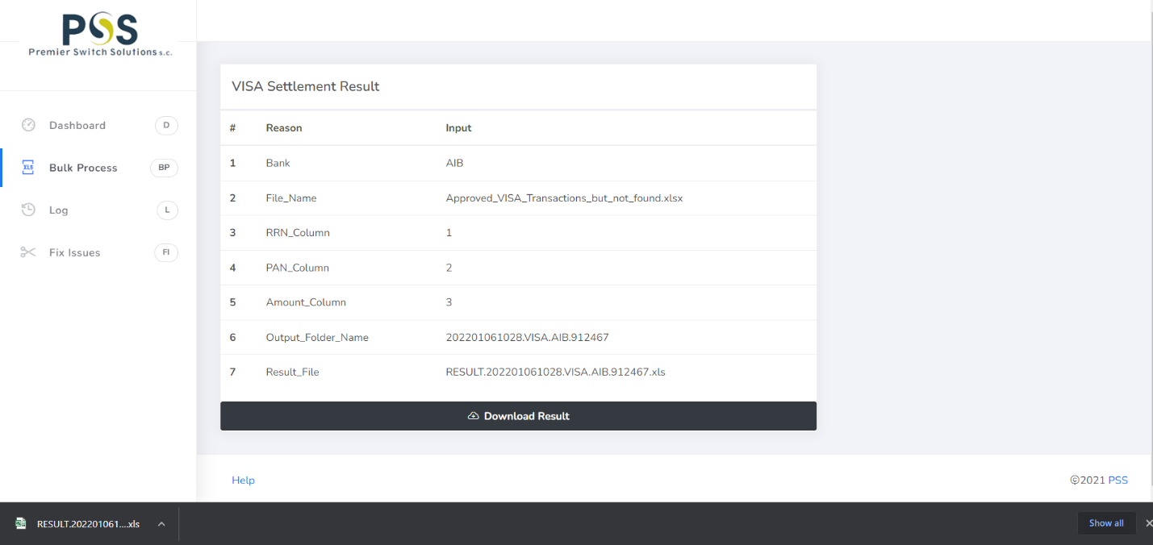

If the Save to database checkbox is checked as the below figure, there is a notification that indicates the data was saved on top of the result page.

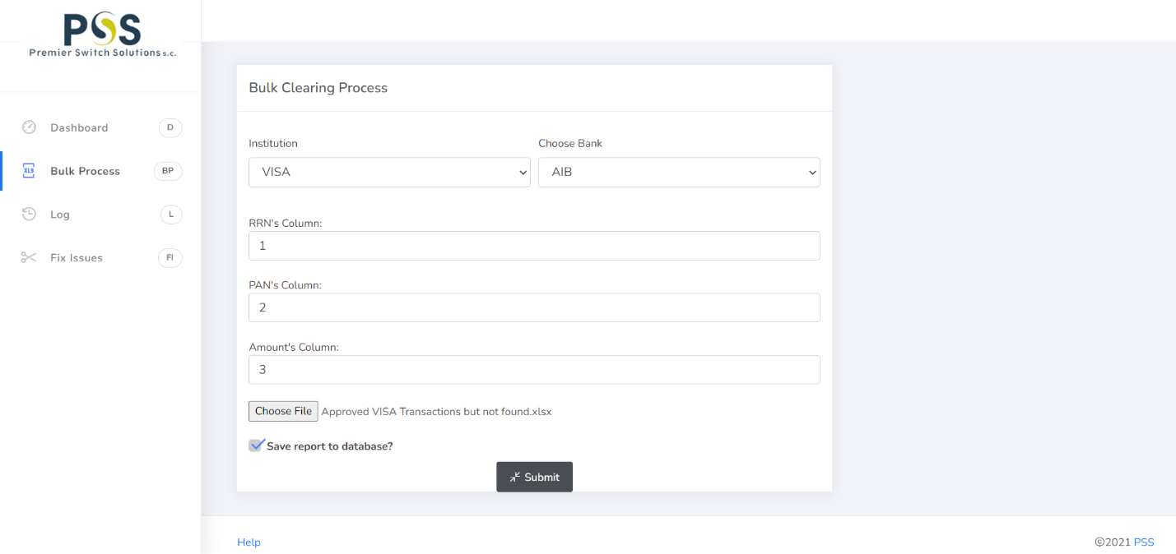

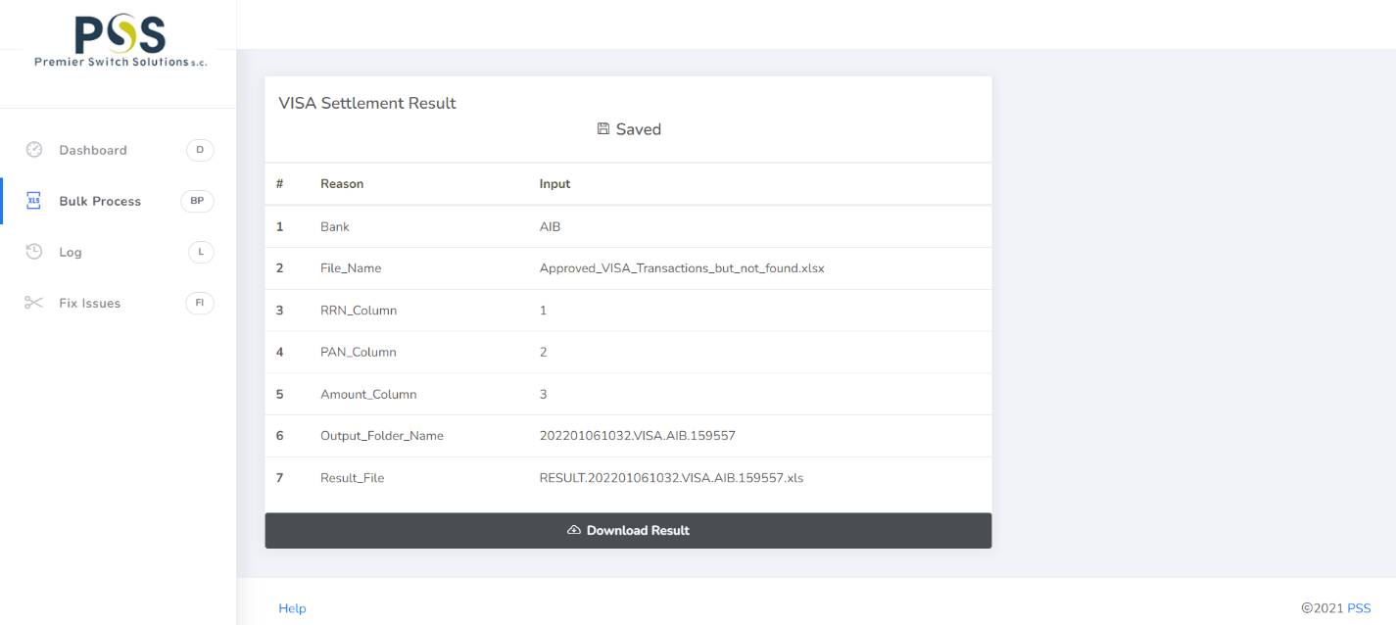

## excel result

The excel result has four sheets - Result, Rejected, Settlement not done, and Requests already saved sheet.

### Result sheet

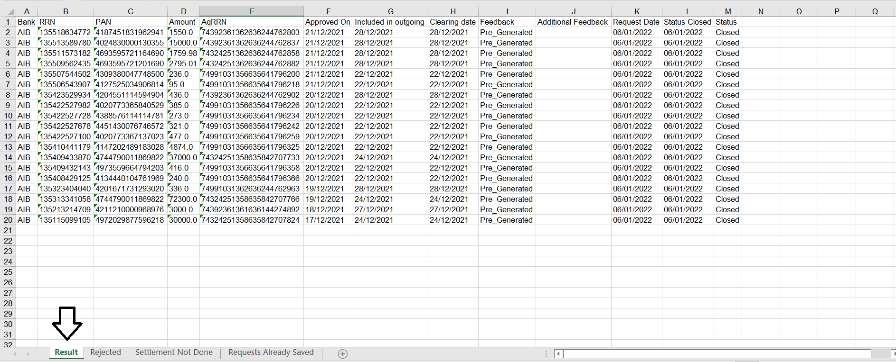

The Result sheet has 13 columns

|  |  |  |
| --- | --- | --- |
| Column | Name | Reason |
| A | Bank | Bank Name |
| B | RRN | Retrieval Reference Number |
| C | PAN | Primary Account Number |
| D | Amount | Transaction Amount |
| E | AqRRN | Acquirer Retrieval Reference Number |
| F | Approved On | Transaction Approved Date |
| G | Included in outgoing | Outgoing File Generated Date |
| H | Clearing Date | Clearing File Generated Date |
| I | Feedback | Explain The Transaction Status |
| J | Additional Feedback | Used For Backend Processer |
| K | Request Date | The User of The Application Requested Date |
| L | Status Closed | The Status Closed Date |
| M | Status | The Status of Transaction, Pending or Closed |

Feedback (Column I) – explain the transaction status in detail

|  |  |  |
| --- | --- | --- |
| No | Feedback | Reason |
| 1 | Pre_Generated | The outgoing file is already generated.  Status is closed. |
| 2 | Not_Processed_Yet_After_EOD | When the transaction date and the requested date are similar, the outgoing file will be generated after EOD because EOD is not yet processed.  Status is pending. |
| 3 | IN_CL_NOT_OUT_S2M | Included in clearing but not in outgoing, so this case needs to be logged to S2M.  Status is pending till S2M team solve the issue. |
| 4 | Pre_Included_In_Clearing | For Local transactions outgoing file may not be generated but the clearing file is already generated in this case.  Status is closed. |
| 5 | SETTLE_NOT_DONE_EOD | The settlement was not done from the terminal side, so manual settlement should be done. After the manual settlement done the outgoing file and clearing file will be generated after EOD.  Status is pending. |
| 6 | REM_STAT_CHANGED_EOD | The remittance status is changed automatically to procced the interrupted process. After EOD the outgoing file and clearing file will be generated.  Status is pending. |
| 7 | Y_S2M | The remittance status is Y so it needs to be logged to S2M for further processing.  Status is pending |
| 8 | REM_DATA_NOT_FOUND_S2M | The transaction is not found in the remittance transaction table, the case needs to be logged to S2M.  Status is pending. |
| 9 | Uncaught_Tran_transaction_record_table_error | If there is uncaught result, the investigation should be done manually rather than this App. |
| 10 | UNCAUGHT_REM_TAB_ERROR |
| 11 | Uncaught Authorization Error |

### Rejected sheet

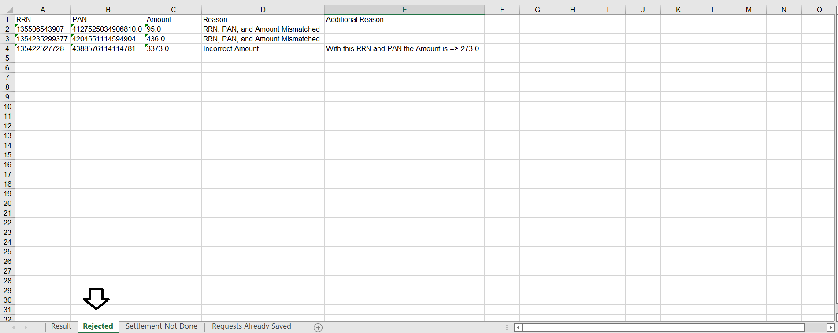

The rejected sheet has five columns

|  |  |  |
| --- | --- | --- |
| Column | Name | Reason |
| A | RRN | Retrieval Reference Number |
| B | PAN | Primary Account Number |
| C | Amount | Transaction Amount |
| D | Reason | Reason for the rejection |
| E | Additional Reason | To explain the reason in detail |

Reason (Column D)

|  |  |  |
| --- | --- | --- |
| No | Reason | Explanation |
| 1 | Not POS transaction | If the transaction is not POS transaction |
| 2 | Incorrect Amount | The provided amount is not correct, the correct amount will be displayed in the additional feedback. |
| 3 | RRN, PAN, and Amount Mismatched | The RRN or the PAN is incorrect |
| 4 | Transaction Reversed | The transaction is reversed so the outgoing file will not be generated. |
| 5 | Not Approved Transaction | The transaction is not approved, the response code will be displayed in the additional reason table. |

### Settlement Not Done sheet

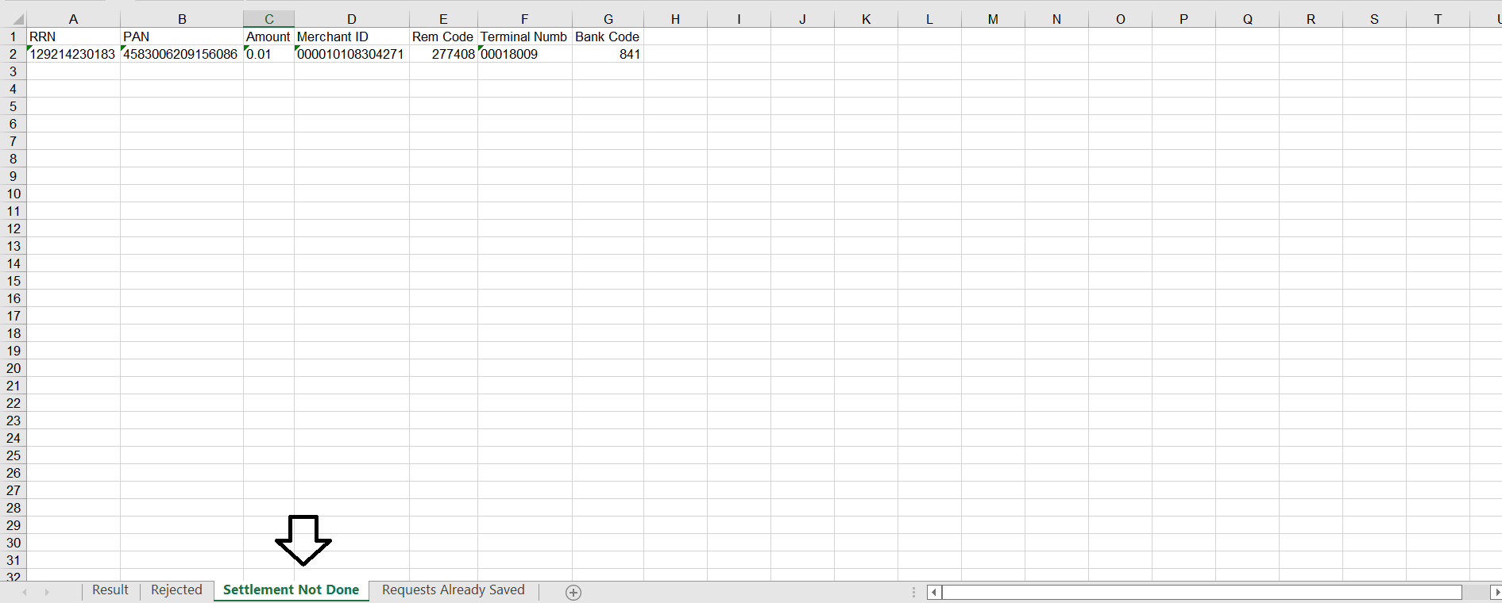

The settlement Not Done sheet has seven columns that helps for the manual settlement

|  |  |  |
| --- | --- | --- |
| Column | Name | Reason |
| A | RRN | Retrieval Reference Number |
| B | PAN | Primary Account Number |
| C | Amount | Transaction Amount |
| D | Merchant ID | Merchant Identifier |
| E | Rem Code | Remittance Code |
| F | Terminal Numb | Terminal Number |
| G | Bank Code | Bank Code (ID) |

### Requests Already Saved sheet

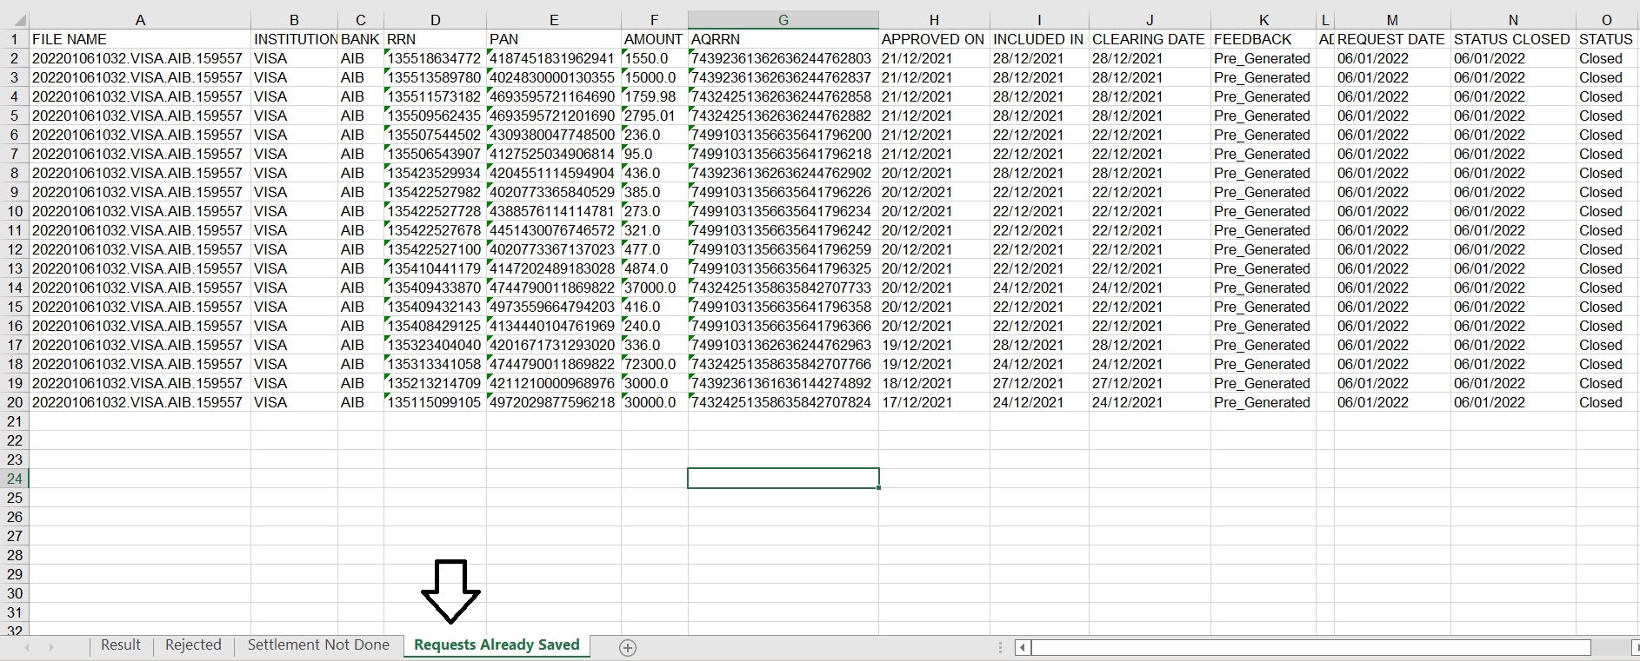

The requests’ already saved sheet has 15 columns that are fetched from the Database.

# Log Page

The log page has the database’s information that has been saved. It has 15 columns.

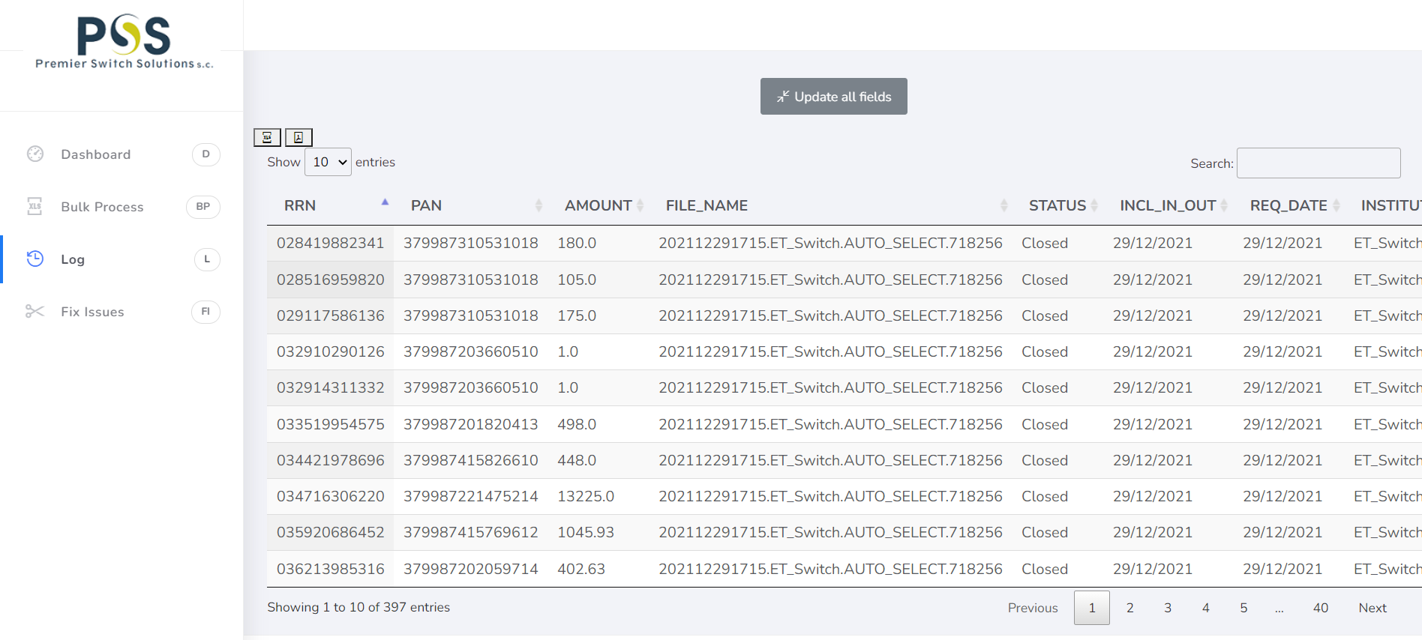

LOG Columns

|  |  |  |
| --- | --- | --- |
| No | Columns | Reason |
| 1 | RRN | Retrieval Reference Number |
| 2 | PAN | Primary Account Number |
| 3 | AMOUNT | Transaction Amount |
| 4 | FILE_NAME | The result file name |
| 5 | STATUS | The Status of Transaction, Pending or Closed |
| 6 | INCL_IN_OUT | Included in outgoing file date (Outgoing File Generated Date) |
| 7 | REQ_DATE | The User of The Application Requested Date |
| 8 | INISTITUTION | Institutions such as VISA, Mastercard, and others |
| 9 | BANK | Bank Name |
| 10 | AQRRN | Acquirer Retrieval Reference Number |
| 11 | APPROVED_ON | Transaction Approved Date |
| 12 | CLEAR_DATE | Clearing File Generated Date |
| 13 | FEEDBACK | Explain The Transaction Status |
| 14 | ADD_FEEDBACK | Used For Backend Processer, has information based on the feedback |
| 15 | STATUS_CLOSED | The Status Closed Date |

## 

## Log Page Capabilities

### Update

Update the pending in order to get updated result for the pending cases.

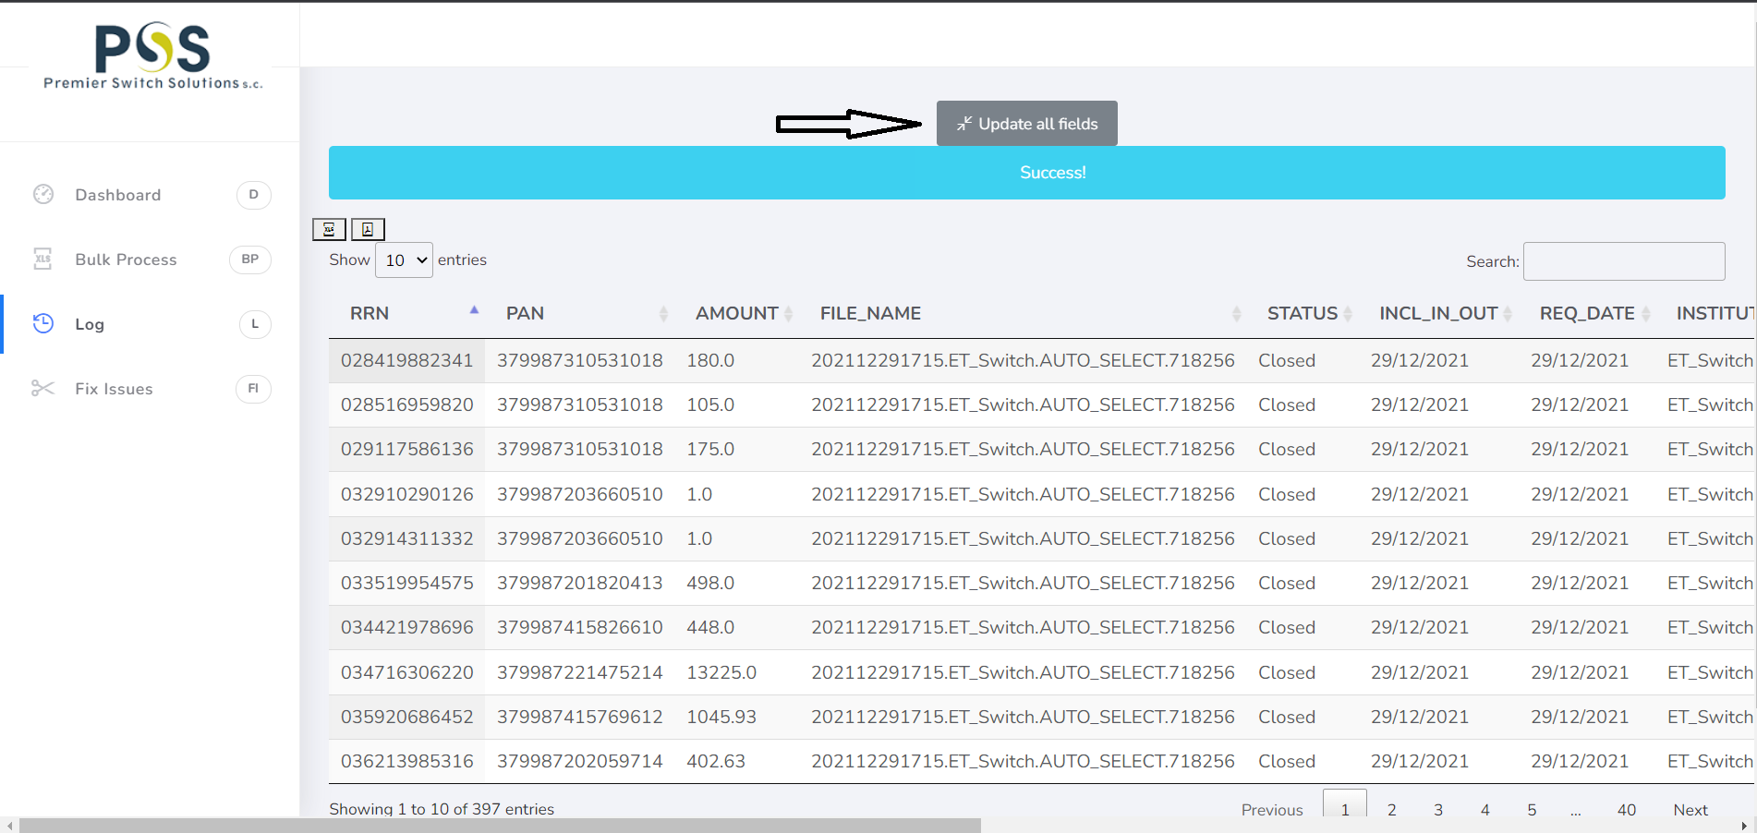

### Search

Individual transactions can be searched based on their RRN, FILE_NAME, STATUS, INSTITUTION, BANK, and some other fields. For instance, the below figure shows searching one transaction by RRN.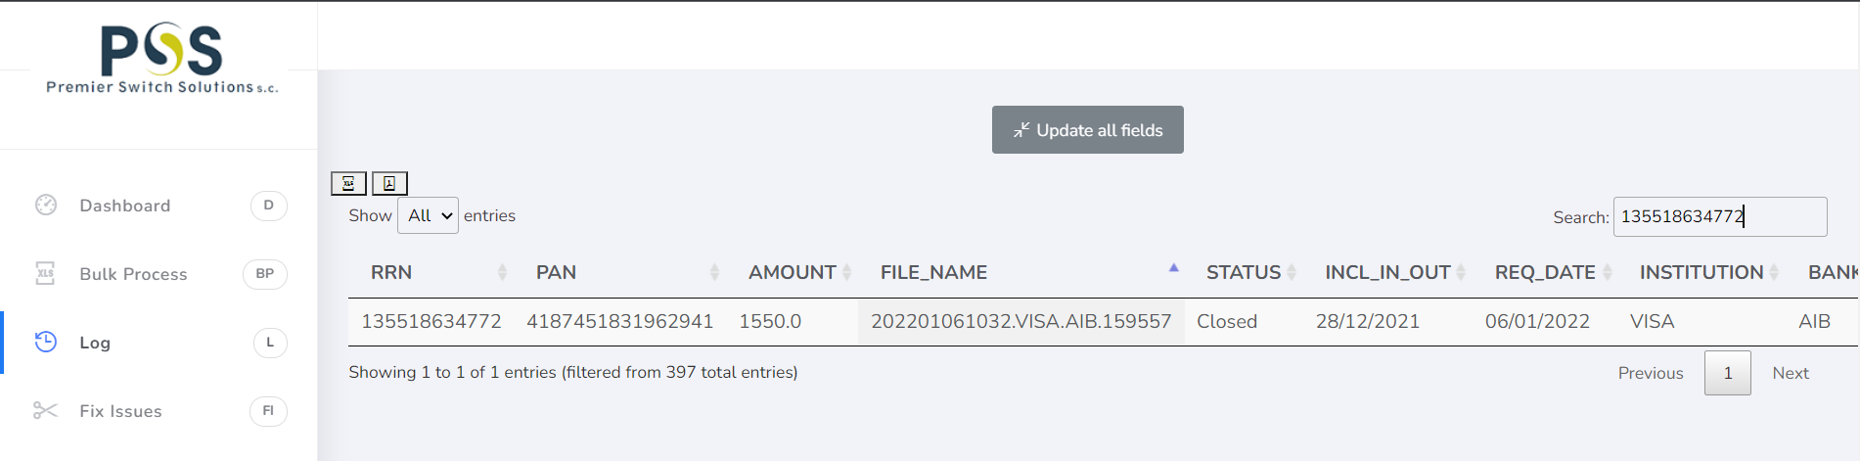

### Paginate

Previous and Next buttons are used for pagination

Show option helps the user to see all transactions

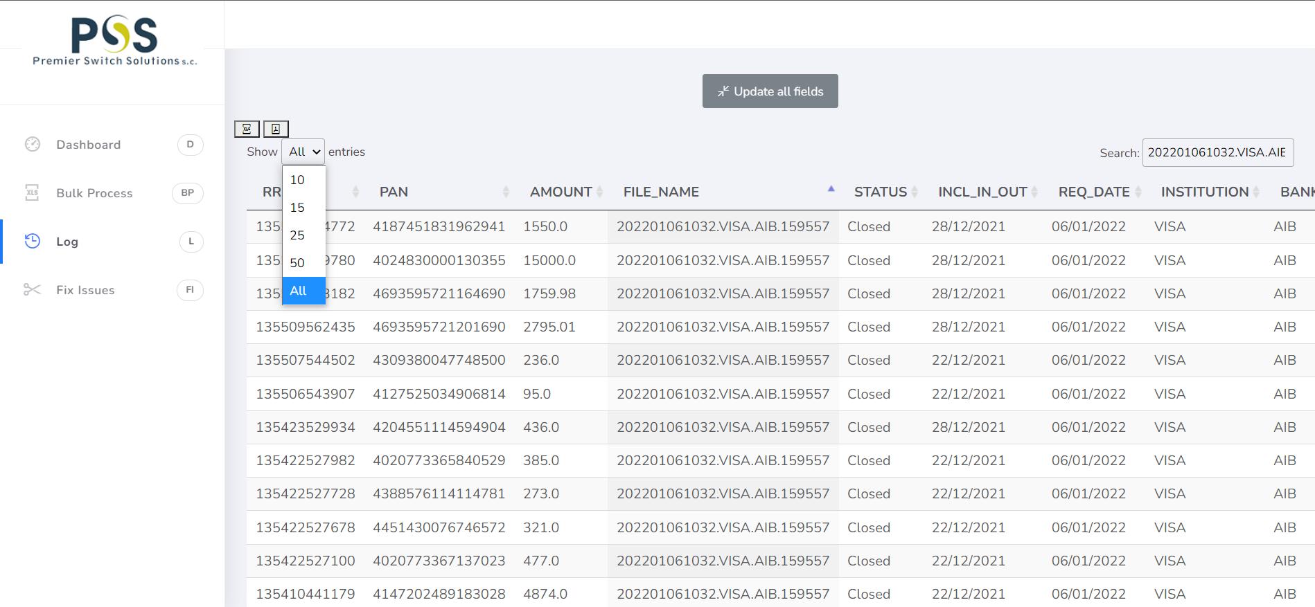

### Export

It has two options for exporting format for the report Excel and PDF.

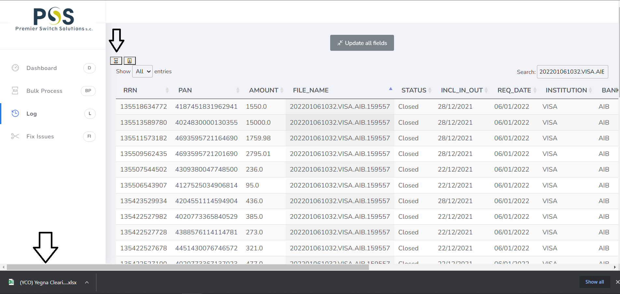

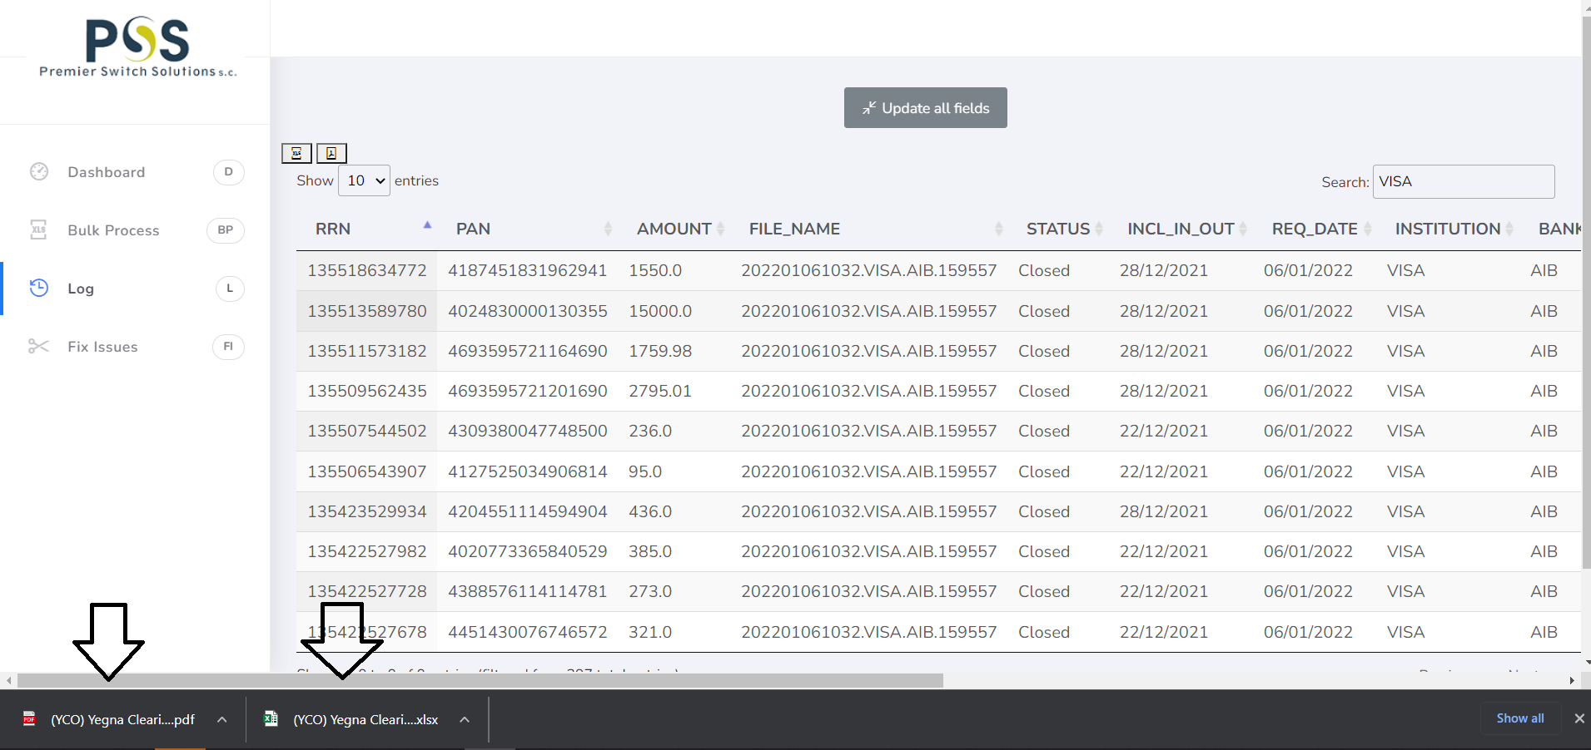

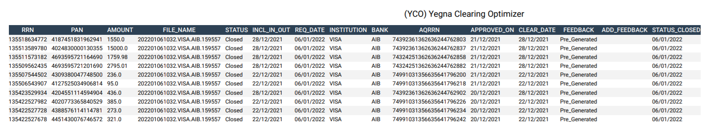

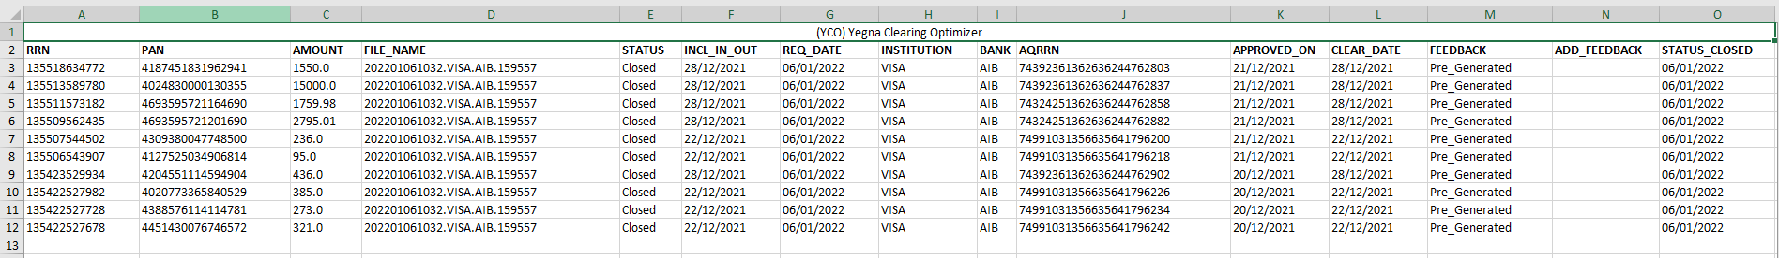

**N.B This application is not fully completed there are things left such as enhanced dashboard, report, and others.**