**Student ID:** 8655295

**Module:** 6006CEM Machine Learning

**Course**: Computer Science

**Table of Contents**

**Introduction** 3

**Dataset description** 4

**Data Analysis** 4

**Data Pre-processing** 5

**Implementation** 10

**Results, Evaluations and Conclusions** 12

**Logistic Regression** 12

**K-Neighbors Classifier** 13

**Random Forest Classifier** 14

**Conclusion** 15

**References** 16

# **Introduction**

Breast Cancer is one of the most common cancers in woman. According to Cancer Research UK, 30% of new female cancer cases belong to breast cancer and is the leading cause of cancer death in women under 50, in the UK, making it a prevalent health issue.

Breast Cancer can come in two forms: benign or malignant. The early diagnosis of the cancer can improve the chance of survival by giving patients more time to undergo cancer treatment. If the type of breast cancer can be predicted and classified early on, it reduces the chance of misdiagnosis and can prevent patients having to go through unnecessary treatments.

The constant evolution of ML learning algorithms has been crucial for the prediction of breast cancer diagnosis, which has been decreasing the deathly rate of people that carry this cancer. Feature extraction and classification algorithms employed in it led to the design of an efficient system (S. P. Rajamohana, 2019).

The objective with this report is critically analysing the dataset above and testing the accuracy of Logistic Regression, K-Neighbors Classifier and Random Forest Classifier when it comes to the diagnosis prediction, malignant or benign.

# **Dataset description**

The dataset used, “**Breast Cancer Wisconsin (Diagnostic) Data Set”**, was taken from UCI Machine Learning repository. It was created by Dr. William H. Wolberg, physician at the University of Wisconsin.

The dataset contains the following variables:

**Attribute Information:**

1. ID number
2. Diagnosis (M = malignant, B = benign) 3-32)

**Ten real-valued features are computed for each cell nucleus:**

1. radius
2. texture
3. perimeter
4. area
5. smoothness
6. compactness
7. concavity
8. concave points
9. symmetry
10. fractal dimension

All of these values contain a “mean”, a “worst” and a “standard” value, so we have a total of 32 variables to work with.

### **Data Analysis**

We start by running the command head() to observe our dataset:

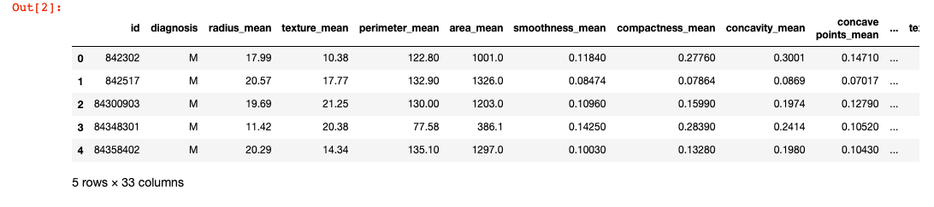

Figure 1 - data.head() command

Next, using shape(), we could see our dataset contains 569 rows with 33 columns.

### **Data Pre-processing**

To test our classification models, pre-processing of the data has to be made, for it to be in a correct format for the testing and evaluation of the models.

#### **Handling missing values**

First, we verified if any of the dataset values are null using the command info():

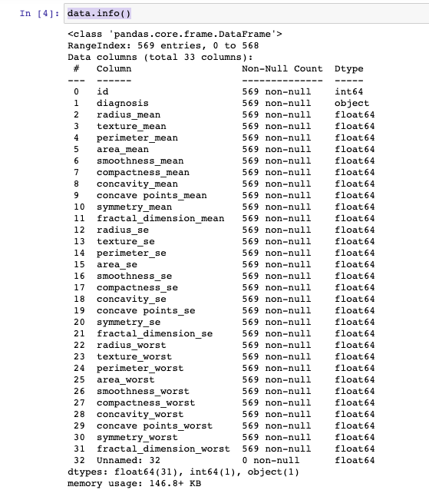

Figure 2 - Data.info() command

As we can observe, column “Unnamed:32” is null so we proceed to drop it since it is not relevant for our case study. Column “id” was also dropped.

Then, we verify if we missed any null values, with “data.isna().sum()” :

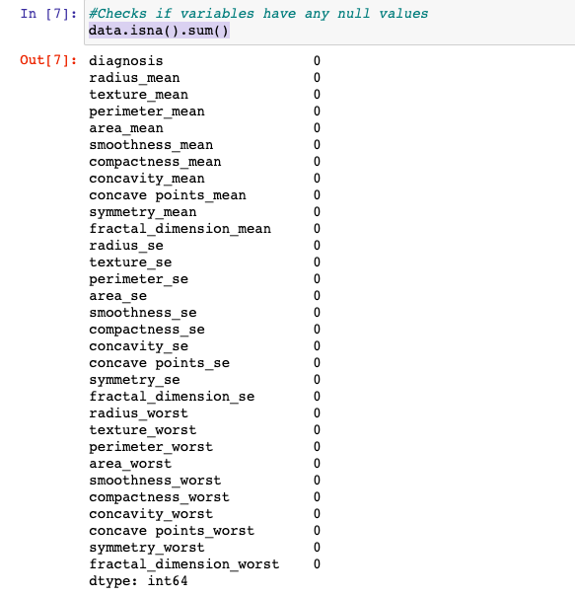

Figure 3 - data.isna().sum() command

As per observation of the image above, there are no null values so we can proceed with the pre-processing of our data.

#### **Handling categorical values**

The next step would be to handle categorical features. Categorical variables contain label values instead of numeric values, so we need to transform them for it to be used with the models.

Looking at our head() command from early, we can see that the ‘diagnosis’ column contains letters instead of numbers. So we run the unique() command on our ‘diagnosis’ column:

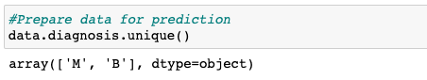

Figure 4 - unique() command

As we can observe, our ‘diagnosis’ column is type object, instead of float like the other columns so we need to transform that ‘M’ and ‘B’ to numbers by mapping ‘M’ to be the number ‘1’ and ‘B’ to be number ‘0’.

We ran our head() command again and it no longer has letters in that column.

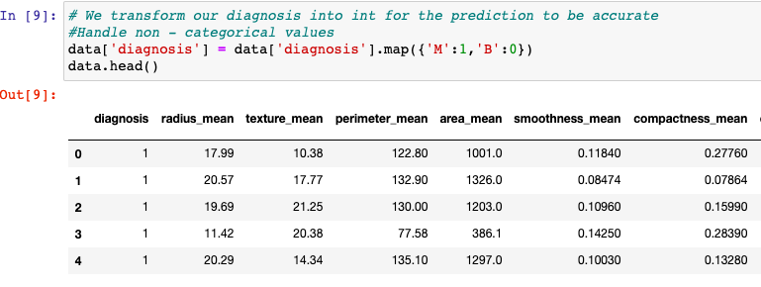

Figure 5 - data.head() to verify categorical change

A barchart was plotted to observe the difference in quantity of Malignant and Benign values:

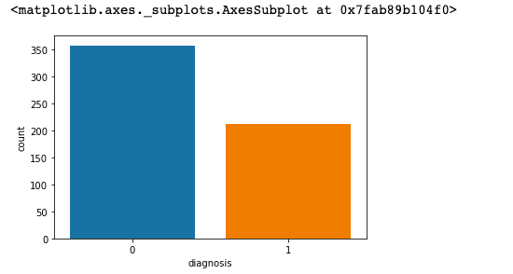

Figure 6 - Barchart

As per observation of Figure 6, there are significantly more Benign cases than Malignant in the dataset.

#### **Feature Selection**

We now proceed with selecting the most relevant features from our data. “The aim of feature selection is to inform decisions about which measures (“features” in machine learning parlance) in the data set should be included in data collection or analysis to optimally predict the outcomes with a minimum number of predictors” (R Brick, Timothy, 2017). Some features become less relevant or are too similar to other, so if we reduce the number of features, we accomplish a more accurate result.

There are several methods for feature selection, however the feature selection will be made based on correlation with each other.

First, the data is transformed into a correlation format, where every feature is compared with each other:

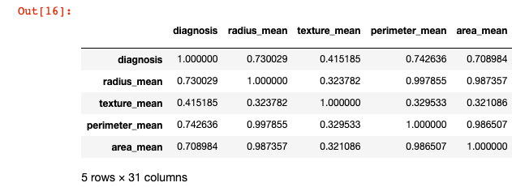

Figure 7 - correlated data

Looking at the values, it’s not really obvious which are more correlated to each other, so we plot our correlated data into a heatmap:

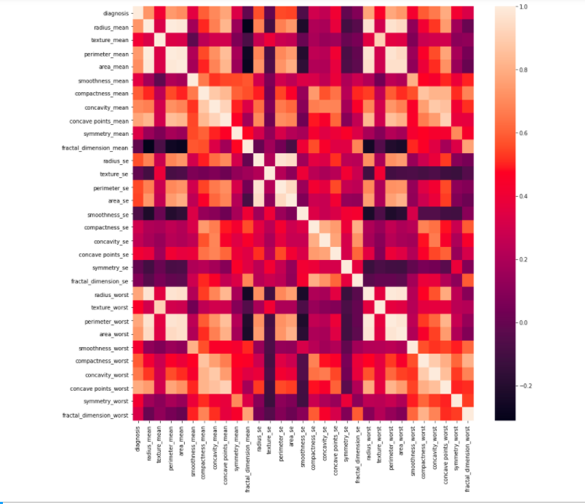

Figure 8 - heatmap

If two or more features have high correlation, it’s only worth keeping one of them, since they are equally relevant to the dataset.

As we can observe, perimeter, area and radius are highly correlated, in all their stages (se, mean and worst) so we will be keeping only the ‘radius_se’, ‘radius_mean’ and ‘radius_worst’, dropping ‘perimeter_mean’, ‘perimeter_worst’, ‘perimeter_se’, ‘area_worst’, ‘area_se’, ‘area_mean’. The data now consists of 24 features instead of 30.

To test if feature selection increases our accuracy, we are going to work with two separate dataframes for our model implementation: ‘data’, which contains the 31 initially already cleaned values and ‘data_tuned’, ‘data’ that suffered feature selection and contains 25 columns.

#### **Scale and Split data**

The next step was scaling the data. Our data contains features that variate on unit, magnitude and range. Scaling helps bring all the features to the same magnitude, for the learning models to understand better and give more accurate results.

For scaling, the function “StandardScaler()” was used to scale our “X” values, that correspond to all the features except our target, “diagnosis”, that corresponds to our “Y”.

Splitting of data was also made. When splitting the data, we end up with two sets of data: a training set and a testing set. The training set of data is going to be what our model is going to learn from and then the model is going to predict the “diagnosis” on the testing set.

To split the data, train_test_split() was used, where the training data size corresponds to 70% and the testing data size corresponds to 30% of the data.

With our data ready to be processed, a Principal Component Analysis (PCA) was plotted in order to summarize all of our information in a graph:

Figure 9 - PCA Plot

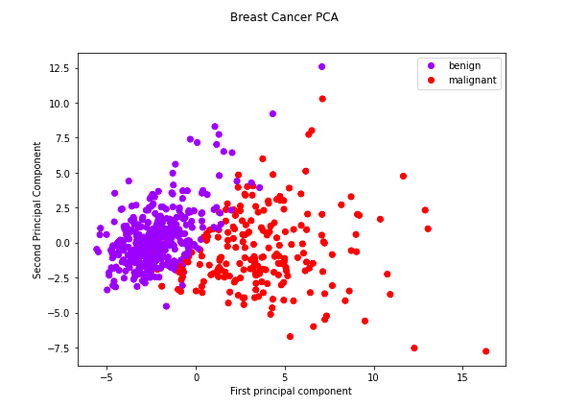

As we can see in the figure above, the “Benign” cases represent less variance than the “Malignant” cases, in both components.

# **Implementation**

With the data ready to be processed, we can implement our learning models: Logistic Regression, K-Neighbors Classifier and Random Forest Classifier. All the models were tested with two datasets: our cleaned data (data) and our data that suffered feature selection (data_tuned).

For all the models, we first selected ‘X’ and ‘Y’ variables and we split the data into a 70/30 percentage, where 70% corresponds to the training set and 30% corresponds to the testing set. We start by fitting the training variables into the model and then we predict the results with our predict() function:

Figure 10 - Training Logistic Regression

For all the models, Cross Validation was implemented with the ‘cross_val_score’ function. Since the models tend to go into overfitting, this is a regularisation technique that helps avoiding that happening. It works by testing our data into new subsets of our data instead of only our training set, to see how it would perform outside of our sample data:



Figure 11 - Cross Validation

The function takes the model, the testing variables, a splitting strategy equal to 5 folds (subsets of data) and an estimator for accuracy. The function tests the model in the 5 folds and then stores the values in “scores”.

For each model, a confusion matrix is plotted. This matrix helps with the visualisation of the comparison between predicted values and actual values, quantifying the performance of a machine learning algorithm.

For the models that take “data_tuned” i.e data with feature selection, there were more processes done to improve the accuracy of the model. Hyperparameter tunning was performed in the form of a Random Search and Grid Search. Hyperparameters control the behaviour of a machine learning model and “the ultimate goal is to find an optimal combination of hyperparameters that minimizes a predefined loss function to give better results.” (Lee, Admond, 2019).

For the Logistic Regression, RandomizedSearch was implemented:

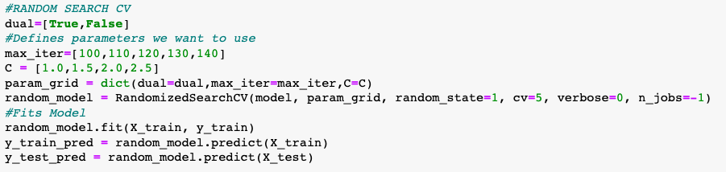

Figure 12 - RandomizedSearchCV

For the K-Neighbors Classifier and Random Forest classifier, GridSearch was implemented:

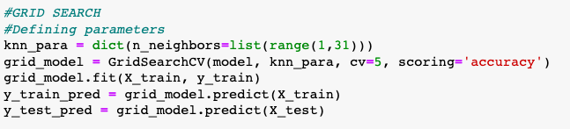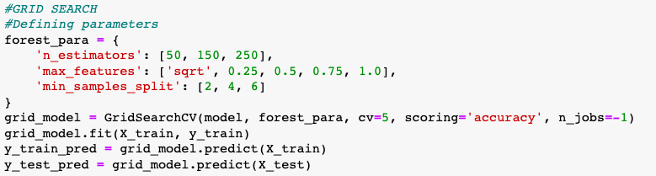

Figure 13, 14 – GridSearchCV

GridSearch iterates through every combination of parameters possible and stores a model for each of these. It’s more accurate, but it’s takes more time to process. RandomizedSearch is quicker to process but can be less accurate since it uses random combinations, with the possibility of the most optimal not being there.

# **Results, Evaluations and Conclusions**

For each model, we evaluated the training accuracy, the testing accuracy and the overall model performance in our data set. Cross Validation Accuracy was also evaluated, and, for better visualisation, a confusion matrix was plotted for each model.

### **Logistic Regression**

As we can see in the figure below, the logistic regression model tested with ‘data’ achieved a 99% training accuracy, a 98% testing accuracy and an overall model accuracy and cross validation accuracy of 98%.

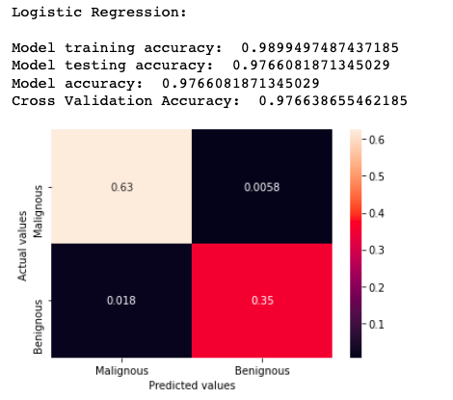

Figure 15 - Logistic Regression Results

Looking at the logistic regression tested with “data_tuned”, with RandomSearch implemented, training accuracy was 99%, testing accuracy was 96% and overall accuracy was 96%. Our cross-validation score is also evaluated at 96%.

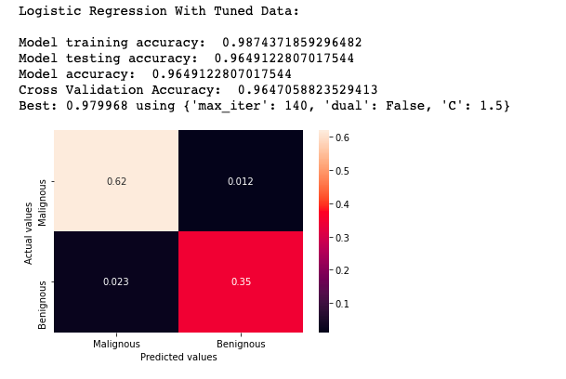

Figure 16 - Logistic Regression results with data_tuned

### **K-Neighbors Classifier**

As we can see in the figure below, the KNN Classifier tested with our ‘data’ achieved a 97% training accuracy and a 96% testing accuracy. The model evaluation concluded with a model accuracy of 86% and cross-validation accuracy of 95%.

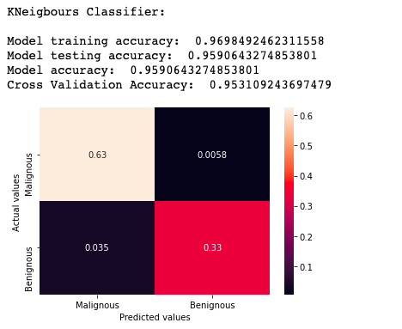

Figure 18 - KNN Classifier results

Looking at the KNN Classifier tested with “data_tuned”, with GridSearch implemented, we have a training accuracy of 96%, a testing accuracy and model accuracy of 94% and a cross validation accuracy of 91%. GridSearch determined that a 95% accuracy is achieved with 23 neighbours used

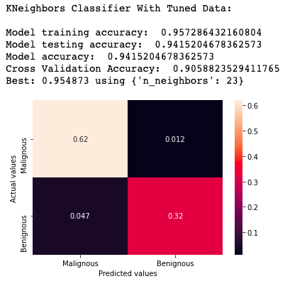

Figure 17 - KNN Classifier with tuned_data

### **Random Forest Classifier**

Observing our Random Forest model, we achieved a training accuracy of 100%, a testing accuracy of 98%, an overall model accuracy of 98% and a cross validation accuracy of 95%.

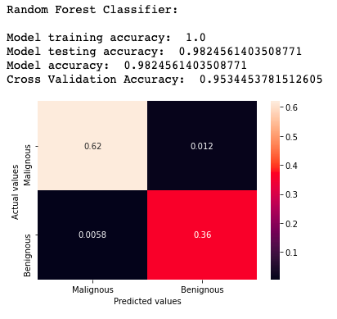

Figure 19 - Random Forest Classifier Results

Even without feature selection and hyperparameter tunning, this model performed the best so far compared to Logistic Regression and KNN Classifier. It is very important to know what model to choose considering the dataset in question, and this was the best choice so far. The training accuracy being 100% shows how well this model learns and prepares to test the data.

The Random Forest model using ‘data_tuned’ and hyperparameter tunning with GridSearch also performed well. The model training accuracy is of 100%, the testing accuracy is 95%, the overall model accuracy is 95% and the cross-validation accuracy is a bit better, at 95.3%.

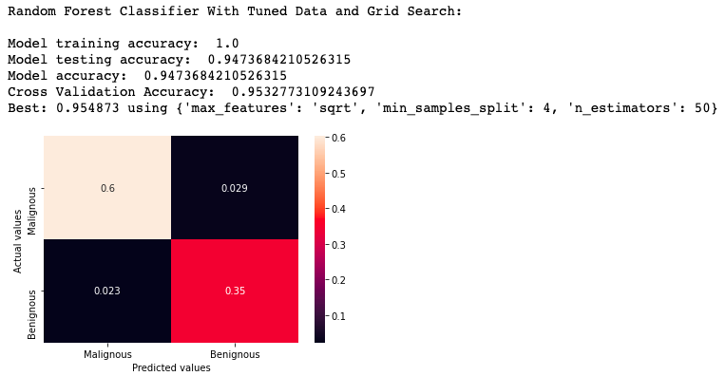

Figure 10 - Random Forest Classifier Results with data_tuned

Although the values are good, (with a training set still at 100%), the overall accuracy and training accuracy decreased.

### **Conclusion**

The model that performed better using both our datasets was Random Forest Classifier and the worst was KNN Classifier.

Inside each model, the model that used a hyperparameter tunning method and was tested with the data that suffered feature selection, performed worse than the model that was tested with the normal dataset. This could be because they hyperparameter combination was not optimal or the features chosen in feature selection weren’t the best, decreasing the accuracy of the model.

Nonetheless, all models present an accuracy above 90%, which shows to be a good thing if bias aren’t considered.

# **References**

* Rajamohana, S. P. (2019) ‘Analysis of Classification Algorithms for Breast Cancer Prediction’.  [online] available from <<https://link.springer.com/chapter/10.1007/978-981-32-9949-8_36>> [26 November 2020]
* Brick, Timothy R. (2017) ‘Feature Selection Methods for Optimal Design of Studies for Developmental Inquiry’. *The Journals of Gerontology* [online] available from <<https://academic.oup.com/psychsocgerontology/article/73/1/113/2970271>> [27 November 2020]
* Lee, A. (2019) ‘’ ‘Why You Should Do Feature Engineering First, Hyperparameter Tuning Second as a Data Scientist’. *Medium* [online] available from <https://towardsdatascience.com/why-you-should-do-feature-engineering-first-hyperparameter-tuning-second-as-a-data-scientist-334be5eb276c>> [27 of November 2020]