**SQL**

https://www.interviewbit.com/sql-interview-questions/

**What is database?**

- A database is an organized collection of data, so that it can be easily accessed and managed.

**What is DBMS?**

-DBMS stands for Database Management System. It is a collection of application programs which allow the user to organize, restore and retrieve information.

Some of the popular DBMS’s are MySql, Oracle, Sybase, etc.

The advantages of DBMS includes:

* Data is stored in a structured way and hence redundancy is controlled.
* Validates the data entered and provide restrictions on unauthorized access to the database.
* Provides backup and recovery of the data when required.
* It provides multiple user interfaces.

**What is RDBMS?**

-Relational Database Management System(RDBMS) is based on a relational model of data that is stored in databases in separate tables and they are related to the use of a common column.

Data can be accessed easily from the relational database using Structured Query Language (SQL).

**Aggregate functions**

-It determines and calculate values from multiple columns in a table and return a single value.

There are 7 aggregate functions in SQL:

* AVG(): Returns the average value from specified columns.
* COUNT(): Returns the number of table rows.
* MAX(): Returns the largest value among the records.
* MIN(): Returns the smallest value among the records.
* SUM(): Returns the sum of specified column values.
* FIRST(): Returns the first value.
* LAST(): Returns last value.

**SQL commands**

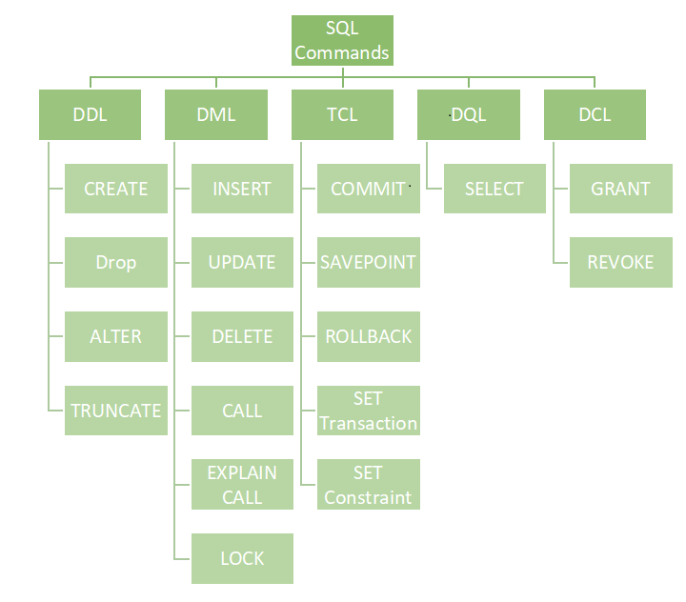

**Normalization**- is the process of removing redundant data from the database by splitting the table in a well-defined manner in order to maintain data integrity. This process saves much of the storage space.

**De-normalization** is the process of adding up redundant data on the table in order to speed up the complex queries and thus achieve better performance.

**Different types of Normalization are:**

* **First Normal Form (1NF):** A relation is said to be in 1NF only when all the entities of the table contain unique or atomic values.
* **Second Normal Form (2NF):** A relation is said to be in 2NF only if it is in 1NF and all the non-key attribute of the table is fully dependent on the primary key.
* **Third Normal Form (3NF):** A relation is said to be in 3NF only if it is in 2NF and every non-key attribute of the table is not transitively dependent on the primary key.

**BCNF** is the Boyce Code Normal form. It is the higher version of 3Nf which does not have any multiple overlapping candidate keys.

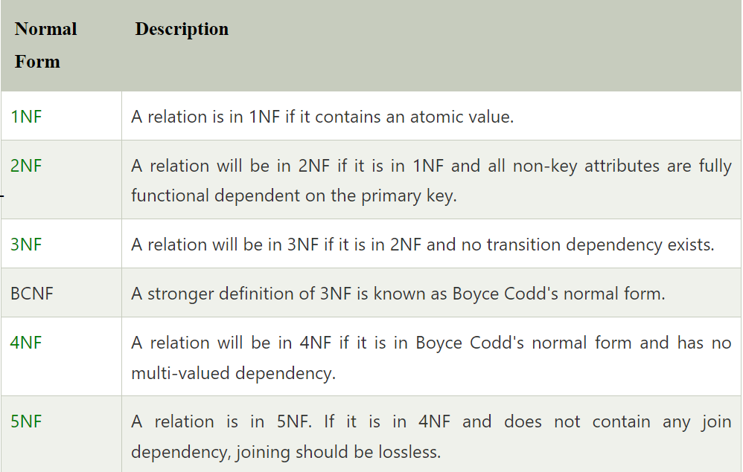

**SQL is Relational Database**