**GoRestAPI**

1. Creating new collection “GoRestAPI”

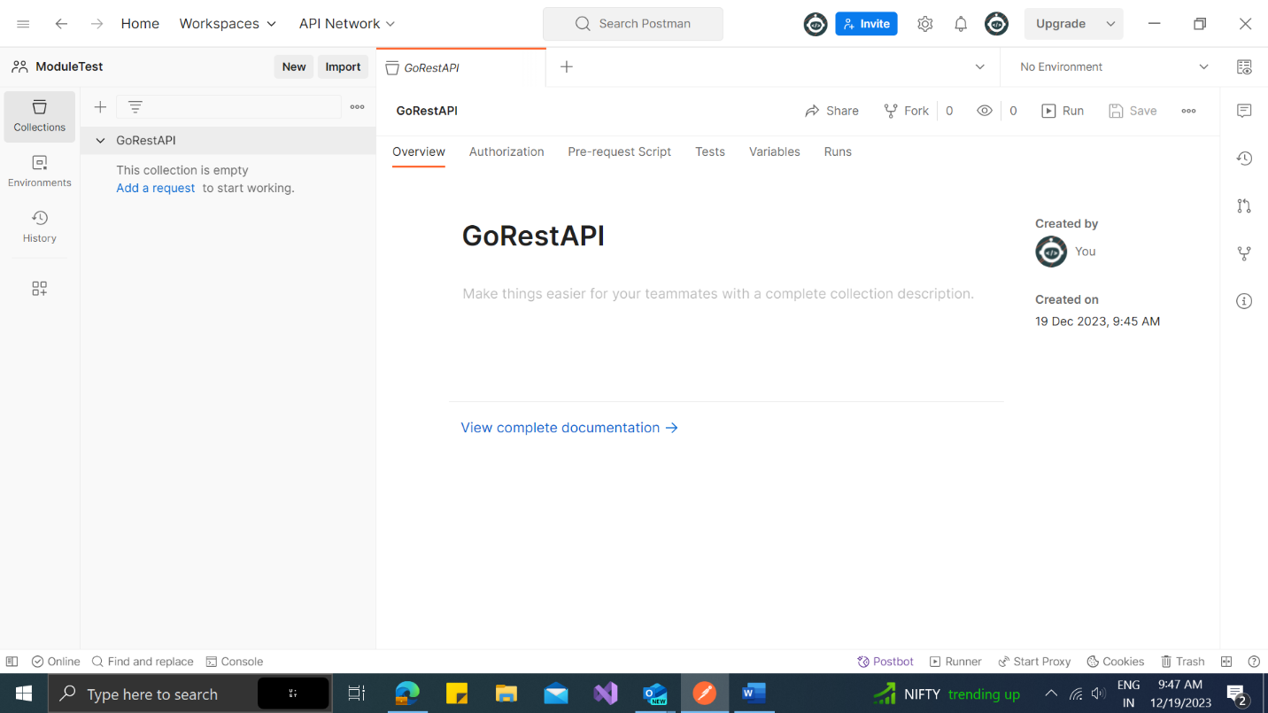

1. Creating an Environment called “GoRestEnv” with variable “baseUrl”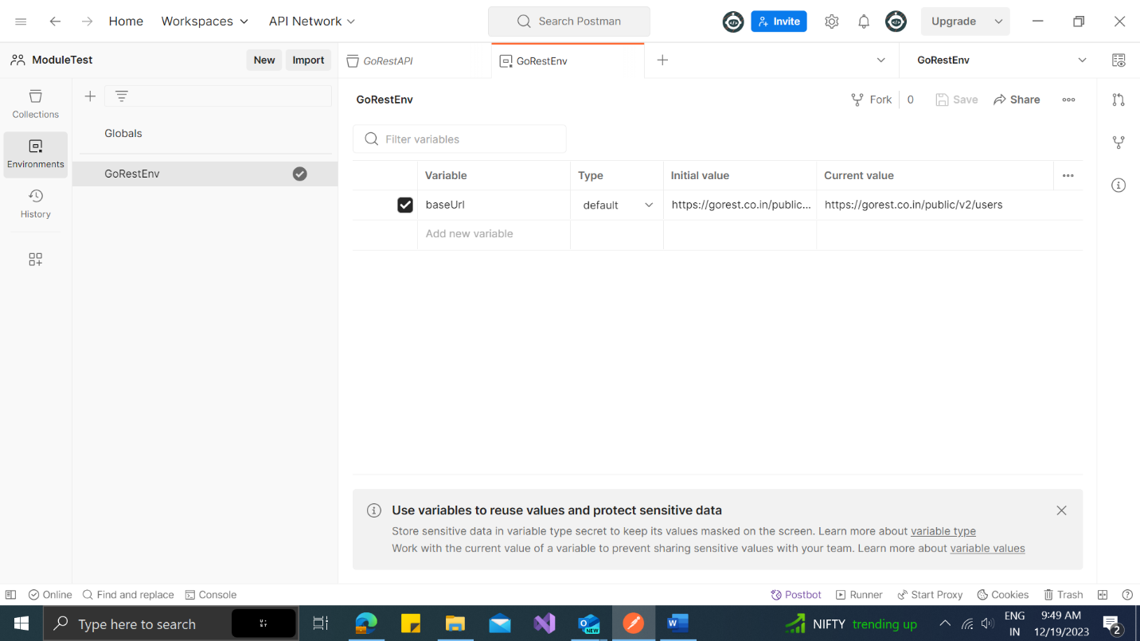
2. GET – GetALLUsers response body

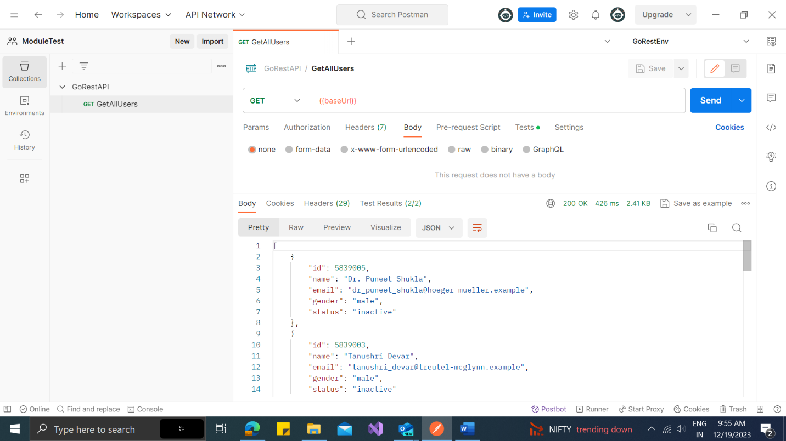

1. GET – GetALLUsers Tests

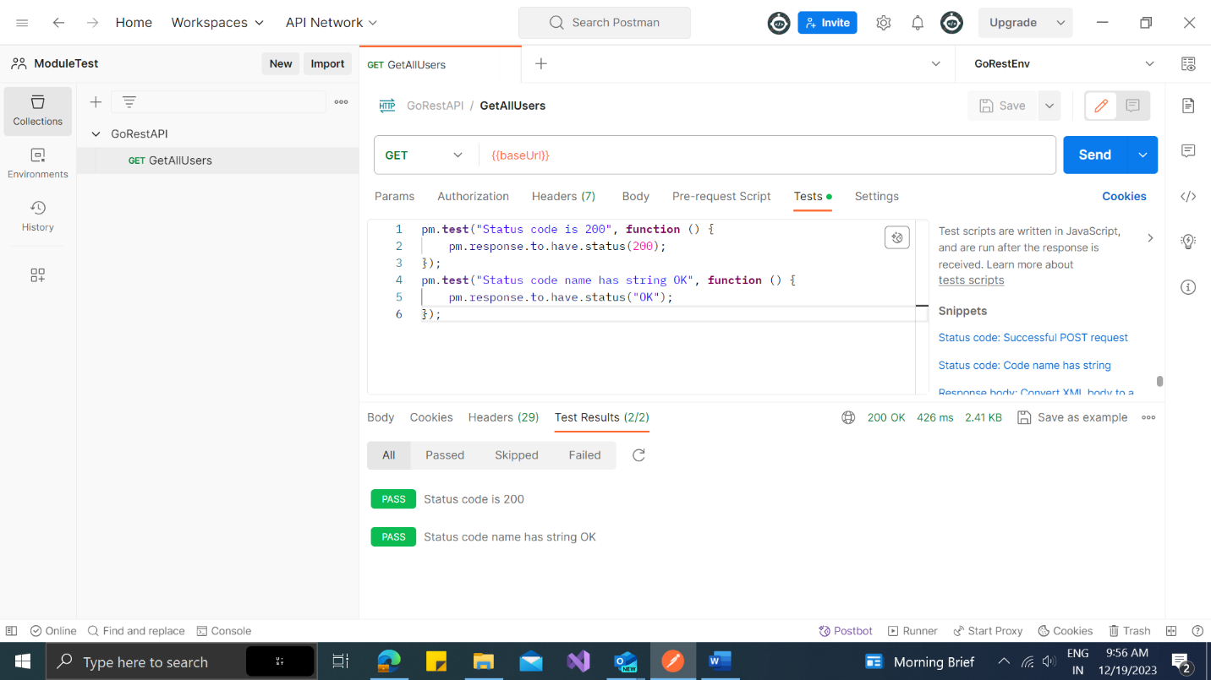

1. GET – GetSingleUser response body

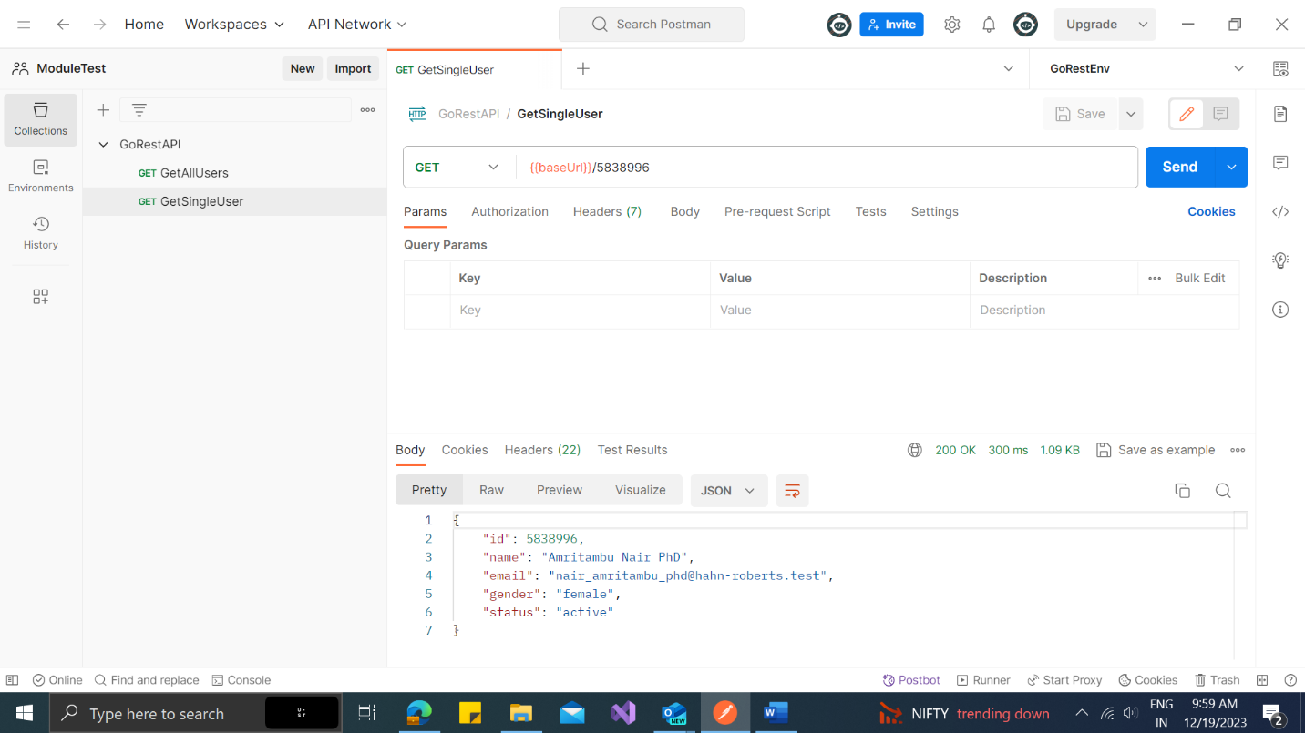

1. GET – GetSingleUser Tests

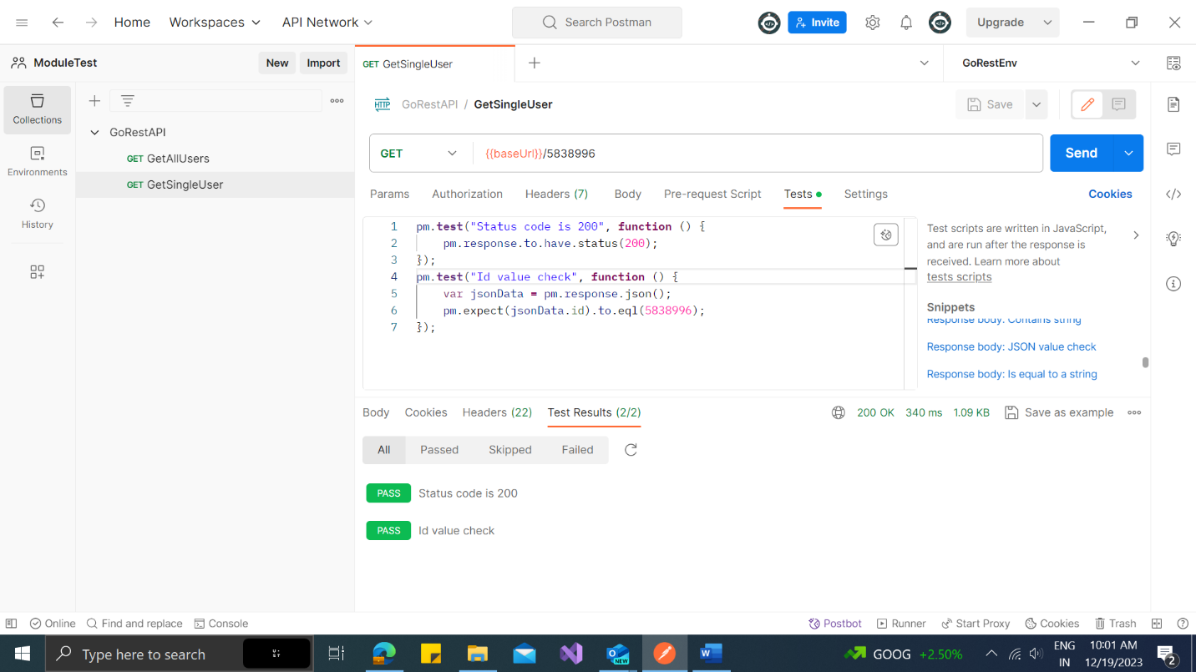

1. POST – CreateUser Response body

1. POST – CreateUser Authorization

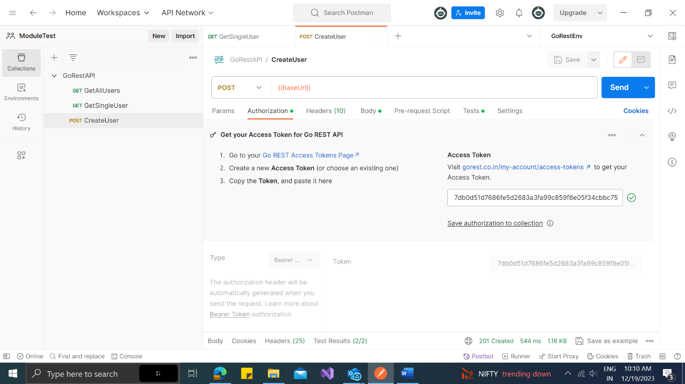

1. POST – CreateUser Tests

1. PUT – UpdateUser Response Body

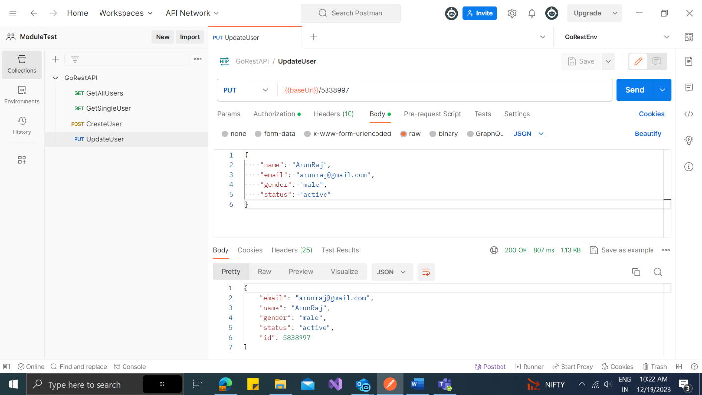

1. PUT – UpdateUser Authorization

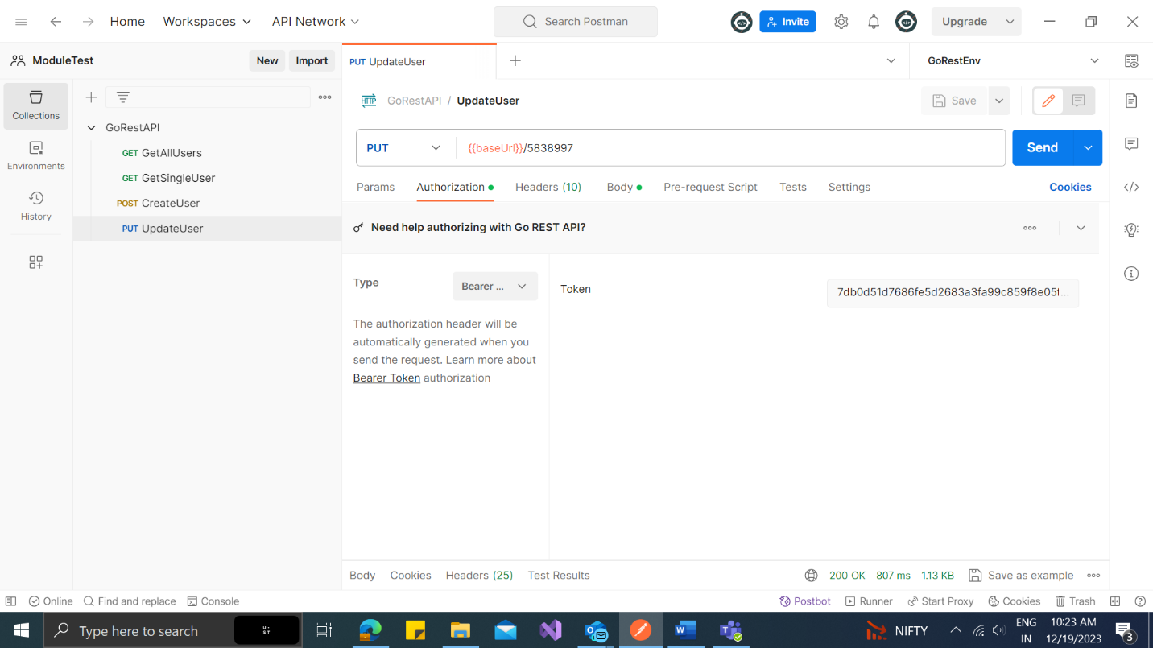

1. PUT – UpdateUser Tests

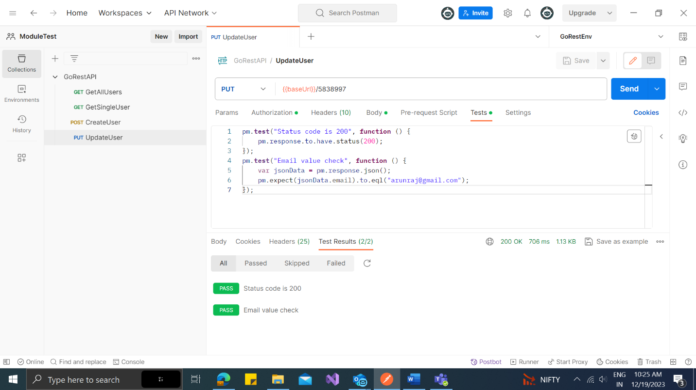

1. Patch – PartialUpdateUser Response Body

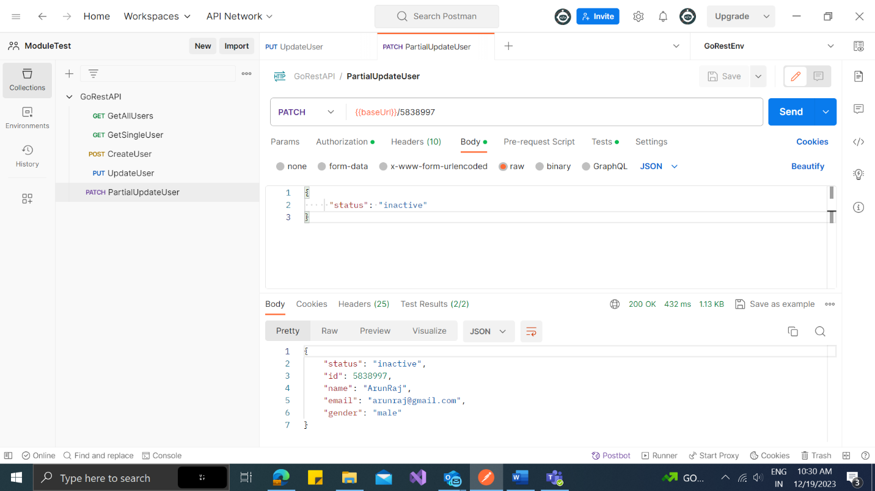

1. Patch – PartialUpdateUser Authorization

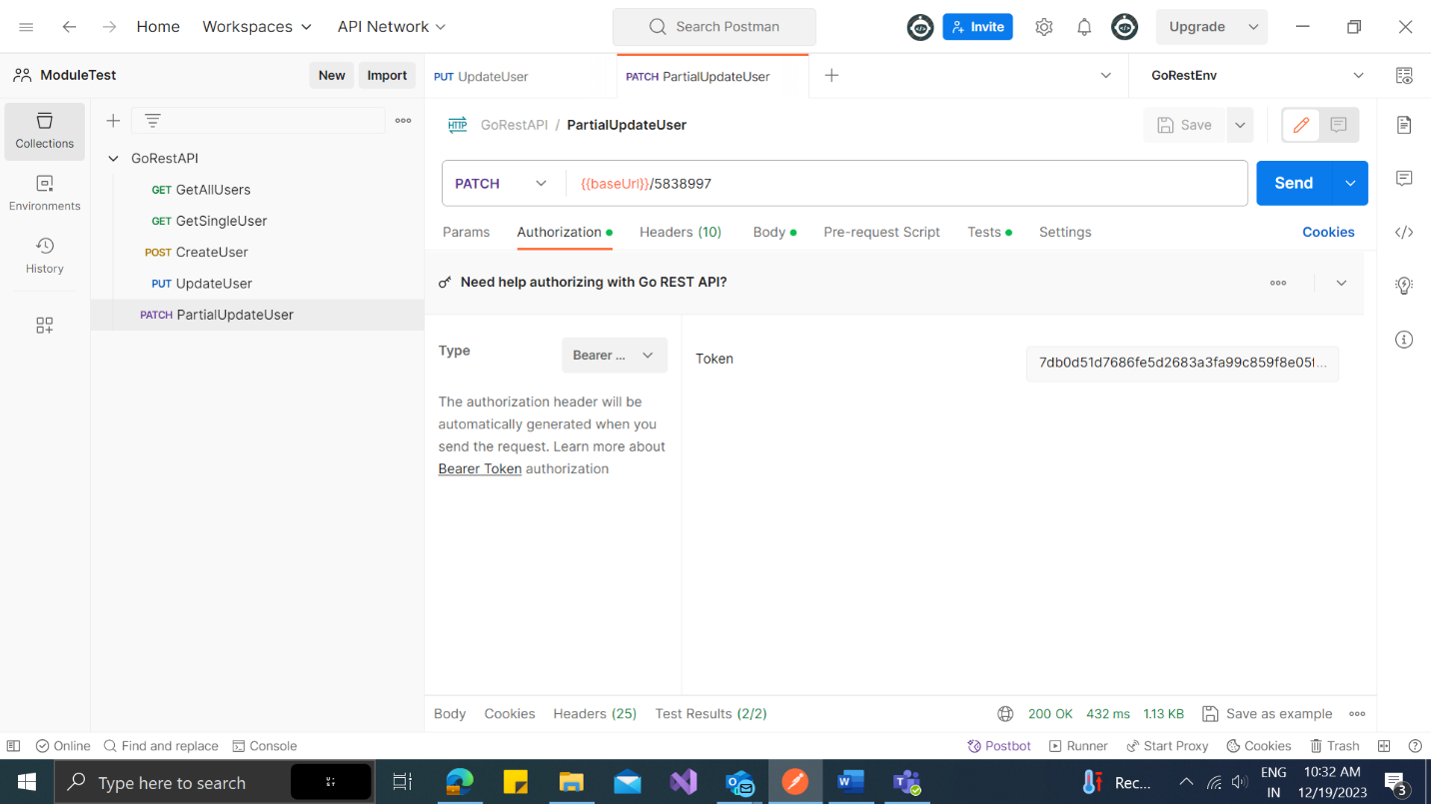

1. Patch – PartialUpdateUser Tests

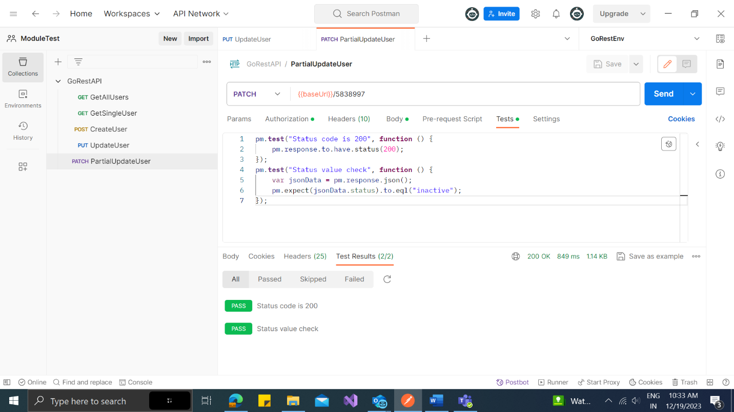

1. DELETE – DeleteUser Response Body

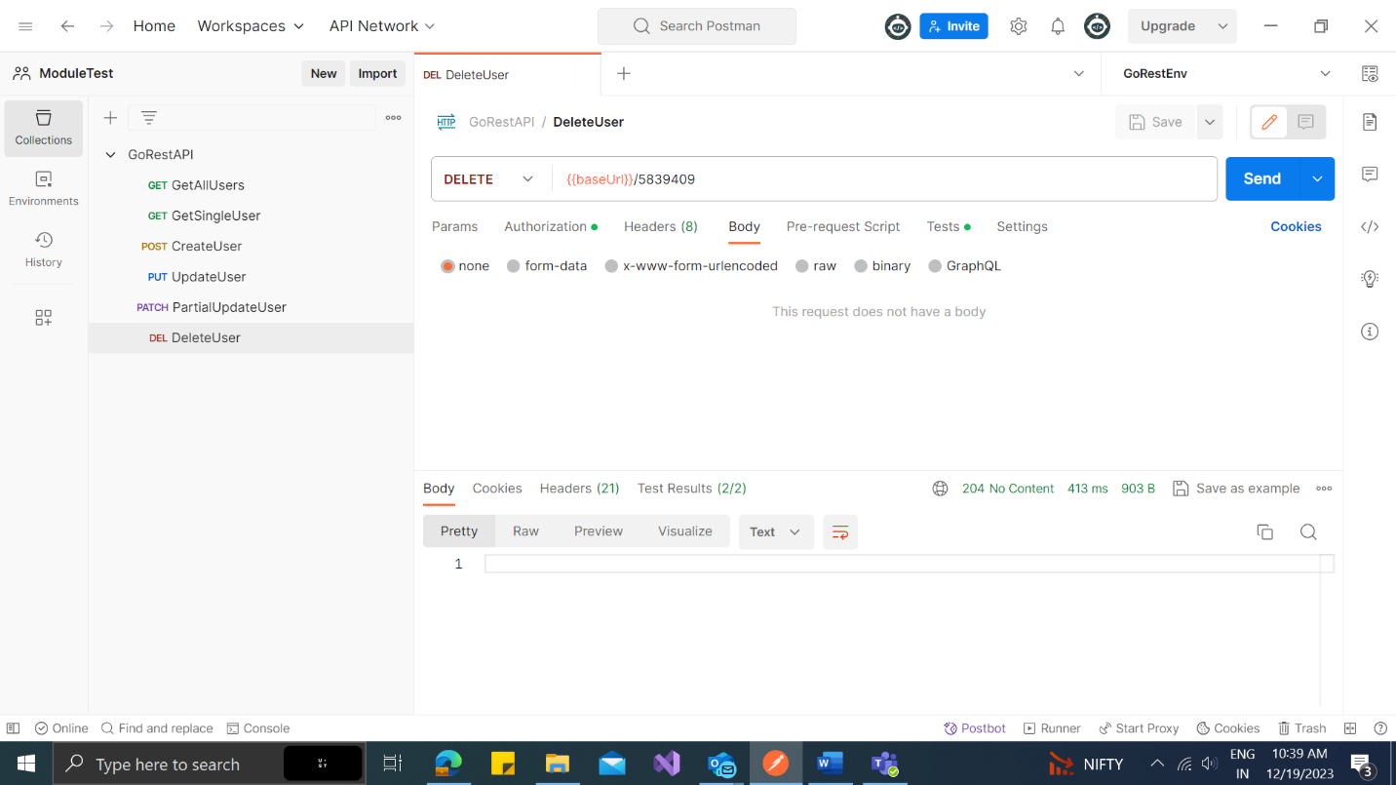

1. DELETE – DeleteUser Authorization

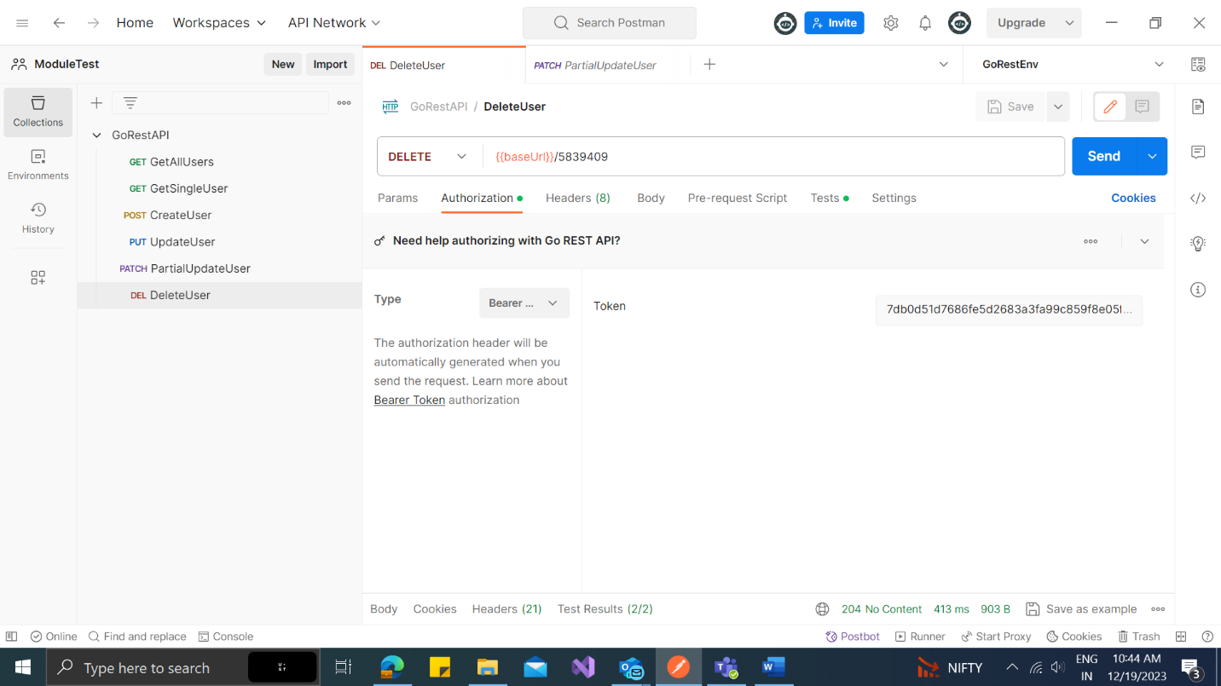

1. DELETE – DeleteUser Tests

