**InfluxDB**

* Open-source time series database
* Open **infuxdb** by going inside the particular folder -> type **powershel**l (like cmd) ->

type **./influxd** **run** (linux command)

* Open browser-> type localhost:8086 -> it will open influxdb -> copy the **token** & save it in notepad(**influxdb_key**)
* Inside **Jmeter-**> Add **Listener** to the thread group -> **Backend listener** -> under **backend listener implementation** -> select **InfluxDBRawBackendListenerClient** -> In **parameters** -> add **some fields**

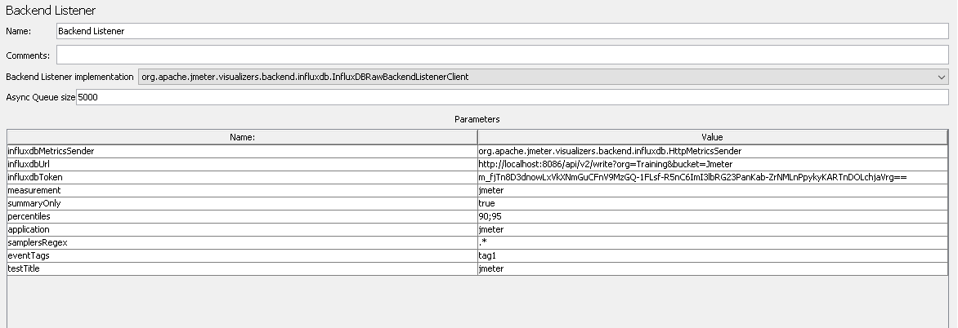

* open **influxdb already opened in browser** -> click on **Data Explorer** -> select **Jmeter** from dropdown ->Do the following:

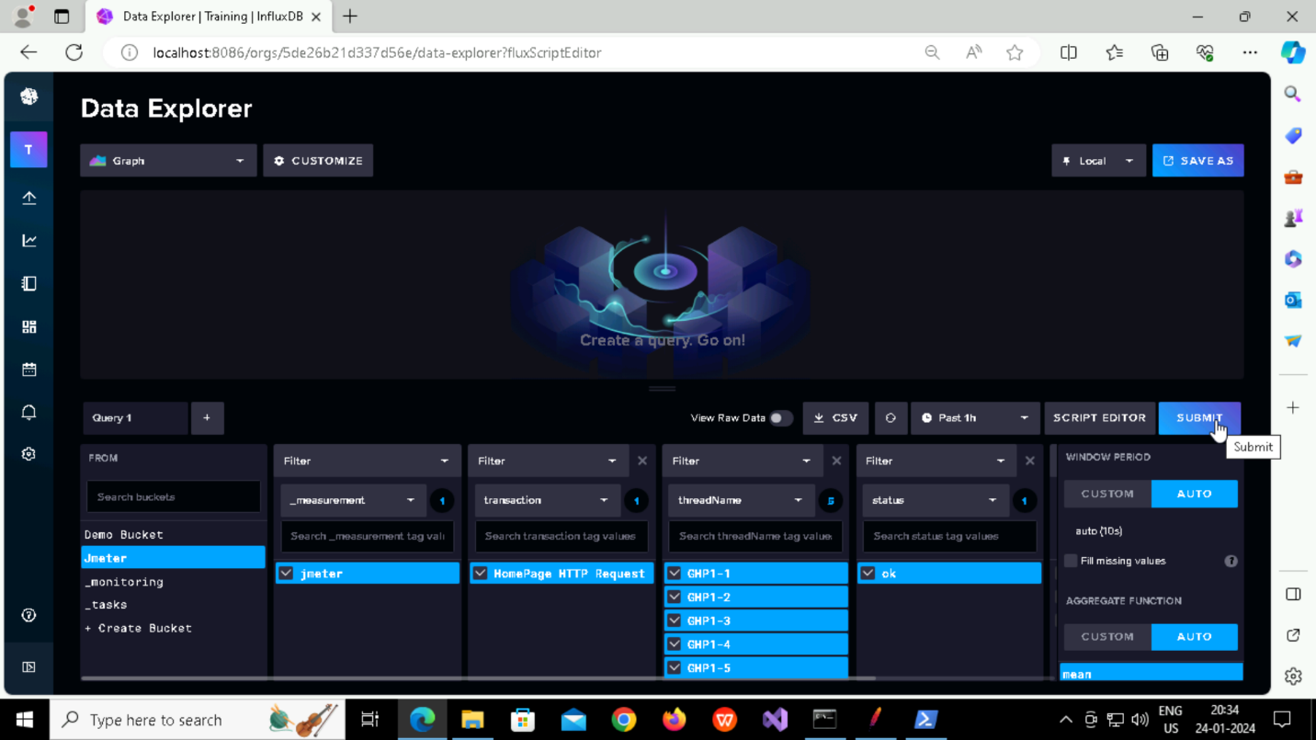

Now open **Grafana** and Do the following:

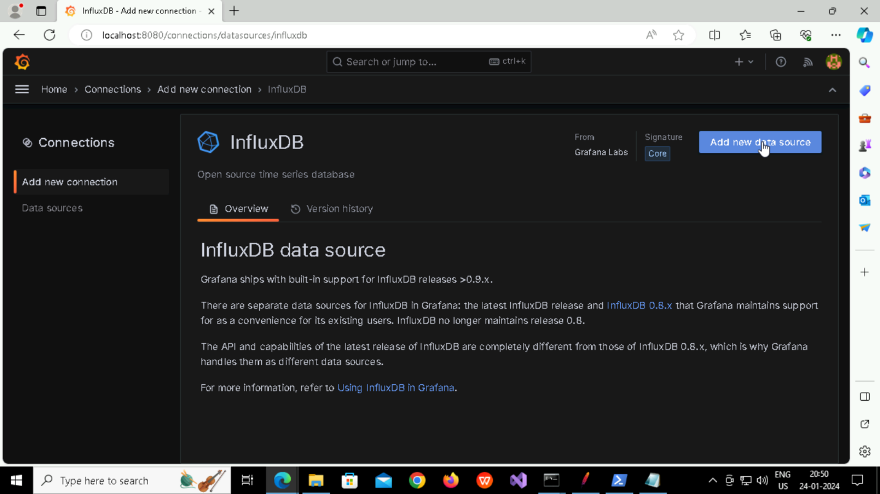

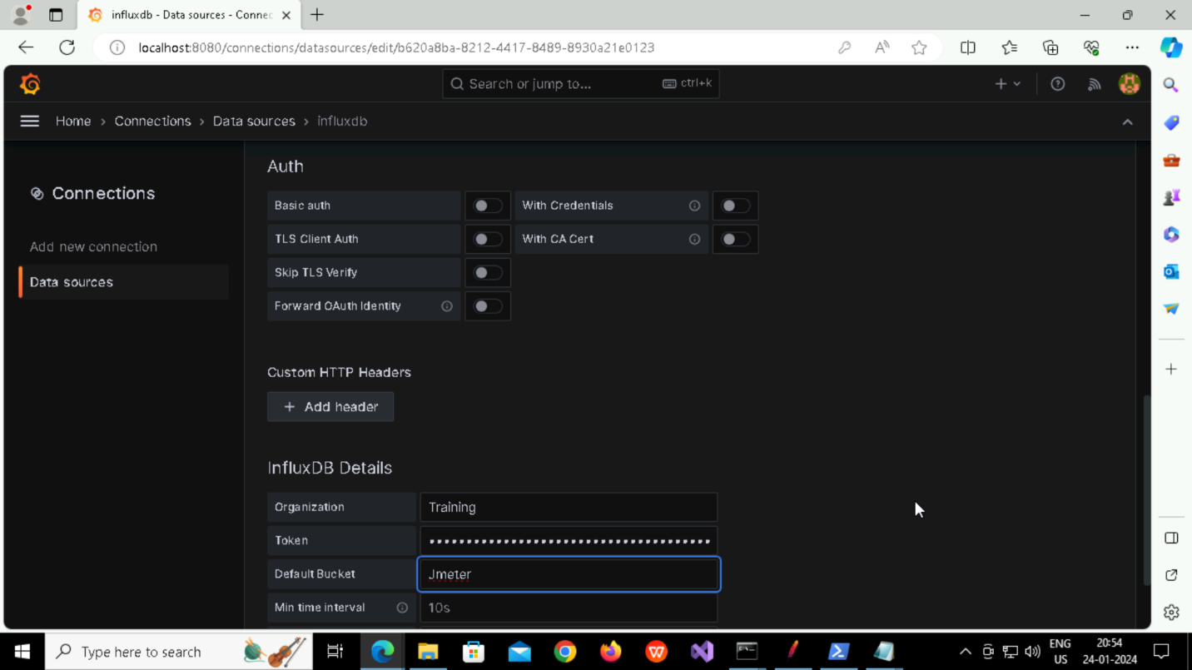

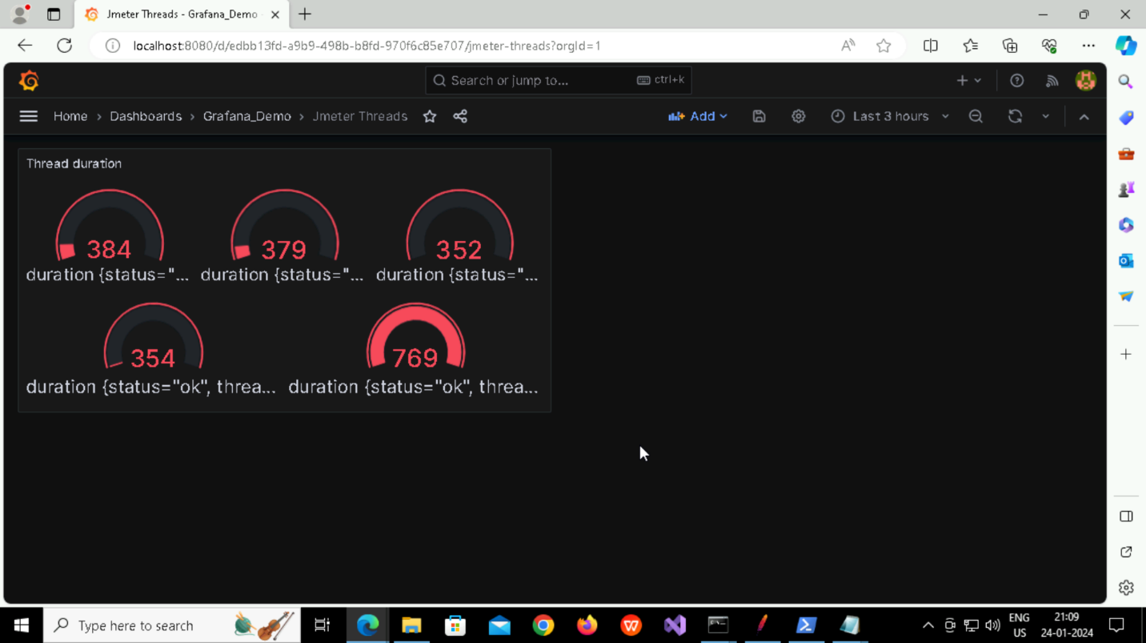

**Annotations:**



