**POSTMAN**

URL: <https://petstore.swagger.io/#/user>

Done HTTP method (GET, POST, PUT, DELETE) for a given scenario.

1. **Creating a new workspace “FoundationExam”**

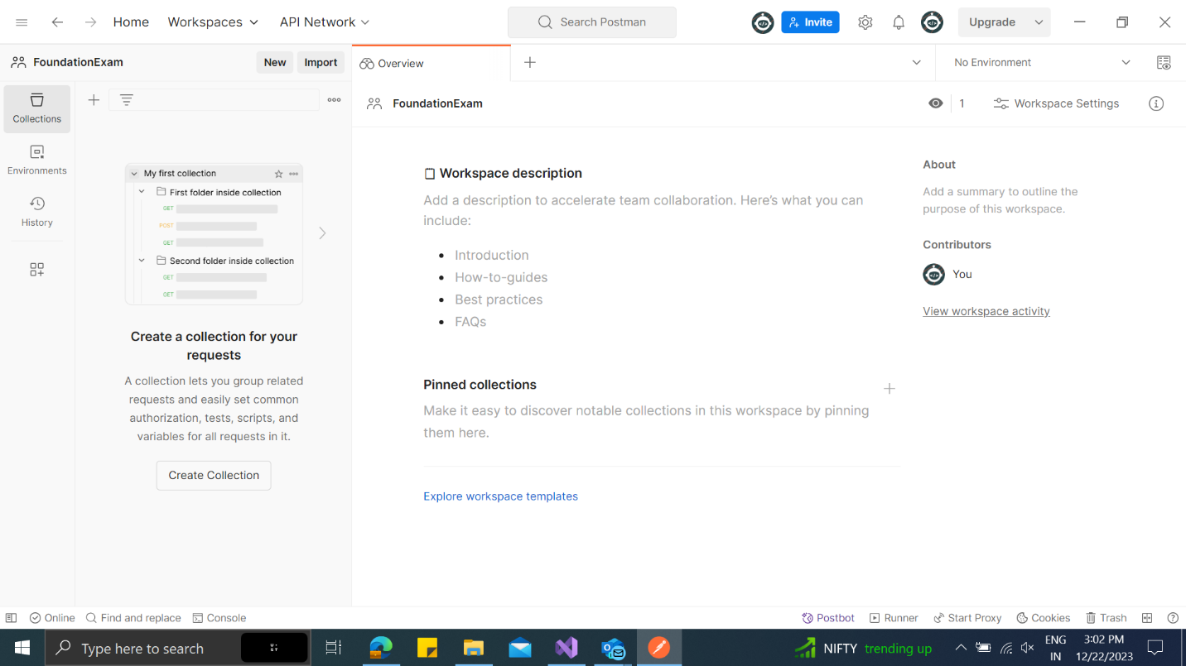

1. **Creating a new Environment called “PetStoreEnv” with variable “baseUrl”**

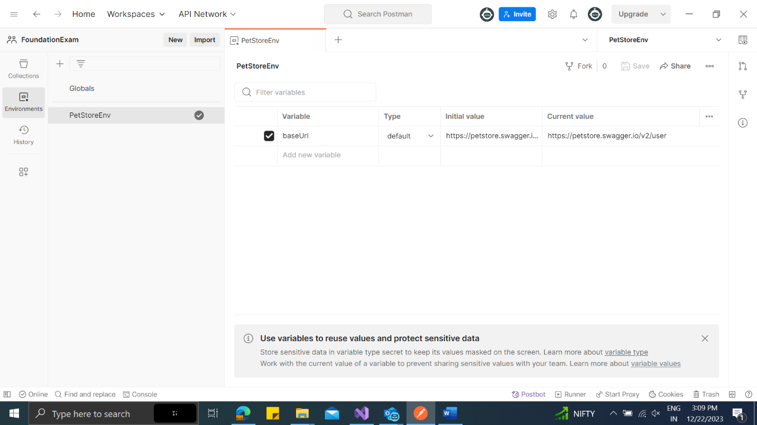

1. **Creating a new Collection “PetStoreAPI”**

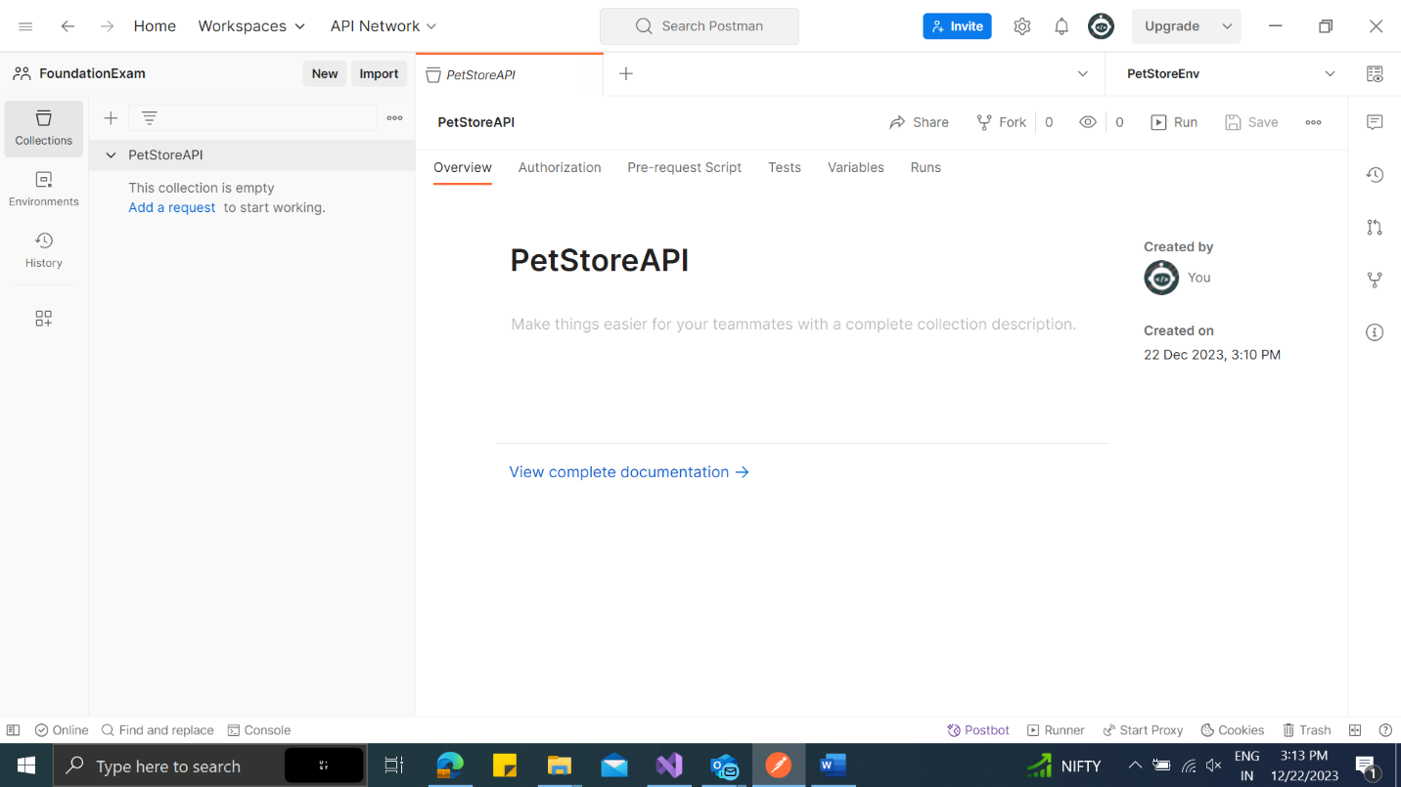

1. **GET – GetUserByUsername Response Body**

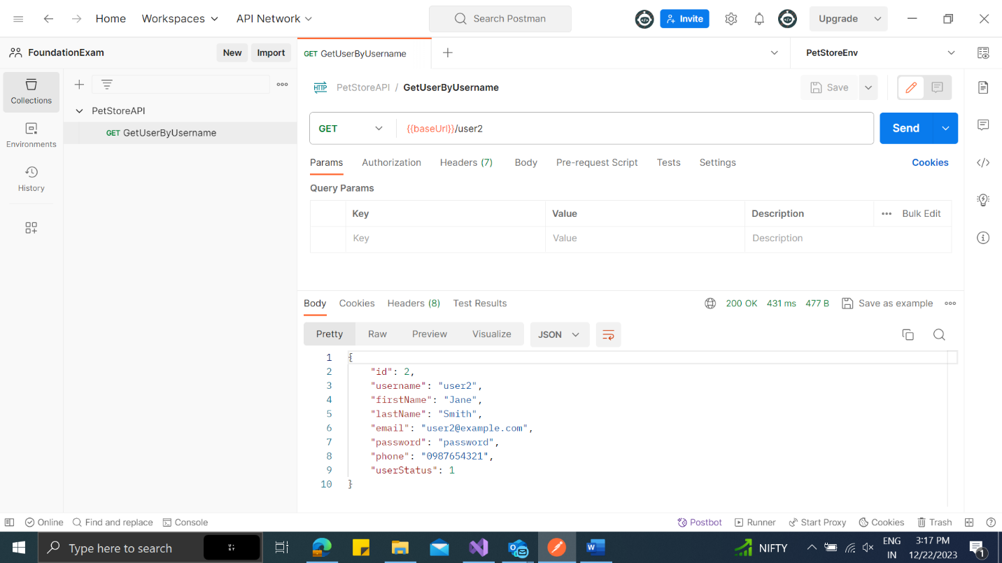

1. **GET – GetUserByUsername Tests**

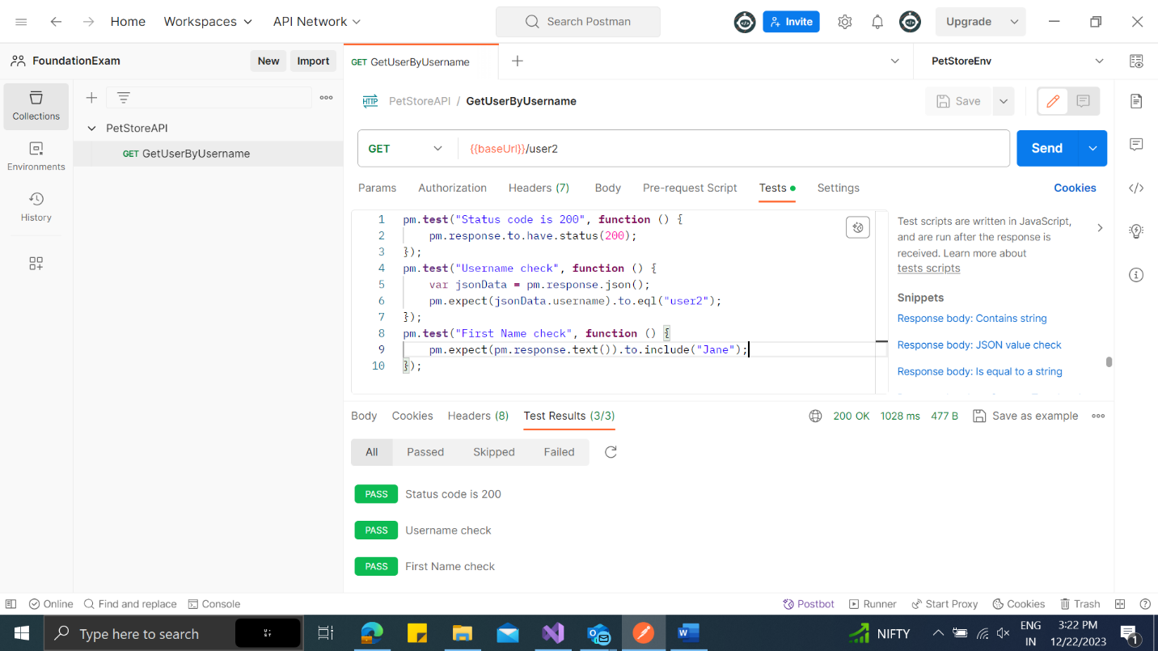

1. **POST – CreateUser Response Body**

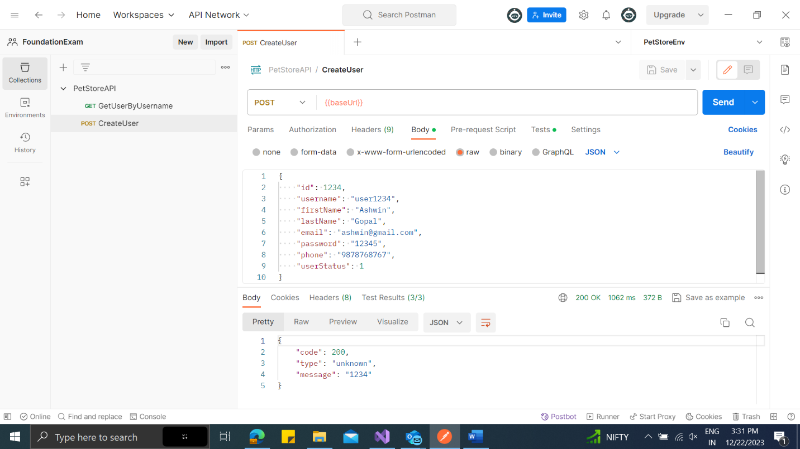

1. **POST – CreateUser Tests**

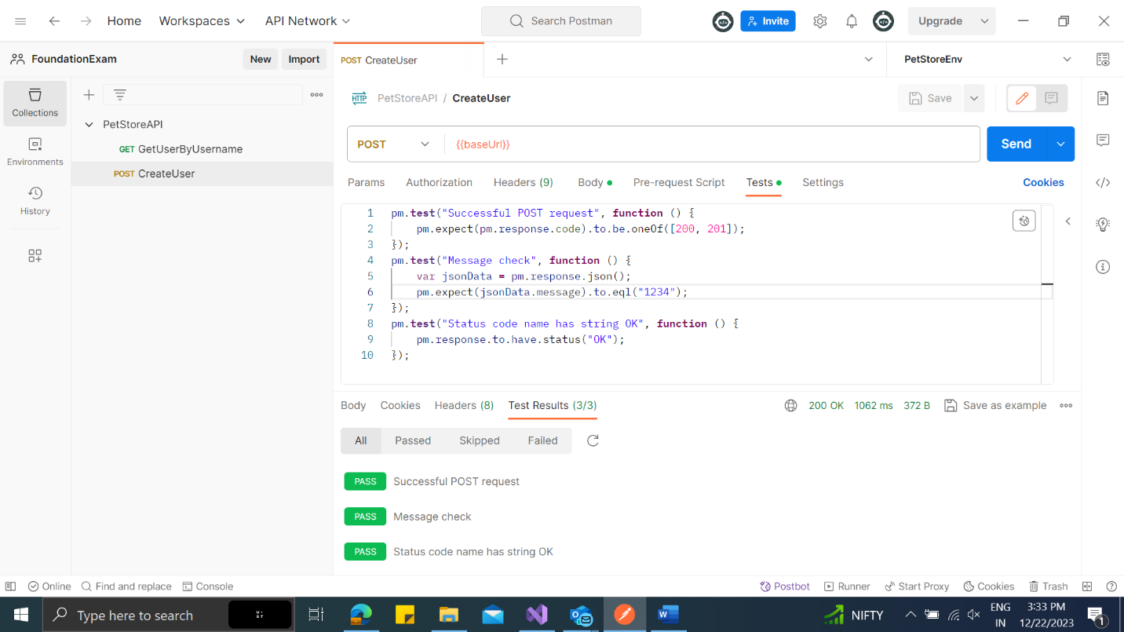

1. **PUT – UpdateUser Response Body**

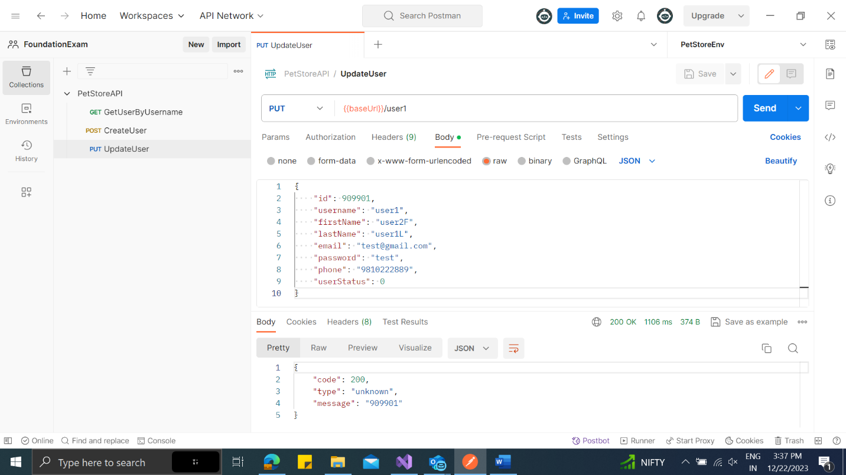

1. **PUT – UpdateUser Tests**

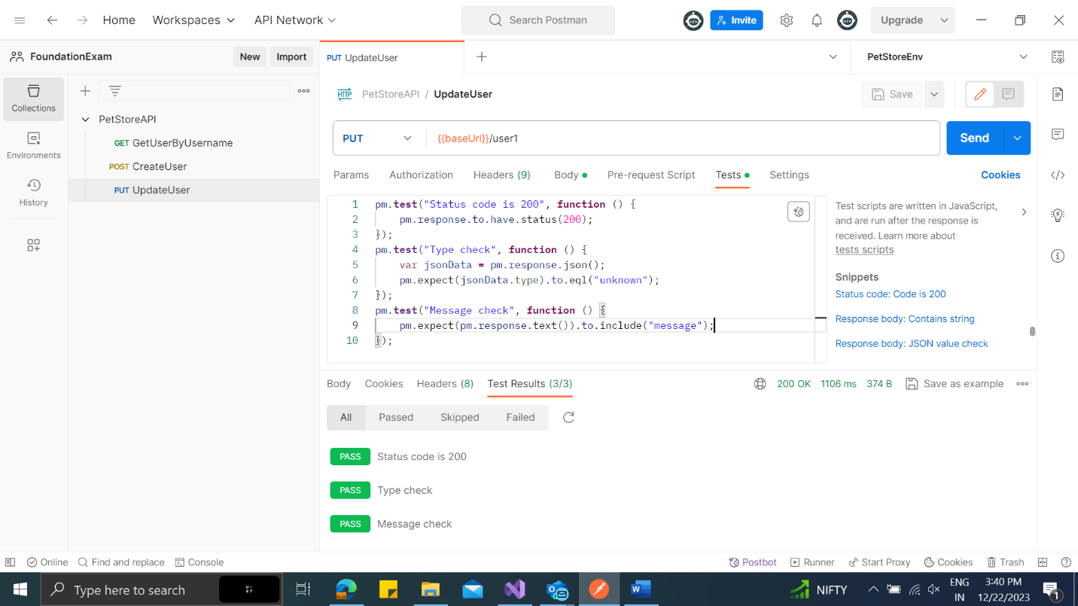

1. **DELETE – DeleteUserByUsername Response Body**

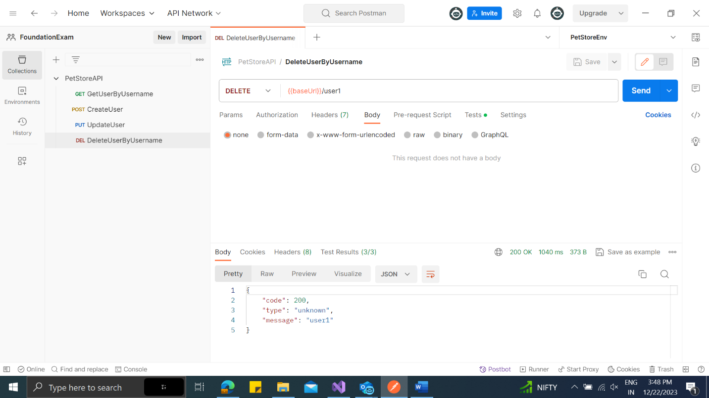

1. **DELETE – DeleteUserByUsername Tests**

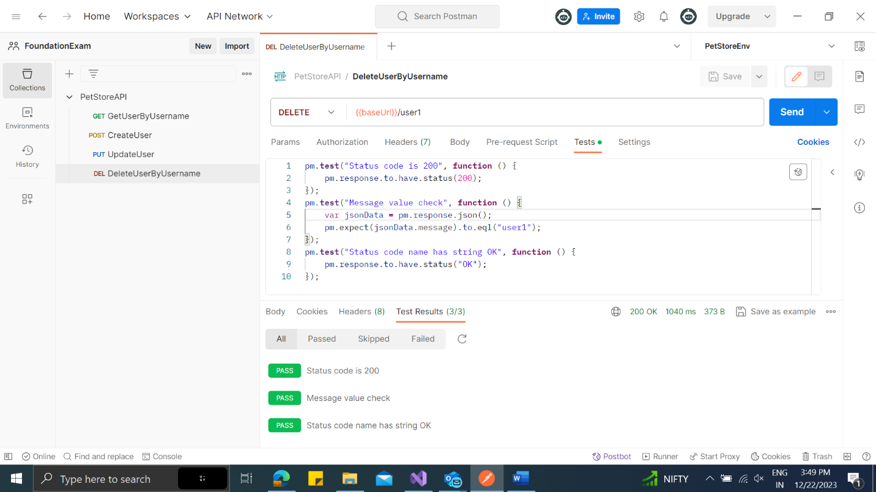

1. **GET – LogsUser Response Body**

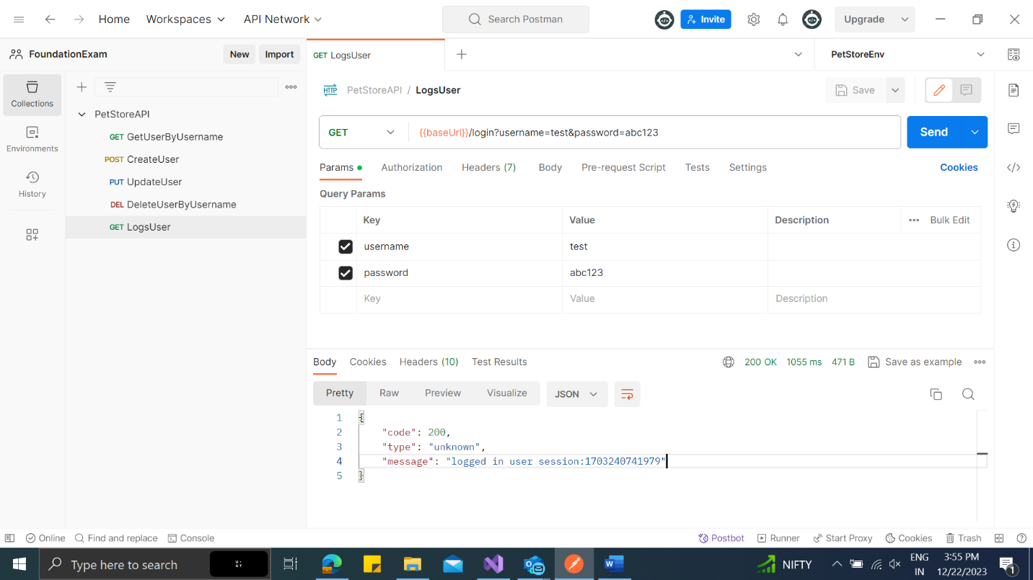

1. **GET – LogsUser Tests**

