**Prometheus**

* Open-source system monitoring & alerting tool.
* Pull model, Push model

**Data model**

* Metrics name & labels

**Metric Types:**

1. Counter
2. Guage
3. Histogram
4. Summary

**Querying Prometheus**

## **Expression language data types****:**

In Prometheus's expression language, an expression or sub-expression can evaluate to one of four types:

* **Instant vector** - a set of time series containing a single sample for each time series, all sharing the same timestamp
* **Range vector** - a set of time series containing a range of data points over time for each time series
* **Scalar** - a simple numeric floating point value
* **String** - a simple string value; currently unused

**Time Series Selectors:**

1. Instant vector selector
2. Range vector selector
3. Offset modifier
4. @modifier
5. Sub Query
6. Operators
7. Functions
8. Comments

Open **prometheus** by going inside the particular folder -> type cmd -> type **prometheus --config.file=prometheus.yml**

Open browser-> **type localhost:9090(default port)** -> it will open prometheus

Type inside Expression box like below -> http_requests_total -> Click on Execute

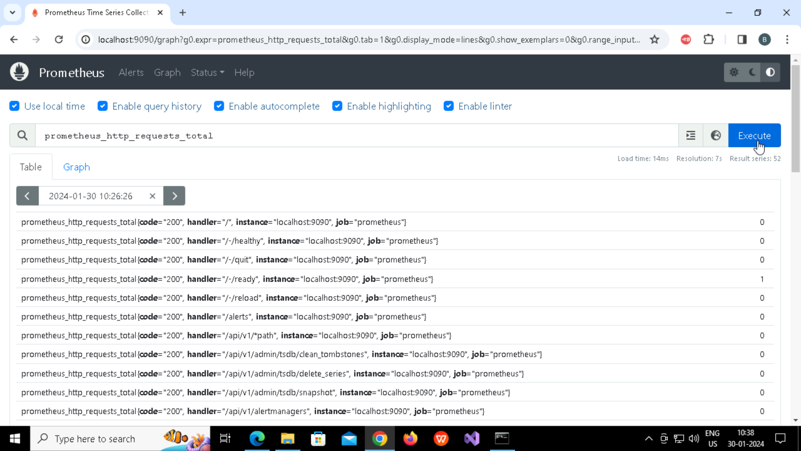

**Status**

* Configuration
* Targets
* Service Discovery

**Exporters**

* Blackbox exporter – monitors endpoints over HTTP, HTTPS, DNS, TCP and ICMP
* Open **blackbox_exporter** by going inside the particular folder -> type cmd -> type **blackbox_exporter (it will open in port 9115)**

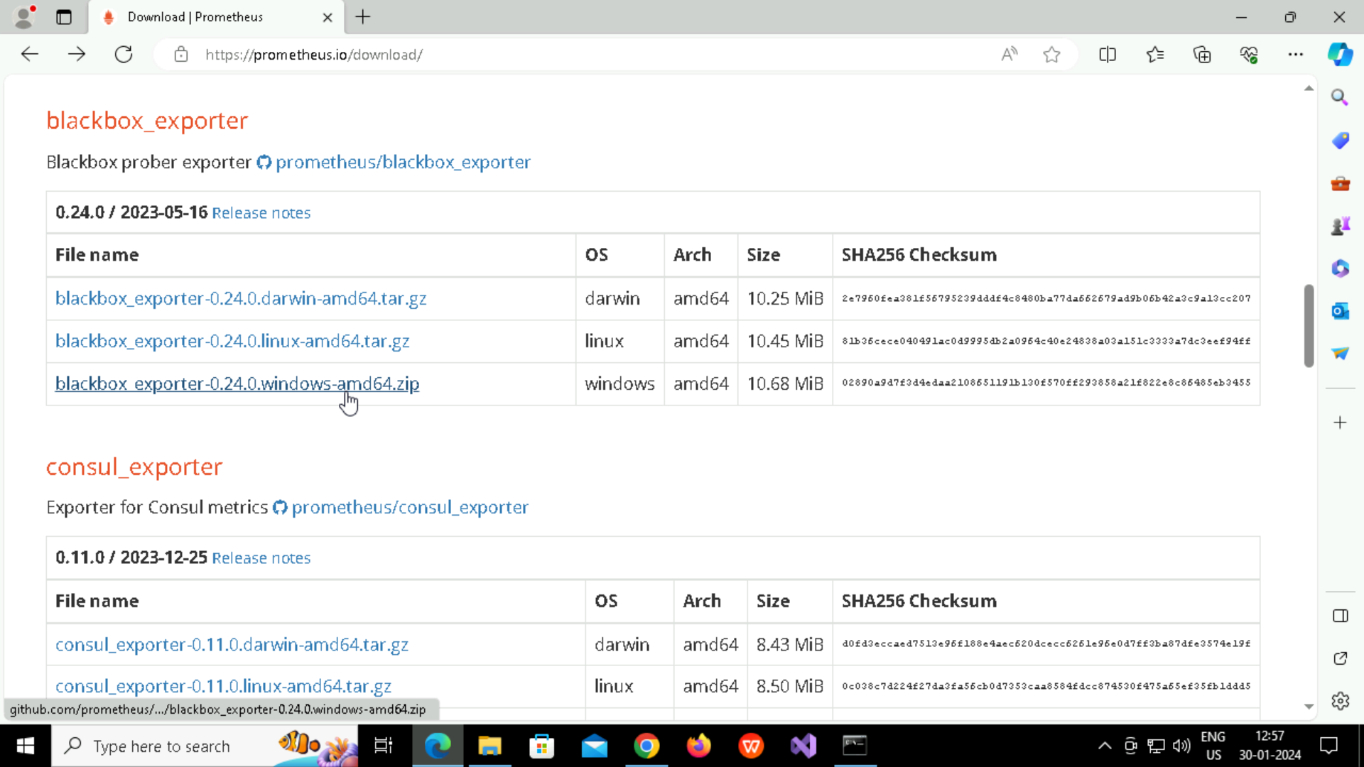

**Right click on the** [**http://localhost:9115/probe**](http://localhost:9115/probe) **link -> open link in new tab**

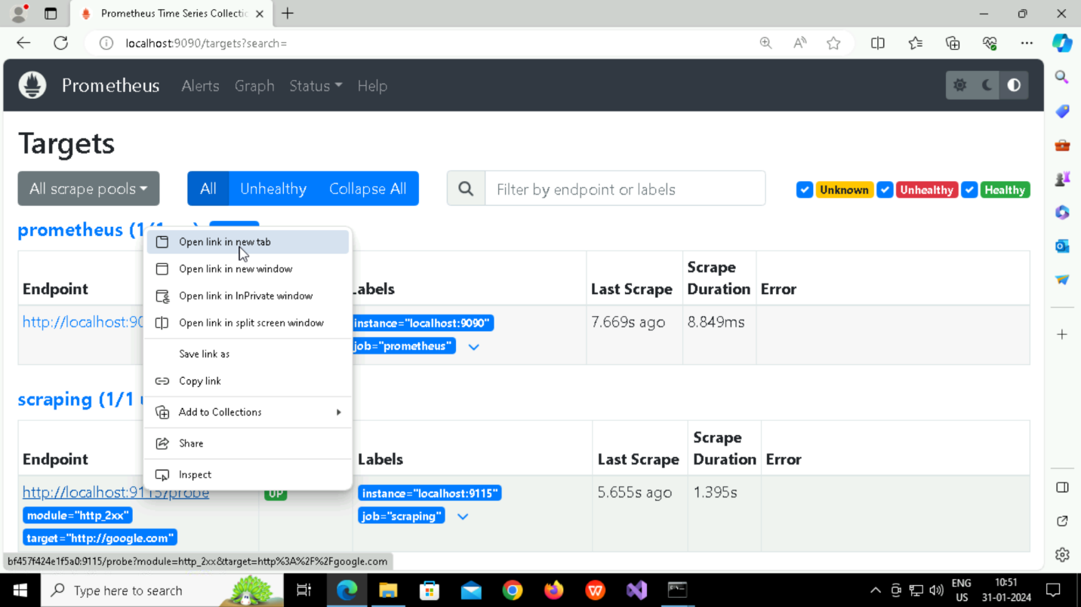

**Link opened in new tab**

