**Multi-Perspective Sentence Similarity Modeling with Convolutional Neural Network**

Citation:

{ **Title**:{Multi-Perspective Sentence Similarity Modeling with Convolutional Neural Network },

**Author**:{Hua He,Kevin Gimpel, and Jimmy Lin},

**Journal** ={Association for Computational Linguistics 2015 },

**Year** = {2015},

Link= {<http://www.emnlp2015.org/proceedings/EMNLP/pdf/EMNLP181.pdf>} }

**Input format for prediction**:

Sentence 1, Sentence 2

**Output format for prediction**:

Sentence 1, Sentence 2, Similarity score

**Input format for training**

The **semeval-sts 2012,**2013,2014,2015,2016 is preprocessed and converted into tsv format is used for training the model.

The input is in the tsv format as shown below:

Similarity_Score Sentence1 Sentence2

The Model consists of two main components:

* Sentence model
* Similarity measurement layer

The model consists of two main components as shown in figure:

1 .A sentence model for converting a sentence into a representation for similarity measurement; we use a convolutional neural network architecture with multiple types of convolution and pooling in order to capture different granularities of information in the inputs.

2. A similarity measurement layer using multiple similarity measurements, which compare local regions of the sentence representations from the sentence model.

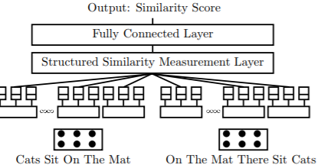

The code is implemented in python 3.5 and tensorflow 1.0.0

The benchmark metrics used is **semeval-sts 2012,**2013,2014,2015,2016 for training and testing the data.

**Evaluation metrics and results**

**Loss: 14.6**

**Accuracy: 80%**

Github Link: <https://github.com/Fengfeng1024/MPCNN>

Youtube Link: <https://youtu.be/Jbc6W1JGBxA>