STUDENT TASK MANAGER
Java Object-Oriented Programming Project
Project Report
Submitted in partial fulfilment of the requirements for the Java Programming course.
Submitted by: Gouni Brundavan Reddy
Roll Number: 160125733161
Department: Computer Science and Engineering
Academic Year: 2026–2027
Project : Java, Collections Framework, Threads, Exception Handling

1. Abstract
Student Task Manager is a menu-driven Java console application designed to help students organise academic and personal activities in one place. Users can add coursework tasks, store personal goals, view all tasks, mark tasks as completed, delete tasks, run a background reminder check, and save task information to a local text file.
The project is intentionally designed around core object-oriented programming principles. A common abstract Task class represents shared task data. AcademicTask and PersonalTask extend it to provide specialised task information. The subclasses override methods to describe their own category and details. A TaskRepository interface separates the operations expected from storage from the concrete collection-based implementation.
The application uses Java collections to manage tasks during execution. A Runnable implementation performs a reminder check on a separate thread, illustrating basic multithreading. Input validation and exception handling protect the application against blank titles, duplicate IDs, invalid numeric task IDs, and file errors. Java NIO classes such as Path and Files provide file persistence.

Project objectives
- Apply inheritance and method overriding to model different task types.
- Use an interface to define a clear repository contract.
- Use Java collections to store and search task objects.
- Demonstrate a worker thread with Runnable, Thread.start(), and join().
- Handle invalid input and file-related failures gracefully.
- Use Java NIO to save and read task records from a UTF-8 file.

Scope
This is a local, single-user demonstration application. Tasks remain in memory while the program is running and are written to a file when the user selects Save. The current version does not automatically reconstruct Task objects from the saved file; it displays the saved records for verification.

2. Problem Statement and Requirements

2.1 Problem statement
Students often need to track assignments, lab work, examinations, revision goals, and everyday activities. Keeping these tasks in separate notes can make it difficult to review progress. The goal is to build a small application that provides a single task list, supports different task categories, validates user actions, and stores a record of tasks in a file.

2.2 Functional requirements
- The application shall show a menu and accept a user-selected operation.
- The user shall be able to add an academic task with a subject and due date.
- The user shall be able to add a personal task with a priority.
- The application shall list task ID, category, status, title, and specialised details.
- The user shall be able to mark a task complete or remove it by ID.
- The application shall run a pending-task reminder check on a separate thread.
- The application shall save task records to a local UTF-8 text file and display saved records.

2.3 Non-functional requirements
- Usability: options and error messages should be understandable.
- Maintainability: task data, repository operations, storage, and user interaction are separated into classes.
- Reliability: invalid input should not terminate the application.
- Portability: the application should run on any operating system with a compatible JDK.
- Low resource use: no external database or third-party library is required.

2.4 Software and hardware requirements
Software: JDK 17 or later, a terminal or command prompt, and optionally an IDE such as IntelliJ IDEA, Eclipse, or Visual Studio Code. Hardware: an ordinary computer capable of running a Java development kit. Internet access is not required at runtime.

3. System Architecture
The application follows a simple layered design. The user interface receives commands and calls domain or service objects. Task subclasses represent the domain model. The repository interface defines the collection operations, and the in-memory repository implements those operations. TaskStorage is a separate utility responsible for file persistence.

3.1 Architecture overview
- Presentation layer — TaskManagerApp: menu, input, output, and exception messages.
- Domain layer — Task, AcademicTask, PersonalTask: task attributes and task-specific behaviour.
- Repository layer — TaskRepository, InMemoryTaskRepository: adding, listing, searching, and deleting tasks.
- Service layer — ReminderService: checks pending tasks in a worker thread.
- Persistence layer — TaskStorage: writes and reads task records using Java NIO.

3.2 Text architecture diagram
+-------------------------------+
| TaskManagerApp |
+---------------+---------------+
| uses
+-------+--------+
| |
+-----v------+ +-----v------+
| Repository | | TaskStorage|
| Interface | | (Java NIO)|
+-----+------+ +------------+
| implemented by
+-----v-----------------------+
| InMemoryTaskRepository |
+-----------------------------+
| stores Task objects
+-----v-----------------------+
| Task (abstract base class) |
+-------------+---------------+
| extends
+-------+--------+
| |
+-----v------+ +-----v------+
| Academic | | Personal |
| Task | | Task |
+------------+ +------------+
TaskManagerApp also starts ReminderService on a worker thread.

3.3 Design rationale
This separation avoids placing all logic in one large class. The interface makes it possible to replace the in-memory repository with another implementation later. The abstract base class avoids duplicated common fields and methods. The storage helper isolates file operations so I/O exceptions can be handled at the application boundary.

4. Module Description

4.1 Task — abstract base class
Task stores the ID, title, description, completion state, and creation time shared by every task. Its constructor validates that the title is not blank. It declares getCategory() and getTaskDetails() as abstract methods, requiring concrete subclasses to provide their own implementation. It also defines common display and file-record methods.

4.2 AcademicTask
AcademicTask extends Task and adds subject and dueDate fields. Its overridden getCategory() method returns Academic, while getTaskDetails() returns the subject and due date. The class also overrides toFileRecord() to append its specialised fields to the saved record.

4.3 PersonalTask
PersonalTask extends Task and adds a priority field. It overrides getCategory() and getTaskDetails() to report personal-task information. This allows both subclasses to be handled through a common Task reference while still displaying their own specialised details.

4.4 TaskRepository interface
TaskRepository declares add(), getAll(), findById(), and remove(). The interface describes what a repository can do without requiring callers to know how the tasks are stored.

4.5 InMemoryTaskRepository
InMemoryTaskRepository implements TaskRepository using an ArrayList. Its methods are synchronized to keep collection operations coordinated if accessed by more than one thread. Duplicate IDs are rejected. getAll() returns an unmodifiable snapshot so callers cannot directly alter the internal list.

4.6 TaskStorage
TaskStorage encapsulates the file path and uses NIO Files methods to create parent directories, write UTF-8 records, and read saved lines. It creates or replaces the file when Save is selected. An IOException is propagated to the application, where it is caught and shown to the user.

5. Object-Oriented Concepts

5.1 Inheritance
Inheritance allows a specialised class to reuse accessible behaviour from a base class. In this project, AcademicTask and PersonalTask extend Task. Both automatically inherit common operations such as getId(), getTitle(), markCompleted(), and isCompleted(). This avoids repeating the same fields and methods in every task class.

5.2 Method overriding and runtime polymorphism
Both subclasses override getCategory() and getTaskDetails(). When the application loops through List<Task>, it calls task.getCategory() and task.getTaskDetails(). Java selects the implementation belonging to the actual object at runtime. An AcademicTask prints its subject and due date, while a PersonalTask prints its priority.

5.3 Abstract class
Task is abstract because a generic task does not have one universal category or detail format. The abstract methods ensure that every concrete task type supplies its own category and details.

5.4 Interface
TaskRepository is a contract. TaskManagerApp depends on the interface instead of depending directly on the ArrayList implementation. This follows programming-to-an-interface and improves testability and extensibility.

5.5 Encapsulation
Task fields are private, and callers use public methods to inspect or update permitted values. The title setter repeats validation so an invalid blank title cannot be introduced after construction.

Concept-to-code mapping
- Task.java — abstract class, private fields, common behaviour.
- AcademicTask.java — inheritance and overridden methods.
- PersonalTask.java — inheritance and overridden methods.
- TaskRepository.java — interface declaration.
- InMemoryTaskRepository.java — interface implementation and collection use.

6. Collections and Multithreading

6.1 Collections framework
The repository stores task objects in an ArrayList<Task>. ArrayList supports dynamic growth and convenient iteration. The List interface is used in method signatures, reducing dependence on one concrete implementation. Optional<Task> communicates that a search may or may not find a task. Streams are used to filter pending tasks and convert tasks into file records.
The repository rejects duplicate IDs by searching the existing list before insertion. The synchronized keyword on repository methods coordinates concurrent access to the internal collection. getAll() creates a snapshot and wraps it as unmodifiable, which protects the internal list from accidental external structural changes.

6.2 Multithreading
ReminderService implements Runnable, so its run() method contains the background work. When the user chooses option 6, the program creates a Thread with a ReminderService instance and starts it. The JVM executes run() on the worker thread rather than directly on the main menu thread.
The worker obtains a task snapshot, filters tasks that are not completed, and prints the pending count and task titles. The main thread calls join() to wait until the reminder worker finishes before continuing. InterruptedException is handled by restoring the interrupted status with Thread.currentThread().interrupt().

6.3 Thread flow
- User chooses the background reminder option.
- TaskManagerApp creates a Thread around ReminderService.
- start() schedules the worker's run() method.
- ReminderService reads the task list and filters pending tasks.
- The worker prints reminder information and exits.
- join() ensures the main flow waits for completion.
This is a small educational example rather than a continuously running scheduler. A future version could use ScheduledExecutorService for periodic reminders.

7. Exception Handling and Java NIO

7.1 Exception handling
The program uses exceptions to detect and communicate invalid operations. IllegalArgumentException is used for a blank title, blank academic subject, duplicate task ID, or invalid numeric ID. The menu loop catches input errors and continues running instead of terminating.
IOException is caught around save and file-view operations. This covers problems such as unavailable directories, permissions, or other file-system failures. InterruptedException is caught when waiting for the reminder thread; the interrupt flag is restored before the application continues. A final general exception handler prevents an unexpected runtime issue from immediately ending the menu, although production applications should normally log unexpected exceptions in more detail.

7.2 Java NIO concepts
- Path.of("data", "tasks.txt") represents the destination file path.
- Files.createDirectories() ensures the parent directory exists.
- Files.write() writes UTF-8 records and uses CREATE plus TRUNCATE_EXISTING options.
- Files.readAllLines() reads saved lines using UTF-8.
- Files.notExists() checks whether the file is absent before reading.

7.3 Data format
Each task is written as a pipe-separated text record. Common fields include ID, category, completion state, title, description, and creation timestamp. Academic tasks append subject and due date. Pipe characters inside user-entered text are replaced with slashes so the delimiter is not accidentally repeated in the record.
The file is intended as a simple demonstration format. A more robust production version would use CSV escaping or JSON and would implement parsing, schema validation, and reconstruction of task objects on application startup.

7.4 Error examples
- Blank title → “Task title cannot be empty.”
- Non-numeric task ID → “Task ID must be a whole number.”
- Duplicate ID → “A task with this ID already exists.”
- Missing saved file → the app reports that no saved records exist yet.

8. Testing and Sample Output

8.1 Test cases
Test | Action | Expected result
TC-01 | Add valid academic task | Task is added with subject and due date.
TC-02 | Add valid personal task | Task is added with priority.
TC-03 | View tasks | Both task categories show correct details.
TC-04 | Enter letters for task ID | Validation message appears; menu continues.
TC-05 | Complete an existing task | Status changes to COMPLETED.
TC-06 | Delete an existing task | Task is removed from the list.
TC-07 | Run reminder | Worker thread prints pending task titles.
TC-08 | Save and view records | UTF-8 records are written and displayed.

8.2 Sample demonstration
Example sequence: add an academic task titled “Complete Java Assignment” for subject Java, add a personal task titled “Buy notebooks” with High priority, list all tasks, run the reminder, save the records, and view the saved file. Exact creation timestamps vary when the program runs.
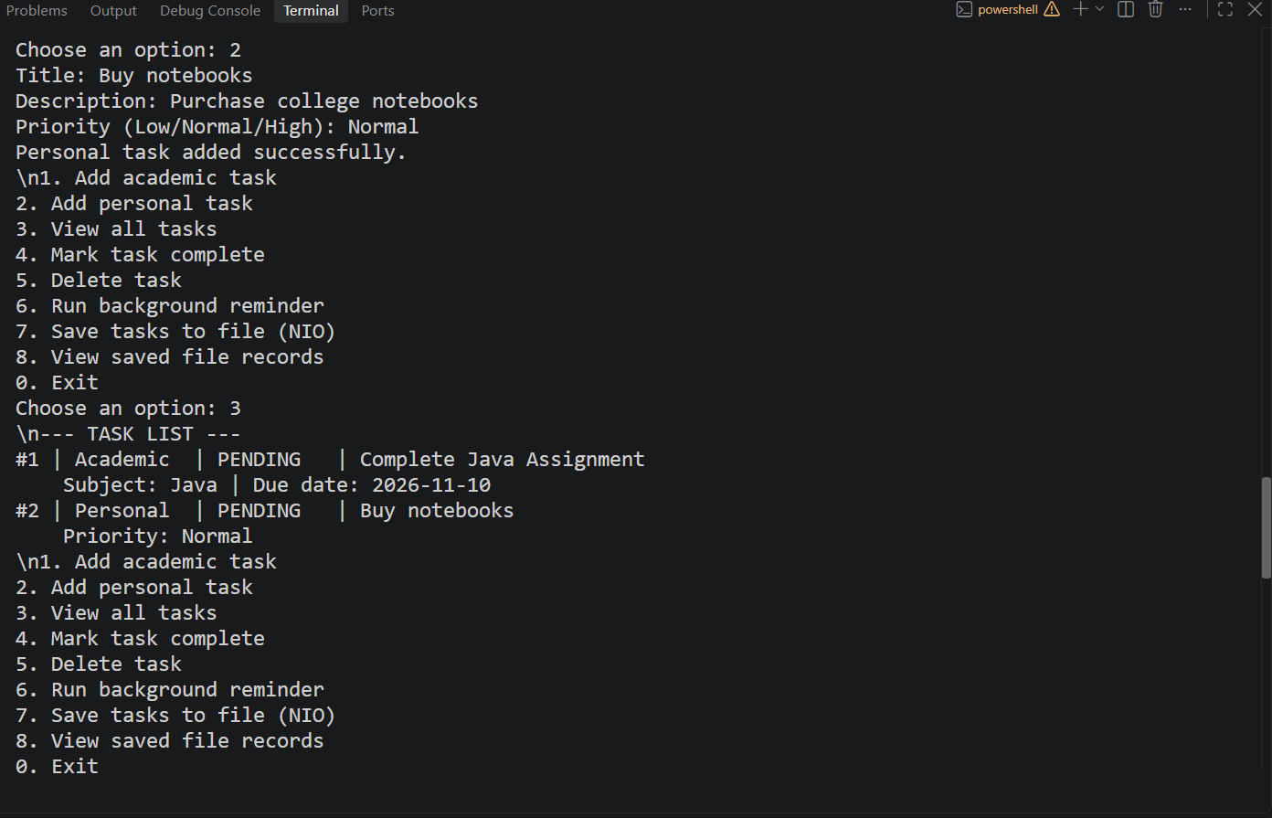

9. Screenshots, Limitations and Conclusion

9.1 Reminder and file output
The following illustrative terminal image shows the reminder worker and the file-save workflow. For final submission, run the program on your own computer and replace these sample images with screenshots captured from your actual run.
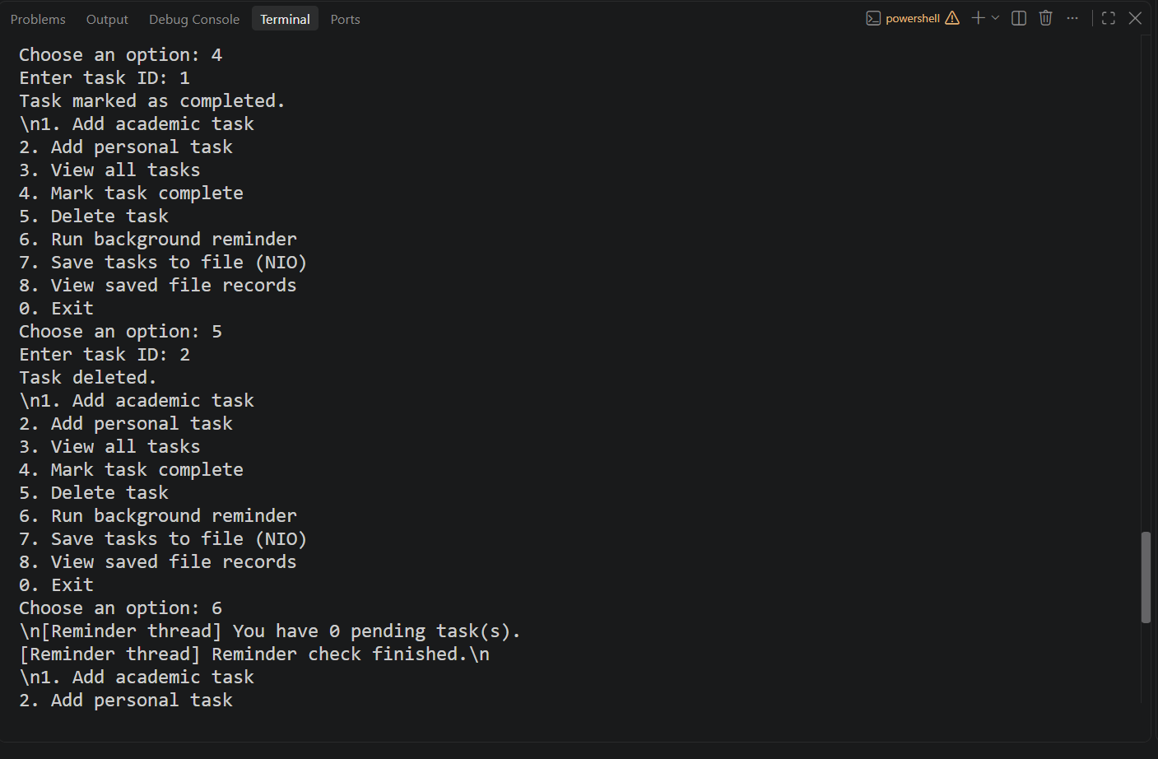

9.2 Current limitations
- Tasks are held in memory until the user saves them; automatic loading into task objects is not implemented.
- The application is a console program and does not include a graphical interface.
- IDs are assigned sequentially during one run and are not restored from a saved file.
- The reminder is started manually and is not a scheduled notification service.

9.3 Future enhancements
- Load saved records automatically when the application starts.
- Add task editing, date validation, filtering, and sorting.
- Use JSON or a database for more reliable persistence.
- Add unit tests and a graphical interface.
- Use ScheduledExecutorService for periodic reminders.

9.4 Conclusion
Student Task Manager demonstrates the required Java concepts in a cohesive application. Inheritance and overriding model different task types, an interface defines repository operations, collections manage task objects, a separate thread checks pending tasks, exception handling protects common operations, and Java NIO provides file storage. The modular design makes the project understandable for coursework and leaves clear opportunities for future improvement.

References
- Oracle Java Documentation — Classes and Objects: https://docs.oracle.com/javase/tutorial/java/javaOO/
- Oracle Java Documentation — Collections: https://docs.oracle.com/javase/8/docs/technotes/guides/collections/overview.html
- Oracle Java Documentation — Concurrency: https://docs.oracle.com/javase/tutorial/essential/concurrency/
- Oracle Java Documentation — Basic I/O and NIO: https://docs.oracle.com/javase/tutorial/essential/io/

