Indian Institute of Technology Jodhpur
CSL7570 — Autonomous Systems
Assignment 2
Multi-Agent Academic Helpdesk Agent
Retrieval-augmented generation with tools, citations and refusals using Google ADK, Ollama and ChromaDB
Submitted by
Name | Roll number
ANSHIKA ROLYA | B23CH1003
BRUNDHA DEVI A | B23CH1015
30 October 2026
Code repository: github.com/brundhaiitj/AS_A2_Acadamic-Helpdesk-Agent_1015_1003

1. Introduction
This report presents a multi-agent Academic Helpdesk Agent for IIT Jodhpur. The agent answers questions about academic programs, course contents, academic rules and regulations, course slots, electives and the academic calendar. It also drafts emails to course instructors to apply for sick leave or to seek permission for a make-up examination. Every answer cites the official document it came from. For any question outside this scope, the agent says that it does not know instead of guessing, and it logs the question so that a human can answer it.
The system runs fully offline on a laptop with 16 GB RAM. It uses Google ADK as the agent framework, LiteLLM to connect ADK to models served by Ollama (Qwen3 8B and Llama 3.1 8B), a local embedding model (nomic-embed-text) and a local ChromaDB vector store.
Summary of results. On a set of 30 evaluation questions, all four configurations refused 100 % of the out-of-scope questions and logged every refusal. The configurations were single agent and multi-agent, each with Qwen3 8B and with Llama 3.1 8B. The multi-agent system with Qwen3 8B routed 100 % of the questions to the correct specialist agent and answered 70.0 % of all questions correctly. The single agent with Qwen3 8B reached the highest accuracy, 76.7 %. Most errors came from retrieval: the wrong academic calendar was chosen for exam dates, and old and new rules appeared in the same text chunk.

1.1 Example questions the helpdesk must handle
Type | Example question | Expected behaviour
Rules | What is the attendance requirement to sit in the Major exam? | Answer from the regulations, with citation
Time table | What is the slot for the course Autonomous Systems? | Look up the course list
Electives | How many 400 level electives have been floated by the Humanities department in this semester? | Count electives for the current semester
Curriculum | How many Open Elective credits do I need to earn in order to get a B.Tech. degree? | Answer from the curriculum, with citation
Email | Write an email to the course instructor of CSL7570 that I need leave for 2 days. | Find the instructor, draft the email, do not send it
Out of scope | What are the available dining options on the campus? | Say it does not know; log the question
Out of scope | What is the best way to reach the campus from Jodhpur city center? | Say it does not know; log the question

2. System architecture
The helpdesk has two versions. The base version is a single agent that holds all tools. The multi-agent version puts an orchestrator in front of three specialist agents. Both versions share the same RAG pipeline, tools, prompt rules and safety callbacks, so the comparison between them isolates the effect of the agent structure.
Layer | Choice
Agent framework | Google ADK (LlmAgent, sub_agents, transfer_to_agent, model and tool callbacks)
LLM connector | LiteLLM (ollama_chat provider) inside ADK
Chat models (Ollama) | Qwen3 8B (thinking mode off) and Llama 3.1 8B; temperature 0, context 8,192 tokens
Embedding model | nomic-embed-text (768-dimensional), served locally by Ollama
Vector store | ChromaDB, persistent, cosine similarity
Structured data | courses.csv (course, slot, instructor, credits, semester), faculty.csv (instructor and office emails)
User interfaces | ADK web UI (adk web src) and a terminal chat (python src/chat.py --agent single|multi)
Hardware | Runs offline on a 16 GB RAM laptop; no GPU required
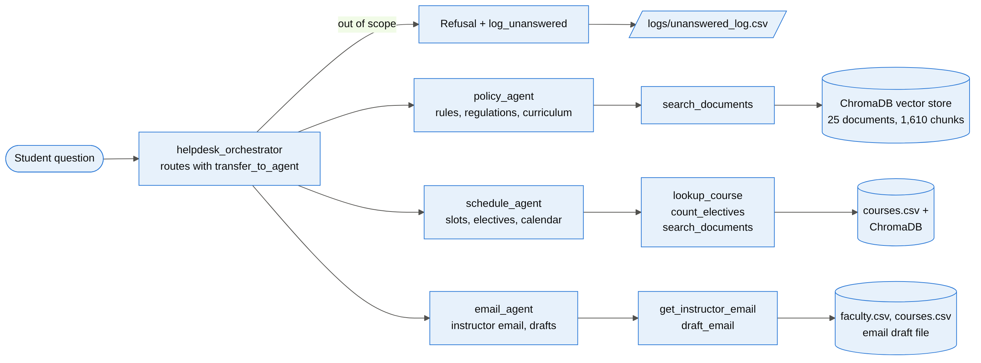
Figure 1. Multi-agent architecture: the orchestrator routes each question to a specialist or refuses it; each specialist uses only its own tools.

3. Document collection
We collected 25 real documents from the official IIT Jodhpur websites (iitj.ac.in and department sites). They cover all the source types the assignment asks for:
- rules and regulations (UG/PG regulations of 2019, 2020 and 2022)
- recent office orders and circulars, including the two Senate-approved amendments of 08 July 2024 on attendance and examinations
- the AY 2026-27 academic calendars and the first-year time table
- course registration and branch-change information
- B.Tech, M.Tech and PhD curricula, the SoLA (Humanities) course list and the list of academic programs
Web pages were saved as clean text. The two scanned circulars had no text layer, so they were transcribed into text files. Course slots, instructors and faculty email IDs are kept as structured CSV files. Personal data was replaced with dummy values: the email IDs of current-semester instructors are dummies such as csl7570.instructor@iitj.ac.in.
# | Document | Category | Year | Chunks
1 | IIT Jodhpur Academic Regulations - UG and PG (web version incl. branch change update) | rules | 2019 (updated 2025) | 150
2 | Rules and Regulations for PG Programmes (enrolled from July 2022 onwards) | rules | 2022 | 113
3 | Academic Regulations (students enrolled from July 2020 onwards) | rules | 2020 | 141
4 | Notification: Amendments to Academic Regulations (26 Oct 2020) | office order | 2020 | 1
5 | Circular: Amendment in the Attendance Policy (08 July 2024; from Sem I AY 2024-25) | office order | 2024 | 4
6 | Circular: Amendment in the Examination Policy - one Minor and one Major exam (08 July 2024) | office order | 2024 | 3
7 | B.Tech Registration and Academic Session FAQ (branch change discontinued from AY 2026-27) | rules | 2026 | 7
8 | Academic Calendar AY 2026-27 | calendar | 2026 | 27
9 | Academic Calendar Summer Term 2026 | calendar | 2026 | 3
10 | Academic Calendar for Executive Students AY 2026-27 | calendar | 2026 | 6
11 | B.Tech Chemical Engineering Programme Course Curriculum (2026) | curriculum | 2026 | 182
12 | B.Tech Chemical Engineering - semester-wise courses (Office of Academics) | curriculum | 2025 | 7
13 | B.Tech Computer Science and Engineering UG Curriculum (2026 onwards) | curriculum | 2026 | 65
14 | CSE Department - Undergraduate Programs (B.Tech CSE and AIDE) | curriculum | 2026 | 6
15 | M.Tech Artificial Intelligence Detailed Curriculum (AY 2025 onwards) | curriculum | 2025 | 58
16 | M.Tech CSE Detailed Curriculum (AY 2025 onwards) | curriculum | 2025 | 51
17 | PhD Computer Science Curriculum with Electives (July 2026) | curriculum | 2026 | 91
18 | M.Tech Data and Computational Sciences Curriculum (July 2025) | curriculum | 2025 | 56
19 | B.Tech Electrical Engineering Curriculum Structure (2nd year onwards) | curriculum | 2020 | 331
20 | B.Tech Mechanical Engineering Curriculum Structure (2nd year onwards) | curriculum | 2020 | 264
21 | School of Liberal Arts (Humanities) - Undergraduate Courses | curriculum | 2025 | 4
22 | List of Academic Programs offered by IIT Jodhpur (AY 2026-27) | programs | 2026 | 8
23 | UG First Year Class Time Table - instructors and classrooms (Office of Academics) | timetable | 2023 | 17
24 | Office of Academics - Announcements (Convocation 2026 etc.) | notices | 2026 | 13
25 | IIT Jodhpur - All Announcements | notices | 2026 | 2
Table 1. The 25 indexed documents (data/csv/sources.csv lists each URL).

4. RAG pipeline
The ingestion script (src/ingest.py) reads PDF and text files and splits each page into overlapping chunks of 900 characters with an overlap of 150 characters. It embeds each chunk locally with nomic-embed-text, using the search_document: and search_query: prefixes the model expects, and stores the chunks in ChromaDB. The result is 1,610 chunks from 25 documents, built in about one minute.
Each chunk carries metadata: document title, file name, page, year, category and URL. These fields are what the agent quotes in its citation [Source: <document>, p. <page>].
At query time, search_documents embeds the question and retrieves the 10 nearest chunks. It then adds a small recency bonus (+0.004 per year after 2019) so that a newer rule outranks a superseded one, and returns the top 5 with their source, page, year and relevance score.
Retrieval test. On 10 test queries, one of the expected documents was in the top 3 results for every query (hit@3 = 10/10).
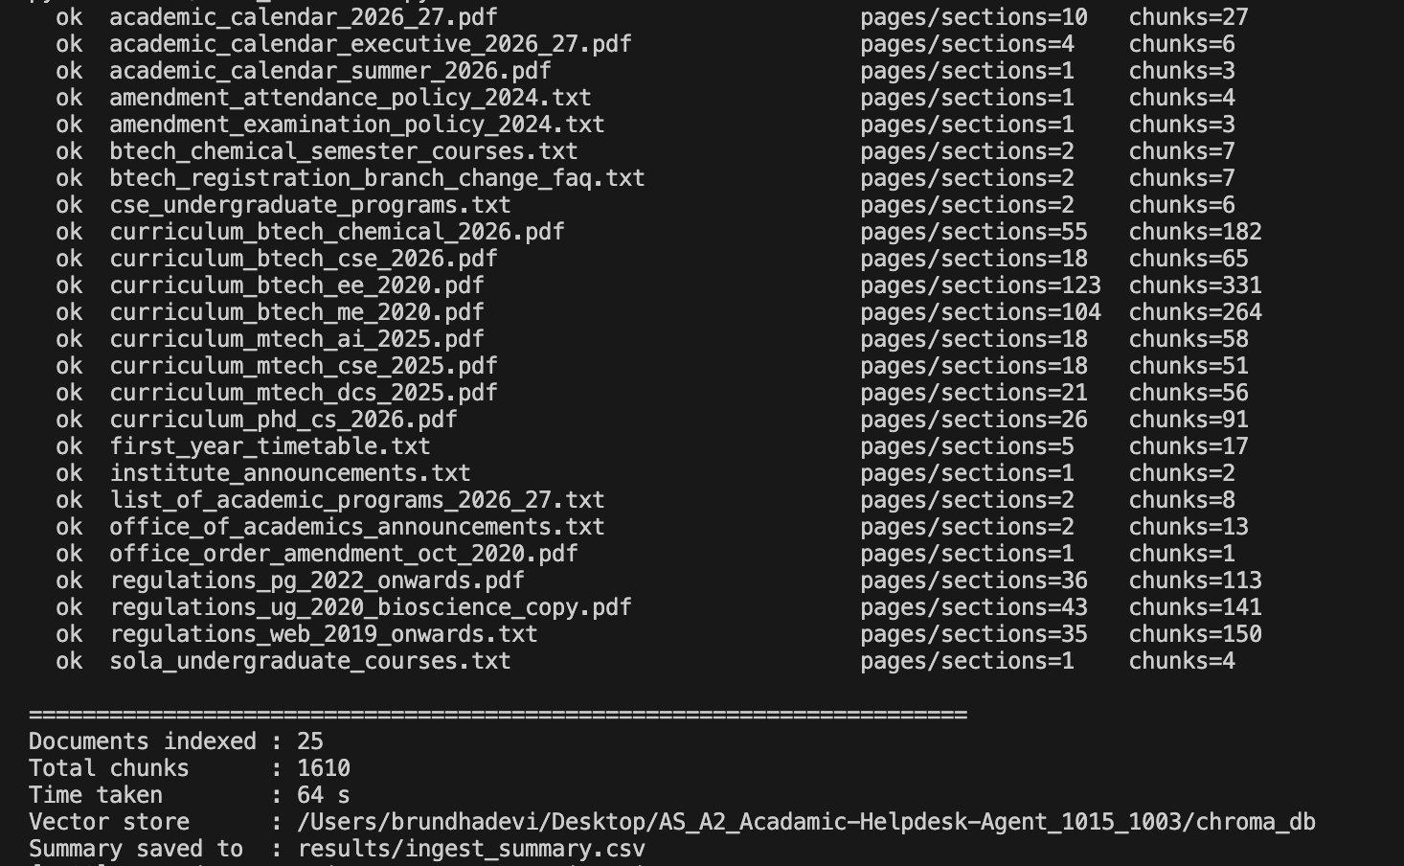
Figure 2. Ingestion output: 25 documents, 1,610 chunks.
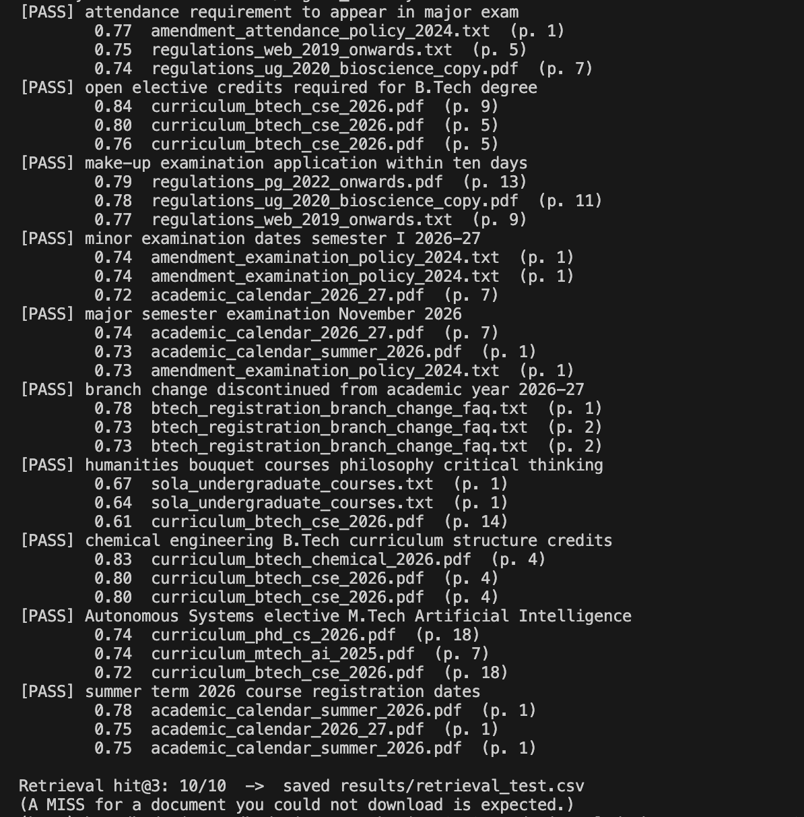
Figure 3. Retrieval test: hit@3 = 10/10, with relevance score, document and page for each hit.

5. Tools
The agents use six Python function tools (src/tools.py). ADK turns each function's signature and docstring into a tool definition for the LLM.
Tool | Purpose | Data source
search_documents(query) | Returns the 5 most relevant chunks with document title, page, year and relevance | ChromaDB
lookup_course(course) | Slot, instructor, credits and room of a course, by code or name | courses.csv
count_electives(department, level) | Number and list of electives floated in the current semester (AY 2026-27 Sem I) by a department at a level | courses.csv
get_instructor_email(course_code) | Instructor name and email, and the department office email | courses.csv, faculty.csv
draft_email(course_code, purpose, details, …) | Builds a sick-leave / leave / make-up exam email with the relevant rule, saves it to outputs/email_drafts/ for the student to review; never sends it | courses.csv, faculty.csv, regulations
log_unanswered(question, reason) | Appends a question the agent cannot answer to logs/unanswered_log.csv for a human | log file

6. Base version: single agent
The single agent is one ADK LlmAgent that has all six tools and an instruction with explicit rules:
- Scope. Answer only questions on academic programs, curriculum and credits, rules and regulations, calendar dates, slots and electives, and instructor emails.
- Grounding. Never answer from the model's own memory; every fact must come from a tool result.
- Tool choice. Rules go to search_documents, a course to lookup_course, an elective count to count_electives, an email ID to get_instructor_email, and an email to draft_email.
- Citation. End every answer with [Source: <document>, p. <page>], and never cite a tool name as a source.
- Refusal. If the question is out of scope or the documents do not contain the answer, call log_unanswered and reply with a fixed message: "I'm sorry, I don't know the answer to that… I have logged your question for the helpdesk staff to answer."
- Versions. If documents of different years disagree, follow the newest one and name it.
Safety callbacks. Small local models do not always follow the prompt. A model callback shared by all agents (src/guardrails.py) does three things:
- removes any reasoning ("thinking") text, so the user sees only the final answer
- if a refusal was given without calling log_unanswered, logs the question automatically
- replaces any refusal with the standard text, which removes invented citations such as [Source: log_unanswered]

7. Multi-agent version
The multi-agent version (src/multi_agent) follows the design suggested in the assignment: a helpdesk orchestrator transfers each question to a policy agent, a schedule agent or an email agent.
Agent | Handles | Tools
helpdesk_orchestrator | Reads the question and transfers it with transfer_to_agent; refuses and logs out-of-scope questions itself; never answers academic questions | log_unanswered
policy_agent | Rules and regulations, attendance, exams, grading, leave, credits, curriculum | search_documents, log_unanswered
schedule_agent | Course slots, time table, instructors of a course, electives this semester, calendar dates | lookup_course, count_electives, search_documents, log_unanswered
email_agent | Instructor email IDs; leave and make-up exam email drafts | get_instructor_email, draft_email, log_unanswered

- Routing. The orchestrator chooses a specialist from the specialists' descriptions and calls ADK's built-in transfer_to_agent.
- No ping-pong. The specialists have disallow_transfer_to_parent and disallow_transfer_to_peers set, so the agent that receives a question must answer it.
- Smaller tool sets. Each specialist sees only its own tools and a shorter instruction, which leaves fewer ways to pick a wrong tool.
- Early refusal. Out-of-scope questions are refused at the front desk, before any retrieval or tool call.
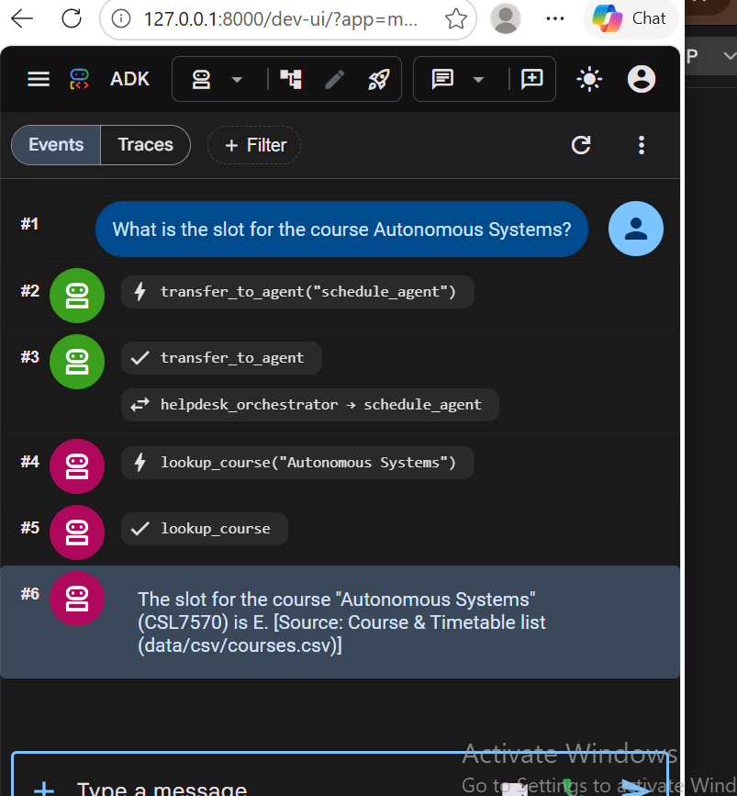
Figure 4. ADK web UI: the orchestrator transfers the question to schedule_agent, which calls lookup_course and answers "Slot E" with its source.

8. Answers to the assignment's example questions
The table shows the actual answers of the multi-agent system (Qwen3 8B) to the example questions from the assignment, taken from the evaluation run. The route column shows the specialist agent and tool that ADK recorded.
Question | Answer (multi-agent, Qwen3 8B) | Route / tool | Result
Attendance requirement to sit in the Major exam | The attendance requirement to sit in the Major exam is that a student's attendance should not fall below 75% in a course. If a student's attendance is below 75%, they will still be allowed to appear for the exams, but they must score at least a C grade to pas… | policy_agent  search_documents | Partly wrong
Slot of Autonomous Systems | The slot for the course "Autonomous Systems" (CSL7570) is E. [Source: Course & Timetable list (data/csv/courses.csv)] | schedule_agent  lookup_course | Correct
400-level electives floated by Humanities this semester | There are 6 electives at the 400 level floated by the Humanities department in this semester. The courses are: Introduction to Philosophy, Fundamentals of Logic, Critical Thinking, Theories of Justice, Gandhian Thought, and Role of Technology in Development. … | schedule_agent  count_electives | Correct
Open Elective credits for a B.Tech degree | Students in the regular B.Tech programme are required to complete 12 credits of open elective courses. [Source: B.Tech Computer Science and Engineering UG Curriculum (2026 onwards), p. 9] | policy_agent  search_documents | Correct
Leave email to the CSL7570 instructor (2 days) | Full draft addressed to csl7570.instructor@iitj.ac.in, subject "Request for leave of absence - CSL7570", marked "This is a draft and has NOT been sent." (see Figure 5) | email_agent  draft_email | Correct
Dining options on the campus | I'm sorry, I don't know the answer to that. It is outside what I can help with, so I have logged your question for the helpdesk staff to answer. | orchestrator  – | Correct
Best way to reach the campus from Jodhpur city | I'm sorry, I don't know the answer to that. It is outside what I can help with, so I have logged your question for the helpdesk staff to answer. | orchestrator  log_unanswered | Correct
Table 2. Example questions from the assignment and the system's answers.
Six of the seven examples are answered correctly with a correct citation or tool result. The attendance question cites the right document, the 08 July 2024 circular. It correctly says that attendance should not fall below 75 % and that a student is still allowed to appear for the exams. However, it also repeats the C-grade condition, which belongs to the superseded policy quoted inside the same circular. The cause is analysed in Section 11.
Email draft (Q21). The email agent returns the full draft for the student to review; the email is saved in outputs/email_drafts/ and is never sent:
This is a draft and has NOT been sent.
To: csl7570.instructor@iitj.ac.in
Subject: Request for leave of absence - CSL7570
Body:
Dear Sir/Madam,

I am writing to inform you that I will be unable to attend the classes of CSL7570 - Autonomous Systems and to request leave for the following: 2 days.

I will submit the supporting document (e.g. medical certificate) as required, and I will make sure to cover the missed lectures and any assignments.

Thank you for your consideration.

Yours sincerely,
Student Name
Roll No.: Roll Number
IIT Jodhpur

Figure 5. Email draft produced for Q21 (instructor email is a dummy value).
Log of unanswered questions. Every refused question is written to logs/unanswered_log.csv with a status for the helpdesk staff:
Time (UTC) | Question | Reason | Status
2026-10-29 18:50:25 | What are the available dining options on the campus? | refused by agent (auto-logged) | pending human answer
2026-10-29 20:37:04 | What is the best way to reach the campus from Jodhpur city center? | out of scope | pending human answer
2026-10-29 20:26:43 | What will the weather be like in Jodhpur tomorrow? | out of scope | pending human answer
2026-10-29 20:27:29 | How do I apply for a hostel room change? | refused by agent (auto-logged) | pending human answer
2026-10-29 20:27:48 | Who won the last IPL final? | out of scope | pending human answer
2026-10-29 20:28:34 | Can you write a Python program to sort a list? | refused by agent (auto-logged) | pending human answer
Table 3. Excerpt of the unanswered-question log (out-of-scope questions).

9. Evaluation method
Question set. eval/questions.csv contains 30 prompts:
- 12 policy questions
- 8 schedule questions
- 4 email questions
- 6 out-of-scope questions
The set includes all seven examples from the assignment. Each question has an expected answer, an expected source document and an expected tool. eval/answer_keys.csv lists, for each question, the key facts the answer must contain and the specialist agent that should handle it. The full list is in Appendix A.
Metrics (eval/score.py):
Metric | Definition
Accuracy | The answer contains all key facts and is not a wrong refusal; for out-of-scope questions, the answer is a refusal. Every answer was also checked by hand and the automatic score was corrected where needed.
Groundedness | For in-scope questions: the [Source: …] cites one of the expected documents.
Citation present | For in-scope questions: the answer contains a [Source: …] citation at all.
Correct refusal | Share of out-of-scope questions that were refused. False refusal: share of in-scope questions that were wrongly refused.
Refusals logged | Share of out-of-scope questions that appear in logs/unanswered_log.csv.
Correct tool / routing | The expected tool was called; for the multi-agent system, the question reached the expected specialist (or stayed with the orchestrator if out of scope).
Consistency | The same question was asked again in a second run; we record whether the answer text or its correctness changed.

Configurations. We evaluated four configurations: the single agent and the multi-agent system, each with Qwen3 8B and with Llama 3.1 8B. In run 1, all 30 questions were asked in all four configurations. In run 2, 10 questions were asked again in both Qwen3 configurations to measure consistency. In total, 140 answers were scored. All runs used Ollama on CPU, temperature 0, and a fresh session for every question. The scripts are eval/run_eval.py (asks the questions), eval/score.py (scores them) and eval/final_tables.py (tables and charts).

10. Results

10.1 Overall metrics
Configuration | Accuracy | In-scope accuracy | Grounded | Citation present | Correct refusal | False refusal | Refusals logged | Correct tool | Correct routing | Median time
Single · Qwen3 8B | 76.7 % | 70.8 % | 79.2 % | 95.8 % | 100.0 % | 4.2 % | 100.0 % | 96.7 % | – | 250 s
Multi · Qwen3 8B | 70.0 % | 62.5 % | 58.3 % | 79.2 % | 100.0 % | 16.7 % | 100.0 % | 93.3 % | 100.0 % | 171 s
Single · Llama 3.1 8B | 73.3 % | 66.7 % | 58.3 % | 83.3 % | 100.0 % | 4.2 % | 100.0 % | 100.0 % | – | 262 s
Multi · Llama 3.1 8B | 66.7 % | 58.3 % | 58.3 % | 87.5 % | 100.0 % | 4.2 % | 100.0 % | 100.0 % | 93.3 % | 306 s
Table 4. Evaluation metrics on 30 questions (run 1). Groundedness, citation and false refusal refer to the 24 in-scope questions; correct refusal and logging to the 6 out-of-scope questions.
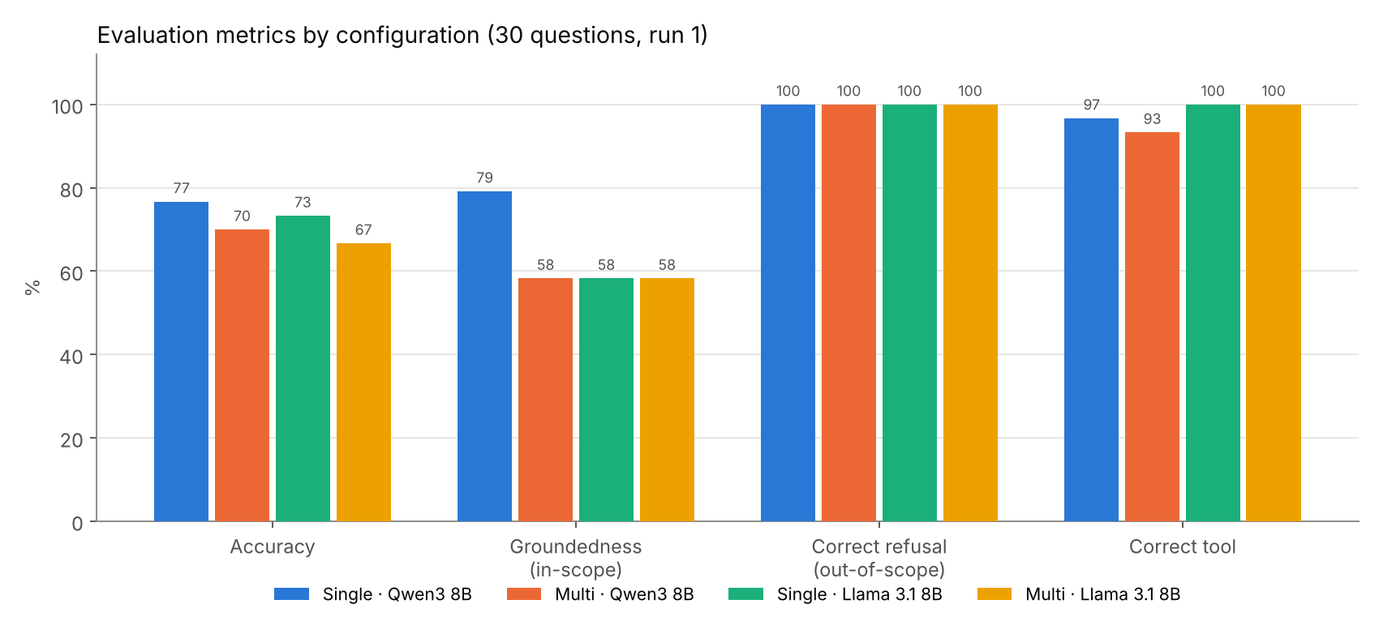
Figure 6. Accuracy, groundedness, correct refusal and correct tool use by configuration.

10.2 Accuracy by question category
Category | Single · Qwen3 8B | Multi · Qwen3 8B | Single · Llama 3.1 8B | Multi · Llama 3.1 8B
Policy (12) | 67 % | 67 % | 75 % | 75 %
Schedule (8) | 62 % | 50 % | 62 % | 62 %
Email (4) | 100 % | 75 % | 50 % | 0 %
Out of scope (6) | 100 % | 100 % | 100 % | 100 %
Table 5. Accuracy (%) per question category (run 1).
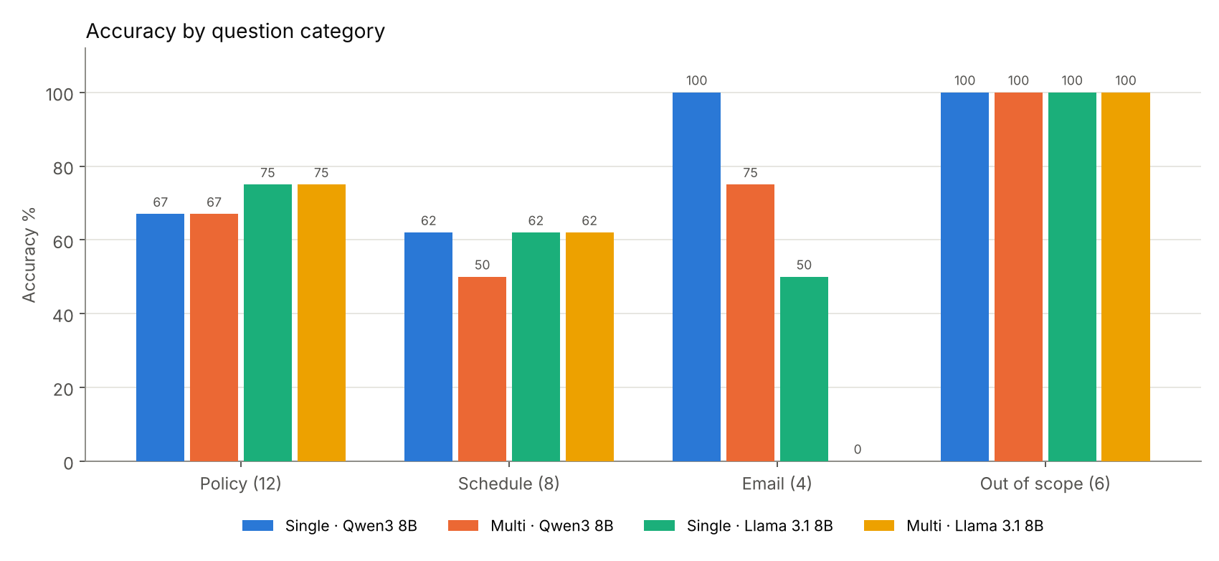
Figure 7. Accuracy per question category and configuration.

10.3 Single agent vs multi-agent
Aspect | Single agent | Multi-agent | Observation
Accuracy (Qwen3 / Llama 3.1) | 76.7 % / 73.3 % | 70.0 % / 66.7 % | Multi-agent about 7 points lower with both LLMs
Correct refusal of out-of-scope questions | 100 % / 100 % | 100 % / 100 % | Equal; multi-agent refuses at the orchestrator without any tool call
False refusals (in-scope) | 4.2 % / 4.2 % | 16.7 % / 4.2 % | Qwen3 specialists gave up on 4 answerable questions (Q06, Q10, Q19, Q23)
Correct routing | – | 100 % / 93.3 % | Qwen3 sent all 30 questions to the right agent; Llama 3.1 misrouted 2
Correct tool | 96.7 % / 100 % | 93.3 % / 100 % | Specialists picked the right tool almost always
Email category | 100 % / 50 % | 75 % / 0 % | Llama 3.1 email agent dropped the draft text from its reply
Median time per answer | 250 s / 262 s | 171 s / 306 s | Multi-agent needs one extra LLM call (the transfer)
Table 6. Single agent vs multi-agent (values: Qwen3 8B / Llama 3.1 8B).
The multi-agent design gives a clear structure: correct routing, small tool sets per agent and early refusals. On this question set, however, it did not improve accuracy. The orchestrator adds one more LLM decision, and a specialist with a narrow instruction refuses more readily when its first search returns weak evidence. The single agent can recover by calling a second tool, which the specialists cannot do outside their own tool set.

10.4 Changing the LLM: Qwen3 8B vs Llama 3.1 8B
Aspect | Qwen3 8B | Llama 3.1 8B
Accuracy (single / multi) | 76.7 % / 70.0 % | 73.3 % / 66.7 %
Groundedness, single agent | 79.2 % | 58.3 %
Policy questions (single / multi) | 67 % / 67 % | 75 % / 75 %
Email questions (single / multi) | 100 % / 75 % | 50 % / 0 %
Routing (multi-agent) | 100 % | 93.3 %
Out-of-scope refusals | 100 % | 100 %
Typical failure | Refuses an answerable question; repeats superseded rule text | Drops the email draft text; copies an email ID with a typo; cites file names instead of titles
Table 7. Effect of replacing the LLM.
Qwen3 8B was the better model overall: it was more accurate in both architectures and grounded its single-agent answers much better. Llama 3.1 8B was slightly stronger on policy questions. For example, it answered the branch-change question (Q10) correctly where both Qwen3 configurations refused. Llama 3.1 was clearly weaker at the email tasks. In the multi-agent system it called draft_email correctly, but replied only with "This is a draft and has NOT been sent." and left out the draft text. It also returned "rjlaxmichouhan@iitj.ac.in" instead of "rajlaxmichouhan@iitj.ac.in".

10.5 Questions whose answers changed between runs
At temperature 0, 15 of the 20 repeated question–configuration pairs produced the same answer. The wording changed in 5 pairs, and the correctness changed in 2:
Configuration | Question | Run 1 | Run 2 | Change
Multi · Qwen3 8B | Q06: How many days of short leave can a UG student take on medical grounds? | Wrong | Correct | Refusal in run 1, correct answer (10 days) in run 2
Multi · Qwen3 8B | Q08: How many credits must a general category B.Tech student earn by the end of the second semester to continue in the program? | Wrong | Wrong | Wrong in both runs; wording changed
Multi · Qwen3 8B | Q22: Draft an email to the instructor of MAL1010 asking for permission to take the make-up exam for the Minor because I was hospitalised. | Correct | Correct | Correct in both runs; email wording changed
Single · Qwen3 8B | Q07: How many grade points is an A- grade worth? | Correct | Wrong | Correct answer (9) in run 1, refusal in run 2
Single · Qwen3 8B | Q22: Draft an email to the instructor of MAL1010 asking for permission to take the make-up exam for the Minor because I was hospitalised. | Correct | Correct | Correct in both runs; email wording changed
Table 8. Answers that changed between run 1 and run 2 (Qwen3 8B).
The questions with identical answers in both runs were Q07 (multi-agent), Q06 (single), Q08 (single), Q13, Q14, Q18, Q21, Q25 and Q26. Both correctness changes were flips between answering and refusing. A small difference in the retrieved chunks or in the model's first decision decides whether the agent trusts the evidence. Factual answers that were given were stable, and refusals of out-of-scope questions were identical in every run.

11. Error analysis
Five questions failed in all four configurations (Q01, Q08, Q14, Q15 and Q16), so most of the lost accuracy comes from retrieval and the document text, not from the LLM or the agent structure.
Questions | What happened | Cause | Possible fix
Q14, Q15: Minor and Major exam dates, Sem I 2026-27 | Answered with Summer Term 2026 dates (May–June 2026) | The summer-term calendar is the newest file, so the recency bonus ranked it above the AY 2026-27 calendar | Filter by semester in the metadata; apply the recency bonus only across academic years
Q16: Sem II classes begin | 1 or 15 January 2027 instead of 4 January 2027 | The calendar table was split across chunks and the row was misread | Ingest calendar tables as structured rows
Q01: attendance for the Major exam | Qwen3 added the superseded C-grade rule; Llama 3.1 stated only the 75 % rule | The circular quotes the old rule just before the revised one, in the same chunk | Index only the revised policy, or tag old paragraphs as superseded
Q08: credits by end of the 2nd semester | 75, 80 or 153 credits; correct answer is 18 | PG regulations and curricula have similar wording; the UG table was not retrieved | Add a UG/PG filter to search_documents
Q06, Q10, Q19, Q23 (multi · Qwen3) | Specialist refused an answerable question | Narrow instruction plus a weak first search | Allow one reformulated search before refusing
Q21, Q22, Q24 (Llama 3.1) | Missing draft text; email ID typo | The model rewrites tool output in its final reply | Return drafts and email IDs verbatim from the tool
Table 9. Main failure cases and their causes.
What worked reliably. Out-of-scope questions were refused and logged in all 24 cases (6 questions × 4 configurations). This comes from the explicit scope list in the instructions and the callback that logs any refusal the model forgets to log. Simple lookups were correct in every configuration, with a citation in most cases: the course slot, the elective count, the Open Elective credits, the make-up exam rule and the semester break. The recency rerank correctly preferred the 2026 curriculum (12 Open Elective credits) over the 2019 regulations (10 credits).

12. Conclusion
We built a local multi-agent academic helpdesk that answers from 25 official IIT Jodhpur documents and structured course data. It cites its sources, drafts instructor emails without sending them, refuses out-of-scope questions and logs them for a human.
On 30 evaluation questions, every configuration refused 100 % of the out-of-scope questions. The multi-agent system routed 100 % (Qwen3) and 93.3 % (Llama 3.1) of the questions to the correct specialist. The best accuracy, 76.7 %, came from the single agent with Qwen3 8B. The multi-agent system reached 70.0 % with the same model.
Qwen3 8B outperformed Llama 3.1 8B overall, especially on grounding and email drafting. Llama 3.1 was slightly better on policy questions. Answers were mostly stable across runs; the two changes were both flips between answering and refusing.
The largest remaining errors come from retrieval: choosing the right calendar, separating UG from PG rules, and superseded text inside new circulars. Metadata filters and cleaner document preparation would address these directly.

13. Code repository and how to run
Path | Content
README.md | Setup, how to run both agents, the tools, the evaluation commands
data/docs/, data/csv/ | The 25 documents; sources.csv (titles, years, URLs), courses.csv, faculty.csv
src/ingest.py, src/embeddings.py | Chunking, local embeddings, ChromaDB index
src/tools.py | The six tools
src/prompts.py, src/guardrails.py | Agent instructions and the safety callbacks
src/single_agent/, src/multi_agent/ | Base single agent; orchestrator with policy, schedule and email agents
src/chat.py, src/runner.py | Terminal chat and programmatic runner
eval/questions.csv, eval/answer_keys.csv | The 30 evaluation questions and their answer keys
eval/run_eval.py, score.py, analyze.py, final_tables.py | Run the questions, score them, and build tables and charts
results/ | Raw answers, scores, consistency table and charts
logs/unanswered_log.csv, outputs/email_drafts/ | Log of unanswered questions; generated email drafts

Run:
- pip install -r requirements.txt
- ollama pull qwen3:8b; ollama pull llama3.1:8b; ollama pull nomic-embed-text
- python src/ingest.py
- adk web src (choose single_agent or multi_agent), or python src/chat.py --agent multi
- python eval/run_eval.py --agent multi --model qwen3:8b; python eval/score.py; python eval/final_tables.py

Appendix A. Evaluation questions and results per question
1 = correct, 0 = wrong (run 1, after manual review). Expected answers and sources are in eval/questions.csv; all answers are in results/scored_all.csv.
ID | Category | Question | Single Qwen3 | Multi Qwen3 | Single Llama | Multi Llama
Q01 | Policy | What is the attendance requirement to sit in the Major exam? | 0 | 0 | 0 | 0
Q02 | Policy | How many Open Elective credits do I need to earn in order to get a B.Tech. degree? | 1 | 1 | 1 | 1
Q03 | Policy | What are the minimum and maximum credits a UG student can register for in a semester? | 1 | 1 | 1 | 1
Q04 | Policy | What is the maximum duration allowed to complete the B.Tech. program? | 1 | 1 | 1 | 1
Q05 | Policy | Within how many days must I apply for a make-up examination and to whom? | 1 | 1 | 1 | 1
Q06 | Policy | How many days of short leave can a UG student take on medical grounds? | 1 | 0 | 1 | 1
Q07 | Policy | How many grade points is an A- grade worth? | 1 | 1 | 1 | 1
Q08 | Policy | How many credits must a general category B.Tech student earn by the end of the second semester to continue in the program? | 0 | 0 | 0 | 0
Q09 | Policy | What is the maximum number of credits I can register for in the summer term? | 0 | 1 | 0 | 0
Q10 | Policy | Is branch change allowed for B.Tech students admitted in 2026? | 0 | 0 | 1 | 1
Q11 | Policy | What happens if a student is absent for four or more weeks in a semester? | 1 | 1 | 1 | 1
Q12 | Policy | How many total credits are required for the B.Tech. in Chemical Engineering under the latest curriculum? | 1 | 1 | 1 | 1
Q13 | Schedule | What is the slot for the course Autonomous Systems? | 1 | 1 | 1 | 1
Q14 | Schedule | When are the Minor examinations in Semester I of 2026-27? | 0 | 0 | 0 | 0
Q15 | Schedule | When are the Major examinations for Semester I 2026-27? | 0 | 0 | 0 | 0
Q16 | Schedule | When do classes begin for Semester II of 2026-27? | 0 | 0 | 0 | 0
Q17 | Schedule | What is the last date to request course withdrawal in Semester I 2026-27? | 1 | 1 | 1 | 1
Q18 | Schedule | How many 400 level electives have been floated by the Humanities department in this semester? | 1 | 1 | 1 | 1
Q19 | Schedule | Who teaches Mathematics I (MAL1010) and what is its slot? | 1 | 0 | 1 | 1
Q20 | Schedule | When is the semester break in Semester I 2026-27? | 1 | 1 | 1 | 1
Q21 | Email | Write an email to the course instructor of CSL7570 that I need leave for 2 days. | 1 | 1 | 1 | 0
Q22 | Email | Draft an email to the instructor of MAL1010 asking for permission to take the make-up exam for the Minor because I was hospitalised. | 1 | 1 | 1 | 0
Q23 | Email | Write a sick leave email to the Chemometrics instructor for 3 days because of fever. | 1 | 0 | 0 | 0
Q24 | Email | What is the email ID of the instructor of EEL1010? | 1 | 1 | 0 | 0
Q25 | Out of scope | What are the available dining options on the campus? | 1 | 1 | 1 | 1
Q26 | Out of scope | What is the best way to reach the campus from Jodhpur city center? | 1 | 1 | 1 | 1
Q27 | Out of scope | What will the weather be like in Jodhpur tomorrow? | 1 | 1 | 1 | 1
Q28 | Out of scope | How do I apply for a hostel room change? | 1 | 1 | 1 | 1
Q29 | Out of scope | Who won the last IPL final? | 1 | 1 | 1 | 1
Q30 | Out of scope | Can you write a Python program to sort a list? | 1 | 1 | 1 | 1
 |  | Total correct (of 30) | 23 | 21 | 22 | 20

