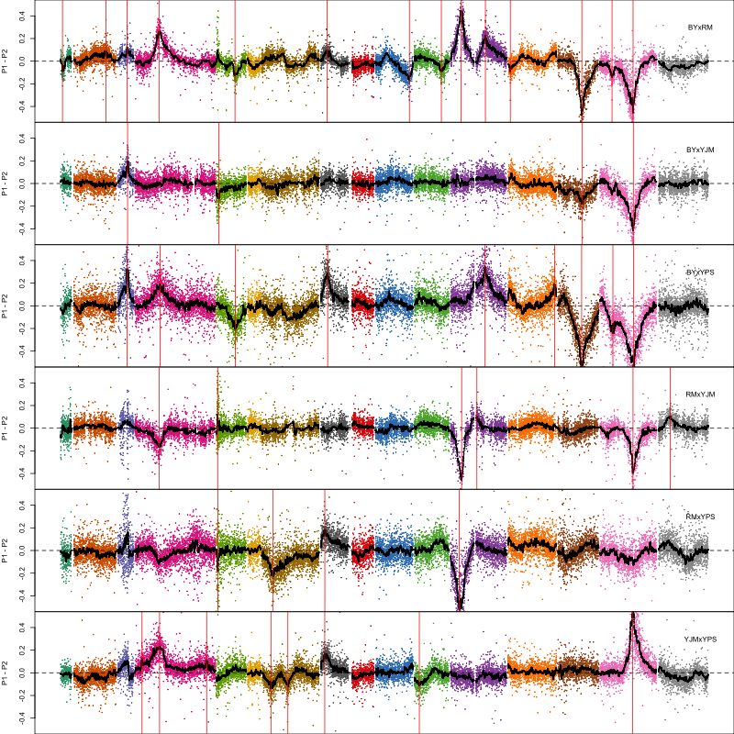
Supplementary Figure 1A. Loci detected for 4-NQO.
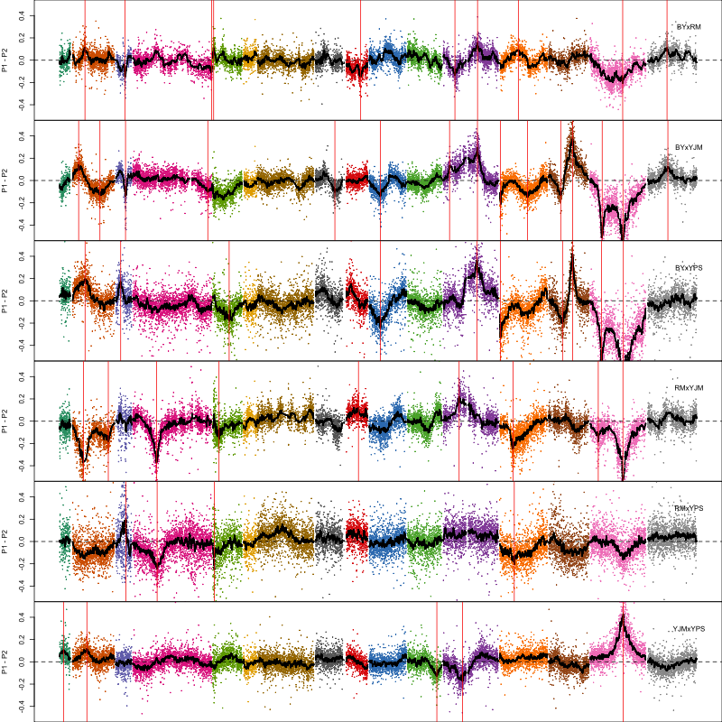
Supplementary Figure 1B. Loci detected for Benomyl.
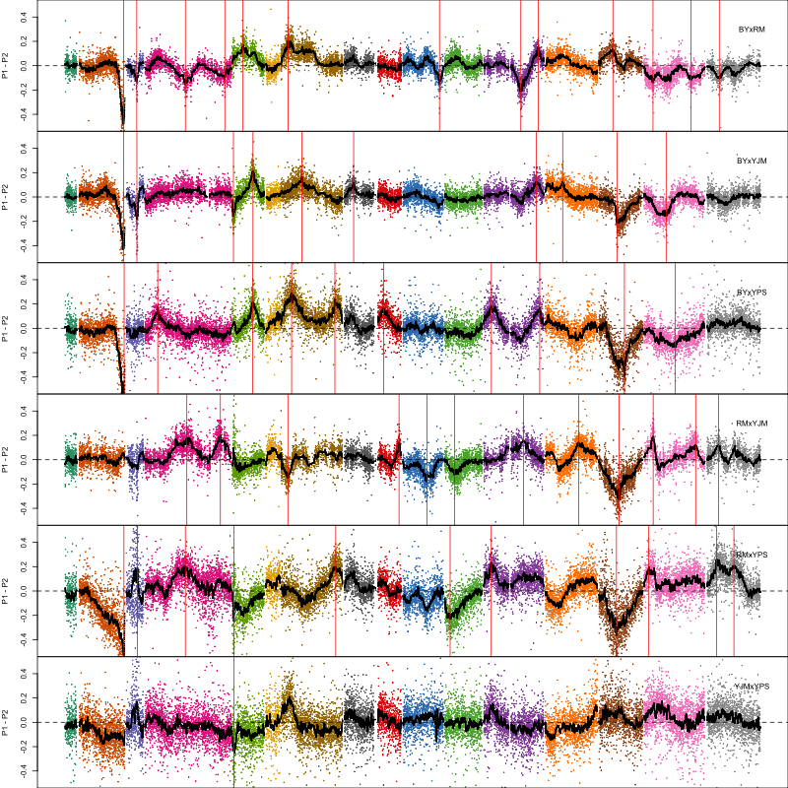
Supplementary Figure 1C. Loci detected for cadmium chloride.
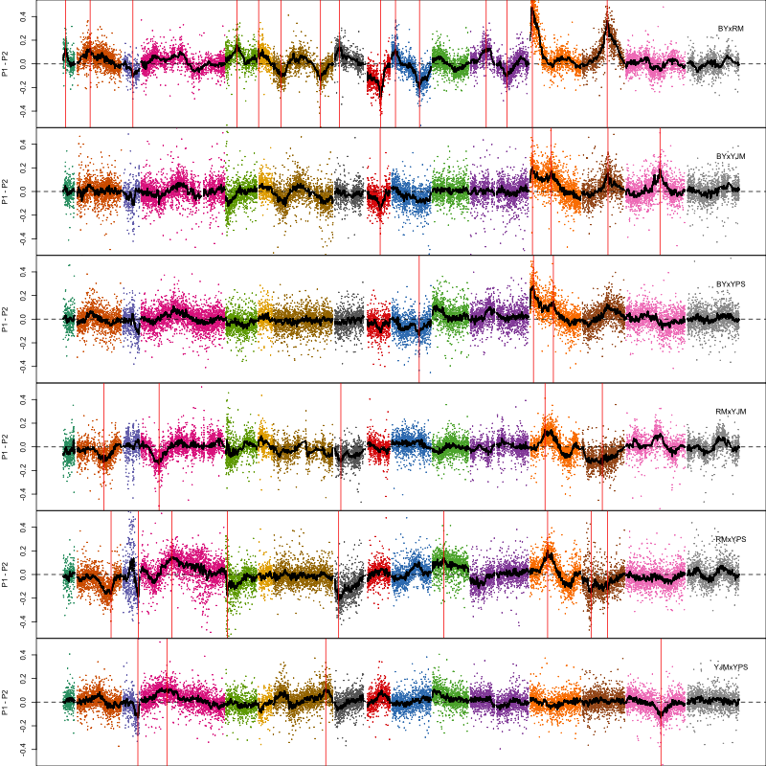
Supplementary Figure 1D. Loci detected for chlorpromazine.
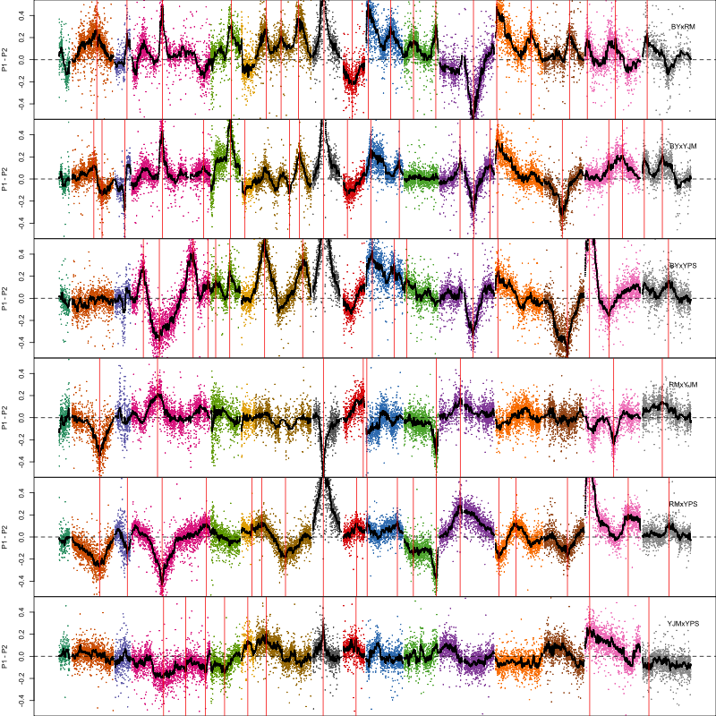
Supplementary Figure 1E. Loci detected for copper sulfate.
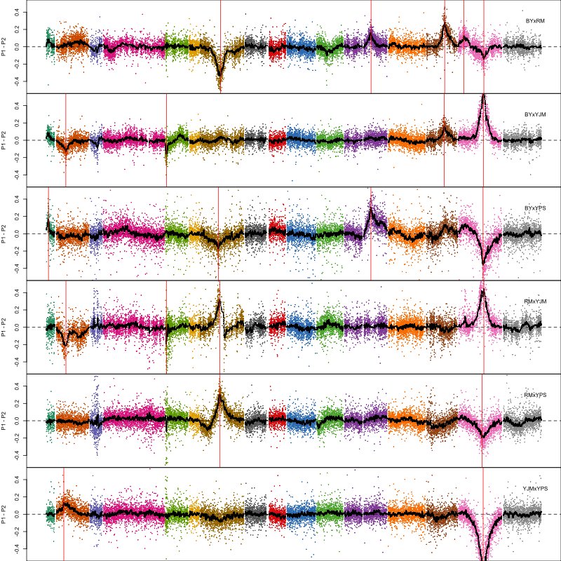
Supplementary Figure 1F. Loci detected for cycloheximide.
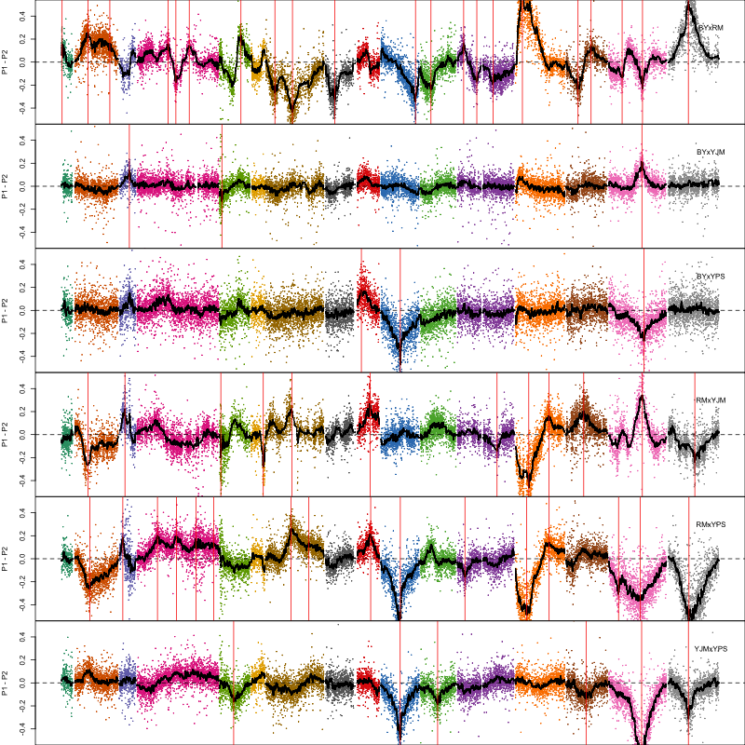
Supplementary Figure 1G. Loci detected for diamide.
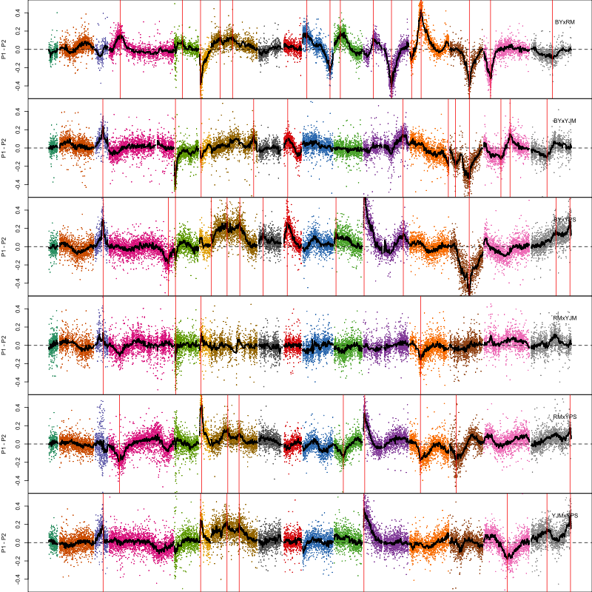
Supplementary Figure 1H. Loci detected for hydrogen peroxide.
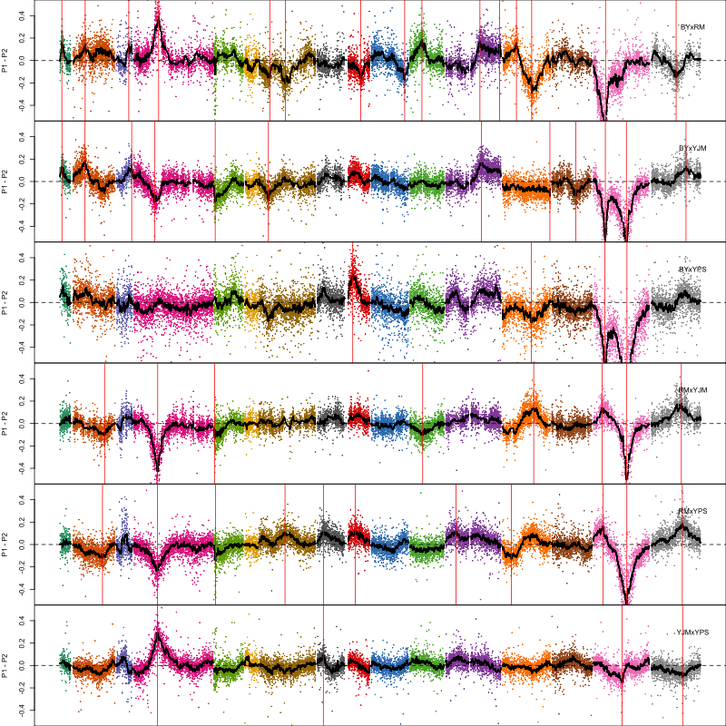
Supplementary Figure 1I. Loci detected for LY83583.
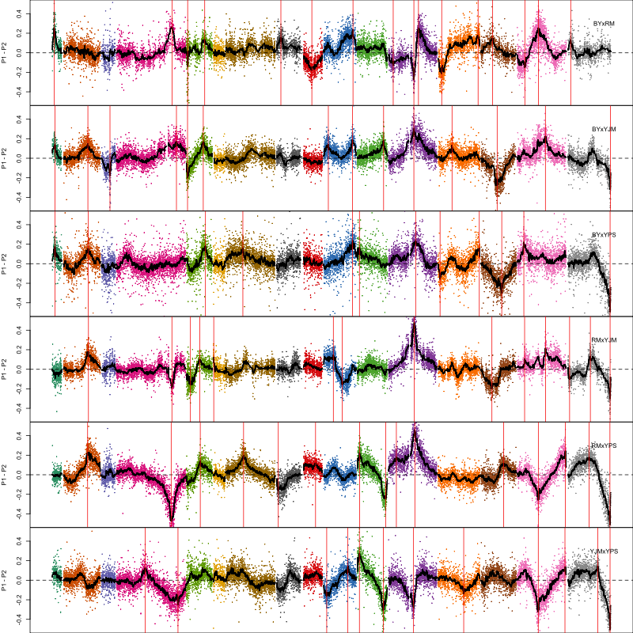
Supplementary Figure 1J. Loci detected for paraquat.
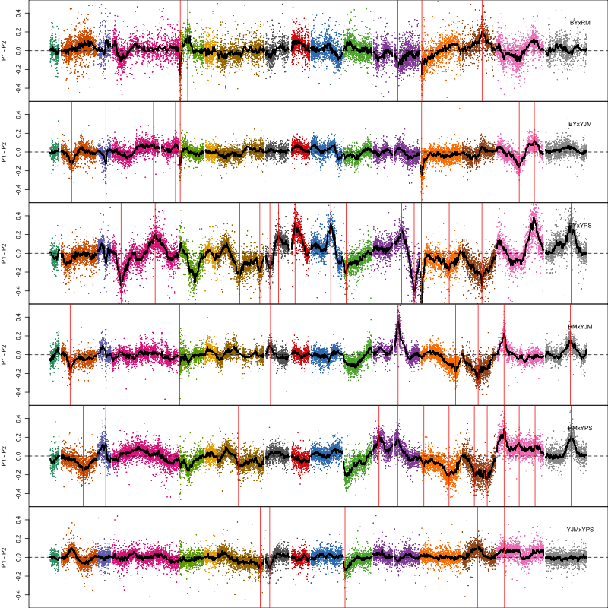
Supplementary Figure 1K. Loci detected for SDS.
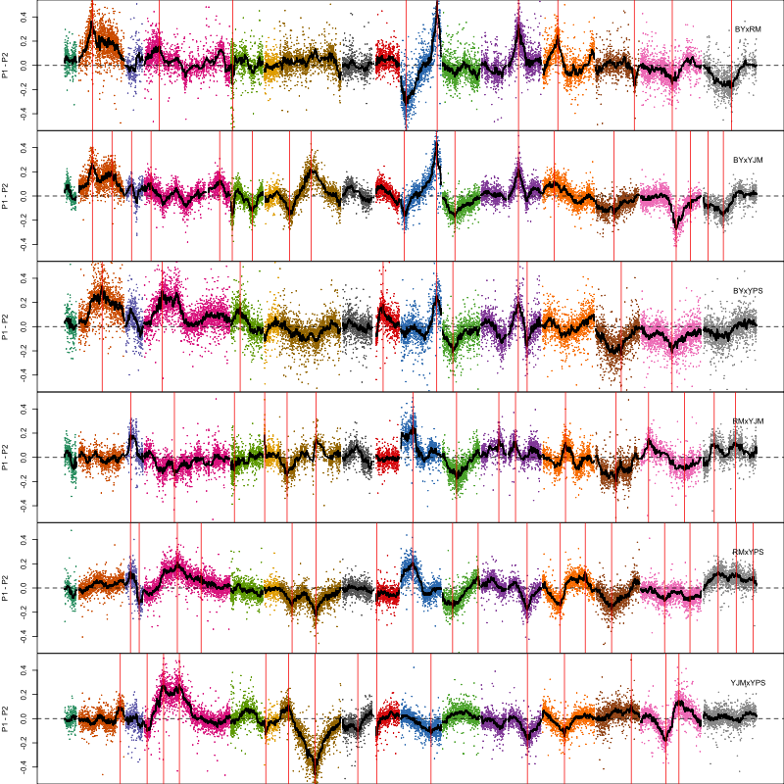
Supplementary Figure 1L. Loci detected for tunicamycin.
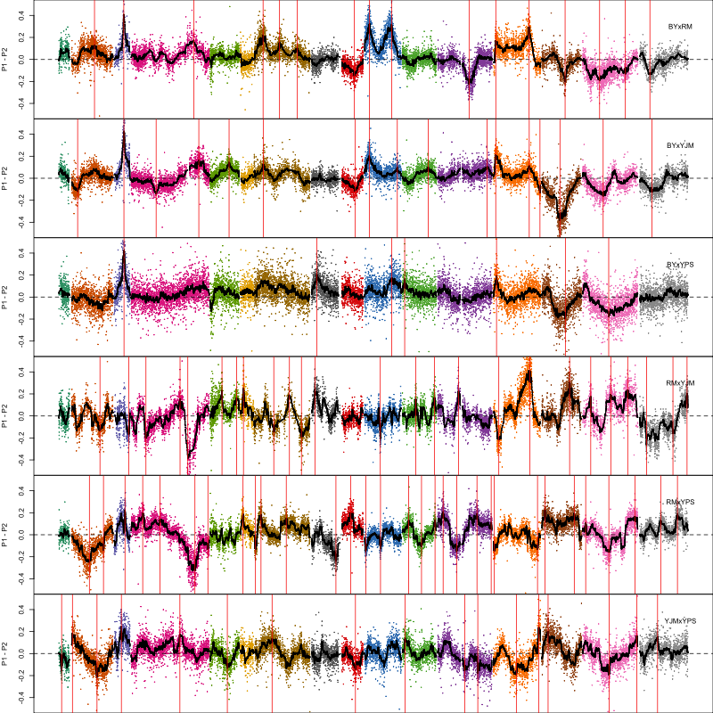
Supplementary Figure 1M. Loci detected for zeocin.

