The Impact of Wolf Reintroduction on Aspen Tree Population (2019-2021)

Context
Alex, a former grad student, studied whether wolf reintroduction helped Aspen trees recover by reducing elk grazing. Alex graduated two years ago. We need to reproduce the main bar chart of his dissertation for a Lab meeting presentation.

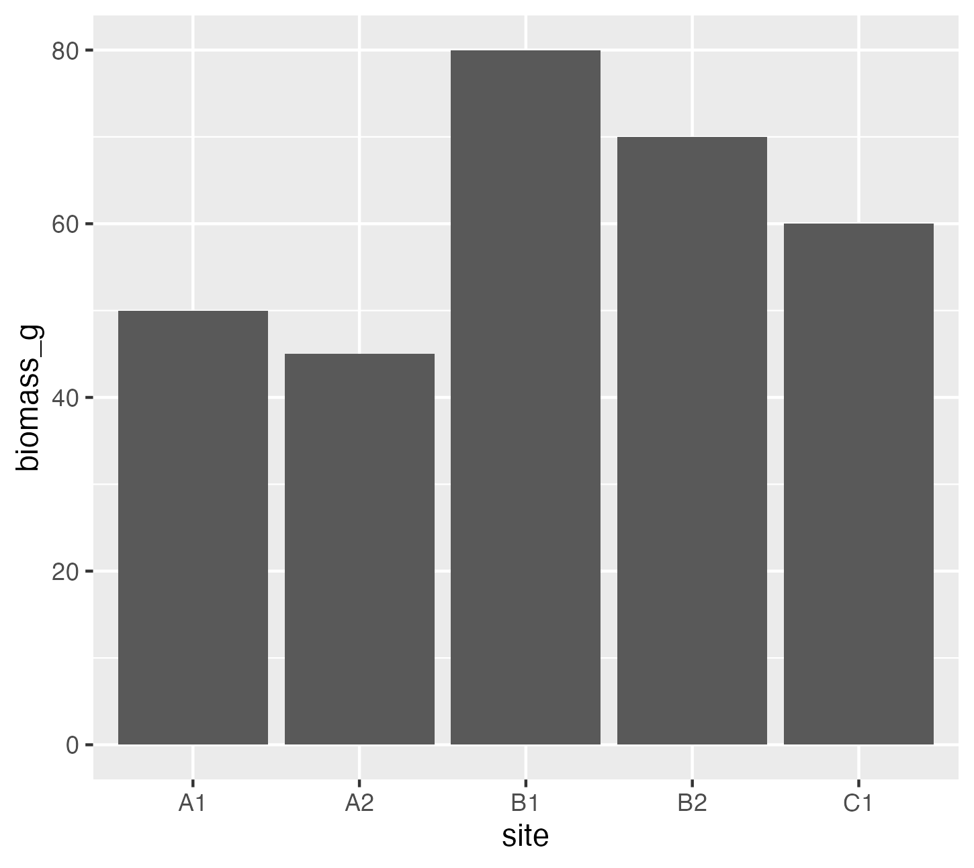

Project file structure
You can download the project from this GitHub repository: https://github.com/UCSB-Library-Research-Data-Services/project_aspen_wolf
/Project_aspen_wolf
├── analysis.R
├── analysis.py
├── data_2019.csv
├── data_2020_new.csv
├── data_combined_FINAL_v2.csv
├── data_combined_FINAL.csv
├── Figure 1.png
├── IMG_0023.JPG
├── keys.qmd
├── manuscript_draft_v4.docx
├── /Old stuff
│ ├── backup_data.xlsx
│ └── test-analysis.R
├── project_aspen_wolf.Rproj
├── README.md
└── S0378112725004499.bib

Prompts

Ok, we got the files… but can we make sense of it!? Are there any improvements we could implement in terms of file structure, file naming convention, code and data documentation?
- File (Re)structure:
  - Improve the directory structure
  - Apply a consistent naming convention
  - Should we delete data_clean.csv or archive it?
- Refactor the R Scripts
  - Can the code run? If not, what are the required changes?
  - Improve comments & variable names
  - Is there any code that might be hard to maintain / prone to failure?
  - Capture your computing environment
- README:
  - Improve project information
  - Improve the metadata by adding a data dictionary
  - Add content description
  - Add licensing information
- Bonus: Any thoughts on the data model itself?

Hints
Here are a few references to help with the documentation of the project:
- File structure: https://perma.cc/PZ8Z-3GLP
- Naming things: https://speakerdeck.com/jennybc/how-to-name-files
- Documentation: https://eds-214.github.io/EDS-214-analytical-workflows/day4-documenting.html

README
Information that should be present on the README
- Project Name: [e.g., Trophic Cascades in Aspen Recovery
- Contributors(s): [Name, Email, ORCID]
- Data Collection:
  - Date: [YYYY-MM-DD to YYYY-MM-DD]
  - Location: [Site Name, Lat/Long, or Bounding Box]
- License/Usage: [e.g., Creative Commons CC0]
More here: https://caltechlibrary.github.io/RDMworkbook/documentation.html#readme-txt

Data Dictionary
Variable Name | Description | Units | Data Type | Accepted Values / Range | Missing Data Code
site | Unique identifier for the study plot
date
height_cm
Diameter_mm
biomass_g | Total above-ground biomass | Grams | Numeric | > 0 | NA
notes | Field observations |  |  | text

Further readings
- Changing aspen stand structure following large carnivore restoration in Yellowstone, https://doi.org/10.1016/j.foreco.2025.122941
- Enabling data-driven collaborative and reproducible environmental synthesis science, https://doi.org/10.1111/2041-210X.70036
- The Research Data Management Workbook https://caltechlibrary.github.io/RDMworkbook/
- Data Management in Large-Scale Education Research https://datamgmtinedresearch.com/

