Dynamic Discount & Loyalty Management System
Student: Irankunda Brune
ID: 28252
Data dictionary

1. Introduction
This section describes the logical data model for the Dynamic Discount & Loyalty Management System.
The logical model defines the entities, attributes, relationships, constraints, and normalization (1NF–3NF) to ensure an efficient and consistent relational database design.
This system helps businesses automatically track purchases, calculate loyalty points, assign tiers, update discounts dynamically, and maintain discount change history for analytics.

2. Entity–Relationship Model

2.1 Identified Entities and Attributes

Entity 1: CUSTOMERS
Attribute | Type | Description
customer_id (PK) | NUMBER | Unique customer identifier
name | VARCHAR2(100) | Customer full name
email | VARCHAR2(100) | Contact email
total_spent | NUMBER | Total amount the customer has spent
loyalty_points | NUMBER | Total loyalty points accumulated
tier | VARCHAR2(20) | Current loyalty level (Silver, Gold, Platinum)
discount_rate | NUMBER | Current discount percentage

Entity 2: PURCHASES
Attribute | Type | Description
purchase_id (PK) | NUMBER | Unique purchase ID
customer_id (FK) | NUMBER | Linked to CUSTOMERS
amount | NUMBER | Purchase amount
purchase_date | DATE | Date of purchase

Entity 3: DISCOUNT_HISTORY
Attribute | Type | Description
history_id (PK) | NUMBER | Unique discount record ID
customer_id (FK) | NUMBER | Linked to CUSTOMERS
old_discount | NUMBER | Previous discount rate
new_discount | NUMBER | Updated discount rate
updated_on | DATE | Date of discount update

2.2 Primary Keys and Foreign Keys

Primary Keys (PKs)
CUSTOMERS → customer_id
PURCHASES → purchase_id
DISCOUNT_HISTORY → history_id

Foreign Keys (FKs)
PURCHASES.customer_id → CUSTOMERS.customer_id
DISCOUNT_HISTORY.customer_id → CUSTOMERS.customer_id

3. Relationship Cardinalities
Relationship | Cardinality | Meaning
Customer → Purchases | 1 : Many | A customer can make many purchases
Customer → Discount History | 1 : Many | A customer can have many discount changes
Purchases → Customer | Many : 1 | Each purchase belongs to one customer

4. Documented Constraints

PK Constraints
Enforce unique identifiers for customer, purchase, and history records.

FK Constraints
Prevent insertion of purchases or history records for customers that do not exist.

NOT NULL Constraints
IDs, purchase amounts, and dates must not be null.

Business Rules
Loyalty points = FLOOR(amount / 10).
Tiers are determined by the number of points.
Discount updates must be recorded in DISCOUNT_HISTORY table.

Trigger Rule
After each purchase, the system automatically updates:
✔ Loyalty points
✔ Total spent
✔ Tier
✔ Discount rate

5. Normalization

First Normal Form (1NF)
All attributes are atomic
No repeating groups
Each table has a Primary Key
✔ Tables meet 1NF

Second Normal Form (2NF)
No partial dependencies
All tables use single-column primary keys
✔ Tables meet 2NF

Third Normal Form (3NF)
No transitive dependencies
All non-key attributes depend only on their primary key
✔ Tables meet 3NF

Normalization Justification
The model reduces redundancy, improves consistency, and ensures reliable updates.
All tables satisfy 3NF, resulting in efficient data retrieval and strong data integrity.

6. Summary of My Phase IV Implementation

A) Database Schema
CUSTOMERS
PURCHASES
DISCOUNT_HISTORY

Sequences

SEQ_CUSTOMER
SEQ_PURCHASE
SEQ_HISTORY

C) Package: LOYALTY_PKG
Includes:
get_tier()
update_discount()
process_purchase()
monthly_review()
Uses:
Cursors
Procedures
Decision logic
Automatic updates
D) Trigger

Automatically updates points, tiers, and discount after each purchase.

E) Testing Scripts
Insert sample customers
Insert purchases
Validate trigger behavior
Run package procedures
Check discount history

ERD Diagram
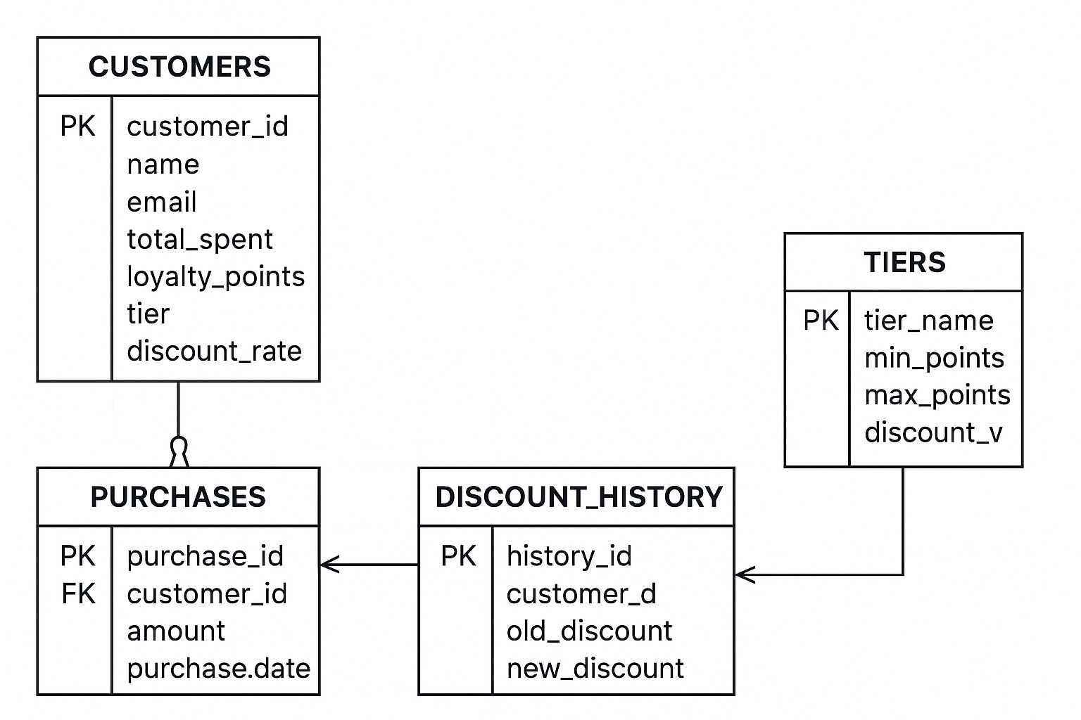

ASSUMPTIONS FOR THE DYNAMIC DISCOUNT & LOYALTY MANAGEMENT SYSTEM

1. Customer Data Accuracy
It is assumed that all customer information (name, email, ID) entered into the database is correct and valid.

2. All Purchases Are Recorded
The system assumes that every customer purchase is entered into the PURCHASES table with the correct amount.

3. Points Calculation Rule Is Stable
The loyalty point formula (1 point per 10 currency units spent) remains constant during the system’s operation.

4. Tier Levels Do Not Change Frequently
Silver, Gold, and Platinum tier ranges are assumed to stay the same, unless changed manually by an administrator.

5. Staff Are Trained to Use the System
It is assumed that employees who manage customers or purchases know how to use the system correctly.

6. Customers Cannot Have Negative Values
The system assumes:
No negative purchase amount
No negative loyalty points
No negative discount values

7. Oracle Database Is Always Available
The system assumes the Oracle PDB (XEPDB1) and PL/SQL environment are fully operational with no downtime.

8. Discount Updates Happen Only Through the System
All discount rate updates are made through:
Triggers
Procedures
Or system logic
No manual database tampering.

9. Security Roles Are Properly Assigned
It is assumed that only authorized users can:
Insert purchases
Update customer details
Run monthly discount reviews

10. Purchase Dates Are Accurate
The system assumes the date on each purchase is the real purchase date, not a future date or mistaken entry.

