Dynamic Discount and Loyalty Management System
Student: irankunda brune
Student ID: 28252
Course: Database Systems / PL/SQL

Abstract
This project presents a PL/SQL-driven Dynamic Discount and Loyalty Management System aimed at helping businesses track customer spending, reward loyal customers, and dynamically adjust discounts based on purchasing behavior. The system stores customer, purchase, and discount history information using a relational database schema. Advanced PL/SQL procedures, functions, triggers, and scheduled jobs handle points calculation, tier assignment, discount updates, and historical logging. This approach improves customer retention, encourages higher spending, and supports data-driven business decision-making.

Table of Contents
Abstract
Introduction
Problem Statement
Project Objectives
System Scope
Database Design
6.1 ERDiagram
6.2 Data Dictionary
System Architecture
Implementation
8.1 Tables & Sequences
8.2 PL/SQL Procedures & Functions
8.3 Triggers
8.4 Scheduled Jobs
BI Reports & Analytics
Testing and Validation
Conclusion
Recommendations

Introduction
Businesses often struggle to track customer spending behavior and reward loyalty effectively. Manual management can lead to inconsistent discount application and missed opportunities to retain high-value customers. This PL/SQL-based system automates the tracking of purchases, loyalty points, and discount adjustments while maintaining a historical record of changes, allowing for personalized incentives and dynamic customer engagement.

Problem Statement
Challenges businesses face include:
Difficulty tracking individual customer spending over time
Inefficient or static discount schemes
Lack of historical records for discount changes
Limited insight into customer loyalty tiers and behavior
A database-driven solution is required to manage, automate, and analyze these loyalty and discount workflows efficiently.

Project ObjectivesTrack customer purchases and spending behavior.
Automatically assign loyalty points for each purchase.
Dynamically adjust discount rates monthly based on spending tiers:
Silver: < 500 points → 5% discount
Gold: 500–999 points → 10% discount
Platinum: ≥ 1000 points → 15% discount
Maintain historical records of discount changes for analysis.
Improve customer retention through personalized incentives.

System Scope
The system manages:
Customer registration and profile management
Recording of purchases
Points calculation per purchase
Tier assignment and discount determination
Historical logging of discount changes
Monthly automated updates of discount rates
BI reporting on customer activity and discount usage

Database Design

6.1 ER Diagram
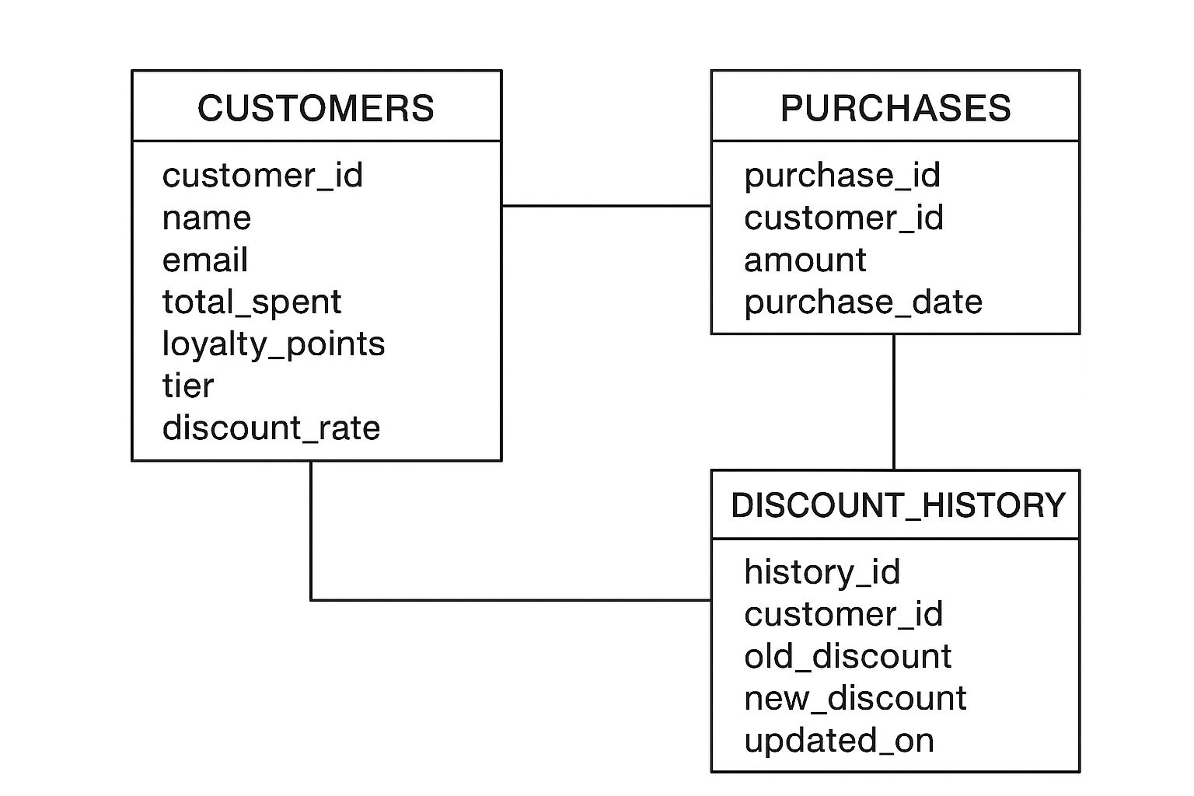

6.2 Data Dictionary
CUSTOMERS
Field | Type | Description
customer_id | NUMBER | Unique ID for each customer
name | VARCHAR2(100) | Customer name
email | VARCHAR2(100) | Contact email
total_spent | NUMBER | Total amount spent
loyalty_points | NUMBER | Total points accumulated
tier | VARCHAR2(20) | Current loyalty level
discount_rate | NUMBER | Current discount %
PURCHASES
Field | Type | Description
purchase_id | NUMBER | Unique purchase ID
customer_id | NUMBER | Linked to CUSTOMERS
amount | NUMBER | Purchase amount
purchase_date | DATE | Date of purchase
DISCOUNT_HISTORY
Field | Type | Description
history_id | NUMBER | Unique record ID
customer_id | NUMBER | Linked to CUSTOMERS
old_discount | NUMBER | Previous discount rate
new_discount | NUMBER | Updated discount rate
updated_on | DATE | Date of discount change

System Architecture
Oracle Database 19c / 21c
PL/SQL Packages for business logic
Triggers to automate points calculation and tier assignment
Scheduled jobs (DBMS_SCHEDULER) for monthly discount updates
Views for reporting and analysis
Analytical SQL for KPI reporting
Implementation

8.1 Tables & Sequences

Tables: CUSTOMERS, PURCHASES, DISCOUNT_HISTORY

Sequences: seq_customers, seq_purchases, seq_discount_history

8.2 PL/SQL Package – LOYALTY_PKG
Procedures & Functions:

record_purchase: Adds purchase, updates total_spent & points

calculate_points: Calculates points earned per purchase

assign_tier: Determines tier based on loyalty points

update_discount: Updates customer discount rate dynamically

log_discount_change: Inserts old/new discount into DISCOUNT_HISTORY

Utility functions:

fn_customer_exists

fn_current_tier

fn_next_discount_rate

8.3 Triggers

After insert on PURCHASES → update total_spent, loyalty points, tier, and discount rate

Before update on CUSTOMERS → maintain data integrity

8.4 Scheduled Jobs

Monthly PL/SQL job using DBMS_SCHEDULER to review all customers and adjust discounts according to current tiers

BI Reports & Analytics

Total customer spending per tier

Number of customers in each loyalty tier

Average discount applied per month

Historical discount changes for each customer

Top spending customers and points earned

Testing & Validation

Insert sample customers and purchases

Verify points calculation and tier assignment

Test triggers for automatic discount updates

Execute monthly discount adjustment job

Validate discount history logging

Generate sample BI reports for verification

Conclusion
The Dynamic Discount and Loyalty Management System demonstrates how PL/SQL automation can manage customer loyalty efficiently, dynamically apply discounts, and maintain historical records for strategic business decisions.

Recommendations

Integrate with an e-commerce platform or POS system for real-time updates

Add email/SMS notifications for loyalty milestones

Extend BI analytics to predict customer churn

Include promotional campaigns for targeted tiers

Consider machine learning to predict high-value customers

