Final Project

Run Wall - Monogame

Bruno Penna Barbosa de Almeida

7772825

PROG2370 – Sec4 – Object oriented gaming

Sabbir Ahmed

January 10, 2018

Run Wall – Description & Features

Run wall is a windows based game inspired on the mobile Android game called FireUp. The game consists in block, placed in the base of the game window, that shoots constantly against blocks that are coming towards it. The main goal of the game is to avoid the shooter to touch the blocks that are coming. As you shoot and kill the blocks, your score increases. The score increases based on blocks life (the number written inside the block), as shown in Figure 1.

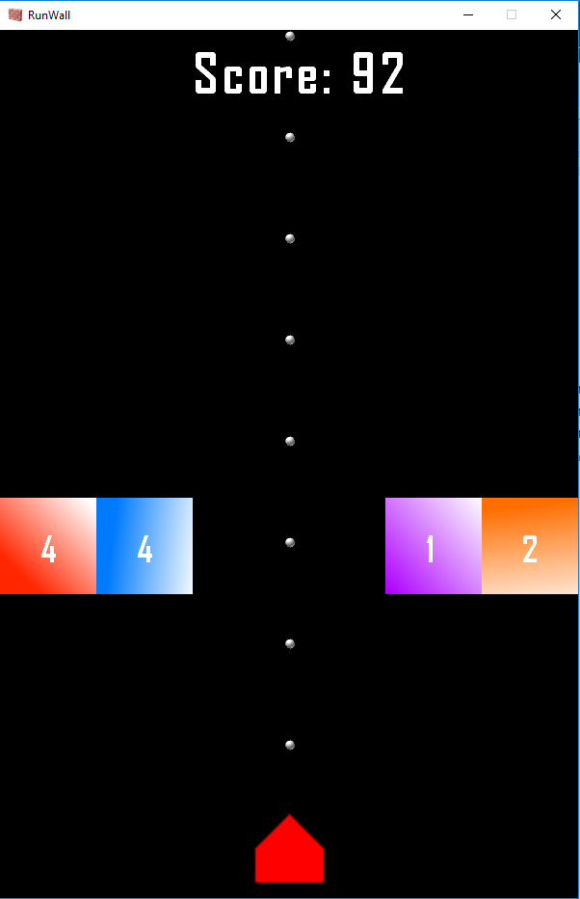

Figure 1: Game Print Screen

The shooter can move left and right and the shots are constantly. At a certain point of the game, when player reach scores of 50 – 100 – 150 and 200, the difficulty will raise, as well as the fire rate. If the shooter touches the block the game will end and show his score.

The next section shows the game’s class diagram.

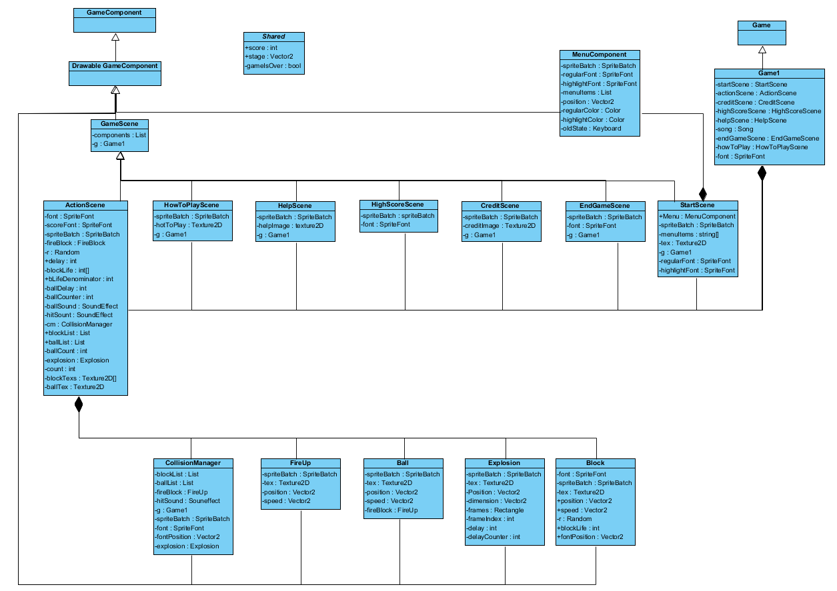

All the blocks have been drawn up by the developer.

The sounds have been downloaded from:

<https://freesound.org>

The initial screen background has been downloaded from:

[www.pexels.com](http://www.pexels.com)