Namecheap is a DNS domain registrar. Publishing websites and webapps to the Internet almost always involves registering a domain and configuring it to point to the right location where the site or app is hosted. This process can be quite daunting especially for less tech-savvy users.
The DNS protocol has some basic concepts, but it can quickly become a rabbit hole. Letting AI assistants handling this, is certainly an advantage.

Namecheap has an API for managing domains: https://www.namecheap.com/support/api/intro/ allowing users to automate tasks, as well as leverage AI assistants to do the DNS management work for them.

  - Enable API access
Go to “Profile > Tools”, and scroll to the bottom under “Business & Dev Tools”. Click the Manage button under subsection Namecheap API Access.
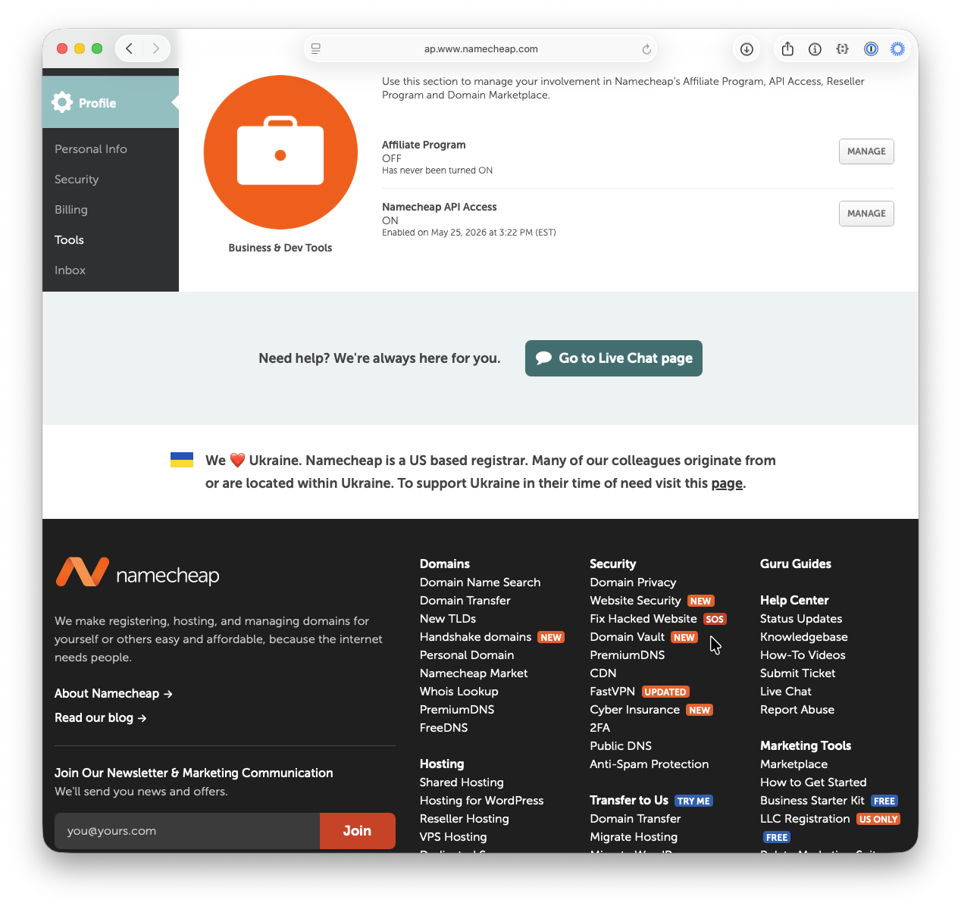
A shortcut is logging in and then navigating to the URL https://ap.www.namecheap.com/settings/tools/apiaccess/ (this URL may change in the future).
Select “ON” to enable the API.
Add the public IP address of the machine (that will connect to the API) to the list of Whitelisted Ips.
Copy and save the API Key in a safe location for future use.
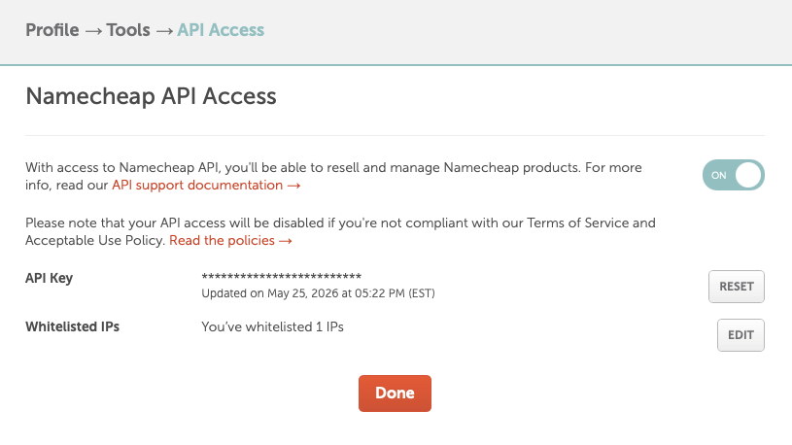
Now we can automate managing Domain Names under Namecheap.
To use AI, enable the Namecheap Skill.
To install in your local machine containing GitHub Copilot CLI, use the following command:
gh skill install brunoborges/namecheap-skill namecheap-dns --scope user

The first time you try to run a command on GitHub Copilot CLI such as “list my namecheap domains”, it will verify the skill is properly configured. In a first run, this is what will happen:
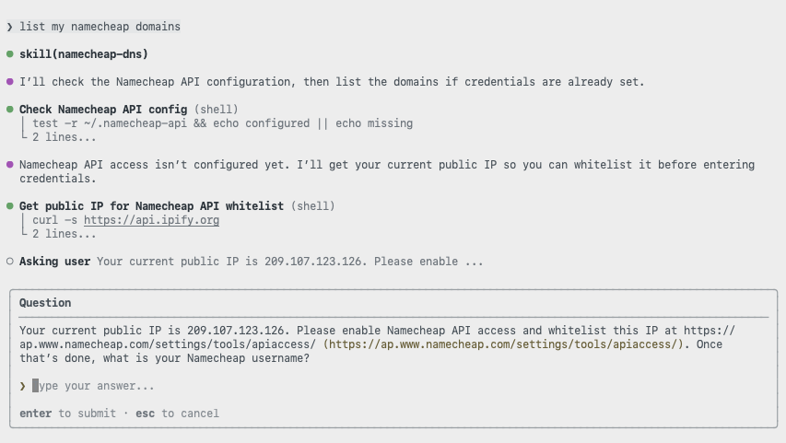
Type your username in.
After this, it will ask for the API Key.
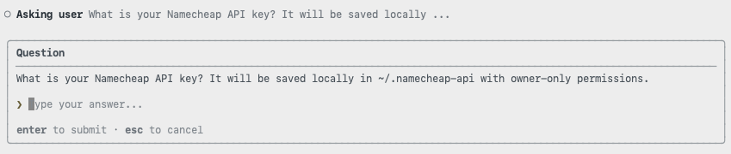
After all is set, Copilot will give you the list of domains in your account:
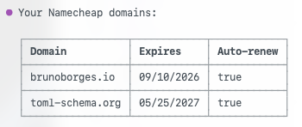

Buy a new domain
For this blog, I purchased one of the cheapest TLD (Top Level Domain) options: .click
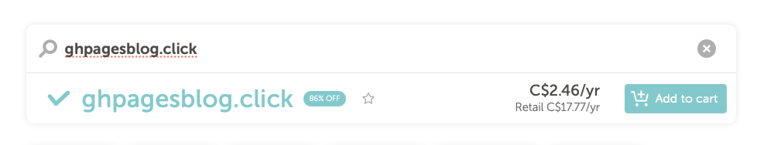
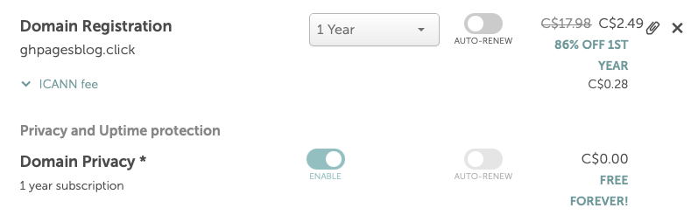
In the end, I paid USD $2.00 (or CAD $2.46).
With a domain ready to be used, let’s now get a website up and running with GitHub Pages.
First, we create a public repository:
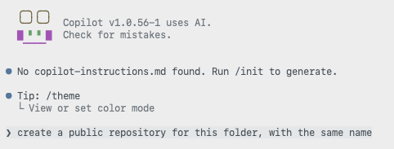
Next, we ask Copilot to create a landing page and enable GitHub Pages for publishing.
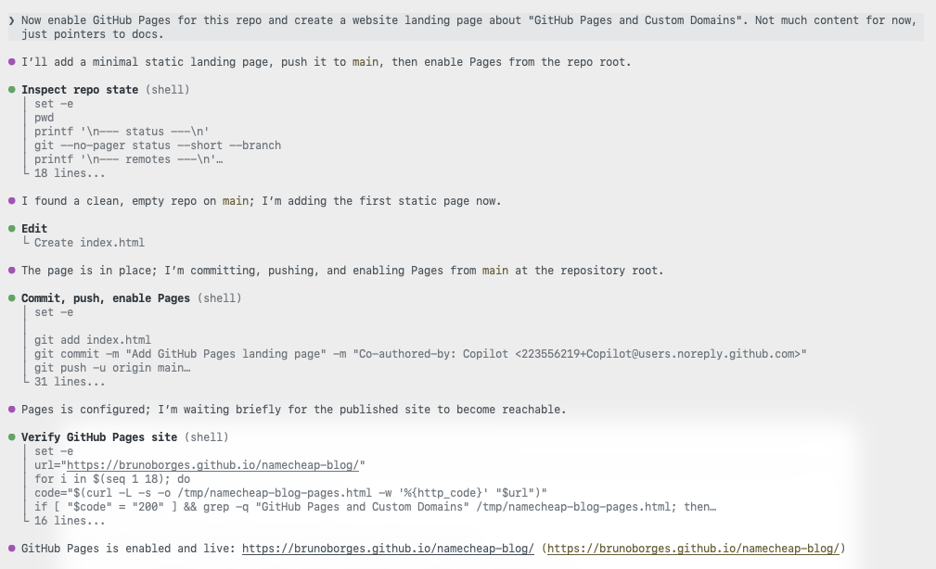
Finally, now it is time to use the Namecheap Skill:
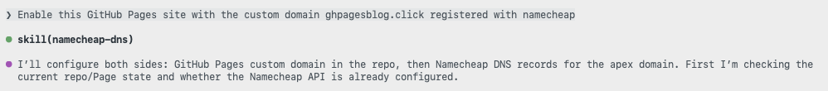
The skill may ask questions:
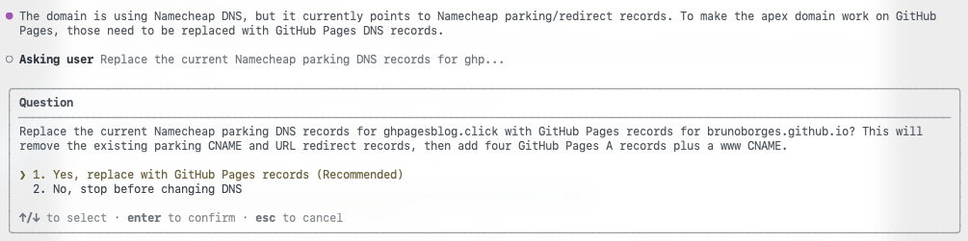
And now the skill does the heavy lift of configuring the DNS to point to GitHub IP addresses for GitHub Pages Custom Domain
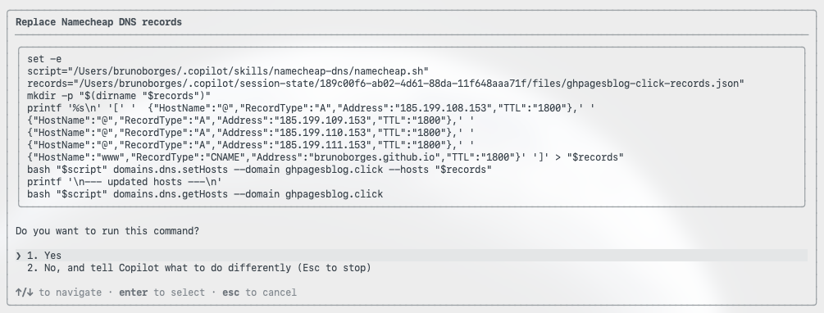
Copilot will ask for a few more things, such as configuring a CNAME file in the repository containing the custom domain.
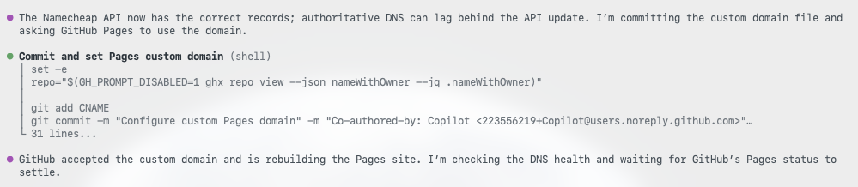
Copilot will now verify if the domain is working:
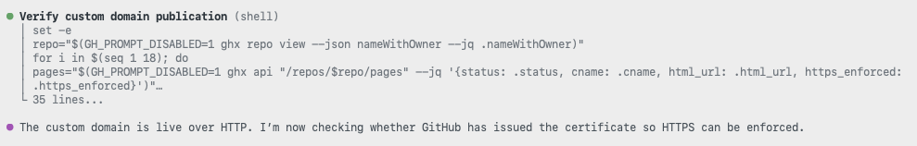
The entire Copilot CLI session is here: https://gist.github.com/brunoborges/167c988a0c4c16b8ccffca995ae98ce2
The domain was bought on 11:21:27 AM EDT.
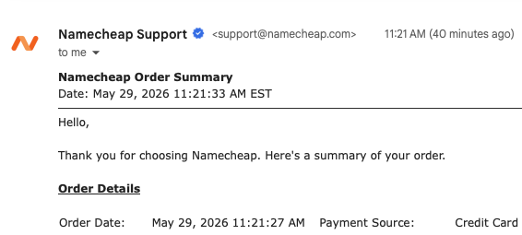
And after all was set and done, the website was live at around 11:35am EDT

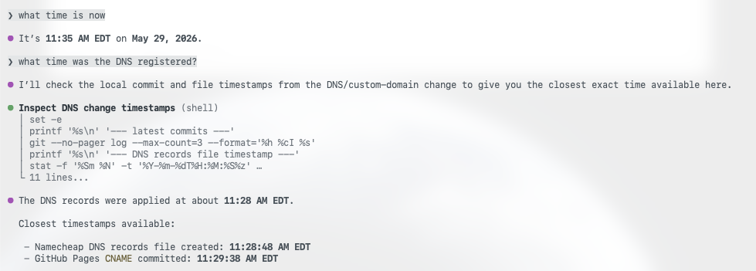
This is how easy it was to configure a GitHub Pages with a custom domain. I did not have to touch any DNS configuration myself.

