GAME PITCH PROPOSAL  
  
CAR TRAVEL RACE

**College:** New Brunswick Community College **Course:** PROG1189 - Comprehensive Development Project **Author:** Bruno Bortoli de Oliveira  
**Date:** 01/17/2023

Document Revision History:

|  |  |  |  |
| --- | --- | --- | --- |
| **Version** | **Date** | **Author(s)** | **Changes** |
| 1.0 | January 17, 2023 | Bruno Bortoli de Oliveira |  |
|  |  |  |  |
|  |  |  |  |

Table of Contents

1.0 Executive Summary 4

2.0 Game Description 4

2.1 Overview 4

2.2 The quest 4

2.3 Main character 4

2.4 Sketch of the main character 4

2.5 Opponents 5

2.6 Sketch of the opponents 5

2.7 Environment 5

2.8 Sketch of the world 5

2.9 Menu 5

2.10 Controls 5

2.11 Sounds 6

3.0 Summary 6

4.0 References 6

1.0 Executive Summary  
  
Car Travel Race is a racing game on a normal road with moving cars and trucks. The player must drive the car carefully and avoid colliding with other vehicles travelling on the road. The player must dodge and overtake cars and trucks to avoid colliding with other vehicles.

In addition to all the skill and attention the driver needs on the road, he still needs to collect the tool pickups to fix the car in case of a collision. In addition to the repair tool, if the vehicle has collided and is damaged, the player will also have to fuel his car by collecting the pickup of gallons of fuel. Only the player with all the skills a driver needs to dodge other vehicles and collect pickups can cross the finish line.

2.0 Game Description

2.1 Overview  
The game takes place on a highway where the movement of cars and trucks is intense. The game’s main objective is to drive the vehicle to the finish line with as minor damage as possible and as much fuel. The game will be a single-player game, and the player will have to have the ability to drive overtaking and dodge other vehicles on the road. In addition to the skills a driver needs, he will have to collect pickups to keep the car moving. The game will have only one phase, and the player will be victorious if he reaches the finish line.

2.2 The quest  
The primary and only mission of the game is to make the player drive the vehicle to the finish line. The game's obstacles are the other cars driving on the road. The player must control the vehicle and avoid colliding with the circulating cars. The rewards in the game will be toolkits and fuel canisters. These kits will appear on the road and can be collected to fix the car if it collides with other vehicles or is low on fuel.

2.3 Main character  
It is a first-person racing game where the player drives the car to the finish line. The main character is a car, and the player can drive the vehicle on the road. The car can have its speed controlled by the player as well as the player can move left and right.

2.4 Sketch of the main character  
The image below represents how the car will look in the game. It's an ordinary car with no special features.  


2.5 Opponents  
Opponents will be cars and trucks that will be driving on the road. These vehicles will have a constant speed and follow a straight line in the same direction as the main car driven by the player.

2.6 Sketch of the opponents  
The image below represents how the opponents will look in the game. It's an ordinary car and truck with no special features.  
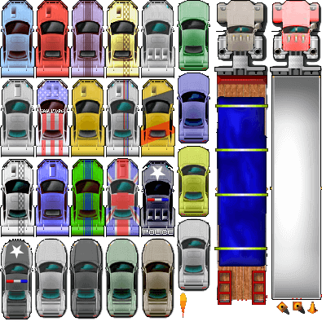

2.7 Environment  
The game will be played on a highway with a regular traffic flow.

2.8 Sketch of the world  
The image below represents where the cars will travel and where the player will drive.  
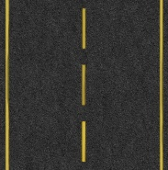

2.9 Menu  
The game's main screen will have the following options as a menu for the player.

1. Play  
2. Instructions  
3. Exit

2.10 Controls  
The controls that the player can use are the keys:  
  
Menu screen: The player can navigate and select the desired option.  
Up - moves the cursor up.  
Down - moves the cursor down.  
Enter - select option.  
  
Game screen: The player can use the below keys to play the game.  
Up - accelerates the car.  
Right - drive the vehicle to the right.  
Left - drive the vehicle to the left.  
P – pause the game.  
Esc - To exit the game.

2.11 Sounds  
The game will have some sounds like:

Music on the menu.  
Vehicle acceleration.  
Vehicle collision.  
Sound when the player collects pickups.

3.0 Summary  
This is a racing game that people of all ages and genders can play. Despite being a simple and lightweight game, having fun with players who enjoy speed and racing takes little. Games like this are more than enough to guarantee fun during all your leisure time.

4.0 References  
All websites below provide free images.  
https://www.pngfind.com/  
https://www.freepik.com/  
https://www.shutterstock.com/