U-Fabrik 3.5
Gives life to your objects

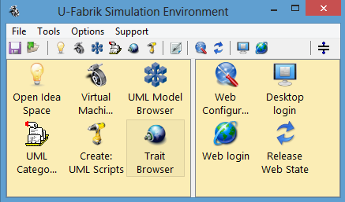

Application

Customization

Manual

All customization operations can be done on the fly
while the system is running !!!

UML Example Model 3
Default Prototype 4
Common Features for Web and Desktop Prototype 4
Prototype Building Rules 5
Web Prototype screenshot 5
Desktop Prototype screen shot 6
Components for Simple Attributes 7
Components for Link Attributes (1x relations) 8
Components for Collection Attributes (Nx relations) 8
Web Prototype unique features 10
Desktop Prototype unique features 10
Prototype Customization 11
Possible Customizations 11
Class Structure Customization 12
Attributes Customization 12
Special Method #printObjectName 13
Customization by adding Behavior 14
Using Virtual Categories for Customization 14
Command Buttons Customization 17

UML Example Model
All examples in this manual will use the following UML class diagram:

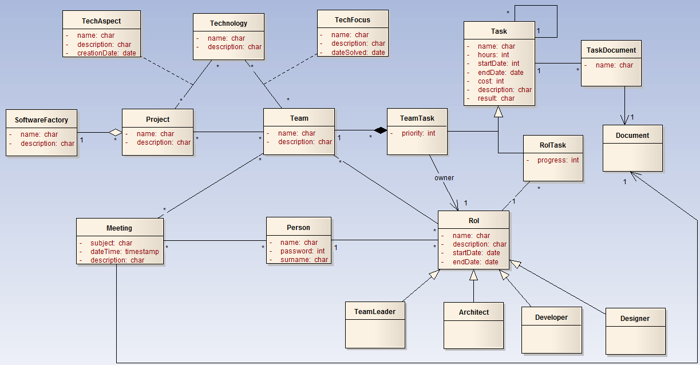

All customization operations can be done on the fly
while the system is running !!!

Default Prototype
In this chapter is described in detail the default prototype built by U-Fabrik. After installing a XMI 2.1 file the U-Fabrik build an UML meta model. Based on this meta model it build the entire prototype on the fly. In the following sections the Web and Desktop prototype will be described.

Common Features for Web and Desktop Prototype
There are some general features that are shared by the Web and Desktop prototype. In this section the common features are detailed. In the following sections the particular features will be detailed.
The U-Fabrik application simulator builds both prototypes on the fly. This means that when an UML object is obtained its meta structure is analyzed. Based on this analysis the U-Fabrik builds a graphical representation (web or desktop) for the class of the UML object and fills it with UML object itself.
One tab for all simple attributes and one tab for each collection attribute.

Web Tabs

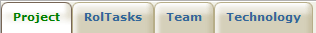

Desktop Tabs

Prototype Building Rules
In this section each component of the prototype is described in detail. For each UML object the U-Fabrik builds:
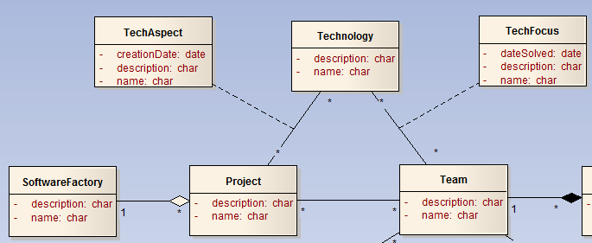
- A Tab for all simple objects.
- A Tab for each collection attributes.
- For each link attribute:
  - Web: a web link.
  - Desktop: a list of one element.

Web Prototype screenshot
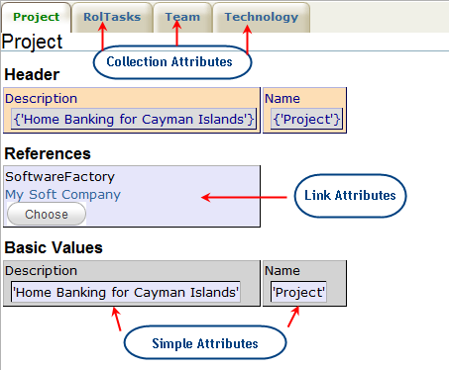
This is the screenshot of the web prototype to view data of Project class. The first Tab always represents the main object. The page can be customized as required (see following chapters). To edit values the web page is very similar but with editing components.

Desktop Prototype screen shot
This is the screenshot of the desktop prototype to view and edit data of Project class. The page can be customized as required (see following chapters).

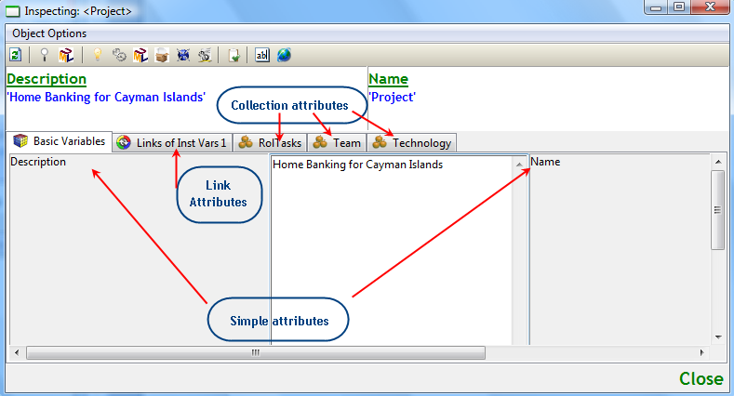

Components for Simple Attributes
For each simple object a proper basic component is built:

 | WEB component | Desktop component
Boolean
Date | 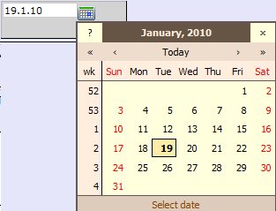 | 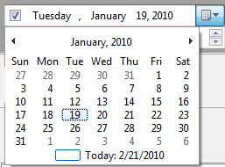
Number |  | 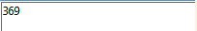
String |  | 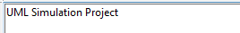
Time
TimeStamp | Date + Time | Date + Time
Each simple attribute will be display in one of this component.

Components for Link Attributes (1x relations)
For each link attribute a link component is built to go to the related object:
 | WEB component | Desktop component
Link Attribute | 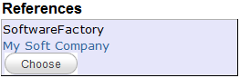 | 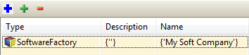
In this example there is a 1xN relation between SoftwareFactory and Project, aSoftwareFactory has N projects and aProject belongs to only one SoftwareFactory.
For the Web Prototype a web link is build with the name of the attribute as label and the object of the attribute as value (in this case a SoftwareFactory).
For the Desktop Prototype a list of only one element is build, when the element of the list is double clicked a new window is open to display the selected object (in this case aSoftwareFactory).

Components for Collection Attributes (Nx relations)
For each collection attribute a list component is build to display the entire objects collection. Following our example, aProject has N teams (instance of class Team):

Web Component for the collection <team> of class Project
The following image shows the Web component used to display an aspect derived from Nx (multiplicity) relations.
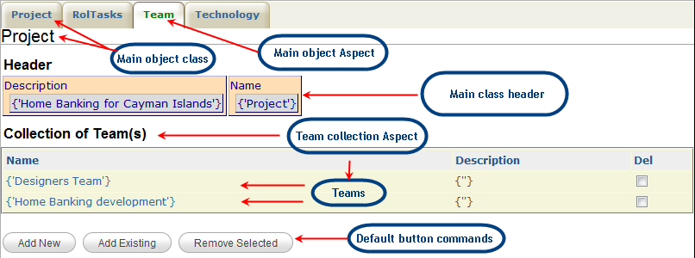
This image shows the collection of Teams of a Project class. This Project has 2 teams: “Designers Team” and “Home Banking Development Team”.
Desktop Component for the collection <team> of class Project
The following image shows the Desktop component used to display an aspect derived from Nx (multiplicity) relations.

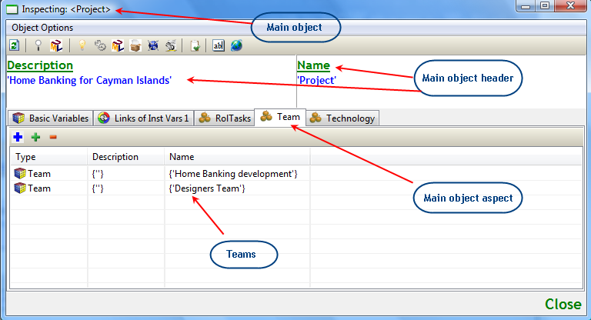
This image shows the collection of Teams of a Project class. This Project has 2 teams: “Designers Team” and “Home Banking Development Team”.

Web Prototype unique features
Link Attributes
In a Web prototype all link attributes are displayed in the main page as Web links.

Desktop Prototype unique features
Link Attributes
In a Desktop prototype all link attributes are displayed in separated tabs as a list of only one element.

The difference between Web and Desktop prototype for links attributes is due to different nature of a Web and Desktop applications.

Prototype Customization
In the previous chapters the default prototype was described in detail. This chapter shows how to customize my UML application beyond the default prototype.
All customizations are done through the creation of the new methods to UML classes and categorized them in virtual categories. Each time the U-Fabrik is about to render an object interface (web or desktop) check these virtual categories in order to customize the default prototype.
These virtual categories are capable of display different aspects of an UML class that are not attributes. In the same way as the default prototype do, these virtual categories can display:
- Simple aspects
- Link aspects
- Collection aspects
- Customized command button

All customization operations can be done on the fly
while the system is running !!!

Possible Customizations
In this section all possible customization for an UML application are analyzed. The possible customizations for an UML application are:
- Add methods to show simple aspects.
- Add methods to show link aspects.
- Add methods to show collection aspects.
- Add methods to perform a command button.
- The #printObjectName method.

Class Structure Customization
The default prototype can be customized to show or hide part of its structure, for example is possible to hide some attributes (simple, link or collection).

Attributes Customization
To show or hide attributes in the prototype just open a UML Model Browser (), go to “Attributes/Relations” tab and select the attribute to hide and open the context menu for the attribute and click in “Enable/Disable” option.
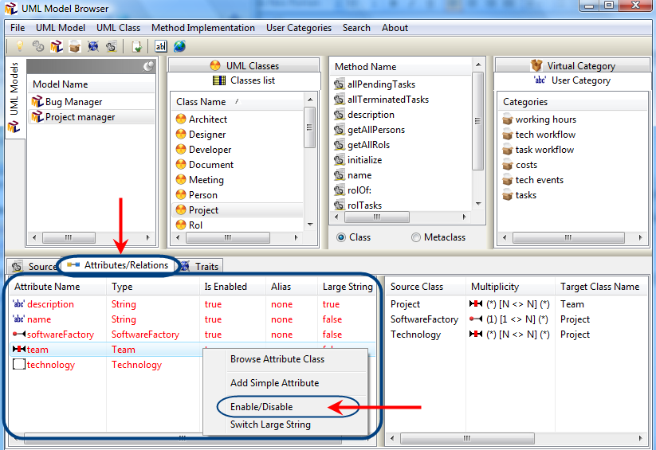
This option “Enable/Disable” turn on and off the attributes of a class, if the attribute is not enable at rendering time that attribute will be not rendered.
The other option is “Switch Large String” if this is false then a regular string component will be displayed. If it is true a component for large strings will be rendered.

Special Method #printObjectName
In the case of link aspects the label of the web link is the type of the object (first image). To customize the value displayed in link aspects implement the method (#printObjectName – second image). If this method does not exist in a class then display the type of the object (first image).
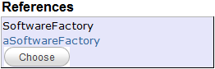

In this case the class SoftwareFactory implements #printObjectName

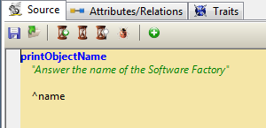
The method #printObjectName answer the name (“My Soft Company”) of the SoftwareFactory.

Customization by adding Behavior
The prototype built by U-Fabrik follows the original UML class diagram but is not enough for good prototype. The default prototype only shows the static structure (class attributes and its direct relations) of an UML class diagram. In order to simulate an entire application is a must to be able to shows the dynamic behavior of a UML class diagram.
How to show the dynamic behavior of an UML application is detailed in this chapter. This is achieved using methods (implementations) that simulate the behavior of the UML application. These methods (implementations) can be grouped in different virtual categories to show the dynamics of the UML class diagram.

Using Virtual Categories for Customization
In this section all virtual categories are described in detail:

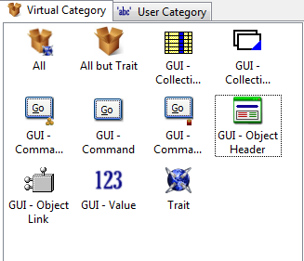

To add a method to a virtual category just drag&drop the method into the virtual category.

There are ten virtual categories to support the application customization.

All customization operations can be done on the fly
while the system is running !!!

“All” Category 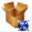
The “All” category when is selected shows all methods of the class. Is not possible to add method to this category, all methods already belongs to it.

“All but Trait” Category 
The “All but Trait” category when is selected shows all methods of the class but if the method belongs to a trait then is not displayed.

“GUI – Collection Aspects” Category
When a collection of UML objects is listed in a GUI component the firsts 4 simple attributes are listed. If you drag&drop methods to this virtual category when a collection of objects is about to be displayed, the U-Fabrik will display the result of invoking these methods (each method will be a column) instead of the firsts 4 simple attributes.
Of course all these method must answer a simple object as number, string, boolean, date, time or timestamp. If one method answers another kind of object (a collection or a domain object) the U-Fabrik will display the type of the object not the value.

“GUI – Collection Tabs” Category
U-Fabrik built a tab for each collection attribute, this can be customized by a drag&drop operation. All methods that belong to this category will be displayed as a tab in the front end application.
To add a new tab to your UML application just create a new method and drag&drop it in this category and the next time the U-Fabrik will display the new tab with the collection component.
All methods of this category must answer a Collection as result, if not the case then a message error will be showed instead of the collection component.

“GUI – Object Link” Category
This category allows adding direct links to domain objects (for 1x multiplicity). Each method of this category generates a link to another domain object.
The method must answer a domain object if not the case then a message error is displayed in the GUI component.

“GUI – Object Header” Category 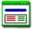
The object header is not defined by U-Fabrik so in the default prototype this area appears as empty. When the header of an object is defined then is displayed always.
To define the header of an object drag&drop methods in this category. These methods must answer simple objects, if not then the type of the object is displayed.

“GUI – Value” Category
This category allows adding simple objects. Each method must answer a simple object if not a message error is displayed in the GUI component.

“Trait” – Category 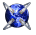
This category is a fixed category and displays the trait methods of a class.

Command Buttons Customization
This section explains how to add command button to an UML application. U-Fabrik supports three kinds of command buttons: regular command buttons, command buttons with stored arguments, and buttons that execute a method to select arguments.
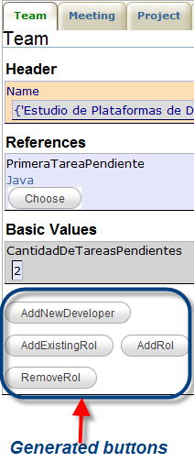

“GUI – Command” Category

The methods of this virtual category are displayed as buttons in the front end application. When the button is clicked the original method is execute and the result of the invocation will be displayed in the web page or in another desktop window.
The method can answer any kind of objects.

“GUI – Command with Arg” Category 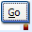

The methods of this virtual category are displayed as buttons in the front end application. But in this category the button can have more than one argument. Arguments are object too, after clicking this button several popup window will ask to select all arguments of the method.
The first step to create a command with arguments is to create an empty method and then drag&drop the empty method into this category. A new window will be opened to configure the method name to execute, the arguments of the methods, and the tab to place the button.
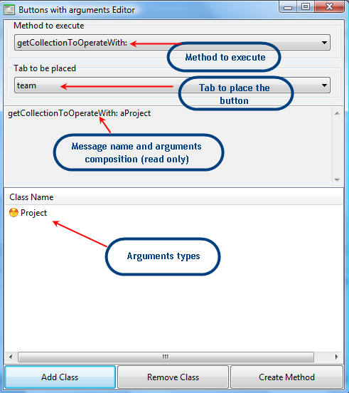
Select the method to execute, the tab to place the button, and the arguments then click on “Create Method” and this will compile a specification for the button with arguments. The arguments are obtained from the object stored in any of the both (global and setup) U-Fabrik objects cache.

“GUI – Command Collection” Category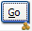
The methods of this virtual category are displayed as buttons in the front end application. But in this category the button can have more than one argument. Arguments are object too, the method selected in “Method to get all arguments” (in this case <rol>) is executed to obtained a collection of objects to be selected as arguments.
The first step to create a command collection is to create an empty method and then drag&drop the empty method into this category. A new window will be opened to configure the method name to execute, the tab to place the button, the method to obtain all possible arguments.
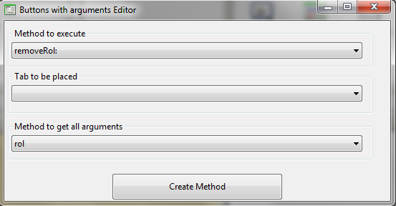
Select the method to execute, the tab to place the button, and the method to obtain all possible arguments then click on “Create Method” and this will compile a specification for the button with arguments. The arguments are obtained from the execution of the method selected in “Method to get all arguments” (in this case <rol>).

