U-Fabrik 3.5
Gives life to your objects

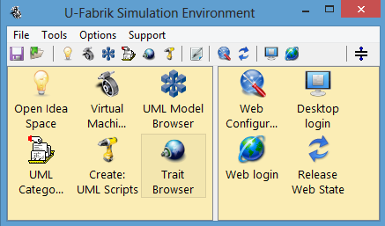

Architecture

Manual

What is U-Fabrik? 3
U-Fabrik Architecture 4
General Architecture 4
The input and output 5
Interaction between elements 6
U-Fabrik History 7
U-Fabrik Design 8
UML Meta Model 8
Prototyping 8
XMI Interaction 11
Simulation of Behavior in the UML Virtual Machine 12
Message Sending 12
Message Processing 13
U-Fabrik Virtual Machine and Core Classes 14
Core Classes 14
Object class 14
Error Class 14
Block class 15
Booleans Classes 15
TreeModel Class 16
Collection classes 17
OrderedCollection Class 17
Value Classes 19
Date Class 19
Time Class 19
TimeStamp Class 19
String Class 19
Number Class 19
U-Fabrik Traits 20
Trait Example with the UML Model 22

What is U-Fabrik?
U-Fabrik is a tool that significantly extends the capabilities of the regular UML modeling tool such as Enterprise Architect®, Visual Paradigm®, and so on.
UML modeling tool build UML models and capture a static view (diagrams) of a system in order to understand the domain and define a solution.
To understand big systems from a static view is very difficult and make the design proper to misunderstanding and errors.
U-Fabrik provides a dynamic view of an UML Model, simulating an entire UML model with desktop and web prototyping.
The use of U-Fabrik simulation and prototyping capabilities in any stage of software development it makes the domain model much reliable, enhance communication capabilities between project’s actors, provide ways to detect early design mistakes, the documentation generation is much more accurate and has others benefit derived from systems simulation.
Usually a XMI 2.1 file version is exported from your preferred UML case tool (such as Enterprise Architect®, Visual Paradigm®, and so on) and imported into U-Fabrik where the simulation and prototyping begins.

U-Fabrik Architecture
The three following pictures depict the entire U-Fabrik Architecture. The first picture shows the general architecture, the second shows the income and the outcome (of the U-Fabrik) and the last one shows how all pieces work together.

General Architecture

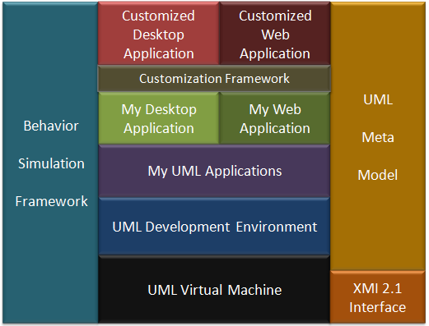
This picture depicts all parts of the U-Fabrik. It has an XMI 2.1 interface to connect with Enterprise Architect®, Visual Paradigm®, and so on. It has a Meta Model to represent all elements contained in the XMI file. It has an UML Virtual Machine to simulate behavior through message sending. On the top of the UML Virtual Machine it has a Graphical Environment for prototyping and simulation. The default web and desktop prototypes are done automatically (after the XMI installation). And it has a Customization Framework that combines the Simulation Framework the UML Development Environment to achieve customization through method implementations and drag&drop operations.

The input and output

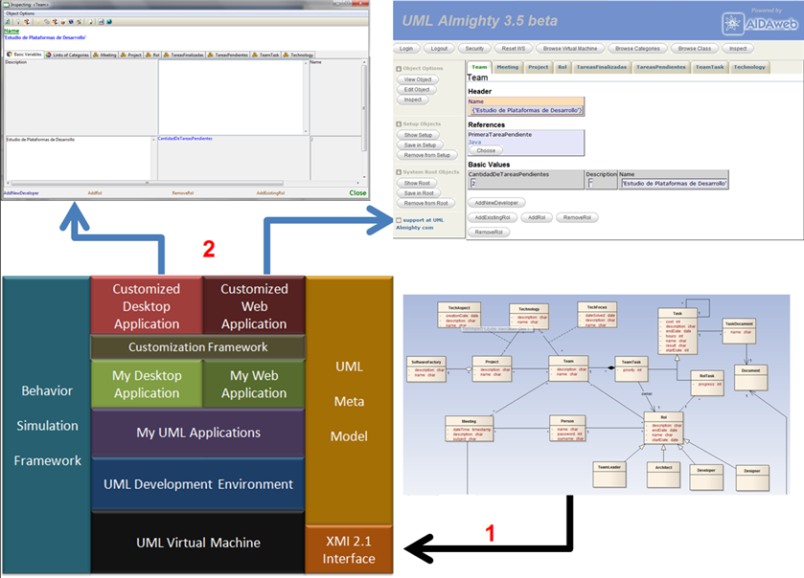
This picture shows the income of the U-Fabrik (1) an UML Class Diagram in XMI 2.1 format. And the outcome produced by U-Fabrik (2) a Desktop and a Web Application.

Interaction between elements

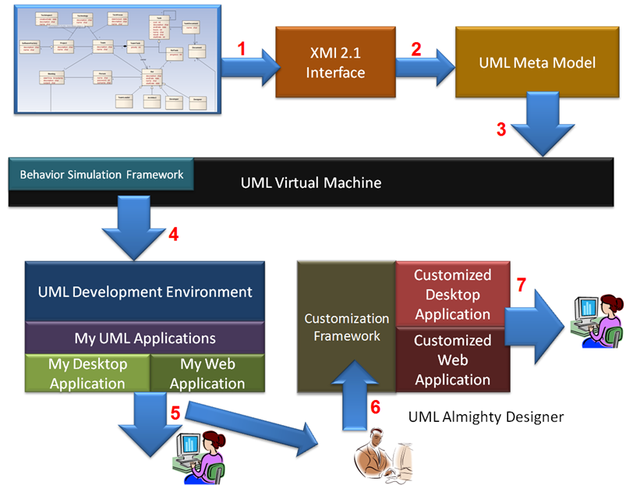
This picture depicts the general iteration between all elements of the U-Fabrik. The first step (1) is to install the XMI 2.1 file. The U-Fabrik will analyze this file and it will produce an UML Metal Model (2) for the diagram. Then the UML Metal Model is connected (3) with the UML Virtual Machine. Now the UML Development Environment it becomes available to work with the UML Meta Model (4). The default desktop and web applications are built automatically (5). The customization framework and the UML Development Environment are used to build customized applications both desktop and web (6) (7).

U-Fabrik History
U-Fabrik was created after years using UML standard to develop applications of all type. Through the years these activities generated a knowledge base about UML development. In the interchange of knowledge between different IT professionals we came to the conclusion that we needed a dynamic environment to simulate and prototype our designs. Not a programming environment but a high level design and simulation environment. After two years of development U-Fabrik 3.5 is a very precious tool for IT companies and professionals that use UML standard.
U-Fabrik is in its third version (3.5) and is in its second year of continuous development.
The first version was finished in 2008. The version 1.0 can only import XMI 1.3 models and show it in a simple environment to perform basic check as: undefined variables, undefined relations, undefined multiplicity, and so on. This version also has a basic UML Meta Model in order to support checks and quick searches.
The second version was finished at the end of 2008. It has the same capabilities as version 1.0 but also can create UML instances, has a much larger environment, has some prototyping capabilities (for desktop and web applications), and can import XMI 2.1 files.
The current version 3.5 has a larger number of features more than any of it predecessors such as: desktop and web simulation and prototyping, larger development environment, a Web Server is included, the ability to persist an entire UML model with its instances (uml objects), extendible core classes, a complete meta model, reflection capabilities, support “on the fly customization”, simulation programming capabilities and so on. In the following chapters we will discuss all U-Fabrik features.

U-Fabrik Design
In this chapter we will show you the internal design of U-Fabrik in order to achieve its big set of features.

UML Meta Model
When an UML class diagram is done it can be exported a XMI 2.1 file, this file is imported into U-Fabrik.
U-Fabrik creates an entire Meta model of each element of the XMI file, such as UML classes, attributes, relations, relations multiplicity and so on. Each element of your UML Class diagram has its representation in the U-Fabrik Meta model.

Prototyping
By exploring and querying the meta model the U-Fabrik creates a prototype (web and desktop) of the UML class diagram. Each class of your class model can be instantiated and view in a desktop window or in a web page.
The prototype represents the static shape of the classes with its attributes, its relations and its relations multiplicities. This feature is instantly available after the import of the UML class diagram (XMI file).
Each UML instance has 3 types of attributes: simple values (numbers, strings, booleans, dates and times), link attributes to others UML objects (derived from 1x1 or Nx1 multiplicity), and collection attributes which are collection of UML objects (derived from NxN or 1xN multiplicity).
When an UML object is created all attributes are initialized with values specified in the class diagram. Simple attributes are initialized with 0 for numbers, true for booleans, empty string for strings and so on. For each link attribute another UML initialized object is created, the class of this new object is defined by the UML relation in the class diagram. Collection attributes are initialized with an empty collection of UML objects, these collections are holder of N objects for NxN and 1xN relation multiplicity. All of this is done automatically by U-Fabrik.

Example UML Model

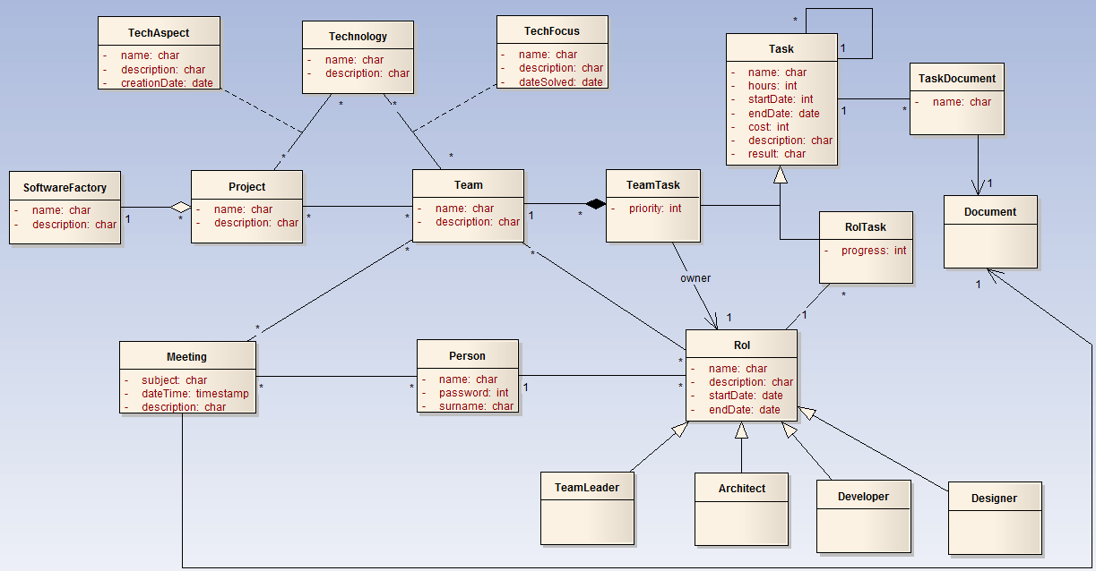
Prototyping example for TeamLeader subclass of Rol class
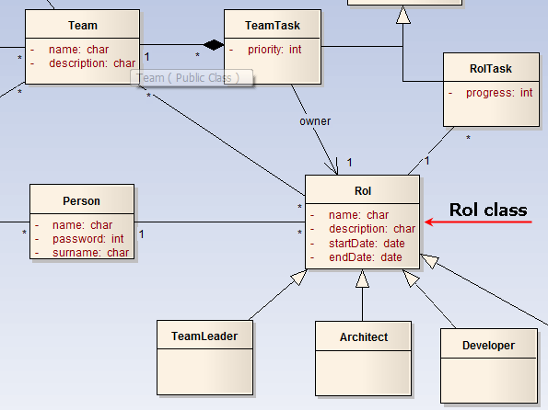

In this example we see the Rol class, a Rol instance will have:
- Simple Attributes
  - Name a String
  - Description a String
  - StartDate a Date
  - EndDate a Date
- Link Attributes (1xX)
  - Persona a UML Person class
- Collection attributes (NxX)
  - Team a Collection of Teams
  - RolTask a Collection of RolTasks

An instance of TeamLeader class subclass of Rol:

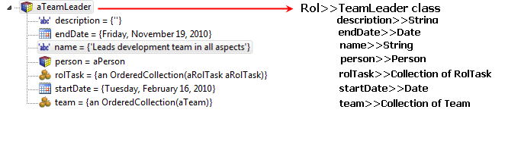

XMI Interaction
U-Fabrik support XMI version 2.1, export your class diagrams to XMI files and then install it into U-Fabrik environment.

Simulation of Behavior in the UML Virtual Machine
In this section will see how U-Fabrik simulates the behavior of an UML class diagram.

Message Sending
In U-Fabrik all objects interact with each other through message sending (anUMLObject message). These messages are natively provided by U-Fabrik. Based on the UML class diagram each class has a set of messages to interconnect with others UML objects.
For example:
aTeamLeader add: aRolTask. “to aTeamLeader add in <rolTask> collection aRolTask”
aTeamLeader add: aTeam. “to aTeamLeader add in <team> collection aTeam”
aTeamLeader numberOfTasks. “answer the number of tasks of aTeamLeader”
aTeamLeader pendingTasks. “answer a collection with pending tasks of aTeamLeader”

In this case we are adding aRolTask and aTeam to aTeamLeader rol. The U-Fabrik checks the UML Meta model to get the correct collection to add each object.
The first message adds aRolTask to instance variable <rolTak> which is a Collection, the second message adds aTeam to instance variable <team> which is a Collection. If a wrong type of object is sent as argument then an error will be answered.
For example: aTeamLeader add: aProject this will answer an Error because TeamLeader class does not have any direct relation with Project class. Also aTeamLeader endDate: ‘hello’ will fail because <endDate> is a Date not a String.

Message Processing
Message sending can combined to achieve a much more complex behavior, the message send is performed by the UML Virtual Machine. For each message in a method the UML Virtual Machine (a method or implementation is a set of messages to different objects):
- Map each name to a real UML object at execution time.
- Get the arguments for the message.
- Send the message to the object with its arguments.
All messages always return an UML object, there is no other possibility. In order to have a simple and very powerful simulation mechanism in U-Fabrik everything is an object.

U-Fabrik Virtual Machine and Core Classes
U-Fabrik provides a core of classes in order to simulate high level behavior of your UML class diagram. In this section will see different core classes and its functionality.

Core Classes

Object class
Object class is the supreme super class of all classes in the system, provides a basic behavior to its subclasses. The more important methods of Object class are:
- == anotherObject → (example) anObject == anotherObject – “answer if two objects are the same”
- getCollectionToOperateWith: anObject → (example)
aTeamLeader getCollectionToOperateWith: aRolTaks “answer the collection of RolTasks of the aTeamLeader object (based on the UML class diagram)”
- setVariableNamed: stringVarName with: anObject → (example)
aProject setVariableNamed: ‘name’ with: ‘UML Simulation Project’– “set the variable named <stringVarName> with UML Object <anObject>. The type of the argument must be the same as in the UML class diagram, if not answer an Error”
- storeAsGlobalObject → aProject storeAsGlobalObject – “store the UML object aProject in a special persistent cache”
- storeAsSetupObject → aTechnology storeAsSetupObject – “store the UML object aTechnology in another special persistent cache”
- vmPerform: → anObject vmPerform: ‘storeAsGlobalObject’ – “send the message <storeAsGlobalObject> to anObject”

Error Class
Any attempt to connect UML objects in any way that is not supported by the original UML class diagram will generate an instance of class Error with a text as description of the error.

Block class
This class allows U-Fabrik to have a very powerful and simple way of specify behavior to an UML class diagram. A Block is a simple set of messages that can have arguments, is very similar to Lisp lambda expressions and Smalltalk BlockClosures.
[ anObject message. anotherObject anotherMessage. ]

simpleBlock := [‘aString’ reverse. 8 > 9. Date newInstance]. “here we created aBlock but we do not execute nothig”
simpleBlock value. “the Block evaluate all messages (#reverse #> #newInstance)”
All messages enclosed in brackets [ ] will create a Block.
Block can have arguments:
“this block multiply the argument <each> by 5”
byFiveBlock := [:each | each * 5].
byFiveBlock value: 10. “answer 50”
byFiveBlock value: 3. “answer 15”
“this block reverse (invert) the argument and then convert the result to uppercase”
reverseUpperBlock := [:each | each reverse asUppercase].
reverseUpperBlock value: ‘hello’. “answer ‘OLLEH’ ”
reverseUpperBlock value: ‘lmu’. “answer ‘UML’ ”
Blocks can be used with high level classes, will see how useful are Blocks combined with Collections to implement very simple and powerful behavior.

Booleans Classes
All comparisons between object always return a Boolean object (true or false).
9 > 5 answer the Boolean object <true>.

TreeModel Class
TreeModel create a tree like structure for high level objects and perform searching operations.
- add: childObject asChildOf: parentObject → (example)
aTreeModel add: aRolTasks asChildOf: parentRolTask
“we add <aRolTask> as child of <parentRolTask> in the tree <aTreeModel>”
- childrenOf: aObject → (example)
aTreeModel childrenOf: parentRolTask
“answer a collection with the children of <parentRolTask> in the tree <aTreeModel>”
- parentOf: aObject → (example)
aTreeModel parentOf: aRolTask
“answer the parent object of <aRolTask> in the tree <aTreeModel>”
- includes: aObject → (example)
aTreeModel includes: aRolTask
“answer whether or not the tree <aTreeModel> includes the object <aRolTask>”

Collection classes
Collection classes allow U-Fabrik to simulate all NxX relations in an UML class diagram. Collections support a wide range of methods in order to connect different UML objects. These methods implements adding, removing, searching, transforming and enumerating operations.

OrderedCollection Class
This is the classic collection used by U-Fabrik to implement NxX relations, the most useful methods are:
Add and Remove messages
- add: anObject → (example)
aCollection add: aRolTasks “add <aRolTask> to the collection <aCollection>”
- remove: anObject → (example)
aCollection remove: aRolTasks “remove <aRolTask> from the collection <aCollection>”
- addAll: anotherCollection → (example)
aCollection addAll: anotherCollection “add the entire collection <anotherCollection> to the collection <aCollection>”
- at: index → (example)
aCollection at: 8 “answer the object in position 8 of the collection <aCollection>”
- size → (example)
aCollection size “answer the size of the collection <aCollection>”
Search messages
- allSatisfy: aBlock → (example)
aCollectionOfProject allSatisfy: [:eachProject | eachProject team size > 5]
“answer whether or not (true or false) all elements of collection <aCollectionOfProject> has more than 5 teams”
- anySatisfy: aBlock → (example)
aCollectionOfProject anySatisfy: [:eachProject | eachProject name = ‘UML Tool’]
“answer whether or not (true or false) any element of collection <aCollectionOfProject> has the name [UML Tool]”
- detect: aBlock → (example)
aCollectionOfSoftwareFactories detect: [:eachSF | eachSF name = ‘My Company’]
“answer the first element that answer true after evaluating <aBlock>, in this case answer the first SoftwareFactory of the collection <aCollectionOfSoftwareFactories> that has the name [My Company]”
- includes: aBlock → (example)
aCollection includes: aProject
“answer whether or not the collection <aCollection> has the element <aProject>”
- isEmpty → (example)
aCollection isEmpty
“answer whether or not the collection <aCollection> is empty”
- select: aBlock → (example) (reject: is the opposite message)
aCollection select: [:eachProject | ‘*UML*’ match: eachProject name]
“answer a new collection with the elements of <aCollection> which its name match the wildcard [*UML*]”
aCollection reject: [:eachProject | ‘*UML*’ match: eachProject name]
“answer a new collection with the elements of <aCollection> which its name does NOT match the wildcard [*UML*]”

Enumerating messages
- first → (example)
aCollection first “answer the first element of the collection <aCollection>”
- last → (example)
aCollection last “answer the first element of the collection <aCollection>”
- do: aBlock → (example)
aCollection do: [:each | each calculateCost]
“to each element in <aCollection> send the message #calculateCost”

Transforming messages
- asArray → (example)
aCollection asArray “convert the OrderedCollection into anArray with the same elements”
- asSortedCollection: aBlock → (example)
aCollection asSortedCollection: [:a :b | a totalCost <= b totalCost]
“answer a new SortedCollection order by ascending #totalCost”
aCollection asSortedCollection: [:a :b | a surname >= b surname]
“answer a new SortedCollection order by descending #surname”

Value Classes
This classes are used to instantiate all simple values of all classes.

Date Class
Date newInstance. “answer the date of today”

Time Class
Time newInstance. “answer the time now”

TimeStamp Class
TimeStamp newInstance. “answer the time stamp with date of today and time now”

String Class
‘this a string’ asUppercase “answer [THIS IS A STRING]”

Number Class
9 * 9 “answer a new number 81”

U-Fabrik Traits
U-Fabrik natively supports traits to capture general behavior. Traits are general method that do not belong to any and can be used by any class. A trait has requirements and exposes messages. The requirements are methods that a class has to implement in order to use the trait. There is only one and powerful trait in U-Fabrik although another traits can be created. This trait is named <UML Relations Methods> and is assigned to all classes after an XMI file is installed, so all classes of the UML class diagram will have this trait to use.
Trait
UML Relations Methods

Requirements
#getCollectionToOperateWith:
#getCollectionToIterateOver:
#setDirectRelationWith:

Since Object class implements these three methods all classes can use this trait.

Trait’s Methods
#add:
#all:satisfy:
#any:satisfy:
#basicAdd:
#basicRemove:
#countNumberOf:
#in:collect:
#in:do:
#in:reject:
#in:select:
#includes:
#mutualAdd:
#mutualRemove:
#remove:

These methods are automatically available to all classes in XMI file.
Example UML Model

This UML class diagram will be used in order to explain the use of Traits. Look at the class SoftwareFactory, Project, Team, Rol, TeamTask and Rol class. A SoftwareFactory can have N Projects. A Project can have N Teams and a Team can participate in different Projects. Each Team has N TeamTask and has N Rols, also each Rol can have N RolTask.

Trait Example with the UML Model
Remember that all imported classes from the XMI file can use this trait. It is assigned automatically after the import of the XMI file.
Here where the Trait is used, the trait added a lot of methods: (#add: #all:satisfy: #any:satisfy: #basicAdd: #basicRemove: #countNumberOf: #in:collect: #in:do: #in:reject: #in:select: #includes: #mutualAdd: #mutualRemove: #remove:).
We are going to create two UML objects. The main is our SoftwareFactory. Now we want to add the Project ‘UML Simulation Environment Project’ to our SoftwareFactory. The following image shows an UML Script where we create a new Software Factory and a new Project:
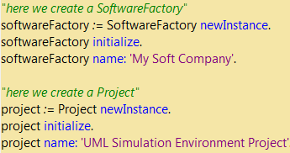

In this case we are going to use #add: message. The UML Virtual Machine using the UML Meta Model get what kind of relation these classes has and perform the defined operation for that relation. In this case is a 1xN relation. The main object (softwareFactory) has a collection of the second object (project) and the second object (project) has a direct reference to (softwareFactory).

Here we send the message #add: to <softwareFactory> with <project> as argument. The message #add: is implemented by the trait and is a general message. Now the <softwareFactory> has <project> in its collection.

Inspecting <aSoftwareFactory>
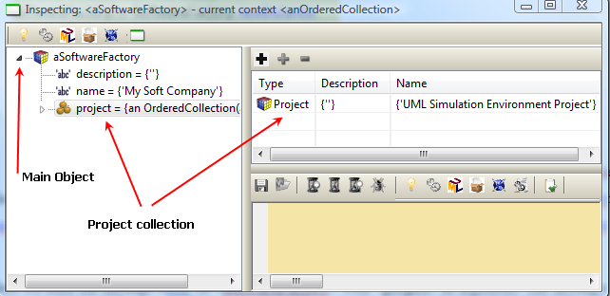
Inspecting <aProject>
