U-Fabrik 3.5
Gives life to your objects

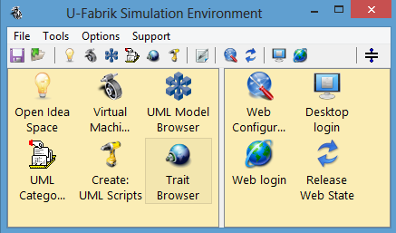

Development

Environment

Manual
U-Fabrik Environment Tools 3
U-Fabrik Shell Manager 3
UML Model Browser 4
Import a XMI 2.1 file 4
UML Model View 5
UML Model Context Menu 7
UML Class Context Menu 8
UML Method Context Menu 9
UML Class Attributes Context Menu 10
UML Class Relations Context Menu 11
User Categories Context Menu 11
UML Workspace for Scripts 12
The three operations of an UML Script 13
UML Object Inspector 14
UML Category Browser 15
Idea Space 16
Web Server Configuration 17
U-Fabrik Advanced Environment Tools 18
Traits Browser 18
Virtual Machine Browser 19

U-Fabrik Environment Tools
This manual will detail all development tools of the U-Fabrik development environment and its functionality.

U-Fabrik Shell Manager
Is the main window of the U-Fabrik from here you can open all tools of the U-Fabrik Development Environment.

UML Model Browser
The UML Model Browser shows the UML class diagram in a new way. All classes are displayed in a list (order by name) and in a tree ordered by the class hierarchy.
Attributes and relations are displayed as the user change the selected class.

Import a XMI 2.1 file
In the menu bar of the UML Model Browser select “File” then select “Import XMI file”. Choose your XMI 2.1 file from your computer and install it in U-Fabrik. Now that your UML class diagram is installed you can start to create objects!!! Open an UML Workspace and try some script for your model.
Each simple attribute of the class diagram is a simple attribute in the UML Class, and each relation of the class will become in another attribute of the class. Depending on the multiplicity of the relation this attribute will be a collection or a link to other UML object. The basic rules are:
- Each simple attributes in the XMI file become a simple attribute in U-Fabrik.
- Each relation in the XMI file become an attribute in the U-Fabrik:
  - For N multiplicity relations become a collection.
  - For 1 multiplicity relations become a direct link to other UML object.

UML Model View
The UML Model Browser has four panes in the top:
- Display installed UML models (class diagrams).
- Display UML classes of the selected UML model.
- Display the method of the selected UML class.
- The category pane will be explained in other chapter.

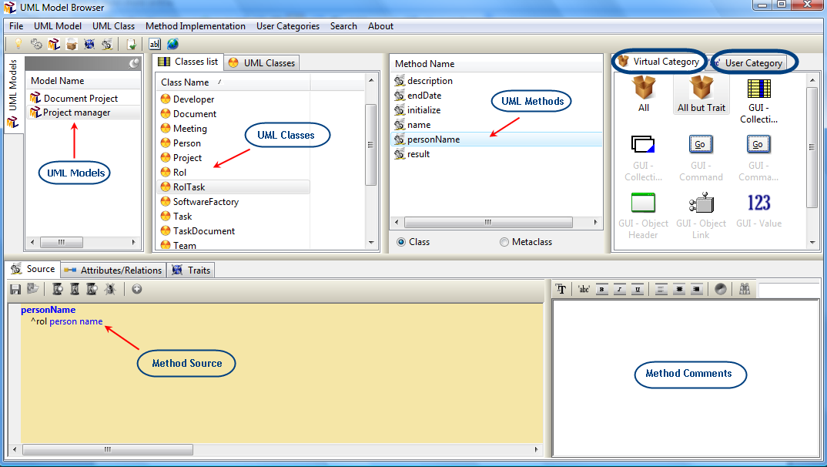

Each time a UML Model is selected the class list is loaded with the classes of the selected model. The same applies when a classes is selected the method pane is loaded with the method of the selected class.
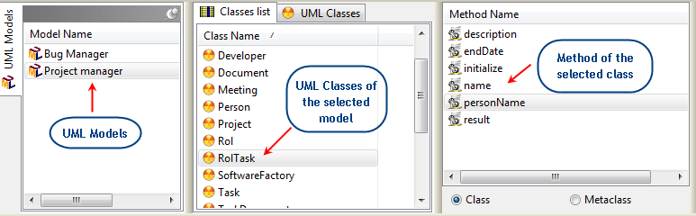

In the bottom it has 3 more tabs: method source, attributes and relations and traits.

Source Pane
The source pane displays the source of the selected method.
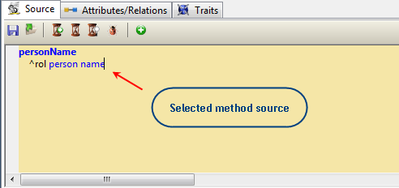

Attributes and Relations pane
This pane displays the attributes and relations of the selected class. Each relation become in an attribute when XMI is installed.
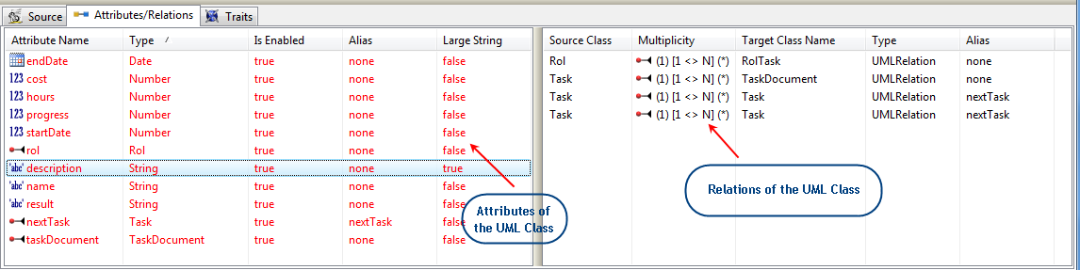

Traits Pane
The pane displays de Traits available for the selected class, from this pane traits can be added or removed.
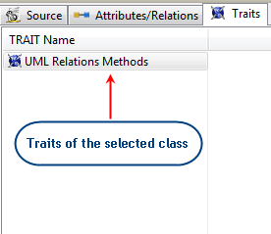

UML Model Context Menu
These are the options in the context menu of a UML Model:
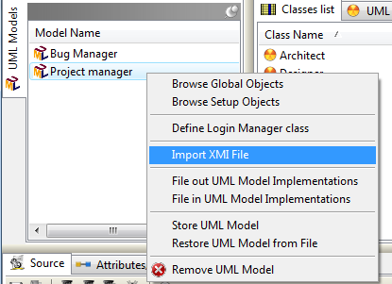
Browse Global Objects:
Open a new window to manage all Global Objects (is a cache of objects).
Browse Setup Objects:
Open a new window to manage all Setup Objects (is another cache of objects, U-Fabrik has two caches to store objects).
Define Login Manager Class:
Define the class in the UML Model responsible for user and password validation. Then the Meta class method #userRootObjectsFor:password: is created. This method answers a collection with the initial objects for the logged user.
Import XMI File:
File Open dialog to install a XMI 2.1 file into U-Fabrik.
File out UML Model Implementations:
Store all implementations in a XML file.
File in UML Model Implementations:
Load all implementations from a XML file.
Store UML Model:
Store the entire UML Model classes and objects in a file.
Restore UML Model from File:
Load an entire UML Model from a file.

UML Class Context Menu
These are the options in the context menu of a UML Class:
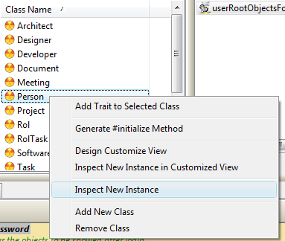
Add Trait to Selected Class:
Open a new window with all available Traits to add to the selected class.
Generate #initialize Method:
Generate #initialize method for the selected class. This method initializes all instances variables of an object. Each variable is initialized based on the original class diagram plus the relations.
Design Customized View:
Open a Window Builder to create a specific view for a class.
Inspect New Instance in Customized View:
Create a new instance of the selected class and inspect it in a Customized view.
Inspect New Instance:
Create a new instance of the selected class and inspect it in a regular Inspector.
Add New Class:
Add a new class to the selected UML Model.
Remove Class:
Remove the selected class from the selected UML Model.

UML Method Context Menu
These are the options in the context menu of a UML Method:
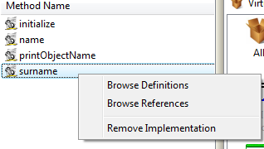
Browse Definitions:
Open a new window with all UML methods that have the same name of the selected method (implementation).
Browse References:
Open a new window with all UML methods that inside its implementation have a call to the selected method (implementation).
Remove Implementation:
Remove the selected implementation from the selected class.
Create an implementation
To create new implementation enters the source of the implementation and click on the button. U-Fabrik will create the implementation and add it to the selected class.
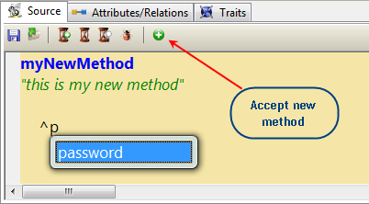

UML Class Attributes Context Menu
These are the options in the context menu of UML Class Attributes:
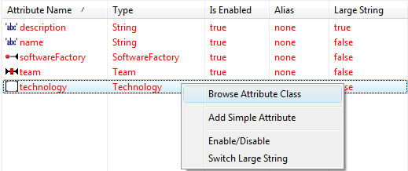

Browse Attribute Class:
Open a new window UML Model Browser selecting the class of the selected attribute. In this case open a new UML Browser in the class Technology.
Add Simple Attribute: open a dialog to add a simple attribute (string, number, Boolean, date, time, timestamp) to the selected class.
Enable/Disable: check “UML Application Customization Manual”.
Switch Large String: check “UML Application Customization Manual”.

If an attribute is double clicked then the browser will go to the class of the double clicked attribute. In this case double click on attribute <team> go to Team class.

UML Class Relations Context Menu
These are the options in the context menu of UML Class Relations:
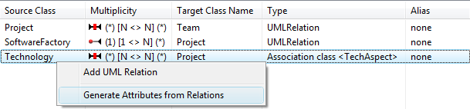
Add UML Relation:
Open a dialog to add a new relation to the selected class.
Generate Attributes from Relations:
Create one attribute for each relation to the selected class. The new attribute will be a collection (NxX multiplicity) or a direct link another object (1xX multiplicity).

User Categories Context Menu
These are the options in the context menu of UML Categories:
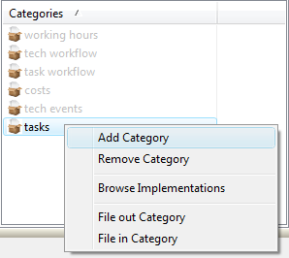

Add Category:
Add a new category to the system; if the name already exists do nothing.
Remove Category:
Remove the selected category from the system (no methods are removed).
Browse Implementations:
Open a dialog with all implementations that belongs to the selected category.
File out/in Categories:
Store/Load all implementations of a category to/from a file.

UML Workspace for Scripts
In the UML Workspace you can create your own UML Script and save it to file.
An UML Script sequence can be: displayed, evaluated, or inspected. The three options are placed in the toolbar . Write your own UML Script and select the text that you want to execute and then: display it or evaluate it or inspect it.

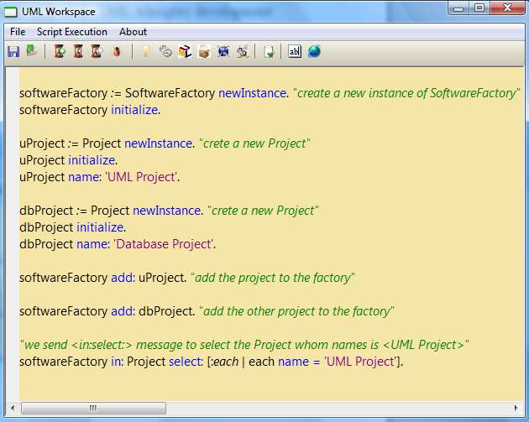
UML Workspaces are useful to create and manipulate objects

The three operations of an UML Script

Display it → send the message and print the result {an OrderedCollection(aProject)}.
Evaluate it → just send (perform) the message.
Inspect it → send the message and inspect the result (in this case anOrderedCollection with aProject).
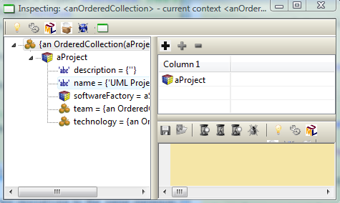

This image shows an UML Inspector. An inspector shows an object and its contents. In this case the inspector is displaying anOrderedCollection with aProject.

UML Object Inspector
The UML object inspector provides a basic interface to view and manipulate any kind of UML objects. Inspectors are built on the fly using the UML Meta Model, so are automatically available after the installation of the XMI file.
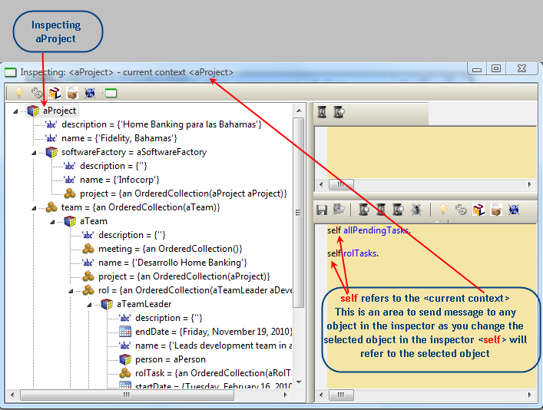
The inspector is showing aProject with all objects that compose it. A Project has:
- <description> (string)
- <name> (string)
- <softwareFactory> (SoftwareFactory)
- <team> (collection of Team)
- <technology> (collection of TechAspect)
All objects can be expanded to display how are composed. Here we can also see that the instance variable (attribute) <softwareFactory> (SoftwareFactory) is composed by: <description >, <name >, <project>.
The inspector allows send messages to any object; self refers to the selected object in the Tree. In this case self is aProject and the messages to send are #allPendingTask and #rolTasks.

UML Category Browser
The UML Category Browser gives an orthogonal view of the system. Not based in UML Class classification but in a User classification. Implementations of different classes can be grouped in the same category to isolate an orthogonal aspect of the system.
The categories are created inside the UML Model Brower and are explored in the UML Category Browser. To add a method to a category just drag & drop the method into the category (in the UML Model Browser). Categories can be added using the context menu of the User Categories pane of the UML Model Browser.
In this case the category <tasks> group methods related to “tasks calculations” and as can be see in the picture a lot of classes and different methods are responsible for “tasks calculations”.
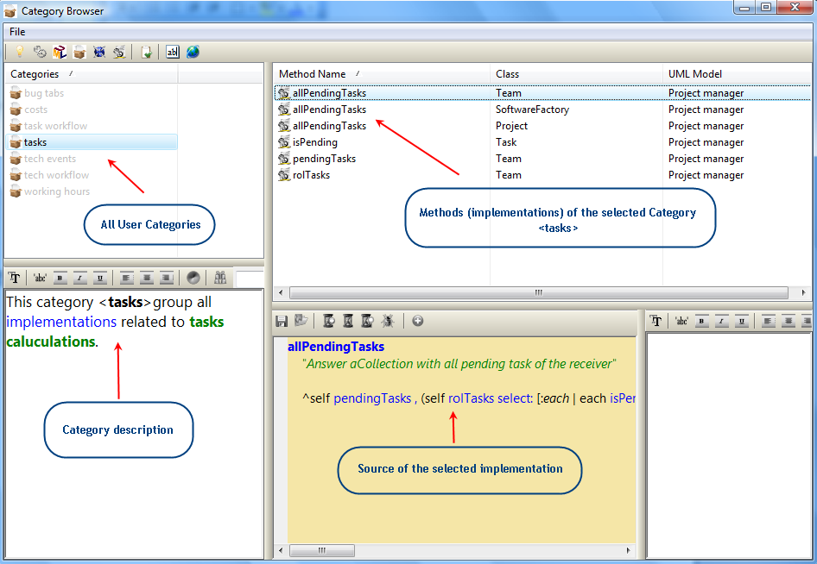
To have a lot of orthogonal views of a system gives us the ability to view aspects of the system that are extended along different class hierarchies and can not be viewed as a whole in the UML Model Browser.
Each category is an orthogonal aspect of the system and each category can be configured (just with drag & drop) as the user needs.

Idea Space
The Idea Space is just an UML Tool holder, where all windows are opened inside the same card container. This is very useful tool just test it in practice. Open one Idea Space and start to open other tool inside it.
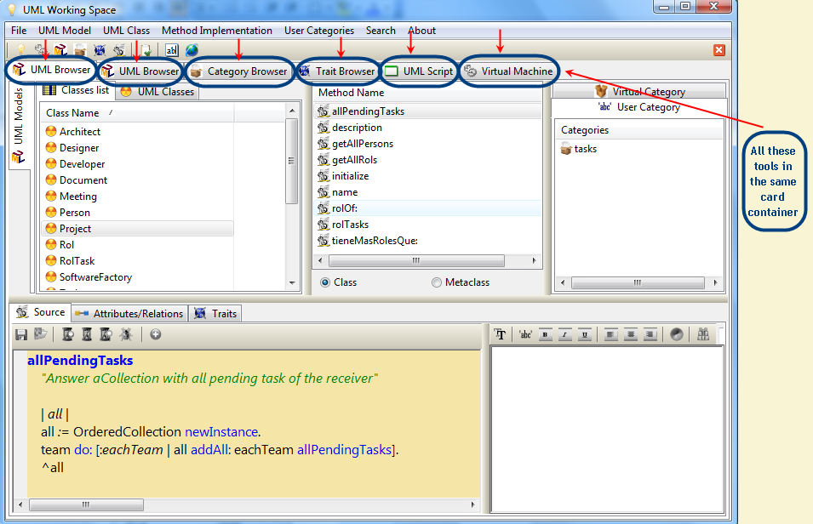
Idea Space help us to focus your attention in one aspect of the system allowing you to have that aspect well isolated in the Idea Space rather than spread it in various different tool windows where is more difficult to get focus.

Web Server Configuration
U-Fabrik comes with its own Web Server so you do not need to install any other software or depend on the IIS. Just start the configured site and your site will be running.

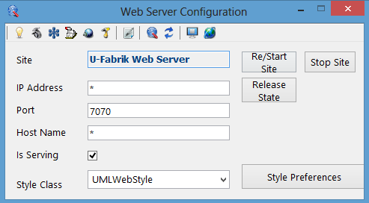

U-Fabrik Advanced Environment Tools

Traits Browser

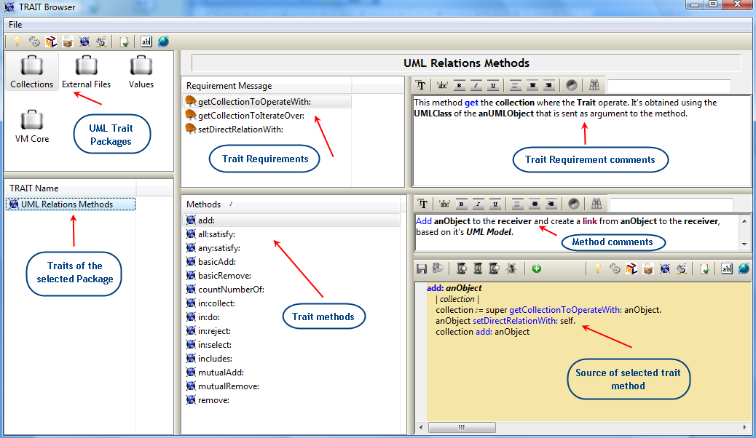

Virtual Machine Browser

