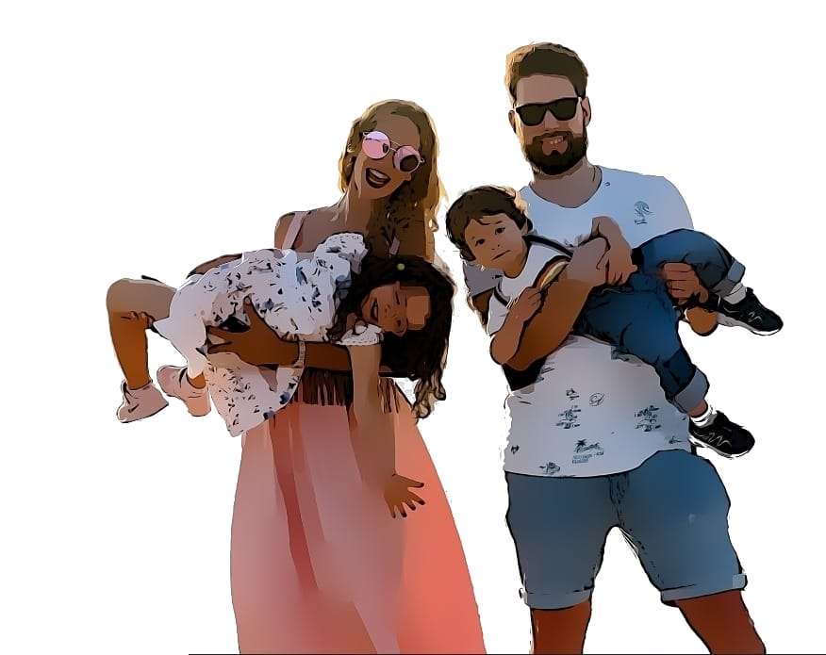

www.genibruno22.pt