UNIVERSITÁ DI PISA

ENGEGNERIA DELL’INFORMAZIONE

**Project 11 – The Carrefour**

**Bruno Augusto Casu Pereira de Sousa**

**Master’s degree Computer Engineering – Computer Systems and Networks**

**592II Performance Evaluation of Computer Systems and Networks**

Pisa, 2022

**Contents**

1. Introduction 3

2. System Description 3

3. System Configuration and Test Scenarios 3

4. Testing Results 3

5. Performance Evaluation and Conclusions 3

# **1. Introduction**

The Carrefour Project is a study case of the supermarket checkout organization, that is, how the clients queue up at the tills, and can process the products they wish to buy. The Project aims to provide a simulator that defines two policies for the clients to perform the Checkout. The scenarios will be tested with different workloads and the results will be analyzed considering the most important Key Performance Indicators, such as the Average Checkout time and the Average Queue Time. These parameters will then define how well the different policies affect the quality of service of the supermarket simulated in the project.

The software used for the simulation is OMNet++, as it provides a proper framework to implement queues and processing centers, necessary for the representation of the supermarket checkout system. The data provided by the simulations will also be analyzed and processed using Microsoft Excel, to display the results in a comprehensive manner, as well as to produce relevant plots of the results.

# **2. System Description**

To model the supermarket actors (clients, tills, and the queues), the concepts of Queueing theory will be used to provide a better view of the characteristics and behavior of those actors, providing a model of a queueing network. The simplest design of the supermarket checkout policy can be defined as a Source sending Clients (jobs) to a Queue, where they wait to be Processed at the Till. This simple network is illustrated in Figure 1:

Figure 1 – Modeling of the simplified supermarket checkout process

The Clients will arrive from the source within a random interval, modeled as an Independent Random Value. The rate that those clients arrive at the queue is represented by **λ**. In this way the time value between each client arrival is defined as **1/λ** (measured in seconds), defined as the Interarrival Time (IA). As the clients arrive for the Checkout, they will enter a First In First Out (FIFO) type Queue and will be placed at the end of it.

The till will be modeled as a processing unit (Service Center, SC), and will perform the client processing in a time interval (also modeled as an independent random value). The client processing rate is defined by **µ**. In this way, the time to process a client in the till is then represented as **1/µ.** The queueing network described for this system is then illustrated in Figure 2:

Figure 2 – Modeling of the simplified supermarket checkout process as a queueing network

From the queueing system described, it is possible to compute and evaluate the Key Performance Indicators of the supermarket and the characteristics that influence on the quality of service provided. The evaluated parameters will then be the Mean Queueing Time (**E[W]**), that is, how much time on average does a client spent on the queue, the Maximum Queue Size (max. **E[Nq]**), and the Mean System Response Time (**E[R]**), that is, the time between a client arriving at the system and leaving it, after the processing in the till.

For the project modeling, there are two policies used for the client processing in the checkout. The first policy to be described, is referred as **Policy A**, and uses a single queue to send the clients to N tills in the system. In addition, the clients must go through a certain distance, depending on the till that is available to it. For this reason, the till assignment to the client at the head of the queue will be that if multiple tills are available, the priority must be sending the client to the nearest queue. The queue distance is proportional to the assigned till number **j** (till 0 is the nearest, and till N is the furthest). The time to reach a till (**t**) is based on a fixed time value **Δ**, and it’s computed by the equation: $t=(j+1)∆$**.**

The above-mentioned characteristics for the Policy A system are illustrated in Figure 3:

Figure 3 – Diagrams for modeling the Checkout Policy A

Given the modeled system and its characteristics, the continuous-time Markov chain (CTMC) of the implemented network can describe the expected behavior for the system. It is also important to consider that the value for the processing time (**1/µ**) is composed of different time constraints that are present in the system. Therefore, the processing time is based on the average time to each the queue, a constant processing time (added to replicate a constant characteristic of processing a client at a till, such as printing the receipt) and the RV representing the client demand (proportional to the number of items a client is buying, and consequentially, the time needed to process all the items). The CTMC illustrated than considers a number **N** of tills in the system:

Figure 4 – CTMC for Checkout Policy A

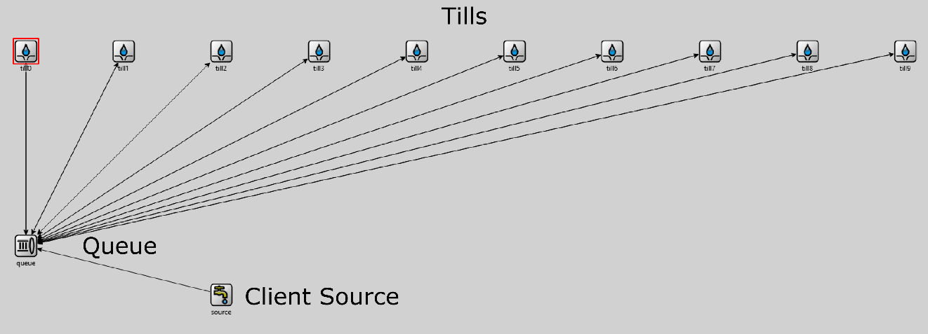

# **3. System Configuration and Test Scenarios**

# **4. Testing Results**

# **5. Performance Evaluation and Conclusions**