Proj. # | Customer | Machine | Direction
 | {{customer}} | {{machine}} | {{direction}}

Order Identification |  |  | Original Representative Samples
Order date | x |  | See Latest Matrix for current in-scope samples
FAT date | x
Purchase Order # | x
Quote # | {{quote}}
Internal Order # | Ox
Customer # | x
Production speed | {{production_speed}}
Design State | In progress
URS Applicable Y/N | x
Ref. Project: | x
COR’s | x
Revision | x
Date / Version | x

Utility Specifications
Voltage |  | {{voltage}} |  |  | Phases |  | {{phases}}
Hz |  | {{hz}} |  |  | AMPS |  | {{amps}}
PSI |  | {{psi}} |  |  | CFM |  | {{cfm}}
Conformity |  | CSA |  |  |  | {{conformity_csa_check}}
Certification | None | {{ce_none_check}} |  | CSA | {{ce_csa_check}} |  | Explosion | {{ce_expl_check}}
 | Comments
Country of destination |  | {{country}}
Comments

BASIC SYSTEMS

Mechanical Basic Machine configuration – spec.1
Sortstar with  Hopper  18ft³ | 220VAC  3 Phases  LEFT TO RIGHT | {{bs_984_check}} | BOM: SRT984 | 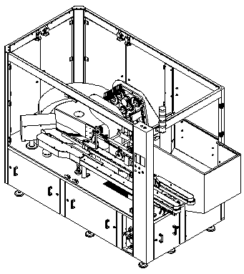
 | 220VAC  3 Phases  RIGHT TO LEFT | {{bs_1230_check}} | BOM: SRT1230 | 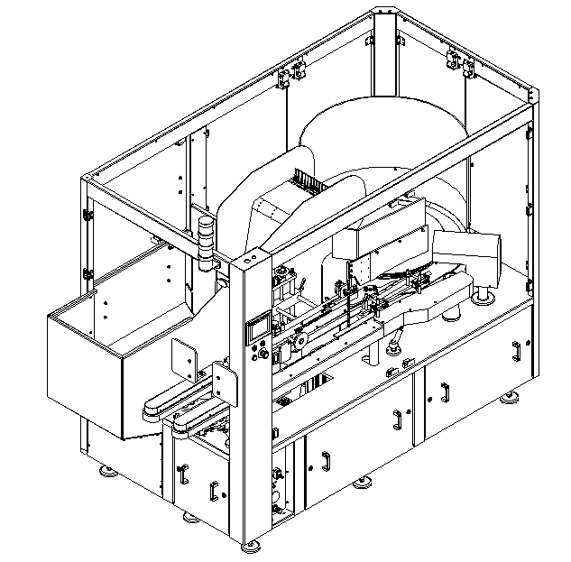
 | 480VAC  &  380 VAC  3 Phases  LEFT TO RIGHT | {{bs_985_check}} | BOM: SRT985 | 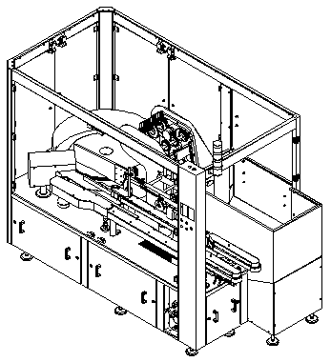
 | 480VAC  &  380 VAC  3 Phases  RIGHT TO LEFT | {{bs_1229_check}} | BOM: SRT1229 | 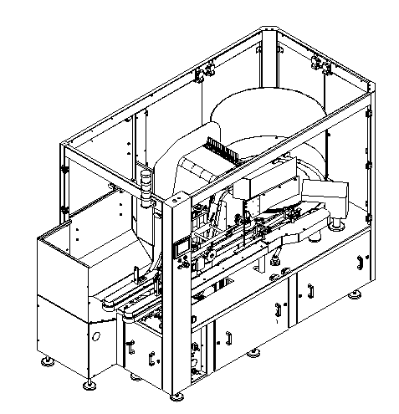
Sortstar with  Hopper  24ft³ | 220VAC  3 Phases  LEFT TO RIGHT | {{bs_1264_check}} | BOM: SRT1264 | 
 | 480VAC  &  380 VAC  3 Phases  LEFT TO RIGHT | {{bs_1265_check}} | BOM: SRT1265 | 

OPTIONAL SYSTEMS

Guarding System – spec.2
Lexan Euroguard Top Cover | {{op_2409_check}} | BOM: EUR2409 | 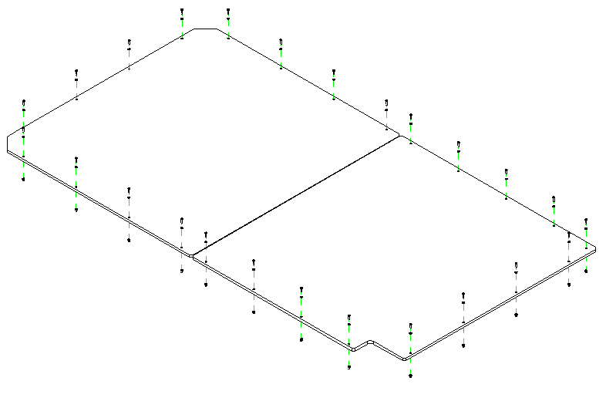
Ionized Air System | {{op_ias_check}} | None  Requires Cap Kit | {{op_nrck_check}}

Electrical
Stack Light |  |  | 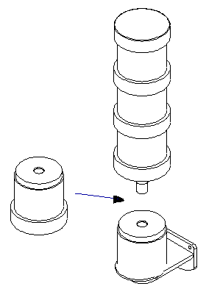
with Buzzer Option | {{el_0369_check}} | PART: ECO369

Option Listing
- (1) Integrated hopper feeder  - (1) Pre-feeder container elevator  - (1) Height adjustment | - (1) Electronic feedback to HMI  - (1) Adjustable in height ± 50 mm (2’’)
{{option_listing}}

Adjustments
Manual |  |  | None
Motorized |  |  | None

Comments

Control Specifications
Explosion proof |  |  | {{cps_ep_check}} |  |  |  | None |  |  |  |  |  |  | {{cps_none_check}}
PLC | B & R |  | {{plc_b&r_check}}
 | CompactLogix |  | {{plc_compactl_check}} |  |  |  | ControlLogix |  |  |  |  |  |  | {{plc_controll_check}}
 | Other
HMI | B & R |  | {{hmi_b&r_check}} |  |  |  | PV 1000 |  |  |  |  |  |  | PV + 600
 | Allen Bradley |  | {{hmi_allenb_check}} |  |  |  | PC Upgrade |  |  |  |  |  |  | {{hmi_pc_check}}
 | Size |  | 5.7”  N/A for vision |  | {{hmi_size5.7_check}} |  | 10” |  |  | {{hmi_size10_check}} |  |  |  |  | 15” |  | {{hmi_size15_check}}
 | Language |  | English |  |  |  |  |  | French
 | Infeed Side |  |  |  |  |  | Outfeed Side
 | Operator side |  |  |  |  |  | Rear
 | Other
Control Panel Post | 1 Axis |  | {{cpp_1axis_check}} |  |  |  | 2 Axis – U-shaped |  |  |  |  |  |  | {{cpp_2axis_check}}
 | 3 Axis |  | {{cpp_3axis_check}}
Low Level Hopper Sensor |  |  |  |  |  |  | None
Remote Technical Service (Secomea)  (1 per line) |  |  |  | {{rts_secomea_check}} |  | None |  | {{rts_none_check}} |  |  |  | Connection Only |  |  |  |  |  |  | {{rts_co_check}}
Comments

REJECT
Fallen Bottle Inspection |  | None |  | Mechanical |  | Electrical
Inverted Bottle Inspection |  | None |  | Mechanical |  | Electrical
Recirculation (into Hopper) |  |  |  |  | None
Diverter Mechanical Reject |  |  |  |  | None

Comments

Cleaning
Ionized Sys w/Vacuum |  |  | None

Comments

Conveyor Specifications |  |  |  |  |  |  |  |  |  |  | None
Supplied by | Customer |  |  |  |  |  |  | Capmatic |  |  |  |  |  | Part of Machine Ax
Width | 3¼” |  |  |  | 4½” |  |  |  |  |  |  | 7½”
 | Other
Length O.L | Infeed |  |  |  |  |  |  | Outfeed |  |  |  |  |  |  |  |  | Single
Height | 36” |  |  |  | Other
Shape | Straight |  |  |  |  |  |  | U |  |  |  |  |  |  |  |  | 90°
Chain Type | STD |  |  |  |  |  |  | Anti-Static |  |  |  |  |  |  |  |  | High Temp
Bed Type | Standard |  |  |  |  |  |  |  |  |  |  | Raised Bed
Layout #
Tunnel Guard | None |  |  |  |  |  |  |  | Infeed |  |  |  |  |  |  | Outfeed
Transf. Guide | None |  |  |  |  |  |  |  | Infeed |  |  |  |  |  |  | Outfeed
Wirecovers | None |  |  | 4-section wireway |  |  |  |  |  |  |  |  |  |  |  | Trough
Bottle Transfer | Conveyor Outfeed |  |  |  |  | End |  |  |  | Machine Side |  |  |  |  | Oper. Side
Comments

Euro guarding |  |  |  |  | None |  |  | {{eg_none_check}}
Panel material | Lexan | {{eg_pnl_check}} | Tempered glass |  |  |  |  | {{eg_pmtg_check}}
Switch type | Key switch | {{eg_stkw_check}} | Magnetic | {{eg_stm_check}} |  | Other |  | {{eg_sto_check}}
Reject Cover | {{eg_rc_check}} | None | {{eg_rcnone_check}}
Outfeed tunnel extension safety guards |  |  |  | None

Comments

Fat Requirements
FAT Formats
FAT Duration

Comments

Manual Specifications
Language | English |  | French
 | Other
Contact Material Certification |  | Yes |  | No
Preventive Maintenance Program |  | Yes |  | No
Type | Electronic |  | Paper
Quantity | 1

Comments

Validation Documents
FAT | {{vd_f_check}} | SAT | {{vd_s_check}} | DQ | {{vd_d_check}} | HDS/SDS | {{vd_h_check}} | FS/DS | {{vd_fd_check}} | IQ/OQ | {{vd_i_check}}
English |  |  |  | French |  |  |  | Other

Comments

Packaging & Transport & Warranty & Install & Spares
Transport charges |  | Capmatic |  |  |  |  |  | {{pt_tcc_check}} | Customer | {{pt_tccu_check}}
Packaging by: |  | Capmatic |  |  |  |  |  | {{pt_pbc_check}} | Customer / Not Incl. | {{pt_pbcu_check}}
Packaging type |  | Skid |  |  | {{pt_pts_check}} |  | Crate | {{pt_ptc_check}} | Sea Worthy | {{pt_ptsw_check}}
Warranty |  | 1YR |  |  |  |  |  | {{wi_war1_check}} | 2YR | {{wi_war2_check}}
Spares Kit |  | None | {{sk_none_check}} |  |  | 1YR |  | {{sk_1yr_check}} | 2YR | {{sk_2yr_check}}
Remote Tech. Service |  | None |  |  |  |  |  | {{rts_none_check}} | Yes | {{rts_y_check}}
Start-up Commissioning |  | None |  | {{stpc_none_check}} |  |  |  | Yes – no. of days | {{stpc_yes}}

Comments

Revision Log
Revision ID: | Date | Description | By:
A

