End of event Strategy MD2026

Our service is Customer service, we answer questions and complaints from customer about their orders and our goal is to provide quick answers with a high quality of service. Here we will address the WISMO questions (Where is my order) during a specific period.

We are a jewelry company with 4 factories: 2 in Israel (Kiriat Gat and Nazareth), 1 in Hungary (Abony) and 1 in Thailand.
TGI Kiriat Gat: 110
TGN Nazareth : 113
TGH Hungary : 122
TGO Thailand : 125
In those factories, we handcraft personalized jewelry. Each product is set according to production days based on the material, number of engravings, stock, …
And at each factory, we offer 3 shipping options: regular, middle and urgent methods with different shipping companies.
Each option doesn’t take the same number of days for delivery. Urgent is the fastest one, while regular is the slowest one.
And each one is not making delivery the same day. Example our partner FedEx for Urgent is not delivering on Saturday OR none of them delivers on Holidays ….
On top of it, each factory is not open on the same days, we don’t have the same flights for deliveries, and we don’t produce all the products in each factory.

Therefore, we have developed a very complex algorithm for each customer’s orders based on all the criteria explained above the last moment he can order to get his order on time for a specific day / event.” Different cart”
We mainly work based on Special event such as Mother’s Day, Valentines, Christmas…as we know the date in advance each year and for each country
Here are 2 potential examples:
- A US customer, who wants a product which needs 4 days of production with the express method and produced in Hungary must order on February 8th to get on time for Valentines on February 14th.
- A French customer, who wants a product which needs 3 days of production with the regular method and produced in Nazareth must order on December 11th to get on time for Christmas Days on December 24th.
We define as
Green Event : the last day to order based on Shipping country, products, factories and method (we have a lot of green events as each one is a combination of all these factors) in order to get the order on time for the event
Red Event : The last day for each Factory to ship a product to be delivered on time based on the shipping method and shipping country (we have a lot of red events as each one is a combination of factory + shipping Method + destination) in order to get the order on time for the event. Once an order is shipped before the red event it is supposed to arrive on time for the event.
Regular Method can deliver from Monday to Saturday and Express Method from Monday to Friday

Mother Day & Father Day around the world
Key 2026 Mother's Day Dates:
- UK (Mothering Sunday): March 15, 2026 - Done
- USA, Canada, Australia : May 10, 2026
- Germany, Italy, Netherlands, Denmark, Switzerland, : May 10, 2026
- France: May 31, 2026 (last Sunday of May)

Key Father's Day 2026 Dates Around the World:
- May 14, 2026 : Germany
- June 6, 2026: Switzerland.
- June 13, 2026: Austria, Belgium
- June 21, 2026: United States, UK, Canada, France, Ireland, Mexico, Netherlands
- September 5, 2026: Australia,
- November 8, 2026: Finland, Norway, Sweden

Main Green Event (based on 4 Production days)
8 AM IL Time
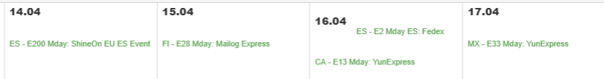
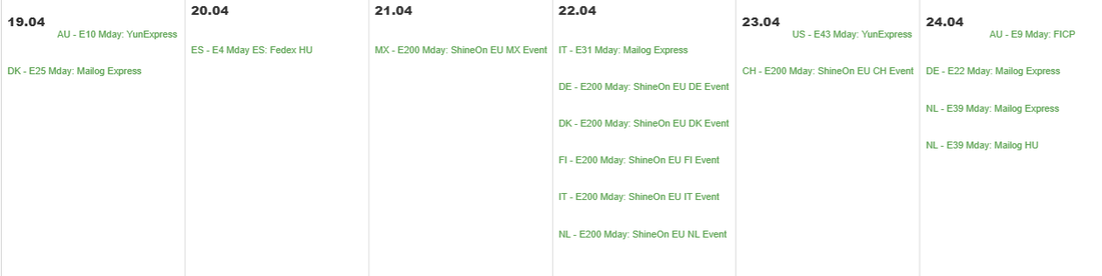
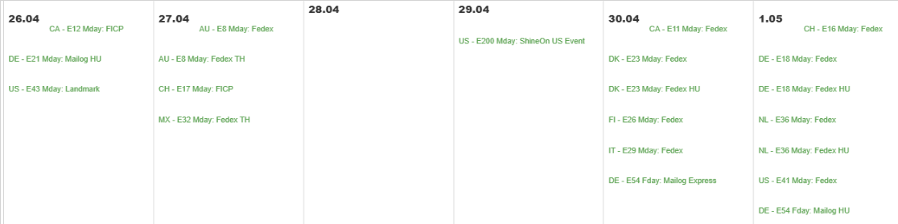
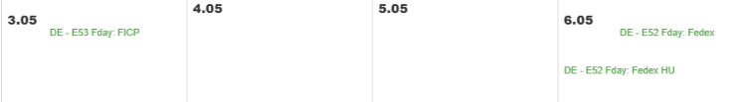
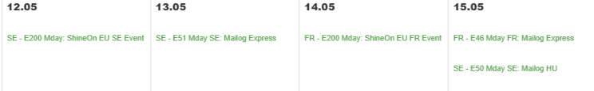
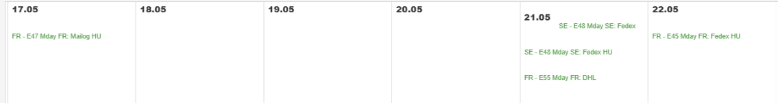

This means basically that for US (main market) , starting from April 23rd – less and less products are guaranteed – the last ones will be the last minute Pack – see below
Jewellery Red Event
In the morning of the Red Event at 7: 00 AM IL Time, Notch stops to answer WISMO messages that are plan for the Event (ETA =< Date of the Event) AND not Shipped AND Notch MOVE all these messages to Queue “On Hold”. Those conversations are identified in these searches: Red Event not shipped WISMO Not Direct & Red Event not shipped WISMO Direct
- 05/01: MX, AU
- 05/04: CA (HU & TH), FI (HU)
- 05/05: CA (IL), DK (IL & HU), FI (IL), IT (HU), US (TH & HU)
- 05/06 : US (IL), NL (IL & HU), DE, CH, US ShineOn
- 05/11 – Father Day : DE (IL & HU)
- 05/26 : SE (HU & IL), FR (IL)
- 05/27: FR (HU)
- 05/07: LL (US)
Last delivery Day:
05/08 for all methods – On Hold – all WISMO shipped
05/09: Bonus for regular methods – On Hold – Regular Method WISMO Shipped

For each red event, our IT provides a list of all the orders that missed the last shipment (production, stock issue, other ..). Tenengroup tags those customers as Last Issue = Late Red Event MDAY2026 and shares the list with Notch
Then Tenengroup sends a proactive message to those customers and informs them that the order won’t be on time. We offer compensation to pick between (a gift, a coupon for next order and sometimes also shipping refund)
The email subject is An update about your order -XXX and we tag this conversation with Late Red Event MDAY2026 + Proactive
Here is an example of template (can be different for each event, country, …):
Dear Ashley,
We are currently experiencing a surge in orders, and unfortunately, the delivery of your order (273101573) is expected to arrive 2-3 days after Valentine's Day. We understand the significance of this romantic occasion and apologize for any inconvenience this may cause.
Rest assured, our dedicated team is working hard to fulfill these orders, making sure that your special gift reaches its destination as swiftly as possible.
Our customers cherish the gifts they receive from us, so we remain optimistic that the delayed arrival will be met with understanding and appreciation.
In our commitment to making amends for the delay, please explore the various compensation options available to you https://www.oakandluna.com/articles/9111, including the opportunity to select a complimentary gift from our collection. We hope you find something that resonates with you.
Wishing you and your loved one a memorable Valentine's Day celebration,
Customer Care Team

Then TenenGroup waits for the green light from Notch to proceed with On Hold
Following this operation, Tenengroup goes to the search ON HOLD – TOTAL to retrieve these conversations and 2 options
- If tag Late Red Event MDAY2026 – then Tenengroup either closes the first message as double if the proactive already take care of the question OR updates the Queue and Notch answers based on the proactive sent. (Notch must re-run the flow)
Then following the proactive message, some of these customers answer this message and Notch has to deal with the following scenarios :
- Thanks for the update / I am disappointed: in that case, we just apologize again
- You ruined my expectations, and I want a better compensation: we stick to the compensations from the email sent (unless VIP order – then we find another compensation, based on their needs). VIP in that case are excluded from Notch
- You ruined my expectations, and I want to cancel: we tell the customer we can’t cancel now, as its still being shipped. But once it is received, get in touch with us again, if the order is no longer needed.
- Other cases : customer asks for an update, when should they expect to receive the order, why is too late, what is the problem : we answer them these questions based on the situation.

- If no tag Late Red Event MDAY2026 – then Tenengroup updates the Queue and Notch answers as usual – Notch must rerun the flow on those messages – “Might be on Time”

Sometimes, even on the Red Event day, the factory and Shipping teams agrees on a “last Chance” option which means that they will try to ship the leftovers orders the next day but this time with a 30% chance to be on time (basically, cities closed to the hub, big cities). If this option is offered, we will postpone the red event strategy for one more day which means that we will continue to consider that the orders will/might be on time. What we do in that case, we keep the messages on Hold one more day. And we tag all those orders Last Chance MDAY2026 to identify them.
Then the next day, we will apply almost the same red event strategy :
- If the order is shipped, we release the message to be answered by Notch with a slice difference – the message is Might be on time, we do our best and we continue to monitor and will update you if might be late
- If the order is not shipped, regular red event policy - Late Red Event MDAY2026 + Proactive

Then TenenGroup waits for the green light from Notch to proceed with On Hold

Jewellery Last Day of Delivery
In the morning of the last delivery day (Friday 8th for Urgent and Saturday 9th for regular) at 7: 00 AM IL Time, Notch stops to answer WISMO messages that are plan for the Event (ETA =< Date of the Event) AND Shipped AND NOT DELIVERED AND Notch MOVE all these messages to Queue “On Hold”
Those conversations are identified in this search : Last Day Delivery Monitoring - No order Delivery date
Our shipping department monitors the risk of late delivery the last day of the delivery for each method and share with us a file with all the orders shipped on time but that might be late for Event. They provide this list around 1 PM Israel time for European orders and around 9 PM for US orders.
When we have this list, Tenengroup tag those customers as Last Issue = MBL MD2026 and shares the list with Notch
Tenengroup sent a proactive message to those customers and informed them that the order might be late. We offer compensation to pick between (a gift, a coupon for the next order and sometimes also shipping refund).
The email subject is an update about your order -XXX and we tag this conversation with MBL MDAY2026 + Proactive

Here is an example of template:
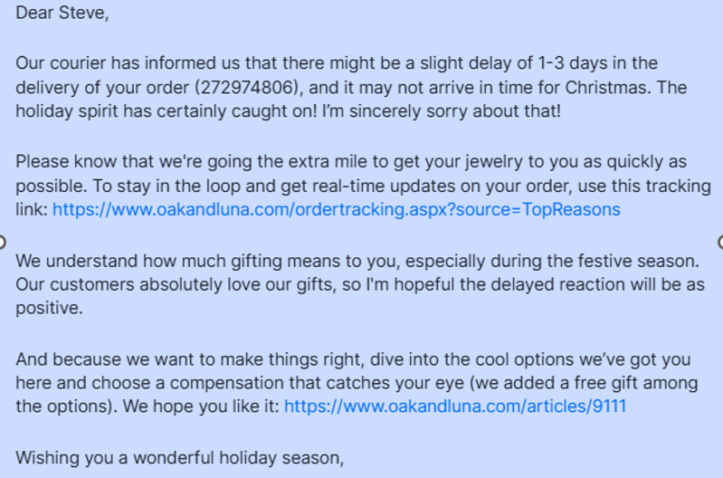
Note : sometimes we have 2-3 emails depending on what we already communicated in the days before
New step regarding Sapir Monitoring: compare the list of all the orders supposed to for Event vs Sapir’s monitor and vs Matrix vs AfterShip
Then TenenGroup waits for the green light from Notch to proceed with On Hold
Following this operation, Tenengroup goes to the search Bruno - ON HOLD – TOTAL to retrieve these conversations and 2 options
- If tag MBL MDAY2026 – then Tenengroup either close the first message as double if the proactive already take care of the question OR updates the Queue and Notch answer based on the proactive sent. (Notch must re-run the flow)
- If no tag MBL MDAY2026 – then Tenengroup updates the Queue and Notch answers as usual, based on the monitoring file, they will be on time (even already delivered).

Though guaranteed
Customer comes back asking why they received the confirmation email (or they saw it somewhere else) that the order won’t make it by MDAY – ETA is different from what they thought it was (even though when they were ordering they got an impression that we are guaranteed order to arrive on time. )
This happens because they don’t pay attention to the shipping method (and they ordered the order with slower shipping method and not the fastest one that is in fact still guaranteed for MDAY) – or sometimes there is a bug.
Steps to take in this case:

1. If the order already has the fastest shipping method
- No further upgrade is possible.
explain to the customer:
“Your order is already using the fastest available shipping method, so it can’t be upgraded further. While we always do our best to deliver on time, not all products can be guaranteed for MDAY delivery.”
Offer alternative solutions:
Not personalized product

If the order not guaranteed for MDAY might be a bug:
- If the shipping description says delivery by MDAY, but the ETA in Order Management (OM) shows a later date, this could be a cart bug.
- Assign it to the TL (Adi/Thijs)

Every day Tenengroup will update green event for every site

2. If the order has a slower/middle shipping method
- The order must be upgraded to the fastest shipping method available.
- Notch should check if there’s still availability to guarantee delivery by MDAY with the upgrade.
If a green event still exists for the site:
- Explain to the customer that a shipping upgrade is required
- If customer agrees, move the conversation to the OCy queue.
- When the customer confirms, the OCy team will issue an MR (Merchant Request) for the shipping upgrade.

When no green events remain (final days)
- Apologize :
“Unfortunately, MDAY delivery is no longer available for this item.”
- Offer the not personalized as an alternative solution:
“We do have non personalized products available - it’s a great way to still surprise your loved one with something special on time! This is how it works: ...”

Jewellery & Lilme & Lou Regular monitoring during events

Despite the monitoring of the orders on time for the Event, we also monitor the orders all days long to see if the order will be delivered on time for ETA.
We are aware of potential delays. In that case we have the following flows:
- ETA-1: one day before ETA, we have a list of orders that might be late. In that case TenenGroup sents a proactive message to those customers and informed them that the order might be late. We offer compensation and a coupon for the next order
*If the order is shipped
The email subject is Important update regarding your order -XXX and we tag this conversation with a tag ETA-1 shipped + proactive
Here is an example of template:

Dear John,
Despite our best efforts, your order may arrive later than the expected delivery date 2/21/2025.
I completely understand how important it is for you to receive your order on time and I apologize for the delay. Based on the latest tracking information, your order is expected to arrive 1 to 3 business days later than the original estimated date we provided.
Track My Order page: https://www.oakandluna.com/ordertracking.aspx?source=TopReasons
To make up for this inconvenience, I'd like to offer you a 20% off coupon for your next purchase with us: LTE2A9KC3P2L.
I also know that if you've purchased something as a gift, it's important to have something to show for it in the meantime. That's why we've created a digital card that you can share with your loved ones to let them know their gift is on its way.
https://cdn.oakandluna.com/digital-asset/banners/giftcertificate_OL.jpg
Thank you so much for your understanding!
Important : during the last days of the event, we stop ETA-1 shipped email to not interfere with the Event. As we inform the customer from a potential 1-3 BD Delay, the last ETA is 3 days before the last delivery day of the Method
for MDAY 2026 : The last ETA-1 shipped will be for ETA May 5th.
Stop ETA-1 shipped email to not interfere with the Event- 3 days before the last delivery day of the shipping method.
*If the order is not shipped
The email subject is Important update regarding your order -XXX and we tag this conversation with a tag ETA-1 not shipped + proactive
Here is an example of template:

Dear John,
XXXX
Important : during the last days of the event, we stop ETA-1 not shipped email to not interfere with the Event, as on red event, we already inform the customer from delay
All the ETA-1 operations are starting back right after the day of the Event.

Other operations during event based on the situation
- Customs Issue: the customer picks the regular method, we are using the shipping Method USPS for the US. The factory prepares all the orders (one package per order – ready to be shipped) with this method, scan them, the tracking is now “Label created” and then they put all the packages in a consolidated box that we send to our hub in New York with DHL (express method).
After 2 days, the package is supposed to arrive and then our people from the hub open the box and drop the orders individually to the Post office and from that point a new tracking is activated by the USPS network and we can expect a delivery between 1-3 days based on the address of the customer. Sometimes, customs issues in the US or other problems appear and create a delay for the delivery to the hub.
Tenengroup tag these orders as Shipping update_XXX_No action if not action is required or Shipping update_XXX_Action if an action is required which means a communication to the customer
It will help us to recognize those cases when customers will contact customer service and give the CSR the guideline to inform the customer (we have a slice delay because of unexpected issue with the US administration, but once it will be fine, the tracking will be updated and the delivery in the next 3 business days).
Indeed, in that case on one hand the final delivery will be delayed but on the other hand also delaying the first tracking in the US territory. This is making the customers anxious because the status stays “Label created” during many days. In that case, as the orders might be late, most of the ETA-1 flow already inform them.
- Issue with a flight: the flight used on the red event date encounters a problem and therefore all the orders from this flight will/might be late for the event. In that case we sent a proactive message to those customers and informed them that the order will/might be late. We offer compensation to pick between (a gift, a coupon for the next order and sometimes also shipping refund).
The email subject is an update about your order -XXX and TenenGroup tag this conversation with a tag Shipping update_XXX_Action
Here is an example of a template:
Hi Travis,
I wanted to update you on the status of your order. Due to an unexpected airport logistics issue, your package missed its scheduled flight, which may cause a slight delay. While we’re still hopeful it could arrive in time for Valentine’s Day, there is a chance it might arrive by Monday (2/17) instead.
I understand how important it is for you to receive your order on time, and I’m sorry for this situation. Please know that this delay was entirely due to external shipping factors beyond our control, but we’re doing everything possible to get your package to you as soon as possible.
I appreciate your patience and understanding. If there’s anything else I can do to help, please don’t hesitate to reach out.

- Stuck in customs HU : Shipping update_Customs HU_No action or Shipping update_Customs HU_Action
There is customs issue/bottle neck in Hungary, which can delay the flight or even make the package missing the flight and then make the order late for XMAS
Based on the scenario we will operate with a MBL / Late message

- Not shipped because error (ex : 140 orders - Free candle OAL – order is shipped from TH/HU and the candle from US (partner) – made a mistake on the invoice in the factory – the factory order is stuck in customs until new invoice while the candle is shipped as planned in the US and will be delivered on time. The jewelry won’t be on time for MD !! waiting for the list and TG will operate with a new tag Shipping update_Free Candles_action

MDAY Tags
- Late Red Event MDAY2026
- Proactive
- Last Chance MDAY2026
- MBL MDAY2026
- ETA-1 shipped
- ETA-1 Not shipped
- Shipping update_Reason_Date_No action
- Shipping update_Reason_Date_Action – (email : thank you for your patience) –(ex : Shipping update_duplicate labels_20251112_Action)
- Production update_Reason_Date_No action
- Production update_Reason_Date_Action
Email from Neva
- Name of the Tag
- Business case
- Scenario
- Template sent
- Expecting answer

End of event Strategy – Lime and Lou

- Our role is providing customer service. We answer questions and complaints from customers about their orders. Our goal is to provide quick answers with a high level of service. Here we will address the WISMO (where is my order) questions during a specific period (referred to as “event” – Christmas, Valentine’s Day, Mother’s Day, Father’s Day).
- We sell personalized wall art, various personalized home decorations, and some personalized apparel. We work with several production facilities, each with its own production time and shipping method. Production times are fixed and cannot be shortened, regardless of the chosen shipping option. Never use the word “supplier” in the replies, use production facilities, factories or warehouses (for the customer it must look like we make the order). To avoid confusion, we’ll refer to them as ‘Production Facilities’ throughout this document
- All items are produced in the customer’s country, except for those from Hawkins, which are made abroad
- Saturday delivery is available in some regions and with certain shipping methods, but not all.
Here is an overview of the most important production facilities, how to recognize them (based on sku) and the production/shipping methods.
SKU Prefix | Supplier Id | Production Facility | Notes
100 | 700 | Jondo | Majority of orders
102 | 202 | Prodigi | 2nd biggest
106 | 206 | Bay Photo
109 | 209 | Apliiq | Apparel
180 | 180 | PicTheGift

We mainly work, based on special events, such as Christmas (Xmas), Valentines Day, Mothers’ Day, …We know the last production and last shipping date (cutoff) in advance. In the schedule below are the different production facilities, with the last date the customer can order to have his order delivered on time for the event. Dates are in MM-DD-YYYY format. The orders on that date should be placed before 10:00 AM – ISRAEL TIME!

We work with 2 events: Green Event & Red Event. The start/end date of those events depends on many factors: Product, supplier, shipping method, & shipping country.
Green event runs:
- Free:
- 24/04 -> 29/04
- Basic Plus: 27/04 -> 30/04
- Premium: 30/04 -> 04/05
- Premium Plus (overnight) 03/05 - > 05/05Red event runs:

Supplier | Destination | Shipping Method | Shipping Method | Method's Table Name NEW | Red Date PSTF | Last Delivery Day | Red Event
JONDO US | US | PREMIUM PLUS |  | JONDO US CANVAS Overnight | 1 | 5/8/2026 | 5/7/2026
JONDO CA | CA | PREMIUM PLUS |  | JONDO CA Overnight | 1 | 5/8/2026 | 5/7/2026
JONDO AU | AU | PREMIUM |  | JONDO AU Urgent | 2 | 5/8/2026 | 5/6/2026
JONDO EU | NL,DE | PREMIUM |  | JONDO EU Urgent | 2 | 5/8/2026 | 5/6/2026

- Green event
  - The last day to order, based on the production facility, product, and shipping method, to get the order on time for the event.

Red event
  - The last day for each production facility to ship a product to be delivered on time, based on the shipping method. Once an order is shipped before (or on the day of) the red event, it is supposed to arrive on time for the event. Most shipping methods deliver from Monday to Friday; some methods (also based on the location of the customer) do deliver on Saturday.

In the morning of the Red Event at 7: 00 AM IL Time, Notch stops to answer WISMO messages that are planned for the Event (ETA =< Date of the Event) AND not Shipped AND Notch MOVE all these messages to Queue “On Hold”. Those conversations are identified in these searches: L&L Red Event not shipped WISMO Not Direct & L&L Red Event not shipped WISMO Direct

For each red event we have a list of all the orders that missed the last shipment (various reasons: late production, late design, ….) Lime&Lou tags those customers as Last Issue = Late Red Event MDAY2026 and shares the list with Notch.
Then, Lime&Lou sends a proactive message to those customers and informs them that the order won’t be on time for the event. We offer compensation (to pick between a gift, a coupon for a next order or shipping fee refund).
The email subject is “An update about your order – XXX and we tag this conversation with Late Red Event MDAY2026 + Proactive
Here’s an example template:
Hi Sue,
Thank you so much for choosing Lime & Lou to celebrate this special Mother’s Day.
We’ve been working with love to prepare each piece, but due to higher demand than expected, your order is running slightly behind and unfortunately won’t make it in time for Mother’s Day. I know how disappointing this can be, and I’m truly sorry.
Your order is almost ready and will ship soon—you’ll receive a tracking email as soon as it’s on the way.
As a small thank-you for your patience, I’d love to offer you something special:
👉 https://www.limeandlou.com/articles/9111
I completely understand how important this gift is, and I truly appreciate your understanding. If there's anything else I can help with, just let me know—I'm here for you.
Kind regards,
Customer Support Team

Following this operation, Lime&Lou goes to the search ON HOLD – TOTAL to retrieve these conversations and
- If tag Late Red Event MDAY2026: Lime&Lou either closes the first message as double (if the proactive email already took care of the question) OR
- Lime&Lou updates the queue and Notch answers, based on the proactive sent. Notch must re-run the flow!
Then, following the proactive message, some of these customers answer this message and Notch must deal with the following scenarios:
- Thanks for the update / I am disappointed: in that case, we just apologize again
- You ruined my expectations, and I want better compensation: we stick to the compensation from the email sent.
- You ruined my expectations, and I want to cancel. We tell the customer we can’t cancel now, as it’s still being shipped. But once it is received, get in touch with us again, if the order is no longer needed.
- Other cases: the customer asks for an update, when they should expect to receive the order, why it is too late, what is the problem: we answer these questions based on the situation.
- If customers ask for more compensation or discount, Notch stops replying and Lime&Lou will take care.
If no tag Late Red Event MDAY2026 – then Lime&Lou updates the queue, and Notch answers as usual

Last Day of Delivery

In the morning of the last delivery day (Friday 8th/ Saturday 9th ) at 07:00 IL Time, Notch stops to answer WISMO messages that are plan for the Event (ETA =< Date of the Event) AND Shipped AND NOT DELIVERED AND Notch MOVE all these messages to Queue “On Hold”
Those conversations are identified in this search: Last Day Delivery Monitoring – No order Delivery date
Our shipping department monitors the risk of late delivery on the last day of the delivery for each method and shares with us a file with all the orders shipped on time, but that might be late for Event. They provide this list around 1 PM Israel time for European orders and around 9 PM for US orders.
When we have this list, Lime&Lou tags those customers as Last Issue = MBL MDAY2026 and shares the list with Notch
Lime&Lou sent a proactive message to those customers and informed them that the order might be late. We offer compensation to pick between (a gift, a coupon for the next order and sometimes also shipping refund).
The email subject is an update about your order -XXX and we tag this conversation with MBL MDAY2026 + Proactive
Here is an example of template:
Dear Landon,
Our courier has just informed us of a possible slight delay in the delivery of your order (350216978), which means it might not arrive in time for Mother's Day.
I'm truly sorry for any inconvenience this may cause.
We know how meaningful it is to give a special gift on such an important day - it's just as important to us. To help make the wait a little easier, we’ve prepared a heartfelt video you can share with your mum in the meantime. You’ll find it here, along with a selection of compensation options we've prepared for you - including a free gift: https://www.limeandlou.com/articles/9111
Wishing you a Mother's Day filled with love and cherished memories,
Kind regards,
The Lime Team

Note: sometimes we have multiple emails, depending on what we already communicated in the days before
New step regarding Sapir Monitoring: compare the list of all the orders supposed to for Event vs Sapir’s monitor and vs Matrix vs AfterShip

Following this operation, Lime&Lou goes to the search ON HOLD – TOTAL to retrieve these conversations and 2 options
- If tag MBL MDAY2026 – then Lime&Lou either close the first message as double if the proactive already take care of the question OR updates the Queue and Notch answer based on the proactive sent. (Notch must re-run the flow)
- If no tag MBL MDAY2026 – then Lime&Lou updates the Queue and Notch answers as usual, based on the monitoring file, they will be on time (even already delivered).

Thought Guaranteed
Customers sometimes believe their order will arrive on time for the event, even though it was not guaranteed.
This may happen when:
- The order was placed after the Green Event cutoff
- The customer selected a slower shipping method
- One or more items were no longer guaranteed
- A cart bug displayed “on time for Mday” while the ETA showed a later date
- The customer requested changes that caused a delay

1. Wrong or Slow Shipping Method
If the customer chose a slower shipping method and the Green Event is still active for that item:
→ Consider a shipping upgrade.
- Normally: the customer pays the difference. Notch can send the payment link
- Upgrade for free if:
  - The order total is over $300 USD, Lime&Lou will reply
  - The customer is tagged with VIP tag, Lime&Lou will reply
  - TL approval is granted (for unreasonable customers or to prevent cancellation). This means that Notch will assign the cases where the customer refuses to pay for shipping upgrade to Lime&Lou
- If Notch is not sure (not sure about ETA/history/Shipping method), the conversation should be assigned to Lime&Lou
2. Already on the Fastest Shipping Method or Green event is over
→ No further upgrade is possible.
Be empathetic and explain that the ETA shown in the order confirmation reflects the true expected delivery time.
- Always be empathetic and professional.
- Never blame the customer.

3. Cart Bug Cases
If the OM or Kustomer order information shows “on time for Mday” but the ETA is later than February 14th,
→ Notch will not reply.
→ Move the message to Lime & Lou manual check for review and potential free shipping upgrade.

4. Customer Changed Item After Ordering
If the customer originally ordered on time but later requested changes that delayed production,
→ Remind that the delay was caused by those approved changes and that the new ETA reflects this adjustment. If Notch is not sure, the conversation should be assigned to Lime&Lou

Other operations during event, based on the situation (Production _XXX)

- All shipping is locally (except production facility “Hawkins”, which has a very low volume and will never be operated with proactive). Therefore, there are no issues with customs or delayed international flights.
- In case of a domestic issue with one of the couriers – we will set-up a plan with proactive and specific tagging and Lime&Lou will inform Notch asap
- The most important, potential, big issue that can occur = production facility issues (technical hardware issues, understaffed facilities). We operate those with a proactive and a tag that describes the issue (e.g.: “LaL_Late_Acryllic_3sept”). Lime&Lou will update Notch when such a tag has been created & used and what strategy we will follow, based on the impact in volume & delayed production days
Example of a template:
Hi Emily,
We wanted to let you know that due to an unexpected temporary technical issue in our production facility, your acrylic order has unfortunately been delayed by a few working days.
To minimize the impact, we’ve upgraded your shipping to express delivery at no extra cost, so your order will reach you as quickly as possible once it leaves our facility.
As part of our commitment to you, we also offer compensation options for delayed orders: https://www.limeandlou.com/articles/9111
We’re very sorry for the inconvenience and appreciate your patience.
You’ll receive shipping confirmation as soon as your package is on its way.
Thank you for your understanding and for choosing us.
Kind regards,
Lime and Lou Team

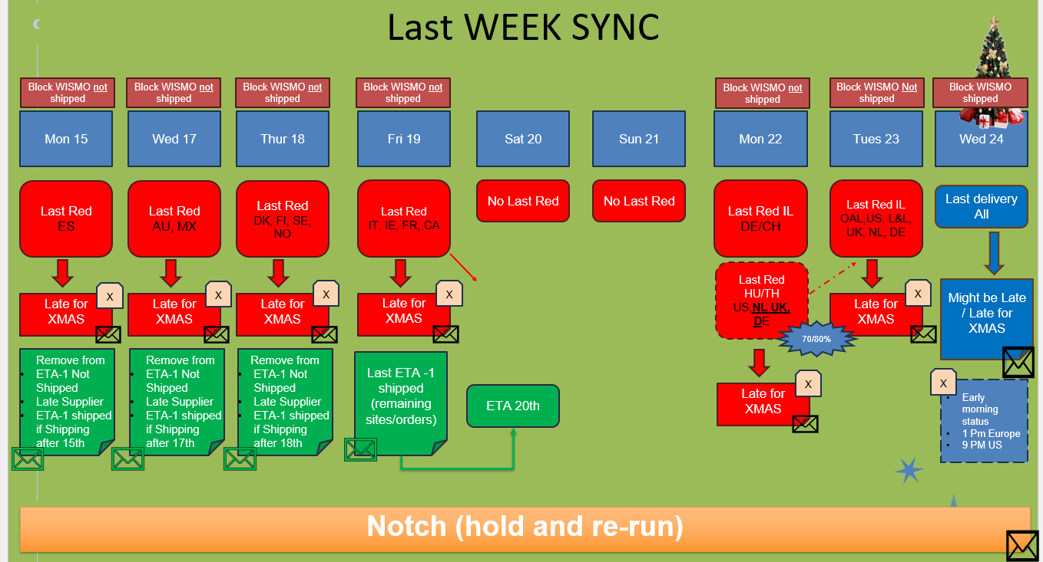
To update MDAY

