WISMO
WISMO -ON TIME
Scenario:
- The customer wants to know where is the order.
- The order is on time, within timeframe.
- In most cases the customer will receive the WISMO automation that will ask him to confirm his address.
1. Check if today < ETA
2. If yes = On time
3. If the ETA passed = Late

Please select the relevant case:
Time frame only applies if the site country is the same as the delivery address.
Order In Production
Policy:
Time frame only applies if the site country is the same as the delivery address
Procedure:
1. Check order status on OM
2. Verify the following information:
a. When was the order placed
b. Shipping method
c. Estimated delivery time
3. Make sure the order is not LATE SUPPLIER (if yes then go to LATE SUPPLIER POLICY)
4. According to the shipping method, can the order make it on time?
a.If yes, send email order on time
b. If not, order = LATE.
Shipped- Trackable methods
Procedure:
1.Track the shipment using the Courier’s official site
a. If DHL: there might be a discrepancy between our ETA and DHL’s
b. If on time- Update customer that order is on its way
c. If not on time- see Late Policy
Non trackable methods
Policy:
Time frame only applies if the site country is the same as the delivery address
Procedure:
1. Status on OM should be 'Sent Shipping notification'
2. Verify 'shipping customer date'
a. If date is not past the ETA (=ON TIME)
b. If date is past ETA, go to LATE POLICY

LATE SHIPING
🎯 GOAL:
Goal for us is to make sure the customer feels taken care of by offering timely updates and the right compensation depending on how late the order is.
🔁 STEP-BY-STEP PROCESS:
🟡 Step 1: Proactive Compensation Email
- If there is a Late Supplier Flag, the customer will automatically receive a proactive email with:
  - 20% discount
  - An updated ETA (check OM > ETA based on shipping date)
- No action needed from agent unless the customer reaches out again.
🟠 Step 2: Customer Reaches Out – Is It Late?
✅ Check:
- Go to OM > Estimated Delivery date.
- If the date is in the past = Order is Late.
- Check if “Late Supplier” flag is on.
🔹 IF NOT LATE SUPPLIER:
🔄 Depending on how late:
⏱ Less than 3 Business Days Late:
- Apologize politely.
- Let the customer know there's a slight delay.
- Provide an updated ETA (use tracking info).
- Do not send compensation link yet.
⏰ More than 3 Business Days Late:
- Send shortcut: “LATE first email”
- Includes a late compensation link offering:
  - MYKA: $20 coupon or free gift (Linda necklace or men’s bracelet)
  - OAK & LUNA: 20% coupon or free gift (earrings only)
  - My Name Necklace Israel: 20% coupon or free gift (bracelets)
💸 If the customer paid for shipping and insists on a refund:
- Escalate for a shipping refund
- Do not send the compensation link - refund replaces it.
🔹 IF LATE SUPPLIER:
- Check CSR Remarks or History tab in Kustomer:
  - Was the customer already informed about the delay?
  - Was any compensation already offered?
- If not already done:
  - Update the customer with the current ETA based on OM > “ETA based on shipping date.”
  - No compensation needed unless otherwise escalated.
🔁 Step 3: Follow-Up Messages
- 2nd time customer contacts us: use shortcut “LATE second email”
- 3rd time customer contacts us: use shortcut “LATE third email”
🔹 Note: Only use these if the case is not a DNR (Did Not Receive) or Lost case.
⚠️ KEY REMINDERS:
- Always check and communicate accurate ETA using tracking and OM.
- Use compensation options only when appropriate.

LATE SUPPLIER
Slug:order-late-supplier-SybspAnoh
Copy URL

View Article

Scenario:
The customer contacts us asking where his order is, and the order is late because of production issues.
If the Order cycle team didn't handle this as a "late supplier" case- handle it as regular late- don't use the late supplier link/ email
Policy:
Order is late supplier ONLY if the OM is marked as and item is still in production after the specified Production Time Frame
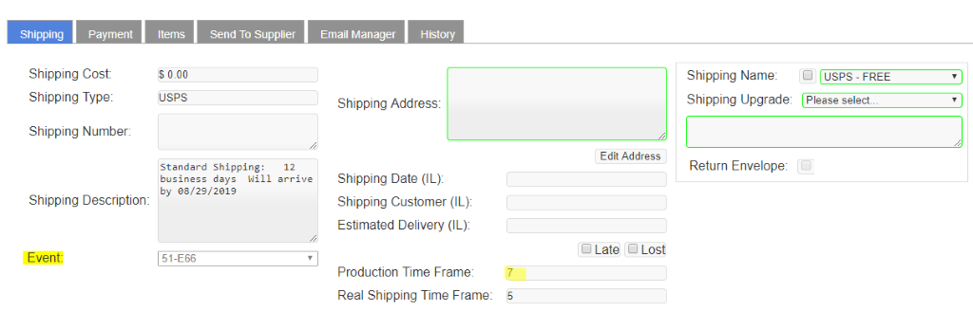
If BO didn't handle this as "late supplier" case- handle it as regular late
Procedure:

- In cases where shipping upgrade can ensure that the order will make it on time, “operations” will upgrade for free. If this is the case, and the customer’s order was upgraded - If the shipping method was not upgraded the customer receives AUTO email with compensation, same as late shipping
- If the customer already received the compensation offer update the customer what will be the ETA based on the OM field "ETA based on shipping date" don't send compensation again.
- If the customer didn't receive compensation then check where is the shipment (if its far away from address then offer a compensation link. If it is nearby- chances will arrive on time or will not be very late, so only offer $15 gift card. )
- If according to the ETA based on shipping date" the order is lost- follow the lost policy.
- If the customer was not offered compensation- follow the late policy.

LOST - ALL METHODS
General:
In ALL cases – first check the tracking number on the shipping company’s website or on: www.17track.en

LOST TWICE:
For GOLD/ Diamonds or Orders over $200: If LOST TWICE escalate for fraud check
Refunds are only possible within 30 days past the ETA. (However, if we have caused the customer to wait for the order to arrive, and it surpasses the 30-day limit after the ETA, a refund must be issued upon the customer's request).
IF OUT OF COUNTRY and LOST for 2nd time, ASK FOR LOCAL ADDRESS (MYKA US sending to Saudi Arabia, ask for the address in US)

FLAGS in OM:
In the OM: make sure Flagged as LOST and leave remarks.
IMPORTANT: If we already have a late flag – CSR needs to remove the late flag and leave the Lost flag only.

Please choose the shipping method and see what policy applies to it:

STANDARD SHIPPING METHOD
Policy:

2 criteria must be met for the order to be declared as ‘Lost’
1. ETA (Based on shipping) + 10 BDs
& (and)
2. Status in the tracking hasn’t changed in the last 3 BDs

Compensation period:
If it has been more than 10 BD – but we do see a movement in the last 3 BDs – ask customer to wait as the order should be delivered soon. You can send a shortcut: "Almost Lost But There's Movement".
Offer:
If you confirm the order is lost - please double-check the address with the customer and then send him an offer to make a reorder. You can send a shortcut: "Lost - trackable offer".
*Item will be shipped with the same shipping method.

If customer is anxious to get a reorder for some event:
Ok to reorder with expedite shipping

Refused Reorder:
Offer a store credit

Refunds: If the customer refuses the reorder &Store credit and wants a refund:

- If more than 10 BDs after ETA based on shipping AND there was no movement in the last 3 BDs - Refund OK (but only after you offered a reorder and a store credit)
- Escalate full refund - If there was paid shipping fee, include the shipping fee in the refund
- If more than 10 BDs after ETA based on shipping AND there was a movement in the last 3 BDs - the customer must wait until the package arrives and then the cu can return it to us. We will issue a refund then. You can use template "Return for refund"

DHL/ FedEx (Urgent Shipping)
Policy:
2 criteria must be met for the order to be declared as ‘Lost’
1) ETA (Based on shipping) + 5 BDs
& (and)
2) Status hasn’t changed in the last 3 BDs

Compensation period:
If it has been more than 5 BDs after ETA based on shipping– but we do see a movement in the last 3 BDs – ask customer to wait and offer compensation - refund of Shipping Cost (on top of the compensation the cu chose in the late).
You can send a shortcut: "Almost Lost But There's Movement".

Offer:
If you confirm the order is lost - please double-check the address with the customer and then send him an offer to make a reorder. You can send a shortcut: "Lost - trackable offer".
*Item will be shipped with the same shipping method.

Customer refuses a reorder:
Offer a store credit.

Refunds: If the customer refuses the reorder & Store credit and wants a refund:
- A. If more than 5 BDs AND there was no movement in the last 3 BDs - Refund OK. You can use shortcut: "Return for refund"
- B. If more than 5 BDs AND there was a movement in the last 3 BDs - the customer must wait until the package arrives and then return to us. Then we can issue a refund.

NON-TRACKED SHIPPING METHODS:

Policy:
The time should be calculated since the "ETA based on shipping date":

- The customer will have the options:
1) Reorder after 5 BD post the shipping time frame date OR
2) To wait until 10 BD post the -shipping time frame -and get a reorder with expedited shipping (free upgrade).
- A refund can be done only upon customer request and after 10 BD post the shipping time frame.
- If customer is anxious to get a reorder for some event:
- Ok to reorder with expedite shipping
For DOM TOM FR cases- after 10 BD offer only coupon, no Shipping upgrade.

Lost up to 100 days
We can only make reorders/refunds if it has been up to 100 days AFTER ETA.

DNR
Scenario:
The customer reports not receiving the order, but the shipping company's site shows it was delivered.
Note: Applicable only for trackable methods.
Policy:
Two options available:

- Free reorder of the same item with the same shipping method. No exchanges or inscriptions allowed.
- Full refund.
For Gold tier customers or orders over $200 with DNR twice, escalate to FRAUD.
Procedure:
- Verify the customer's address.
- Track the order using the tracking number on the courier site.
- Proceed based on the number of days since the order was allegedly delivered:

A: Status Delivered – less than 3 Business days:
- Use template "DNR-Proof"
- Update the customer on the delivery status according to the courier company's site. Ask the customer to wait 3 business days for the package to show (sometimes the delivery person scans the package as delivered before actual delivery).
- Use "Late" disposition.
- If after 3 business days, the customer confirms non-receipt, offer a reorder of the same jewelry without downgrading shipping method. Use template "DNR-Reorder-Offer"
B: Status Delivered – over 3 Business days:
  - Use template "DNR-Reorder-Offer"
  - Offer reorder without waiting.
  - Flag in OM DNR flag – change disposition to “Delivered Not received”
  - Escalate customer selection – Reorder or a refund

RETURN TO SENDER
Handling Returns (to sender) with Different Carriers

PROCEDURE: always check with the customer the address we have on file (to ensure reshipped order wont be returned due to possible to address issues again)
1. USPS
- Return Process: If an order is marked as Return to Sender, it will be sent back to Tomer (New York warehouse)
- CSR Steps:
  - confirm that the status in the tracking is "returned to sender" or "delivered to the sender".
  - Assign conversation to Order Cycle and ask to reship
  - Sometimes customers wants to change the address - in such case write in the note for order cycle the new address to be shipped to
2. Landmark, Global Post and Mailog express
- Return Process: Does not return to Tomer or any other location.
- Next Steps:
  - Reorder required – escalate the case to QA for reorder
  - No need to wait for the item to be sent back, since it will not be sent back.
3. FedEx / DHL
- Return Process: Packages are not returned to Tomer.
  - They are either sent back to the factory or abandoned depending on carrier policies.
- Next Steps:
  - Escalate the case to Shipping - Noga.
  - Noga will decide if the order should be reordered or reshipped.

RETURNING ORDER (BY CUSTOMER)
RETURNING ORDER
The customer needs/asks to return the item for reorder/exchange/refund

Policy:

*Customer needs to return received item in the following cases:
- Damaged (Premium Items only - all sites)
- NS (all reasons)
- Resizing (that requires full reorder)
IMPORTANT: Always check the customer's address (country) of shipping before sending the return instructions (I.e. if customer's shipping address is in the UK and he bought from the US site, item needs to follow UK return label instructions).

For address in US or CA - we send the RL in any case (resizing,damaged,NS). You only need to escalate for a reorder and choose: CREATE RETURN LABEL
for all the other address (countries), here is a procedure:

to follow the procedure what return information to send tot he customer, go to the shortcuts and choose folder: 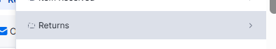
then choose the case:
RL-damaged
RL - NS
RL -Resizing
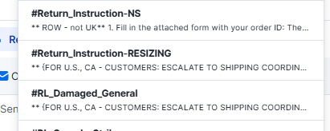
each of the shortcuts it has instructions for specific country (UK, IE, AU, ...) erase the information about all the countries, except for the country where's customer address. Create an email with these return instructions and send i to the customer.

Printing labels:
FOR SPING ONLY!
If a customer doesn't have a printer to print the shipping label, they can use our label generator to generate a QR code to take to customer's local drop-off point. They’ll print the shipping label for the customer. Please note that this option is currently only available in Germany and France

Procedure - Return only
*for the full procedure check the relevant case's policy:
1. Depending on the case - we need to explain the customer they need to return the item before we can proceed with the reorder/exchange/refund.
*In the escalation form - Choose:
CREATE RETURN LABEL (for address in US and CA)
RETURN LABEL SENT (ROW)
2. Proceed based on your site:
US/CA: Escalate for Reorder/refund and Send message to the customer =("the prepaid label with return instructions will be sent to you shortly.")
*Return instructions + Return label will be sent by Shipping Coordinator / QA.
UK: Send return instructions + link to return label
escalate only after the item is returned to us.
ROW:
Non-premium: Send return instructions
Only once customer informs you that they sent the item - Escalate in the refund / reorder form.
Premium: Escalate in the refund / reorder form AND Send return instructions (with PPE).

When can we proceed with the reorder / refund:
US/CA/UK: Non premium- QA will process the reorder/refund the moment the customer drops the return
US/CA/UK: Premium - QA waits for the item to be returned and then makes a reorder
ROW:
Non-premium - Once customer informs us that the item has been shipped back - proceed with the reorder / QA will process the refund
Premium - Only once item is received, shipping coordinator / QA will process the reorder/refund

Shipping Information
Scenario:
Asking about shipping timeframes, what kind of shipping methods we have, or if we ship to a specific country.
Policy:
When a customer asks about shipping, always take into account the shipping method available on-site and the specific country it will be shipped.
Shipping time frames
Procedure:
1. Time frame includes production and delivery
2. Ensure we can produce item in time according to the time frame on site (according to the chosen items and the country where it has to be the order shipped to)
3. Offer ONLY shipping methods available on-site

Shipping time frames
Procedure:
1. Add the items (that the customer intents to buy) in the cart on the site
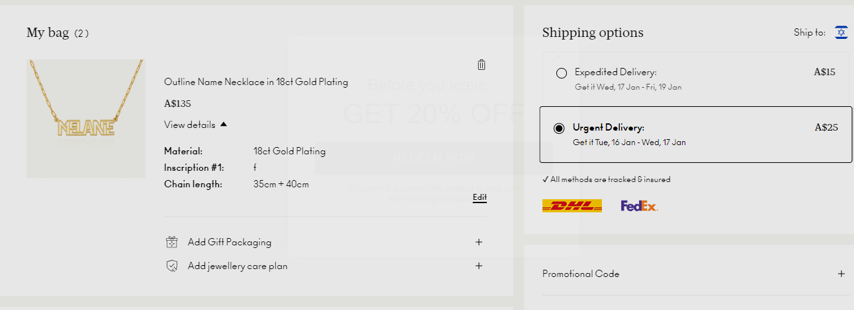
2. Change the shipping country to the customer's country:
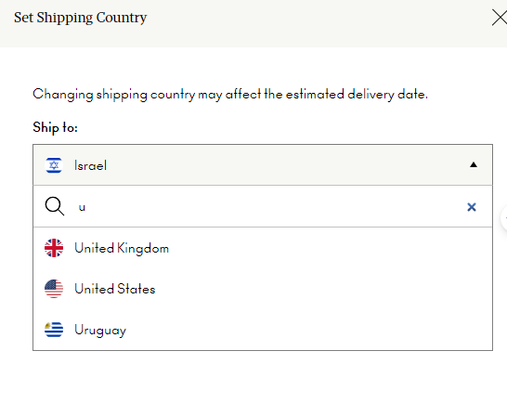
3. See Available shipping methods & Time frames for this specific order that is going to be shipped to this specific country:
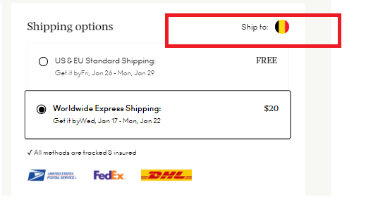

Do we ship to....?
Procedure:
1. See available shipping countries
2. The list of all the countries that we ship can be found in the cart of the site where the customer want's to shop:
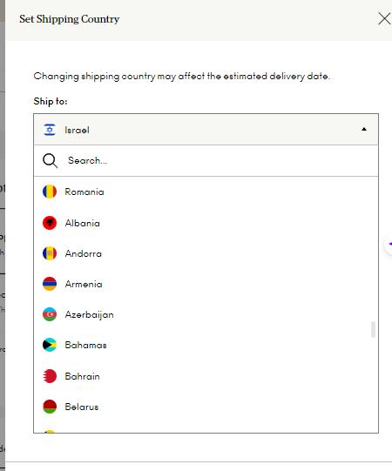

If the Customer's Address is not on the drop down:
Assign the conversation to TL

Change Address - post shipping
Slug:change-address-post-shipping-HyBcEYh9Je
Copy URL

View Article

After Shipping - Non-DHL/FedEx Orders
Procedure: Check Order Status on Courier's tracking
Based on the Order Status:
A. If the order tracking status is:
- DELIVERED: not possible to change the address anymore
- INCOMPLETE ADDRESS (except for apartment number missing): not possible to make changes anymore once it's shipped - you can offer a coupon for a reorder: Non - premium item: 25% coupon and for Premium items: 15% coupon
- STUCK (due to the wrong address - except for apartment number missing): not possible to make a change of an address - you can offer a coupon: Non - premium item: 25% coupon and for Premium items: 15% coupon
- If the tracking status is RTS (Return to sender) please see here
- If APARTMENT NUMBER MISSING - you can reorder for free. If RTS due to apartment missing/house number missing, then follow the procedure for RTS.
After Shipping - DHL/FedEx Orders
Policy: Address changes within the same city are often possible without additional costs.
Procedure:
- Check the order status to ensure it is NOT delivered yet.
- If the change is within the same city:
  - The customer can either contact us or the courier company directly.
  - If the customer contacts us, inform the Shipping Coordinator to process the change.
- If the change is to a different city:
  - For FedEx: Address changes are not possible.
  - For DHL: Inform the Shipping Coordinator to check for additional shipping costs.
    - If there are extra costs, proceed with an MR payment.
    - Provide all necessary details to the Shipping Coordinator for the address change.
- If the customer's address change request with FedEx/DHL is rejected:
  - Inform the customer.
  - Offer a discount coupon:
    - Non-premium: 25% off next purchase.
Premium: 15% off next purchase.

SPLIT SHIPPING - Items shipped from different factories
- In cases that the customer reaches out to us asking about receiving only one item (and not receiving the rest of the items) it could be split shipping.

- Packing department should add in the packing remarks the Tracking number of each of the shipment. In case if the packing remarks are empty, check under history, where its automatically recorded if the items were shipped separately (you will see two different tracking numbers)

