Handling Social Tickets & Social Pages (Facebook & Instagram)

1. Accessing Accounts
- Select the account to manage first (e.g., Theo Grace or Oak & Luna).
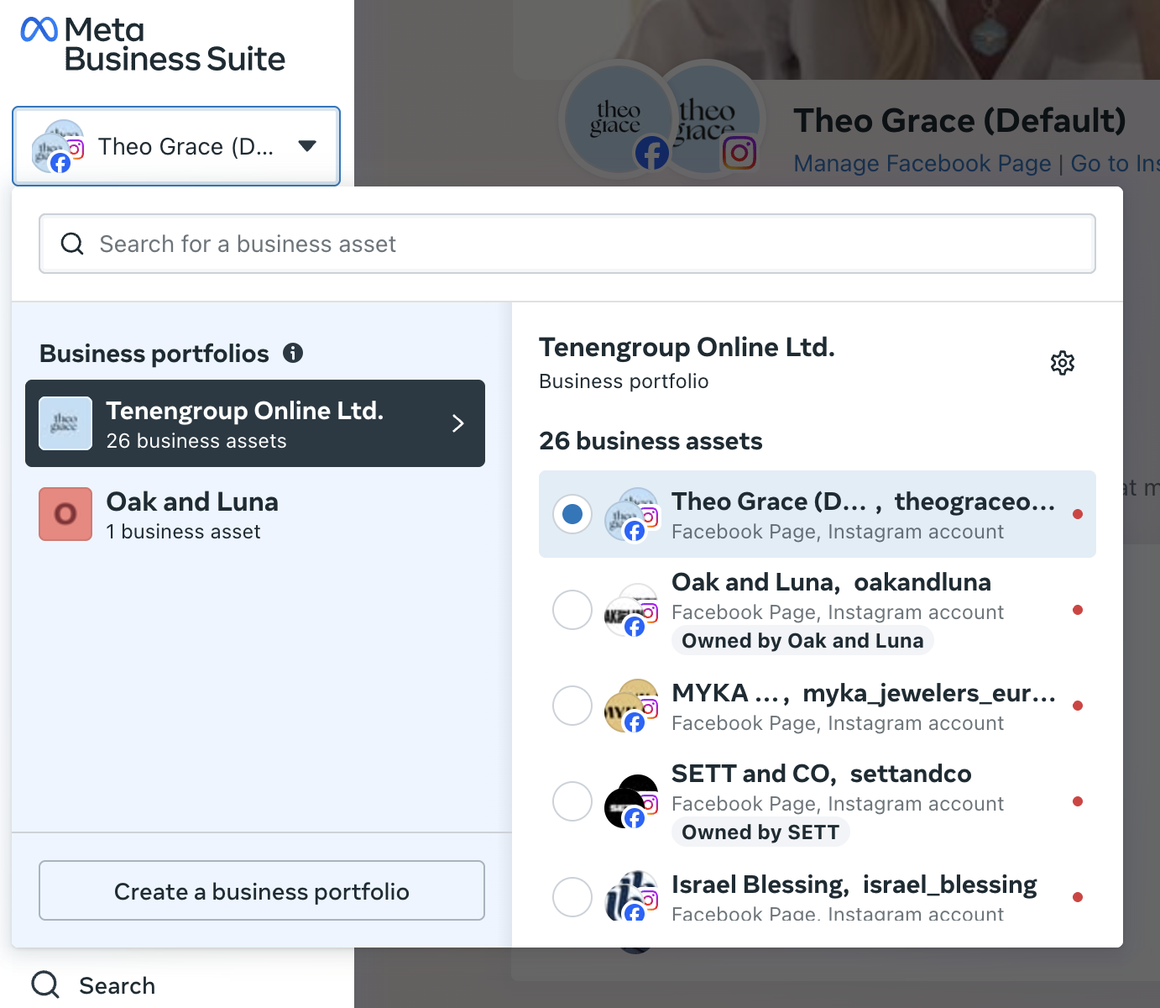
- Navigate to Facebook comments (Instagram follows the same process).
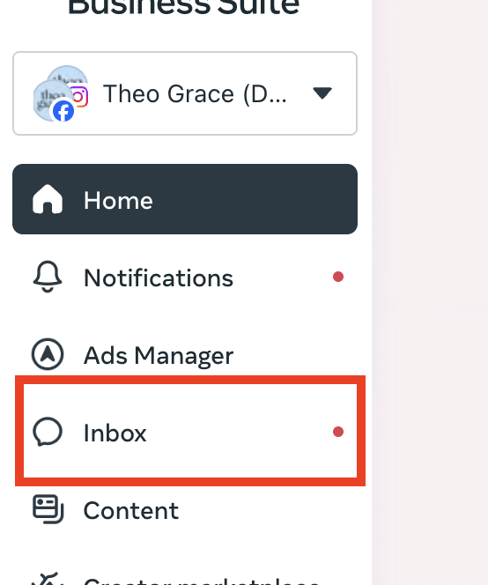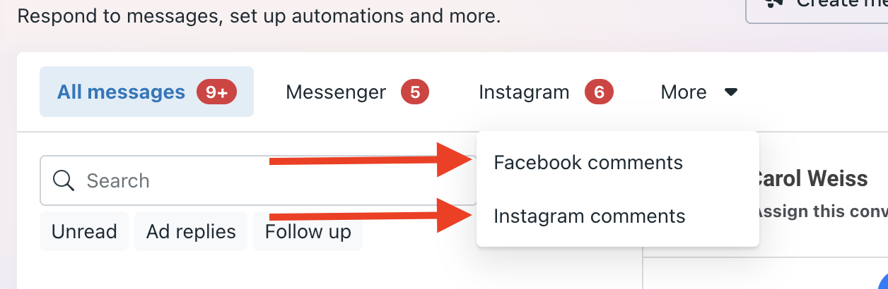

2. Handling Comments

Organizing Comments
- Always sort comments by “Newest” to ensure nothing is missed.
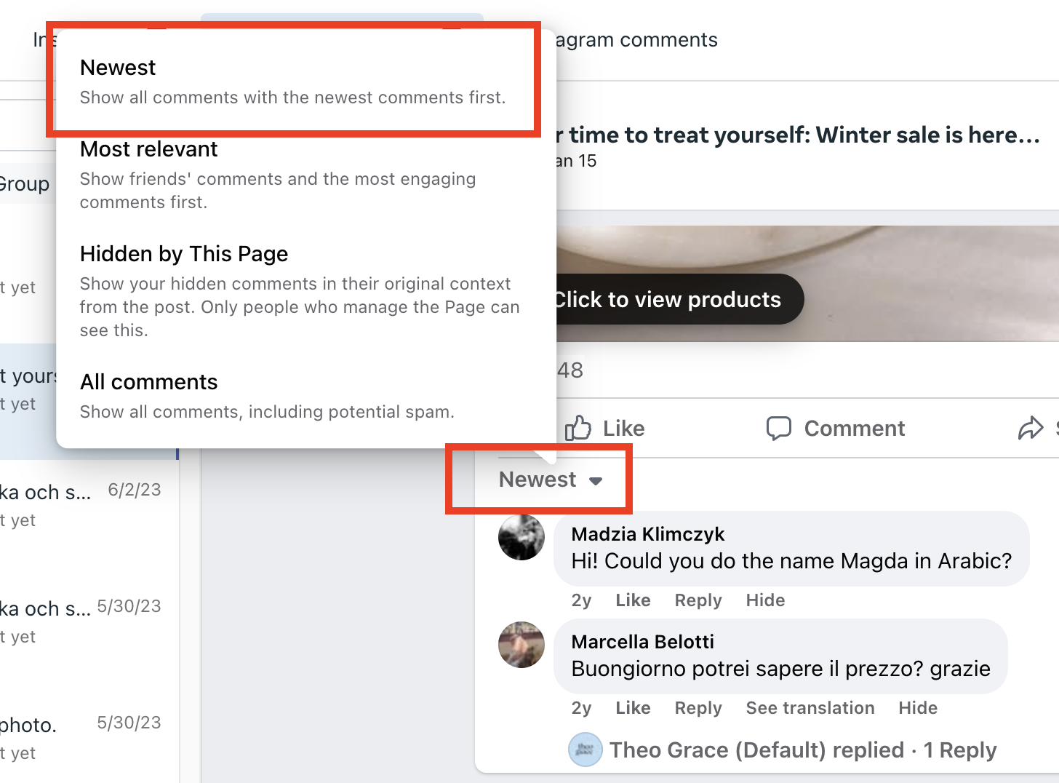
- Click “View more comments” (3-5 times) so all visible comments appear.
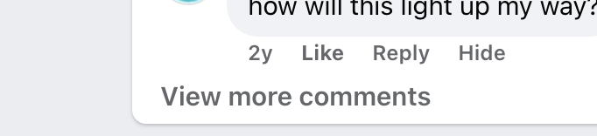

Engagement
- Click the heart/like on:
  - Positive comments about our jewelry
  - Mentions of names
  - Supportive remarks
→ This reassures customers we’re listening, and reappears in their notifications.

Replying to Customers
- Always click “Reply” directly below a customer’s comment → this way, the customer is automatically mentioned and notified.
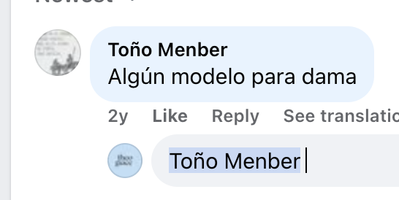
- Keep responses:
  - Friendly, polite, and professional
  - Short and natural in tone for public comments
  - Use emojis when appropriate for light engagement

Pre-Sale Inquiries
- Click the ad itself to see the product in question.
- If the item doesn’t fit the customer’s needs, recommend alternatives directly in the comment.
- Keep responses short and helpful (similar to casual comments).
- Tools like ChatGPT can help shorten and polish messages.

Customer Concerns all the brands except OAL (replying to PUBLIC criticism/concerns for OAL – at the end of the document)
- If the concern needs further attention, reply publicly with something like:
“We’ve sent you a message. Please check your inbox.”
- Then click “Send Message” below their comment to send a private message to the customer.
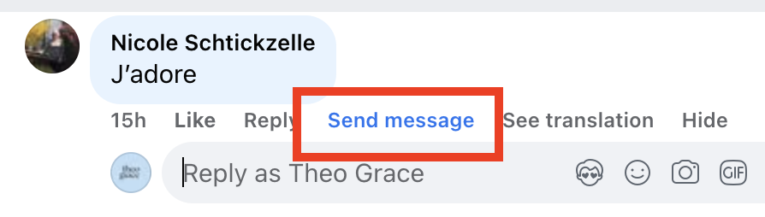
- In the private message, request:
  - Order details (order number or email address)
  - Photos (if it’s a damage/unsatisfied case)
- Always reply in the customer’s language (use translation templates if needed).

Hidden Comments
- Check the “Hidden by this page” section regularly.
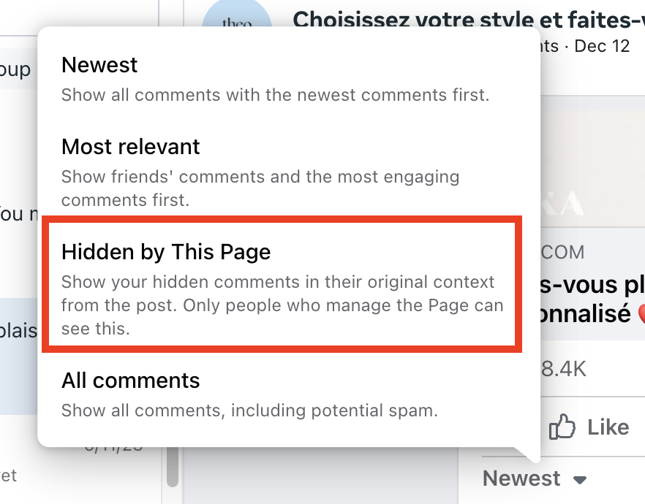
- Sometimes genuine customer concerns (especially damage cases) appear here.
- Best practices:
  - Unhide & respond (to show transparency).
  - Send a personal message as well.
- Hide only offensive, irrelevant, or repetitive comments. Don’t hide all negative reviews — it makes us look less credible. It’s better to reply to those negative reviews and show that we’re here to help, so customers can see that there will always be someone ready to assist them.

3. Moving to Kustomer
- Once a customer replies to a private message, it appears in Kustomer.
- Note: The initial message may not always appear in Kustomer → search their name in Meta Business Suite to review the original context.
- Tag & Merge Conversations:
  - Add order number if provided.
  - Merge tickets with the main account in Kustomer.
  - Fill in disposition & email address to keep records clean. Attention : adding email will merge accounts – add a print screen and if mistake impossible to fix only Marianna can do it
  - Add number of Instagram followers- there is a field
- If the giftee reaches out:
  - Merge as usual, but tag with “giftee” to indicate they’re not the buyer.

4. Handling Duplicates (Email + Social)
- If a customer reached out via both email and social:
  - Continue with the conversation that has more history/context.
  - For the duplicate, close it as a double but still reply:
“We’re already assisting you via email/Facebook. Please continue the conversation there to avoid confusion.”

5. Tone & Professionalism
- Every comment is public → it reflects our brand image.
- Keep responses:
  - Friendly
  - Polite
  - Professional
- Use emojis when appropriate (for light and friendly comments).
- For personal messages, use the email template (formal, structured).
- If unsure about a product detail or process: ask Team Leader first.
  - Since social pages are public, incorrect information could affect customer trust and brand reputation.

6. Handling Critical Customer Comments on Social Media for all the brands (except for OAL – which is at the end of the document)

1. Identify and Investigate the Case
When a customer posts a critical comment (for example: “My order was late and nobody ever replied to me!”), don’t rush to answer.
- Find the customer in Kustomer or OM using their name, email, or order number.
- Check their case history:
  - Look for any existing tickets or communications.
  - Verify if and when we replied
  - Check shipping or delivery updates if the complaint involves a delay.
- Get the full picture before responding. This allows you to write a message that feels personal, informed, and genuine - not copy-pasted.

2. Write a Personalized Public Response
Your public comment should:
- Acknowledge the issue.
- Show empathy and accountability.
- Indicate you’ve looked into their specific case.
- Invite them to continue in private so details can be handled securely.

Example Scenario
Customer comment:
“My order was late and I never even got a response from customer service. Terrible experience!”
Public Reply Example
Hi (NAME) we’re truly sorry for the delay and the frustration this caused. We actually reached out to you earlier, but it seems our message may have gotten lost or ended up in spam - we’re sorry that it didn’t reach you in time. We’ve just sent you another message to help fix this right away. Please check your DMs 💛
(This version sounds empathetic, takes responsibility, and explains the missed communication naturally — without sounding like an excuse.)

Public Reply Example (couldn’t find customer)
Hi (NAME) we’re really sorry to hear about this delay and the trouble reaching us. We’d love to look into your order personally and sort it out as soon as possible. Could you please DM us your order number so we can help right away?

3. Follow Up in a Direct Message (DM)
Once you’ve replied publicly, immediately send a personal DM with empathy and resolution-focused language.

7. Documentation & Reporting
- Maintain the Social File to report:
  - Repeated cases (e.g., sizing issues, late deliveries).
  - Errors spotted in ads.
  - Customer spam activity.
- Documentation guidelines:
  - Links are usually enough.
  - For complex cases, include screenshots and put them on the “Pictures” tab.
  - Ensure reports are complete so the relevant team can review efficiently.
- Don’t forget to add CSR remarks in OM (Order Management):
  - This is very important for colleagues handling emails who cannot see social tickets.
  - Remarks ensure visibility across teams and prevent missed context.

Oak & Luna

Public Comment Response Guidelines OAL ONLY

Public responses must:
- Remain neutral and professional
- Acknowledge the customer’s frustration without implying fault
- Move the conversation immediately to private messages
- Prevent public back-and-forth or explanations
Do not add any information beyond the approved response language:

Approved Responses Only
- “Thanks for sharing – we’ve sent you a DM.”
- “We understand this can be frustrating. Please check your DMs.”
- “Thanks for letting us know. We’ve messaged you privately.”
- “We understand this can be disappointing. DM sent so we can assist further.”
- “We appreciate you reaching out – we’ve sent a DM.”
- “We understand the frustration. We’ve reached out privately.”
- “Thank you for flagging this. We’ve sent a DM.”
- “We understand this can be disappointing – please check your DMs.”
- “Thanks for your comment. We’ve reached out privately.”
- “We understand – sending a DM to assist you directly.”
❗ No edits, additions, or custom wording are allowed.

What Is Not Allowed in Public Replies
Do not:
- Explain the issue
- Provide context or background
- Apologize in a way that implies fault
- Ask questions publicly
- Reference internal processes
- Continue the conversation publicly after the initial reply

After Posting the Reply
Once the approved response has been posted:
- The negative comment must be placed on HIDE
- Further communication must happen only via private message

Standard Protocol
This is now the standard protocol for:
- All negative comments
- All customer complaints
- All public-facing customer issues
No exceptions!

